page1image12916624Q/ Suppose there are two ISPs providing Wi-Fi access in a particular café, with each ISP operating its own AP and having its own IP address block.

Collage of business administration

MIS department

MIS 411: Network Management.

Dr. Shaista Rashid

Assignment 1

Section: 3207

Ghada Turki Almutairi

2210006230

1. Further suppose that by accident, each ISP has configured its AP to operate over channel 11. Will the 802.11 protocol completely break down in this situation? Discuss what happens when two stations, each associated with a different ISP, attempt to transmit at the same time.

*Answer:*

Collisions happen in wireless networks where multiple devices try to transfer data packets concurrently on the exact same channel, resulting in interference with the signal and corrupting data (Kurose, 2020). In this case, where both ISPs inadvertently set up their APs to work on the same channel, the 802.11 protocol encounters serious problems because of increased disruption and collisions.

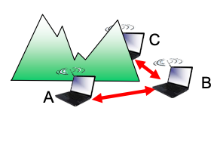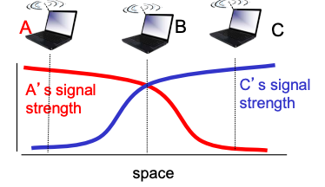Communication between transmission stations is hindered by physical barriers such as buildings, which causes overlooked collisions at the receiver. Furthermore, without the sending stations identifying one another, signal fading in wireless transmission might cause interference at the receiver (Kurose, 2020).

802.11 protocol uses Carrier-detect Multi-Access with Collision Avoidance (CSMA/CA), which requires that nodes detect the channel prior to transmitting, to prevent collisions. Meanwhile, because of limited collision domains, stations might not be capable of identifying each other's transmits if many access points from various ISPs overlap the channels. By the detection of continuing transmissions from other nodes, this method seeks to avoid collisions. Nevertheless, 802.11 doesn't contain collision detection, which makes it difficult to identify collisions, particularly in situations when there are a lot of transferring signals or weak signals being received. The aim of CSMA/CA is still to reduce collisions despite these restrictions (Kurose, 2020). The integrity of data is impacted by collisions, which occur when stations from several ISPs try concurrent transmissions. Even though CSMA/CA has a backoff mechanism, its efficacy may be limited by network coordination problems (Akyildiz et al., 2008).

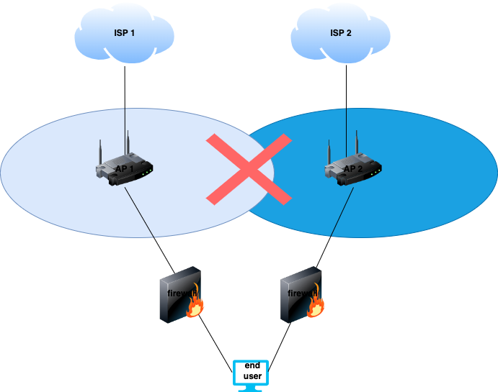

This illustration does a good job of explaining both interference and collision problems that arise from poor AP channel setup. This helps to portray the difficulties encountered by stations connected to different ISPs working on that same channel.

Chanel 11

Chanel 11

1. Now suppose that one AP operates over channel 1 and the other over channel 11. How do your answers change?

*Answer:*

When every AP uses its own channel, interference across networks greatly decreases (Zhang et al., 2010). Stations linked with each ISP perform on their own channels, reducing collisions and boosting overall network performance, potential difficulties might arise from the difficulty of setting up and maintaining APs across several channels, Maintaining ideal channel allocation and reducing interference in changing circumstances can be difficult. Furthermore, interference from outside sources that are not within the network administrator's control can still occur. (Chen et al. 2008). Both networks may cohabit more easily in this setup as it complies with the 802.11 protocol's design specifications (IEEE, 2012).

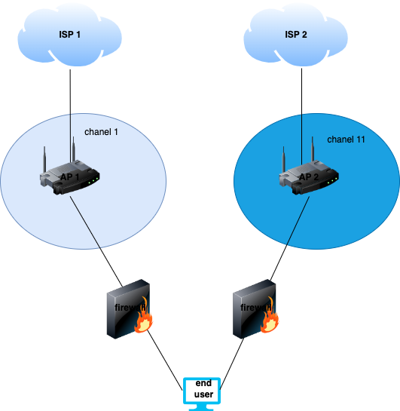

In this illustration, the individual circles indicate the coverage zones of each AP running on a distinct channel. The fact that the circles are not overlapping suggests that there is no interference among the Wi-Fi signals coming from each AP. This shows how setting up access points on separate channels greatly lowers interference and enhances network performance.

In summary, instead of running APs on the same channel, setting them on separate channels greatly improves network performance by lowering interference and collisions.

References:

Kurose, J. F. (2020). Computer Networking: A First Course. Pearson Education.

IEEE. (2012). IEEE Standard for Information technology--Local and metropolitan area networks--Specific requirements--Part 11: Wireless LAN Medium Access Control (MAC) and Physical Layer (PHY) Specifications. IEEE Std 802.11-2012.

Akyildiz, I. F., Wang, X., & Wang, W. (2008). Wireless mesh networks: a survey. Computer Networks, 47(4), 445-487.

Chen, Y., Li, Y., & Zhang, Y. (2008). A survey of MAC protocols for mission-critical applications in wireless sensor networks. IEEE Communications Surveys & Tutorials, 10(3), 88-101.

Zhang, Q., Li, Y., & Zheng, K. (2010). Dynamic channel allocation in cognitive radio networks. IEEE Communications Magazine, 48(9), 126-133.