UART (universal Asynchronous Receiver Transmitter)

A asynchronous serial transmission has two typical parts Receiver and Transmitter. The handling is inside an IC that is typical integrated on all microcontrollers today. This article describes how to handle and testing this basic part in VHDL in the simulator ghdl.

The signal is at silence condition high . A low on line manifest a start of transmission. After this Start Bit the datas are online. The low significant bit is the first bit from data. After data 8bits a high phase have to be on line. This is called Stop Bit. This is only that the next start bit can be correct capture by the receiver.

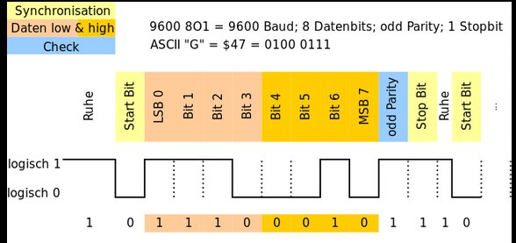

The baudrate specifies the transmission speed. The unit is bit per second.

UART VHDL code.

A test bench is need to test it.