No início do processamento, execução de trace, o principal programa do cromax aparece como não encontrado. No canto inferior, o status da conexão.

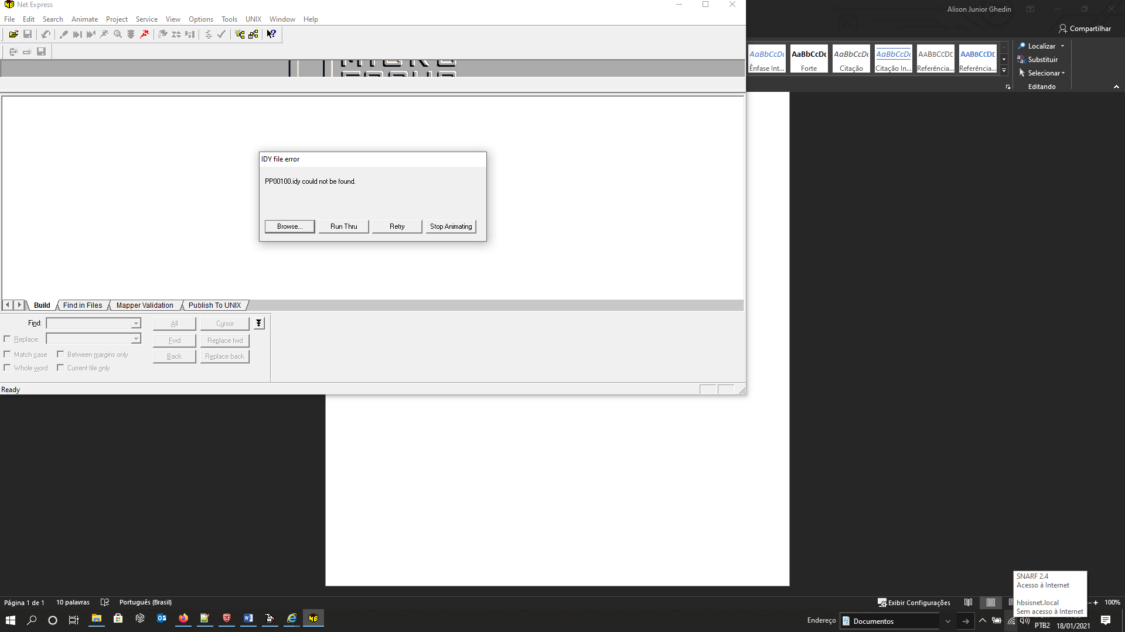

O processo de execução inicia, mas a execução para em pontos aleatórios, sem que seja solicitado. Isso faz com que não consiga concluir o processo de execução com trace.

A conexão com o fort cliente permanece:

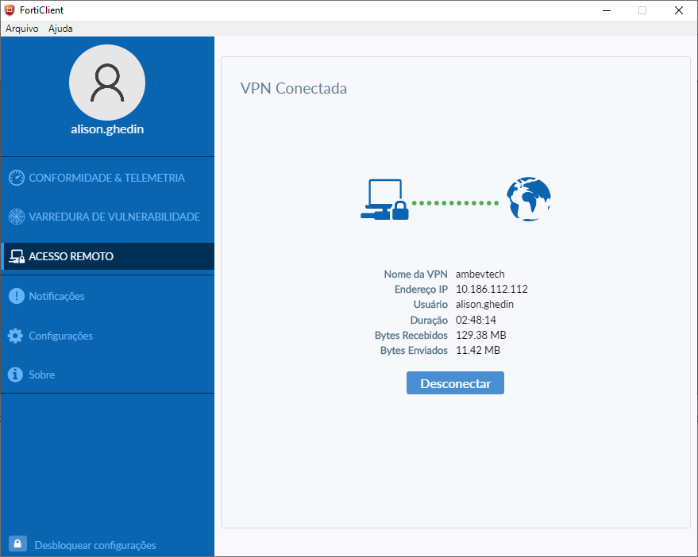

Essa é a tela de admin que é disponibilizada

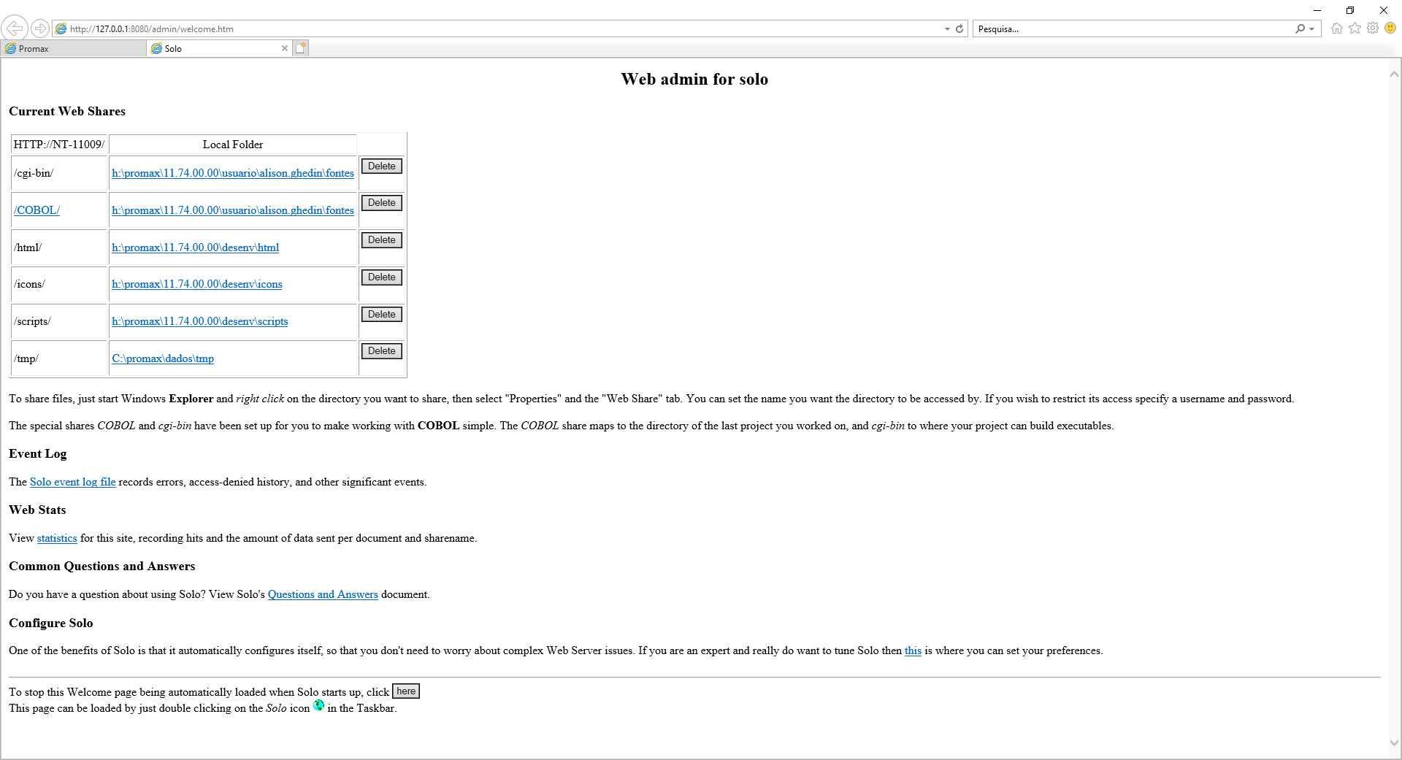

Abaixo a lista de log:

08/01/2021 13:15:12 Connect Die

* - Requested URL(/tmp/work/PWC1173_000_0000.xml)was not located.  
  The URL mapped to local file:  
  C:\promax\dados\tmp\work\PWC1173_000_0000.xml
* NT-11009(127.0.0.1) requested URL: /tmp/work/PWC1173_000_0000.xml

08/01/2021 13:15:15 Connect Die

* - Requested URL(/tmp/work/PWC1173_000_0000.xml)was not located.  
  The URL mapped to local file:  
  C:\promax\dados\tmp\work\PWC1173_000_0000.xml
* NT-11009(127.0.0.1) requested URL: /tmp/work/PWC1173_000_0000.xml

08/01/2021 13:15:18 Connect Die

* - Requested URL(/tmp/work/PWC1173_000_0000.xml)was not located.  
  The URL mapped to local file:  
  C:\promax\dados\tmp\work\PWC1173_000_0000.xml
* NT-11009(127.0.0.1) requested URL: /tmp/work/PWC1173_000_0000.xml

08/01/2021 13:15:21 Connect Die

* - Requested URL(/tmp/work/PWC1173_000_0000.xml)was not located.  
  The URL mapped to local file:  
  C:\promax\dados\tmp\work\PWC1173_000_0000.xml
* NT-11009(127.0.0.1) requested URL: /tmp/work/PWC1173_000_0000.xml

08/01/2021 13:15:24 Connect Die

* - Requested URL(/tmp/work/PWC1173_000_0000.xml)was not located.  
  The URL mapped to local file:  
  C:\promax\dados\tmp\work\PWC1173_000_0000.xml
* NT-11009(127.0.0.1) requested URL: /tmp/work/PWC1173_000_0000.xml

08/01/2021 13:15:27 Connect Die

* - Requested URL(/tmp/work/PWC1173_000_0000.xml)was not located.  
  The URL mapped to local file:  
  C:\promax\dados\tmp\work\PWC1173_000_0000.xml
* NT-11009(127.0.0.1) requested URL: /tmp/work/PWC1173_000_0000.xml

08/01/2021 13:15:30 Connect Die

* - Requested URL(/tmp/work/PWC1173_000_0000.xml)was not located.  
  The URL mapped to local file:  
  C:\promax\dados\tmp\work\PWC1173_000_0000.xml
* NT-11009(127.0.0.1) requested URL: /tmp/work/PWC1173_000_0000.xml

08/01/2021 13:15:33 Connect Die

* - Requested URL(/tmp/work/PWC1173_000_0000.xml)was not located.  
  The URL mapped to local file:  
  C:\promax\dados\tmp\work\PWC1173_000_0000.xml
* NT-11009(127.0.0.1) requested URL: /tmp/work/PWC1173_000_0000.xml

08/01/2021 13:15:36 Connect Die

* - Requested URL(/tmp/work/PWC1173_000_0000.xml)was not located.  
  The URL mapped to local file:  
  C:\promax\dados\tmp\work\PWC1173_000_0000.xml
* NT-11009(127.0.0.1) requested URL: /tmp/work/PWC1173_000_0000.xml

08/01/2021 13:15:39 Connect Die

* - Requested URL(/tmp/work/PWC1173_000_0000.xml)was not located.  
  The URL mapped to local file:  
  C:\promax\dados\tmp\work\PWC1173_000_0000.xml
* NT-11009(127.0.0.1) requested URL: /tmp/work/PWC1173_000_0000.xml

08/01/2021 13:15:42 Connect Die

* - Requested URL(/tmp/work/PWC1173_000_0000.xml)was not located.  
  The URL mapped to local file:  
  C:\promax\dados\tmp\work\PWC1173_000_0000.xml
* NT-11009(127.0.0.1) requested URL: /tmp/work/PWC1173_000_0000.xml

08/01/2021 13:15:45 Connect Die

* - Requested URL(/tmp/work/PWC1173_000_0000.xml)was not located.  
  The URL mapped to local file:  
  C:\promax\dados\tmp\work\PWC1173_000_0000.xml
* NT-11009(127.0.0.1) requested URL: /tmp/work/PWC1173_000_0000.xml

08/01/2021 13:15:48 Connect Die

* - Requested URL(/tmp/work/PWC1173_000_0000.xml)was not located.  
  The URL mapped to local file:  
  C:\promax\dados\tmp\work\PWC1173_000_0000.xml
* NT-11009(127.0.0.1) requested URL: /tmp/work/PWC1173_000_0000.xml

08/01/2021 13:15:51 Connect Die

* - Requested URL(/tmp/work/PWC1173_000_0000.xml)was not located.  
  The URL mapped to local file:  
  C:\promax\dados\tmp\work\PWC1173_000_0000.xml
* NT-11009(127.0.0.1) requested URL: /tmp/work/PWC1173_000_0000.xml

08/01/2021 13:15:54 Connect Die

* - Requested URL(/tmp/work/PWC1173_000_0000.xml)was not located.  
  The URL mapped to local file:  
  C:\promax\dados\tmp\work\PWC1173_000_0000.xml
* NT-11009(127.0.0.1) requested URL: /tmp/work/PWC1173_000_0000.xml

08/01/2021 13:15:57 Connect Die

* - Requested URL(/tmp/work/PWC1173_000_0000.xml)was not located.  
  The URL mapped to local file:  
  C:\promax\dados\tmp\work\PWC1173_000_0000.xml
* NT-11009(127.0.0.1) requested URL: /tmp/work/PWC1173_000_0000.xml

08/01/2021 13:16:00 Connect Die

* - Requested URL(/tmp/work/PWC1173_000_0000.xml)was not located.  
  The URL mapped to local file:  
  C:\promax\dados\tmp\work\PWC1173_000_0000.xml
* NT-11009(127.0.0.1) requested URL: /tmp/work/PWC1173_000_0000.xml

08/01/2021 13:16:03 Connect Die

* - Requested URL(/tmp/work/PWC1173_000_0000.xml)was not located.  
  The URL mapped to local file:  
  C:\promax\dados\tmp\work\PWC1173_000_0000.xml
* NT-11009(127.0.0.1) requested URL: /tmp/work/PWC1173_000_0000.xml

08/01/2021 13:16:06 Connect Die

* - Requested URL(/tmp/work/PWC1173_000_0000.xml)was not located.  
  The URL mapped to local file:  
  C:\promax\dados\tmp\work\PWC1173_000_0000.xml
* NT-11009(127.0.0.1) requested URL: /tmp/work/PWC1173_000_0000.xml

08/01/2021 13:16:09 Connect Die

* - Requested URL(/tmp/work/PWC1173_000_0000.xml)was not located.  
  The URL mapped to local file:  
  C:\promax\dados\tmp\work\PWC1173_000_0000.xml
* NT-11009(127.0.0.1) requested URL: /tmp/work/PWC1173_000_0000.xml

08/01/2021 13:16:12 Connect Die

* - Requested URL(/tmp/work/PWC1173_000_0000.xml)was not located.  
  The URL mapped to local file:  
  C:\promax\dados\tmp\work\PWC1173_000_0000.xml
* NT-11009(127.0.0.1) requested URL: /tmp/work/PWC1173_000_0000.xml

08/01/2021 13:16:15 Connect Die

* - Requested URL(/tmp/work/PWC1173_000_0000.xml)was not located.  
  The URL mapped to local file:  
  C:\promax\dados\tmp\work\PWC1173_000_0000.xml
* NT-11009(127.0.0.1) requested URL: /tmp/work/PWC1173_000_0000.xml

08/01/2021 13:16:18 Connect Die

* - Requested URL(/tmp/work/PWC1173_000_0000.xml)was not located.  
  The URL mapped to local file:  
  C:\promax\dados\tmp\work\PWC1173_000_0000.xml
* NT-11009(127.0.0.1) requested URL: /tmp/work/PWC1173_000_0000.xml

08/01/2021 13:16:21 Connect Die

* - Requested URL(/tmp/work/PWC1173_000_0000.xml)was not located.  
  The URL mapped to local file:  
  C:\promax\dados\tmp\work\PWC1173_000_0000.xml
* NT-11009(127.0.0.1) requested URL: /tmp/work/PWC1173_000_0000.xml

08/01/2021 13:16:24 Connect Die

* - Requested URL(/tmp/work/PWC1173_000_0000.xml)was not located.  
  The URL mapped to local file:  
  C:\promax\dados\tmp\work\PWC1173_000_0000.xml
* NT-11009(127.0.0.1) requested URL: /tmp/work/PWC1173_000_0000.xml

08/01/2021 13:16:27 Connect Die

* - Requested URL(/tmp/work/PWC1173_000_0000.xml)was not located.  
  The URL mapped to local file:  
  C:\promax\dados\tmp\work\PWC1173_000_0000.xml
* NT-11009(127.0.0.1) requested URL: /tmp/work/PWC1173_000_0000.xml

08/01/2021 13:16:30 Connect Die

* - Requested URL(/tmp/work/PWC1173_000_0000.xml)was not located.  
  The URL mapped to local file:  
  C:\promax\dados\tmp\work\PWC1173_000_0000.xml
* NT-11009(127.0.0.1) requested URL: /tmp/work/PWC1173_000_0000.xml

08/01/2021 13:16:33 Connect Die

* - Requested URL(/tmp/work/PWC1173_000_0000.xml)was not located.  
  The URL mapped to local file:  
  C:\promax\dados\tmp\work\PWC1173_000_0000.xml
* NT-11009(127.0.0.1) requested URL: /tmp/work/PWC1173_000_0000.xml

08/01/2021 13:16:36 Connect Die

* - Requested URL(/tmp/work/PWC1173_000_0000.xml)was not located.  
  The URL mapped to local file:  
  C:\promax\dados\tmp\work\PWC1173_000_0000.xml
* NT-11009(127.0.0.1) requested URL: /tmp/work/PWC1173_000_0000.xml

08/01/2021 13:16:39 Connect Die

* - Requested URL(/tmp/work/PWC1173_000_0000.xml)was not located.  
  The URL mapped to local file:  
  C:\promax\dados\tmp\work\PWC1173_000_0000.xml
* NT-11009(127.0.0.1) requested URL: /tmp/work/PWC1173_000_0000.xml

08/01/2021 15:18:33 stopped  
08/01/2021 16:01:04 Registry Init done. Build: Oct 29 2015 02:16:06  
08/01/2021 16:01:04 restart  
11/01/2021 11:00:02 Registry Init done. Build: Oct 29 2015 02:16:06  
11/01/2021 11:00:02 restart  
11/01/2021 15:08:41 Connect Die

* 404 Not Found - Requested URL (/favicon.ico) was not located.  
  The URL could not be mapped to a local file.
* NT-11009(127.0.0.1) requested URL: /favicon.ico

12/01/2021 12:07:46 Registry Init done. Build: Oct 29 2015 02:16:06  
12/01/2021 12:07:46 restart  
12/01/2021 12:09:08 Connect Die

* 501 Not Implemented -
* NT-11009(127.0.0.1) requested URL:

12/01/2021 12:09:08 Connect Die

* 501 Not Implemented -
* NT-11009(127.0.0.1) requested URL:

12/01/2021 12:09:08 Connect Die

* 501 Not Implemented -
* NT-11009(127.0.0.1) requested URL:

12/01/2021 12:09:08 Connect Die

* 501 Not Implemented -
* NT-11009(127.0.0.1) requested URL:

12/01/2021 12:09:08 Connect Die

* 501 Not Implemented -
* NT-11009(127.0.0.1) requested URL:

12/01/2021 12:09:08 Connect Die

* 501 Not Implemented -
* NT-11009(127.0.0.1) requested URL:

13/01/2021 15:21:55 Registry Init done. Build: Oct 29 2015 02:16:06  
13/01/2021 15:21:55 restart  
13/01/2021 15:40:45 The CGI program exceeded server timeout and was terminated.  
13/01/2021 15:48:23 Registry Init done. Build: Oct 29 2015 02:16:06  
13/01/2021 15:48:23 restart  
14/01/2021 11:46:21 Registry Init done. Build: Oct 29 2015 02:16:06  
14/01/2021 11:46:21 restart  
14/01/2021 11:47:40 The CGI program exceeded server timeout and was terminated.  
14/01/2021 16:44:56 Registry Init done. Build: Oct 29 2015 02:16:06  
14/01/2021 16:44:56 restart  
15/01/2021 08:28:04 Registry Init done. Build: Oct 29 2015 02:16:06  
15/01/2021 08:28:04 restart  
15/01/2021 08:29:39 The CGI program exceeded server timeout and was terminated.  
15/01/2021 10:27:40 The CGI program exceeded server timeout and was terminated.  
15/01/2021 11:27:59 Registry Init done. Build: Oct 29 2015 02:16:06  
15/01/2021 11:27:59 restart  
15/01/2021 11:29:16 The CGI program exceeded server timeout and was terminated.  
15/01/2021 11:31:31 The CGI program exceeded server timeout and was terminated.  
15/01/2021 11:33:11 The CGI program exceeded server timeout and was terminated.  
15/01/2021 11:34:36 Registry Init done. Build: Oct 29 2015 02:16:06  
15/01/2021 11:34:36 restart  
15/01/2021 11:35:59 The CGI program exceeded server timeout and was terminated.  
15/01/2021 11:43:30 Registry Init done. Build: Oct 29 2015 02:16:06  
15/01/2021 11:43:30 restart  
15/01/2021 11:45:38 The CGI program exceeded server timeout and was terminated.  
15/01/2021 11:48:57 The CGI program exceeded server timeout and was terminated.  
15/01/2021 12:03:53 Registry Init done. Build: Oct 29 2015 02:16:06  
15/01/2021 12:03:53 restart  
15/01/2021 12:06:18 The CGI program exceeded server timeout and was terminated.  
15/01/2021 12:08:35 The CGI program exceeded server timeout and was terminated.  
15/01/2021 12:12:55 The CGI program exceeded server timeout and was terminated.  
15/01/2021 12:36:59 Registry Init done. Build: Oct 29 2015 02:16:06  
15/01/2021 12:36:59 restart  
15/01/2021 12:50:00 Registry Init done. Build: Oct 29 2015 02:16:06  
15/01/2021 12:50:00 restart  
15/01/2021 12:51:19 The CGI program exceeded server timeout and was terminated.  
15/01/2021 12:53:18 The CGI program exceeded server timeout and was terminated.  
15/01/2021 13:00:50 Registry Init done. Build: Oct 29 2015 02:16:06  
15/01/2021 13:00:50 restart  
15/01/2021 13:02:06 The CGI program exceeded server timeout and was terminated.  
15/01/2021 13:04:04 Registry Init done. Build: Oct 29 2015 02:16:06  
15/01/2021 13:04:04 restart  
15/01/2021 13:05:19 The CGI program exceeded server timeout and was terminated.  
15/01/2021 13:07:33 The CGI program exceeded server timeout and was terminated.  
15/01/2021 13:08:59 The CGI program exceeded server timeout and was terminated.  
15/01/2021 14:31:32 The CGI program exceeded server timeout and was terminated.  
15/01/2021 14:46:04 Registry Init done. Build: Oct 29 2015 02:16:06  
15/01/2021 14:46:04 restart  
15/01/2021 16:24:11 The CGI program exceeded server timeout and was terminated.  
15/01/2021 16:26:26 The CGI program exceeded server timeout and was terminated.  
15/01/2021 16:29:53 Registry Init done. Build: Oct 29 2015 02:16:06  
15/01/2021 16:29:53 restart  
15/01/2021 16:31:32 The CGI program exceeded server timeout and was terminated.  
15/01/2021 16:33:57 The CGI program exceeded server timeout and was terminated.  
15/01/2021 16:37:36 Registry Init done. Build: Oct 29 2015 02:16:06  
15/01/2021 16:37:36 restart  
15/01/2021 16:38:51 The CGI program exceeded server timeout and was terminated.  
15/01/2021 16:41:32 The CGI program exceeded server timeout and was terminated.  
15/01/2021 16:48:02 Registry Init done. Build: Oct 29 2015 02:16:06  
15/01/2021 16:48:02 restart  
15/01/2021 16:49:24 The CGI program exceeded server timeout and was terminated.  
15/01/2021 17:51:48 Registry Init done. Build: Oct 29 2015 02:16:06  
15/01/2021 17:51:48 restart  
15/01/2021 17:53:12 The CGI program exceeded server timeout and was terminated.  
15/01/2021 18:16:25 Registry Init done. Build: Oct 29 2015 02:16:06  
15/01/2021 18:16:25 restart  
15/01/2021 18:22:23 Registry Init done. Build: Oct 29 2015 02:16:06  
15/01/2021 18:22:23 restart  
15/01/2021 18:32:24 Registry Init done. Build: Oct 29 2015 02:16:06  
15/01/2021 18:32:24 restart  
18/01/2021 07:27:33 Registry Init done. Build: Oct 29 2015 02:16:06  
18/01/2021 07:27:33 restart  
18/01/2021 07:29:03 The CGI program exceeded server timeout and was terminated.  
18/01/2021 07:31:15 The CGI program exceeded server timeout and was terminated.  
18/01/2021 07:34:01 Connect Die

* 404 Not Found - Requested URL (/cgi-bin/PP00100.exe) was not located.  
  The URL could not be mapped to a local file.
* NT-11009(127.0.0.1) requested URL: /cgi-bin/PP00100.exe

18/01/2021 07:34:09 Connect Die

* 404 Not Found - Requested URL (/cgi-bin/PP00100.exe) was not located.  
  The URL could not be mapped to a local file.
* NT-11009(127.0.0.1) requested URL: /cgi-bin/PP00100.exe

18/01/2021 07:35:20 Registry Init done. Build: Oct 29 2015 02:16:06  
18/01/2021 07:35:20 restart  
18/01/2021 07:36:48 The CGI program exceeded server timeout and was terminated.  
18/01/2021 07:40:56 Registry Init done. Build: Oct 29 2015 02:16:06  
18/01/2021 07:40:56 restart  
18/01/2021 08:25:33 Registry Init done. Build: Oct 29 2015 02:16:06  
18/01/2021 08:25:33 restart  
18/01/2021 08:28:28 The CGI program exceeded server timeout and was terminated.  
18/01/2021 08:30:16 Connect Die

* 404 Not Found - Requested URL (/cgi-bin/PP00100.exe) was not located.  
  The URL could not be mapped to a local file.
* NT-11009(127.0.0.1) requested URL: /cgi-bin/PP00100.exe

18/01/2021 08:30:23 Connect Die

* 404 Not Found - Requested URL (/cgi-bin/PP00100.exe) was not located.  
  The URL could not be mapped to a local file.
* NT-11009(127.0.0.1) requested URL: /cgi-bin/PP00100.exe

18/01/2021 08:32:17 Registry Init done. Build: Oct 29 2015 02:16:06  
18/01/2021 08:32:17 restart  
18/01/2021 08:40:44 Registry Init done. Build: Oct 29 2015 02:16:06  
18/01/2021 08:40:44 restart  
18/01/2021 08:42:29 The CGI program exceeded server timeout and was terminated.  
18/01/2021 08:44:00 The CGI program exceeded server timeout and was terminated.  
18/01/2021 08:45:19 Connect Die

* 404 Not Found - Requested URL (/cgi-bin/PP00100.exe) was not located.  
  The URL could not be mapped to a local file.
* NT-11009(127.0.0.1) requested URL: /cgi-bin/PP00100.exe

18/01/2021 08:50:18 Registry Init done. Build: Oct 29 2015 02:16:06  
18/01/2021 08:50:18 restart  
18/01/2021 08:51:44 The CGI program exceeded server timeout and was terminated.  
18/01/2021 10:13:05 Registry Init done. Build: Oct 29 2015 02:16:06  
18/01/2021 10:13:05 restart  
18/01/2021 12:18:21 Registry Init done. Build: Oct 29 2015 02:16:06  
18/01/2021 12:18:21 restart  
18/01/2021 12:20:03 The CGI program exceeded server timeout and was terminated.  
18/01/2021 12:23:38 The CGI program exceeded server timeout and was terminated.  
18/01/2021 14:45:55 Registry Init done. Build: Oct 29 2015 02:16:06  
18/01/2021 14:45:55 restart  
18/01/2021 14:47:11 The CGI program exceeded server timeout and was terminated.  
18/01/2021 14:56:04 The CGI program exceeded server timeout and was terminated.

Nova tentativa:

15:22 inicio de novo debug:

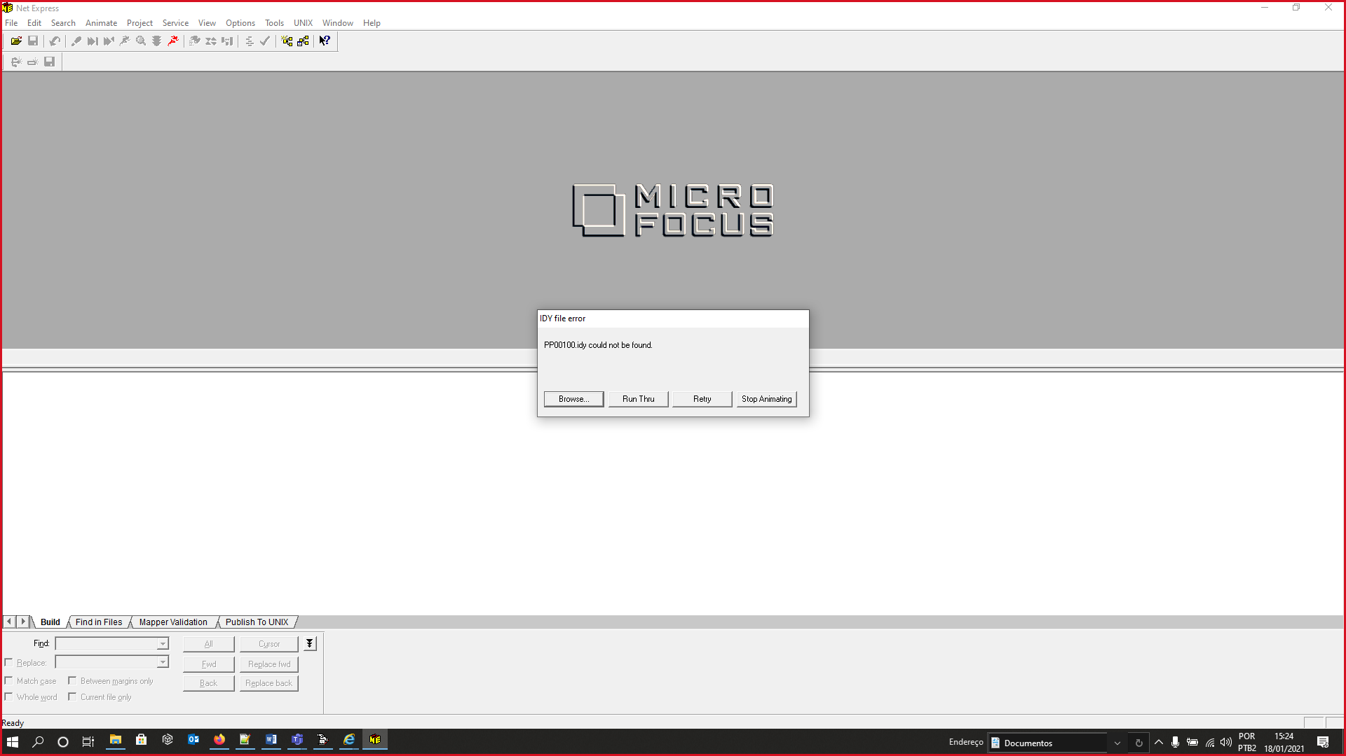

Início do processo de debug.

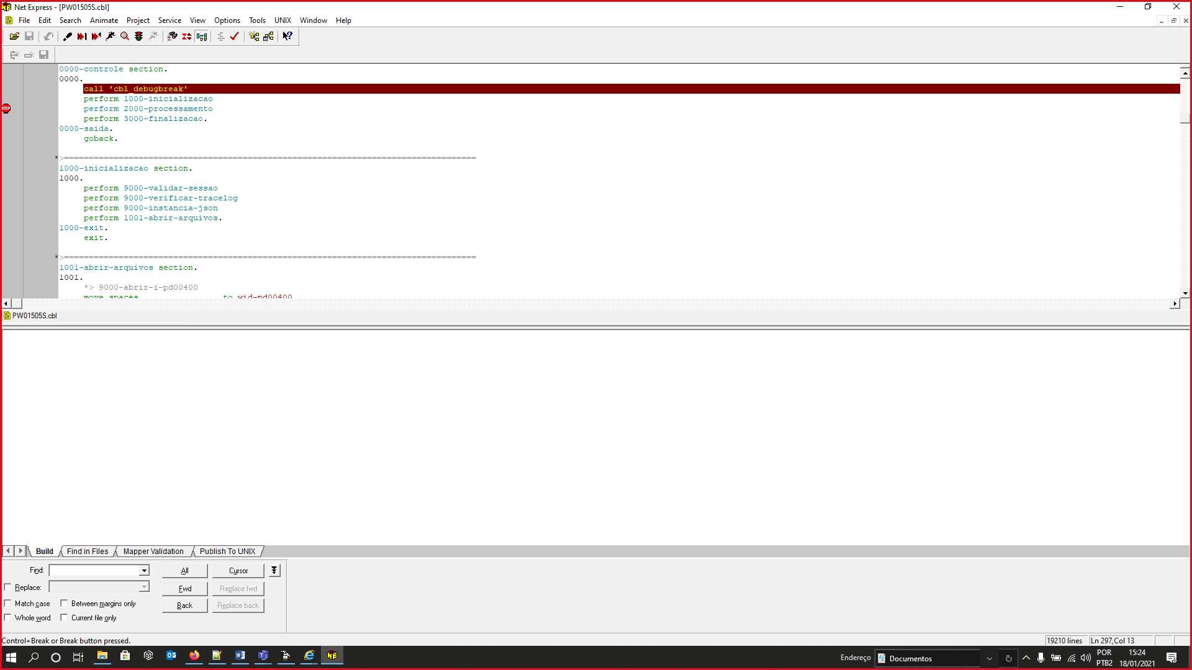

Aqui já parou o processo.

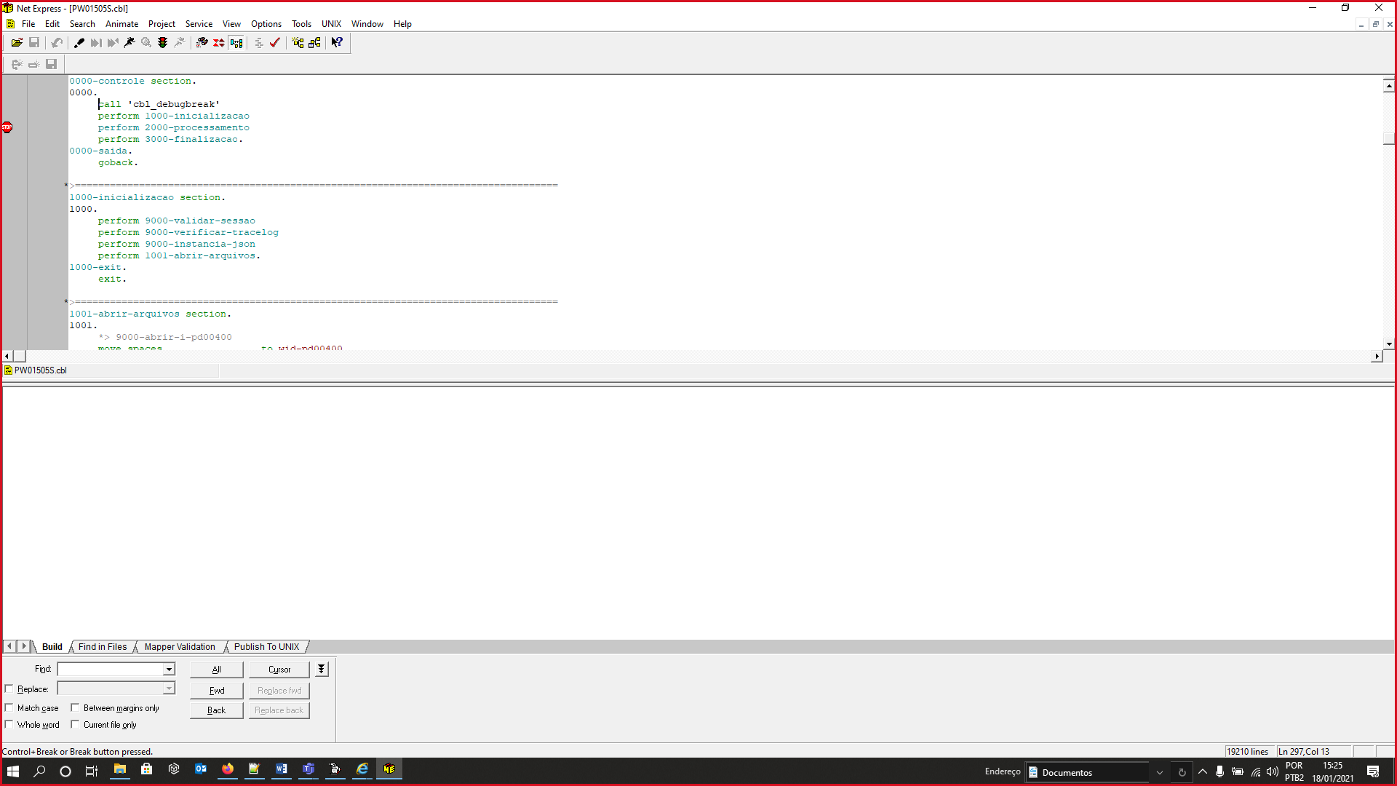

Log:

18/01/2021 15:23:26 Registry Init done. Build: Oct 29 2015 02:16:06  
18/01/2021 15:23:27 restart  
18/01/2021 15:24:56 The CGI program exceeded server timeout and was terminated.