Final Project – SD&S 5300
Caroline Gheen

Introduction
I utilized the American Hospital Association’s Annual Survey IT supplement as my data source, specifically the 2024 responses. This is an annual survey sent out to all member hospitals of the American Hospital Association and assesses their technology and information technology status. It is required and typically filled out by an institution’s CIO. I am studying Health Informatics at YSPH, so I am very interested in the information systems at hospitals, and this is a dataset I have been wanting to explore. My analysis mostly hinges on Health Information Exchanges (HIE) which are networks in which hospitals participate to share information with each other, mainly to improve public health or patient care.

Data
I isolated 6 questions: “Q-10: Indicate level of participation in state, regional, and/or local health information exchange (HIE) or health information organization (HIE),” Options: HIE/HIO is operational in my area and we are participating and actively exchanging data in at least one HIE, HIE/HIO is operational in my area but we are not participating, HIE/HIO is not operational in my area, do not know
“Q-11: Which of the following national health information exchange networks and/or frameworks does your hospital currently participate in,” Options: CommonWell Health Alliance, e-Health Exchange, Civitas, EHR vendor network, Other national HIE and describe, do not participate in, do not know
“Q-14: How does your hospital submit data for public health reporting related to activities below,” Options: syndromic surveillance reporting, immunization registry reporting, electronic case reporting, public health registry reporting, clinical data registry reporting, electronic reportable laboratory result reporting, antimicrobial use and resistance, hospital capacity and utilization of medical records
“Q-18: Does your hospital use any machine learning or other predictive models that display output or recommendations” Options: machine learning, other and describe
“Q-19: To which of the following uses has your hospitals applied machine learning or other predictive models” Options: predicting health trajectories or risk for inpatients, identify high risk options for follow up, monitor health, recommend treatments, simplify or automate billing, facilitate scheduling, other operational process optimization and describe, other clinical use cases and describe
Ownership: government non-federal (state, county, city, city-county, hospital district or authority), non-government/not-for-profit (church operated, other), investor owned/for-profit (individual, partnership, corporation), government/federal (Department of Defense, public health service, Veterans Affairs, federal other, Indian service, Department of Justice)
And I isolated 4 descriptors: AHA ID number, hospital name, total facility beds set up and staffed, and primary Electronic Medical Record (EMR) used.
Questions 11, 14, 18, and 19 are stored as binary indicator variables, where 1 indicates the option was selected and 0 indicates it was not. Institutions could select multiple options, meaning they can participate in multiple HIEs, use HIE to report multiple public health measures, and use ML/AI for multiple tasks. For question 14, only variables related to HIE were included. Four free-text 'other' fields captured write-in responses for use of ‘other’ primary EMR, HIE network participation, predictive models, and AI tasks.
I created two composite variables. The HIE participation score was constructed by summing: one point for participating in any HIE (Q10), one point per HIE network participated in (Q11), and one point per public health reporting type for which HIE was utilized (Q14). The AI score was constructed by summing: one point for using ML or a predictive model (Q18) and one point per task for which AI is used (Q19).
Ultimately these were the variables of interest:
1. HIE Participation Score (continuous, range 0-14)
2. AI Composite Score (continuous, range 0-10)
3. Number of Beds (continuous)
4. Ownership type (categorical)
5. Primary EMR (categorical)

Data Cleaning and Descriptive Plots
The first thing I did was change the names of the variable to make them more human readable and help track which question each variable came from. Despite focusing on only 5 variables, my dataset contained about 48 variables due to the storage of each option as binary indicators.
I explored missingness by making a data frame with each variable, the amount of data present for that variable, amount missing, and the percent complete. Overall, missingness was low, so I questioned if a lot of the missingness was potentially from the same institutions submitting incomplete surveys. I made another data frame that was each institution’s ID, the amount of data present for their survey, amount of missing, and percent complete. Completeness varied across institutions: many had 100% complete data, some fell in the 60–90% range, and some completed as little as 20% of the survey. To determine an appropriate completeness threshold, I evaluated three subsets: how many institutions had at least 61%, 90%, and 100% complete data. Restricting to fully complete records dropped 1,128 institutions but retained 1,513, which I felt was a sufficient sample size and allows me to have no missing data.
All questions had ‘No’ keyed as 0 except Q-18. I recoded ‘No’ for Q-18 to 0 so it was consistent throughout the dataset.
Next, I looked at the different primary EMRs that are used. Cerner (owned by Oracle), Epic, and Meditech are dominant vendors and had the most users as expected. I retained these three vendors as options and collapsed all other options into an individual ‘other’ option. No institutions reported that they did not have an EMR - this is expected as there are government penalties for not using an EMR.
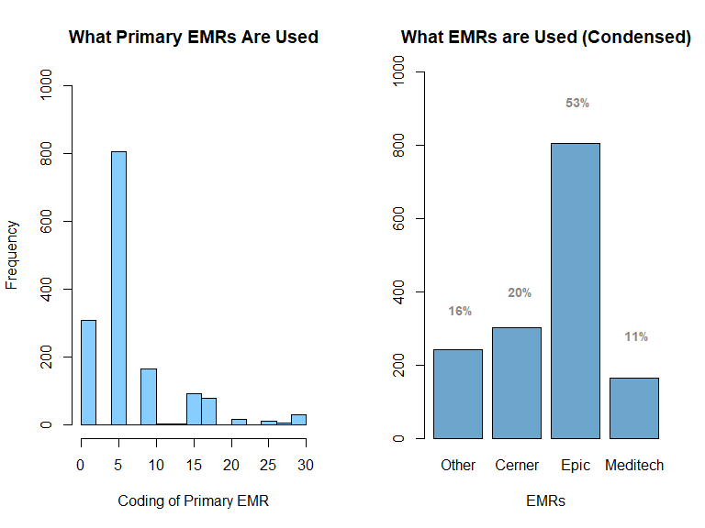
The left barchart shows the original distribution of all options of EMR vendors. The right barchart shows the new distribution of EMR vendors after condensing the options. Epic is the runaway leader with almost half of the institutions using them. Meditech, Cerner, and other EMRs were utilized at similar rates.
Next, the ownership was originally coded as about 45 different options under 4 broad categories: government, non-federal; not-for-profit; for-profit; government, federal. I condensed the options to be the 4 general categories.
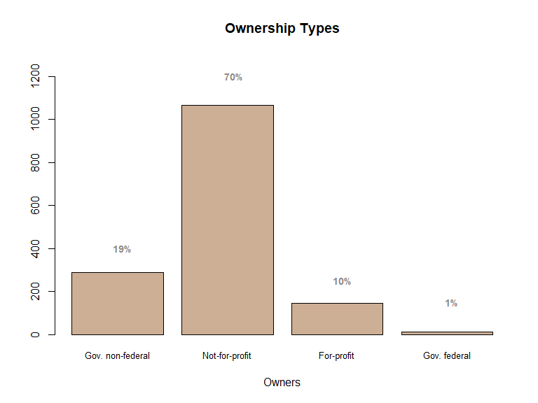
Not-for-profits were the largest category - this makes sense as it includes the religious institutions and the academic medical centers. Federal is smaller than expected; there is only 1 owned by the DOD (this should include military hospitals) and only 9 VAs, which is thought to be the largest healthcare institution, so this is not representative of the actual hospital breakdown and potentially due to only keeping complete responses.
Bed total was used as a proxy for hospital size. It ranged from 3 to 2919, so a very widespread. As is, the variable is heavily right skewed, therefore, I applied a log transformation, which will be used throughout the rest of the analysis. Because no values were non-zero, I did not need to apply a constant first.
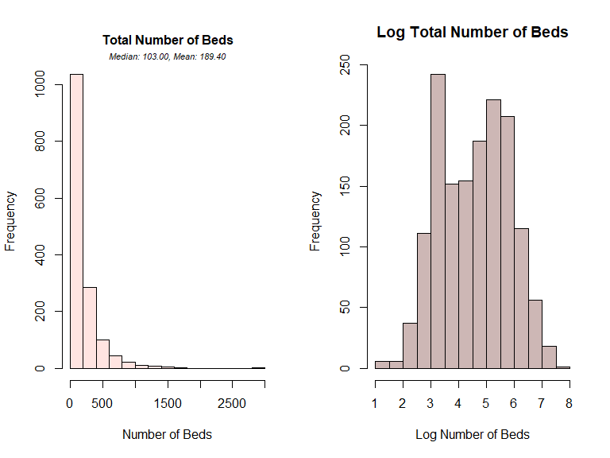
I wanted to explore the free answer text variables: other HIE, other process use of AI, other clinical use of AI. First, I wanted to see if any answers reported in the ‘other’ free text were actually other coded options that should have been selected instead.
There were two hospitals who marked they were participating in CommonWell and also answered that they participated in ‘other,’ then specified a subgroup of CommonWell. I recoded their ‘other’ participation as 0 in order to only count their CommonWell participation once. There were 6 institutions (all from the same parent institution, so likely filled out by the same individual) who marked that they participated in an EHR-based HIE and specified in ‘other’ that they participate in Epic, which is an EHR based HIE. I recoded their ‘other’ participation to 0 so their Epic participation only counted once. Three institutions reported they participate in TEFCA, which is an agreement, not an exchange; one reported participation in eCQM which is a CMS quality measure, not an exchange; and one institution reported that they participate in National Research Institute which is the sharing of genomes but not an established HIE. As none of these constitute HIE participation, their 'other' responses were recoded to 0.
I also analyzed if any of the ‘other’ answers could be their own group. Many of the ‘other’ answers are state exchanges (CA, CO, NJ, CT/MA, KY, IN KA, OH, OK) and federal exchanges. Surescripts, CyncHealth, and Direct Trust had a mediocre number of answers, but not enough to justify being their own category.
The AI clinical and operational process uses also had a free text box to describe any other task for which ML or AI is used. I noticed a lot of overlap in responses (ex: some institutions reported ambient scribes that help doctors take notes as an ‘other’ clinical use and some report it as an ‘other’ process use), leading me to believe there was not a lot of guidance from the AHA in how tasks should be categorized. In creating the AI score, each activity was worth one point regardless of whether it was selected as a named category or written in as 'other,' so reassigning responses would not have an effect on scoring. It should be noted that this scoring method captures breadth of AI use rather than depth, meaning institutions using multiple tools for a single task receive the same score as those using one tool for that task
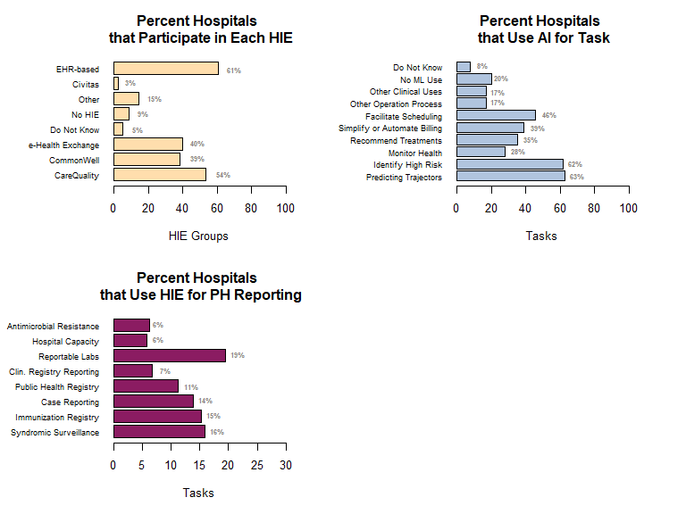
A lot of hospitals participate in EHR-based HIE, CareQuality, and Commonwell. Additionally, many institutions use HIE to report necessary labs. HIE is used for at least some reporting for each option of public health measure. Additionally, a majority of hospitals use ML/AI to identify high risk patients and predict patient trajectory and a good amount use it for facilitating scheduling or billing.
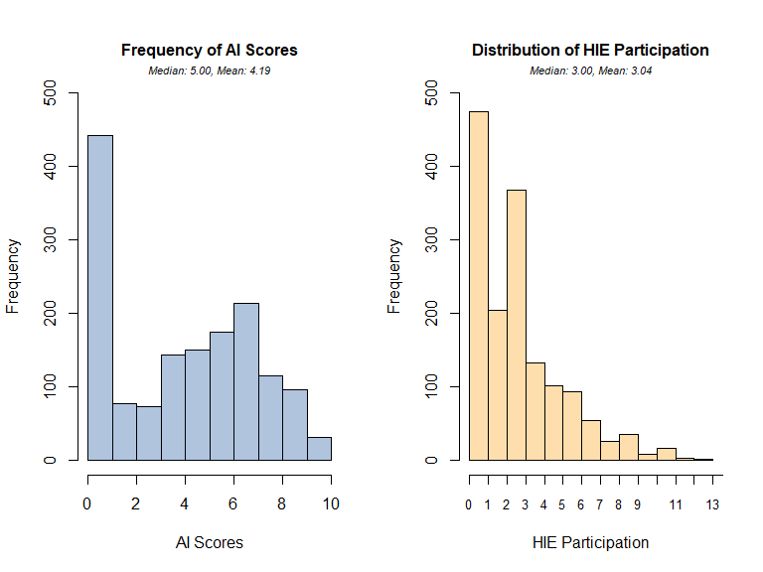
The most common AI score was 0, however all levels of AI scores were represented, with some institutions applying AI or ML across every measured task. We see a lot of institutions do not participate in HIE at all, and no institutions uses HIE for all possible public health reporting manners and participate in all possible HIE. The HIE score distribution does appear to be right-skewed.
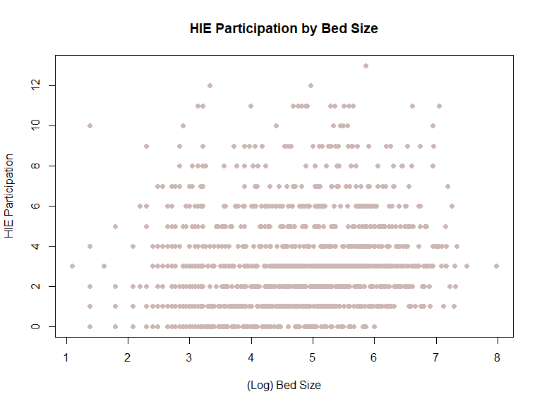
Looking at HIE Participation by bed total, there does not seem to be a strong relationship.
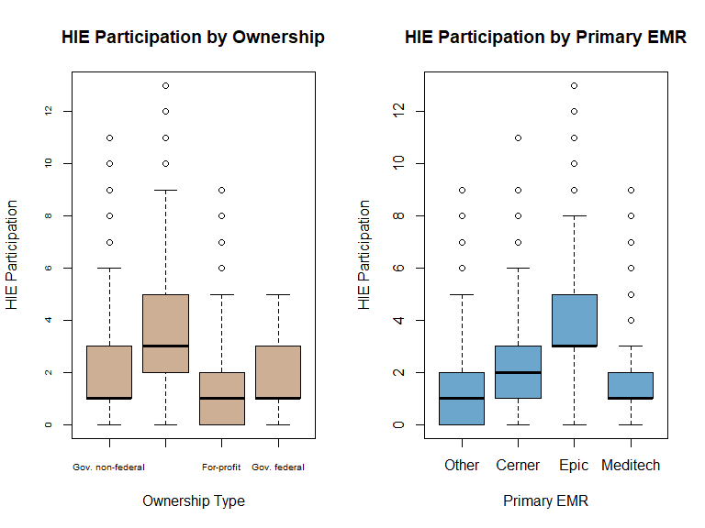
Looking at HIE participation across ownership type, all boxes have overlap with not-for-profits participating the most. There are some high outliers for most of the groups.
Looking at HIE participation across EMR vendors, there is an obvious higher amount of participation for those who use Epic (more on why this makes sense later). Cerner has a slightly higher median level of HIE compared to other vendors or Meditech. There are some high outliers for all groups here as well.
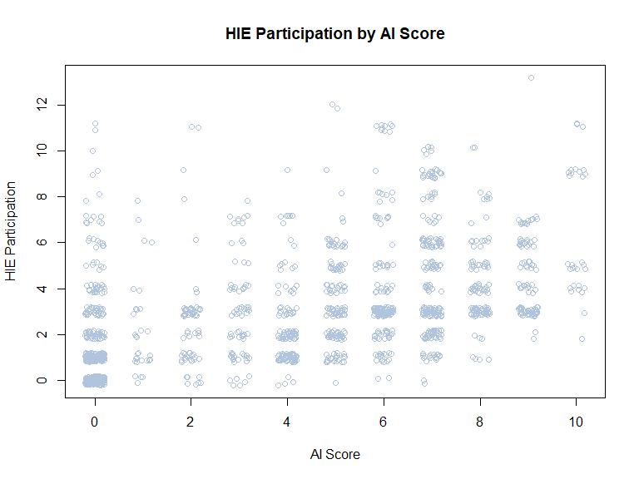
Looking at HIE participation by AI scores (with jitter). It does seem that those who participate in AI less also participate in HIE less and those who use AI more, participate in HIE more.

Analysis
Two Way T-Test
I wanted to answer if not-for-profits and for-profit institutions participate in HIE the same on average.
There are 1065 non-profit institutions and 146 for-profit institutions, so this was an unbalanced sample.
Analyzing the boxplot, it seems not-for-profits participate more on average, but the confidence intervals do overlap. The overall mean and median is closer to the mean and median for only not-for-profit than for-profits.
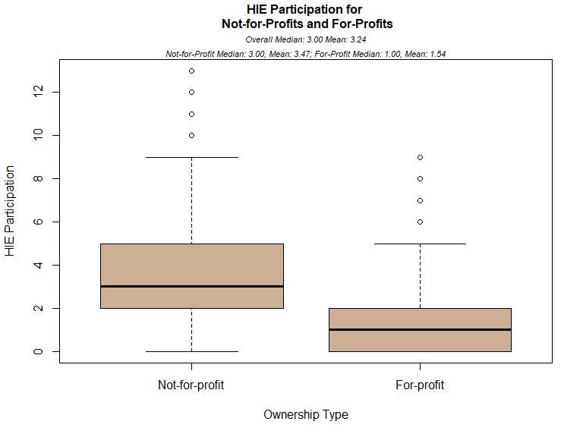
##
## Welch Two Sample t-test
##
## data: groups$hie_participation by groups$ownership
## t = 10.516, df = 201.81, p-value < 2.2e-16
## alternative hypothesis: true difference in means between group 2 and group 3 is not equal to 0
## 95 percent confidence interval:
## 1.564533 2.286609
## sample estimates:
## mean in group 2 mean in group 3
## 3.466667 1.541096
The t-test produces a p-value close to 0 meaning we can reject the null hypothesis that the mean is the same between the groups and conclude the mean HIE participation is not the same for not-for-profits and for-profits. From the confidence intervals, we can conclude that participation is higher in not-for-profits, which is what we expected from the boxplots.

Correlation
Next, I wanted to look at if “bigger” hospitals (aka institutions with more beds) are more likely to participate in HIE and as hospital size increases, does their participation in HIE increase as well.
From the correlation test, there is a slight positive correlation between bed size and institution HIE participation, indicating bigger hospitals do participate in HIE more, but this is not a particularly strong association. There does not seem to be any egregious outliers that are pulling the values.
##
## Pearson's product-moment correlation – HIE and Bed Size
##
## data: data2$hie_participation and log(data2$bdtot)
## t = 6.9954, df = 1511, p-value = 3.961e-12
## alternative hypothesis: true correlation is not equal to 0
## 95 percent confidence interval:
## 0.1278621 0.2254990
## sample estimates:
## cor
## 0.1771163
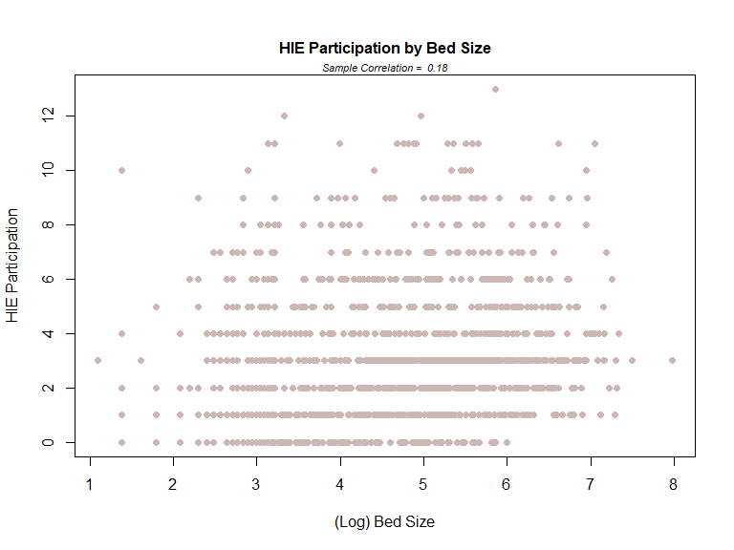
I also wanted to look at if hospitals who are using more AI are participating in HIE more. There is a moderate positive correlation indicating institutions that utilize AI more perhaps utilize their HIE more. There are spots where answers cluster together, like those who use no AI also use HIE very little.
##
## Pearson's product-moment correlation – HIE and AI
##
## data: data2$hie_participation and data2$ai_score
## t = 21.399, df = 1511, p-value < 2.2e-16
## alternative hypothesis: true correlation is not equal to 0
## 95 percent confidence interval:
## 0.4426151 0.5200109
## sample estimates:
## cor
## 0.4822535
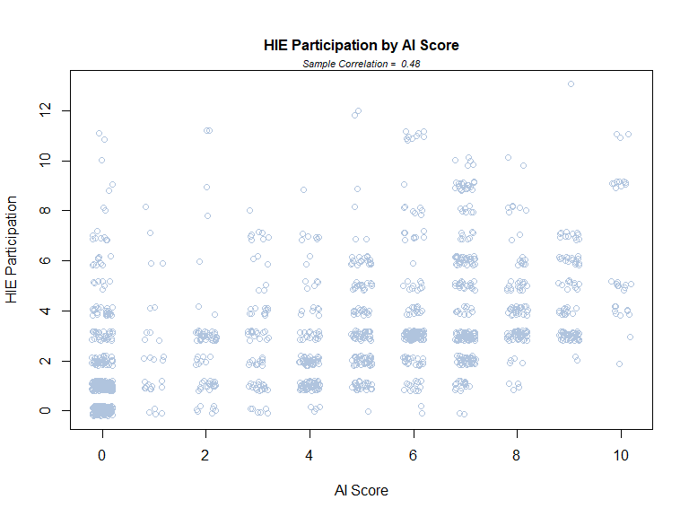
Bootstrap
I wanted to explore what is the difference in HIE participation between EHR vendors, specifically those who use Epic versus those who do not. Epic has an added feature called Cosmos, which shares unidentified data with all institutions who use Epic and acts as a HIE. We would expect those who participate in Epic to have higher levels of HIE because of the availability of this feature to them. To run this analysis, I created binary indicators of if an institution is an Epic user or not.
We see that even aggregating all non-Epic users together, the majority of institutions use Epic. There are 709 institutions not using Epic and 804 that are, indicating a good sample size for each. I want to bootstrap a t-test for this comparison because, looking at the boxplot, there are some high outliers in both groups and neither are normally distributed. Mean HIE participation for Epic users is higher than non-Epic users and closer to the overall average HIE participation scores.
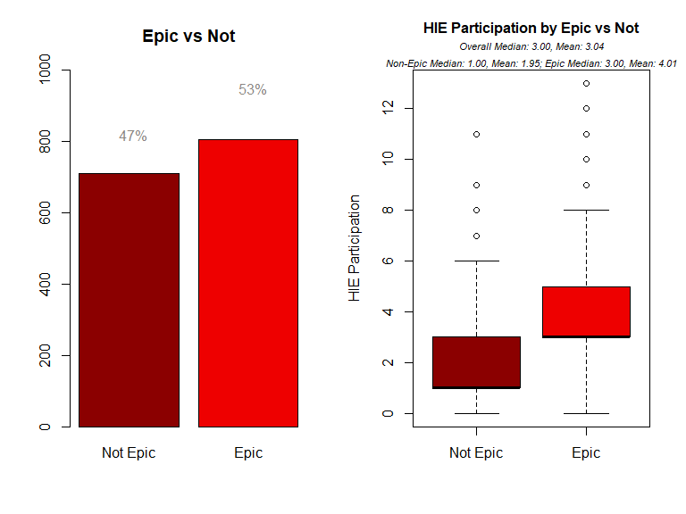
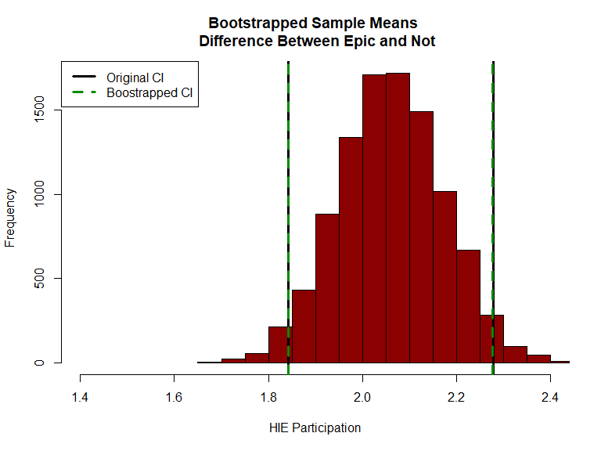
The parametric t-test yielded a very small p-value, leading us to reject the null hypothesis and conclude that mean HIE participation scores differ between Epic users and not. The bootstrap confirmed this, estimating the true difference in means at approximately 2.3 points higher in Epic users, which is consistent with the parametric test results. The near-identical parametric and bootstrapped confidence intervals suggest the original test was not meaningfully affected by outliers or skewed distributions, and that the sample was large enough for the CLT to produce a reliable estimate of the true difference.

Permutation Test
For the permutation test, I wanted to see how likely the results were between HIE participation in Epic vs non-Epic users. I shuffled the labels of being an Epic users or not and recalculated difference in group mean. We can see from the resulting histogram that it is very unlikely to see a difference in group mean this high under the null hypothesis.
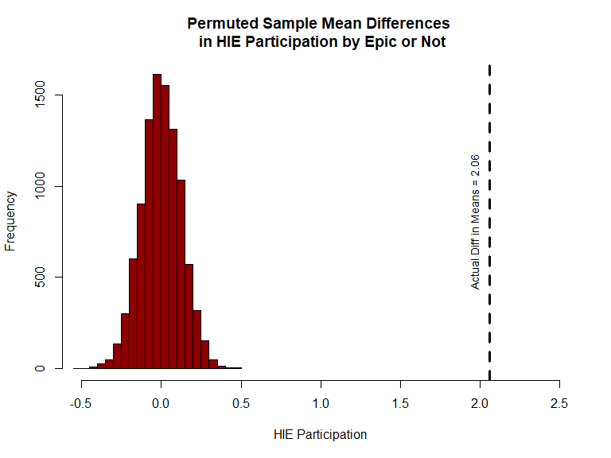

Multiple Regression
I wanted to assess if you could predict HIE participation based on certain variables: bed total(log), ownership type, primary EMR used, and AI score.
Because my HIE participation score is skewed right, I checked the relationship between all predictors and the outcome and predictor using JDRS matrix plot for the raw HIE participation score and a log HIE participation score. Prior to taking the log of the participation score, I added a constant of 0.5 because there were some zeros in my data where people did not participate in HIE at all. This then created negative values. To combat this, I also tried adding 1.5 as a constant. I checked the relationship for all 3 different HIE scores (raw, log +.5, log +1.5). Ultimately, the original HIE values did not have high evidence of heteroskedasticity or non-linearity, but it did have the non-normal distribution. Neither of the log transformations changed the scatterplots of predictors with outcomes, nor did the transformation introduce heteroskedasticity, non-linear relationships, or major outliers, but they did fix the right skewedness.
I was still unsure of which HIE value would be best to use, so I fit 3 different models each with a different type of HIE participation score (raw, log +.5, log +1.5). Comparing the AIC, the log HIE models have a significantly lower AIC than using the raw values (AIC raw HIE = 6475; AIC log + .5 = 2804; AIC log + 1.5 = 1641). I decided to use the model with the log constant of 1.5 because it had the lowest AIC. I also analyzed the Box Cox for this model, and the lambda was close to one, indicating no further transformations were needed.
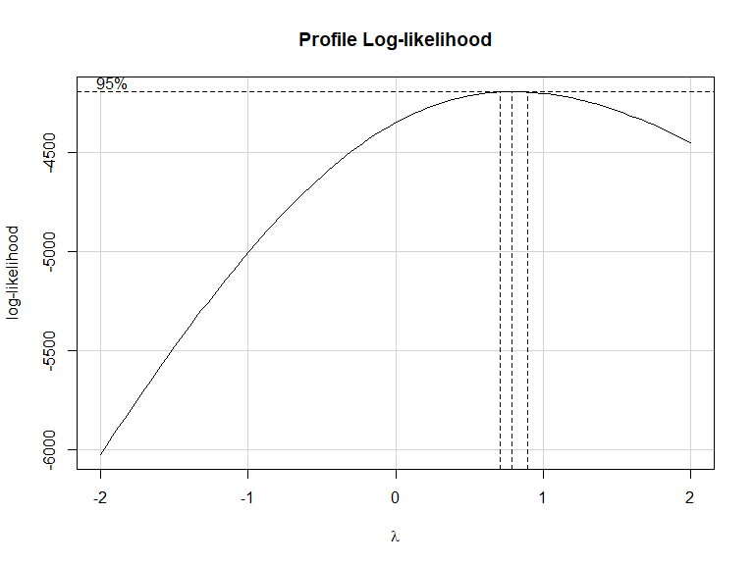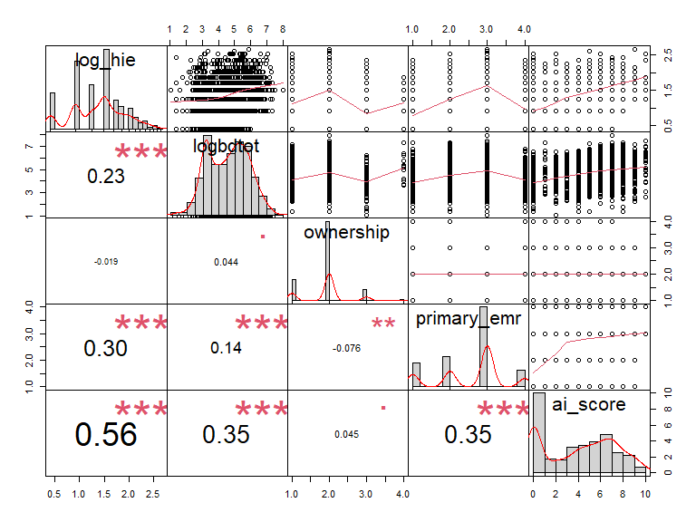
From the matrix plots, there is no evidence of non-linear relationships between the outcome and any of the predictors, nor is there heteroskedasticity or large outliers. From the scatterplots between the predictors, there is no evidence of multicollinearity, heteroskedasticity or large outliers. Because the outcome variable was now transformed, I rechecked the relationships between the outcome and each predictor. From the scatterplots, there is no evidence of non-linear relationships or large outliers. From the boxplot, we can see there is some difference in HIE among the categories.
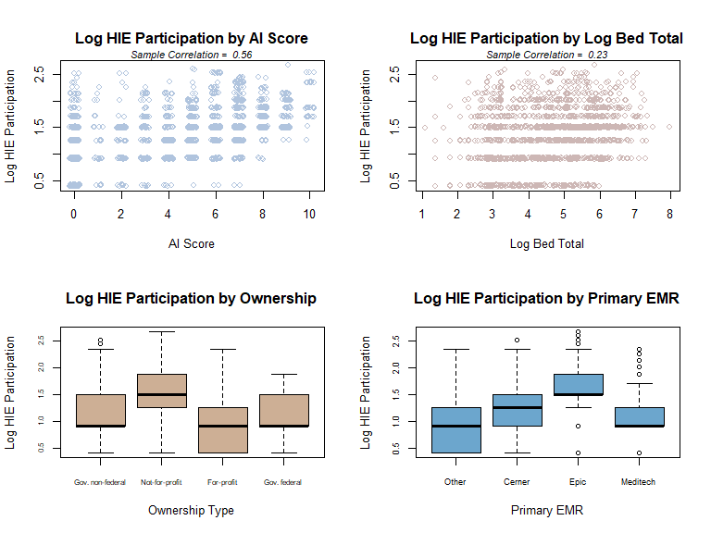
After fitting the model and I attempted backwards regression to determine which predictors were significant. I first removed log bed total as it had the highest p value of .9. This was surprising as I originally thought this would be a good predictor, but as was shown in the correlation above, they were not strongly related. After removing log bed count, primary EMR 2 - Cerner, primary EMR 5 - Epic, ownership 3 - for-profit, and AI score were all significant. All other predictors were left in model. The overall model is significant with a F statistic p-value close to 0. This indicates we can reject the null hypothesis and conclude that these are significant predictors of HIE participation. The adjusted R squared value was .3926, indicating this model can explain almost 40% of the variability in HIE participation. Non-federal government and Other EMR were the reference levels. All of the EMR vendors have a positive coefficient indicating the use of a named vendor leads to more HIE participation than an Other Vendor. Not-for-profits and federal government have a higher participation level relative to non-federal government while for-profits have a lower participation level.
##
## Call:
## lm(formula = df$log_hie ~ df$primary_emr + df$ownership + df$ai_score)
##
## Residuals:
## Min 1Q Median 3Q Max
## -1.08314 -0.28037 -0.08459 0.22775 1.53109
##
## Coefficients:
## Estimate Std. Error t value Pr(>|t|)
## (Intercept) 0.856373 0.033295 25.721 < 2e-16 ***
## df$primary_emr2 0.218326 0.038583 5.659 1.82e-08 ***
## df$primary_emr5 0.407685 0.038940 10.470 < 2e-16 ***
## df$primary_emr9 0.048426 0.043584 1.111 0.26670
## df$ownership2 0.044530 0.029701 1.499 0.13401
## df$ownership3 -0.136175 0.042597 -3.197 0.00142 **
## df$ownership4 0.188249 0.118966 1.582 0.11377
## df$ai_score 0.056136 0.004394 12.776 < 2e-16 ***
## ---
## Signif. codes: 0 '***' 0.001 '**' 0.01 '*' 0.05 '.' 0.1 ' ' 1
##
## Residual standard error: 0.4146 on 1505 degrees of freedom
## Multiple R-squared: 0.3926, Adjusted R-squared: 0.3898
## F-statistic: 139 on 7 and 1505 DF, p-value: < 2.2e-16
Lastly, I checked the residuals of the model. The errors are overall normally distributed although there is some departure at the top right of the tail. This could be due to the continuous predictors being practically categorical and no variables having negative values. I did check the residual plots of the other tested models (raw HIE and log +.5), and this model has the closest to normal distribution of errors. Additionally, there is no evidence of heteroskedasticity on the fits vs studentized residuals plot, but you can see the harsh bottom line which is typical of variables that do not extend past 0. There are some points that extend past the +/-3 threshold, but they are not worrisome. Additionally, there are a few high leverage points but none that are concerning.
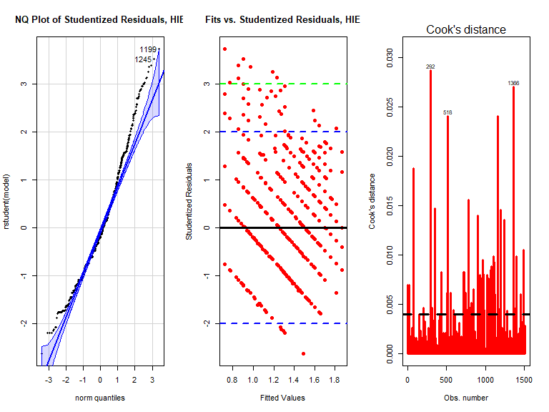
ANCOVA
Lastly, I did an ANCOVA to determine if there was an interaction between EMR provider and AI score and how they affect HIE score - meaning does the AI score affect the HIE score differently based on EMR provider. The plots analyzed in the multiple regression above shows the assumptions were met enough for the model.
All predictors are significant at 0.01 alpha level. All predictors have a positive slope meaning regardless of the EMR vendor, more AI score indicates higher levels of HIE participation. Cerner, Epic, and Meditech all have a higher intercept than Other EMR vendors. Meditech and Other vendors increase at a similar rate. Epic and Cerner users have a higher slope indicating those who use Epic and Cerner and have high AI scores participate in HIE more. The adjusted R squared is .3845 so this model accounts for about 38% of variability in HIE participation. The F statistics for the model was close to zero indicating we reject the null hypotheses and conclude the means are different, there is an effect for treatment group, and the group have an interaction.
I then checked the residual plots. There is a larger influence point (1072). I ran the model without this point and while it changed the Cook’s distance plot, it did not have an influence on the model. Therefore, I deemed it unnecessary to remove. Otherwise, the errors are pretty normally distributed and there is no evidence of heteroskedasticity.
##
## Call:
## lm(formula = df$log_hie ~ df$ai_score + df$primary_emr + df$ai_score *
## df$primary_emr)
##
## Residuals:
## Min 1Q Median 3Q Max
## -1.10675 -0.30569 -0.06913 0.23761 1.42624
##
## Coefficients:
## Estimate Std. Error t value Pr(>|t|)
## (Intercept) 0.856632 0.029506 29.033 < 2e-16 ***
## df$ai_score 0.034250 0.013789 2.484 0.01311 *
## df$primary_emr2 0.164837 0.047996 3.434 0.00061 ***
## df$primary_emr5 0.411630 0.047234 8.715 < 2e-16 ***
## df$primary_emr9 0.111284 0.052665 2.113 0.03476 *
## df$ai_score:df$primary_emr2 0.042461 0.016242 2.614 0.00903 **
## df$ai_score:df$primary_emr5 0.026738 0.014936 1.790 0.07364 .
## df$ai_score:df$primary_emr9 0.001452 0.019307 0.075 0.94004
## ---
## Signif. codes: 0 '***' 0.001 '**' 0.01 '*' 0.05 '.' 0.1 ' ' 1
##
## Residual standard error: 0.4163 on 1505 degrees of freedom
## Multiple R-squared: 0.3874, Adjusted R-squared: 0.3845
## F-statistic: 136 on 7 and 1505 DF, p-value: < 2.2e-16

## Anova Table (Type III tests)
##
## Response: df$log_hie
## Sum Sq Df F value Pr(>F)
## (Intercept) 146.109 1 842.9079 < 2.2e-16 ***
## df$ai_score 1.069 1 6.1694 0.01311 *
## df$primary_emr 13.359 3 25.6886 3.311e-16 ***
## df$ai_score:df$primary_emr 1.827 3 3.5131 0.01472 *
## Residuals 260.876 1505
## ---
## Signif. codes: 0 '***' 0.001 '**' 0.01 '*' 0.05 '.' 0.1 ' ' 1
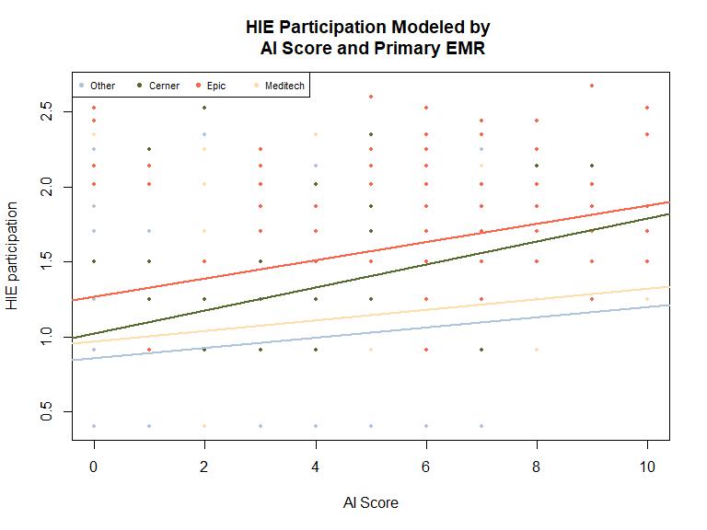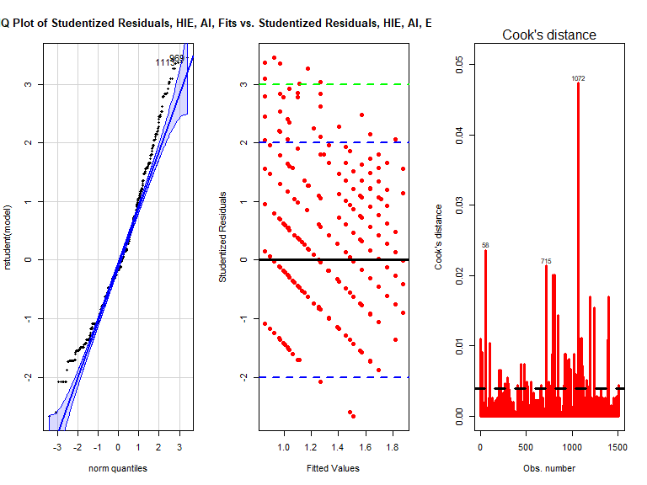

Conclusion and Summary
Several conclusions can be made from the analyses. Not-for-profit institutions participate in HIE at higher rates than for-profits, and Epic users showed greater HIE participation than users of other EMR vendors. Correlation analyses revealed positive associations between HIE participation and both bed size and AI score, with AI score showing a stronger relationship than bed size.
A multiple regression model using ownership type, EMR vendor, and AI score explained approximately 40% of the variability in HIE participation score. Finally, an ANOVA revealed a significant positive interaction between EMR vendor and AI score, particularly among Epic and Cerner users, meaning that as AI adoption increases, the association with HIE participation is even stronger for Epic and Cerner users than for those using another EMR.

