**Balkendiagramm-TAbellen**

|  |  |  |  |  |  |
| --- | --- | --- | --- | --- | --- |
| gender | | | | | |
|  | | Amount | Percent | Valid Percent | Cumulative Percent |
| Valid | male | 87 | 43,1 | 43,3 | 43,3 |
| female | 114 | 56,4 | 56,7 | 100,0 |
| Total | 201 | 99,5 | 100,0 |  |
| Missing | System | 1 | ,5 |  |  |
| Total | | 202 | 100,0 |  |  |

|  |  |  |  |  |  |
| --- | --- | --- | --- | --- | --- |
| age | | | | | |
|  | | Amount | Percent | Valid Percent | Cumulative Percent |
| Valid | 20-30 years | 149 | 73,8 | 73,8 | 73,8 |
| 30-40 years | 31 | 15,3 | 15,3 | 89,1 |
| 40-50 years | 9 | 4,5 | 4,5 | 93,6 |
| > 50 years | 13 | 6,4 | 6,4 | 100,0 |
| Total | 202 | 100,0 | 100,0 |  |

|  |  |  |  |  |  |
| --- | --- | --- | --- | --- | --- |
| job | | | | | |
|  | | Amount | Percent | Valid Percent | Cumulative Percent |
| Valid | apprenticeship | 6 | 3,0 | 3,0 | 3,0 |
| study/dual study | 98 | 48,5 | 48,5 | 51,5 |
| job starter | 24 | 11,9 | 11,9 | 63,4 |
| professional | 69 | 34,2 | 34,2 | 97,5 |
| pensioneer | 5 | 2,5 | 2,5 | 100,0 |
| Total | 202 | 100,0 | 100,0 |  |

|  |  |  |  |  |  |
| --- | --- | --- | --- | --- | --- |
| Ø monthly income | | | | | |
|  | | Amount | Percent | Valid Percent | Cumulative Percent |
| Valid | ca. 0-1.000 € | 88 | 43,6 | 43,6 | 43,6 |
| ca. 1.000-2.000 € | 26 | 12,9 | 12,9 | 56,4 |
| ca. 2.000-3.000 € | 43 | 21,3 | 21,3 | 77,7 |
| ca. 3.000-4.000 € | 29 | 14,4 | 14,4 | 92,1 |
| ca. > 4.000 € | 16 | 7,9 | 7,9 | 100,0 |
| Gesamtsumme | 202 | 100,0 | 100,0 |  |

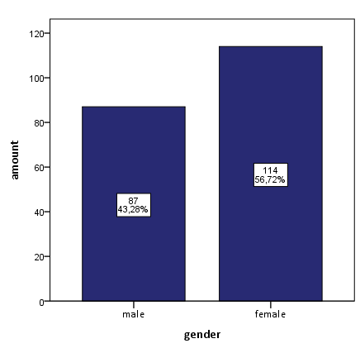

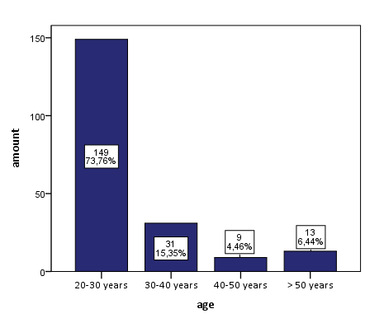

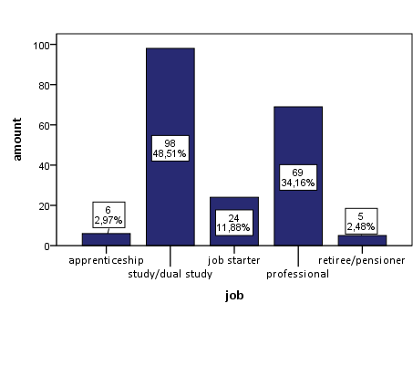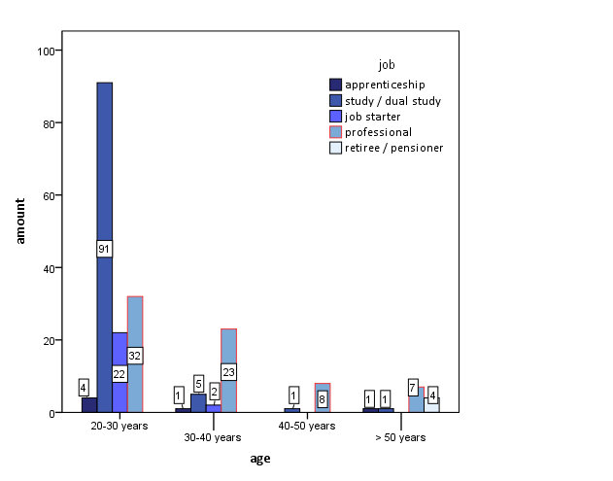

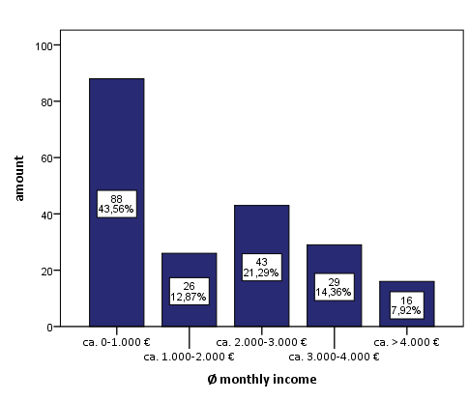

**Kreisdiagramm-TABELLEN**

|  |  |  |  |  |  |
| --- | --- | --- | --- | --- | --- |
| 6 WTP for fundraising by neighbour’s children - for refugee children | | | | | |
|  | | Amount | Percent | Valid Percent | Cumulative Percent |
| Valid | 0-2 € | 29 | 14,4 | 15,0 | 15,0 |
| 2-4 € | 42 | 20,8 | 21,8 | 36,8 |
| 4-6 € | 76 | 37,6 | 39,4 | 76,2 |
| > 6 € | 46 | 22,8 | 23,8 | 100,0 |
| Total | 193 | 95,5 | 100,0 |  |
| Missing | System | 9 | 4,5 |  |  |
| Total | | 202 | 100,0 |  |  |

|  |  |  |  |  |  |  |  |
| --- | --- | --- | --- | --- | --- | --- | --- |
| 18 WTP for donation at train station - for homeless | | | | | | | |
|  | | Amount | Percent | Valid Percent | | Cumulative Percent | |
| Valid | 0-2 € | 130 | 64,4 | 73,0 | | 73,0 | |
| 2-4 € | 33 | 16,3 | 18,5 | | 91,6 | |
| 4-6 € | 11 | 5,4 | 6,2 | | 97,8 | |
| > 6 € | 4 | 2,0 | 2,2 | | 100,0 | |
| Total | 178 | 88,1 | 100,0 | |  | |
| Missing | System | 24 | 11,9 |  | |  | |
| Total | | 202 | 100,0 |  | |  | |
| 1 WTP per night- for wellness-hotel – next year | | | | | | | | |
|  | | Amount | Percent | | Valid Percent | | Cumulative Percent | |
| Valid | 100-150 € | 139 | 68,8 | | 72,0 | | 72,0 | |
| 150-200 € | 42 | 20,8 | | 21,8 | | 93,8 | |
| 200-250 € | 9 | 4,5 | | 4,7 | | 98,4 | |
| > 250 € | 3 | 1,5 | | 1,6 | | 100,0 | |
| Total | 193 | 95,5 | | 100,0 | |  | |
| Missing | System | 9 | 4,5 | |  | |  | |
| Total | | 202 | 100,0 | |  | |  | |

|  |  |  |  |  |  |  |  |  |
| --- | --- | --- | --- | --- | --- | --- | --- | --- |
| 12 WTP per night- for wellness-hotel – next weekend | | | | | | | | |
|  | | Amount | Percent | | vaild Percent | | Cumulative Percent | |
| Valid | 100-150 € | 122 | 60,4 | | 66,7 | | 66,7 | |
| 150-200 € | 46 | 22,8 | | 25,1 | | 91,8 | |
| 200-250 € | 12 | 5,9 | | 6,6 | | 98,4 | |
| > 250 € | 3 | 1,5 | | 1,6 | | 100,0 | |
| Total | 183 | 90,6 | | 100,0 | |  | |
| Missing | System | 19 | 9,4 | |  | |  | |
| Total | | 202 | 100,0 | |  | |  | |
| 24 WTP for wine – wine department | | | | | | | |
|  | | Amount | Percent | vaild Percent | | Cumulative Percent | |
| Valid | 0-2 € | 7 | 3,5 | 4,0 | | 4,0 | |
| 2-4 € | 34 | 16,8 | 19,5 | | 23,6 | |
| 4-6 € | 66 | 32,7 | 37,9 | | 61,5 | |
| > 6 € | 67 | 33,2 | 38,5 | | 100,0 | |
| Total | 174 | 86,1 | 100,0 | |  | |
| Missing | System | 28 | 13,9 |  | |  | |
| Total | | 202 | 100,0 |  | |  | |

|  |  |  |  |  |  |
| --- | --- | --- | --- | --- | --- |
| 16 WTP for wine – online order | | | | | |
|  | | Amount | Percent | Valid Percent | Cumulative Percent |
| Valid | 0-2 € | 6 | 3,0 | 3,4 | 3,4 |
| 2-4 € | 25 | 12,4 | 14,0 | 17,3 |
| 4-6 € | 57 | 28,2 | 31,8 | 49,2 |
| > 6 € | 91 | 45,0 | 50,8 | 100,0 |
| Total | 179 | 88,6 | 100,0 |  |
| Missing | System | 23 | 11,4 |  |  |
| Total | | 202 | 100,0 |  |  |
| 13 WTP for new favourite car - 50 Thsd. € won | | | | | |
|  | | Amount | Percent | Valid Percent | Cumulative Percent |
| Valid | 30.000 € | 91 | 45,0 | 50,3 | 50,3 |
| 35.000 € | 41 | 20,3 | 22,7 | 72,9 |
| 40.000 € | 28 | 13,9 | 15,5 | 88,4 |
| > 40.000 € | 21 | 10,4 | 11,6 | 100,0 |
| Total | 181 | 89,6 | 100,0 |  |
| Missing | System | 21 | 10,4 |  |  |
| Total | | 202 | 100,0 |  |  |

|  |  |  |  |  |  |
| --- | --- | --- | --- | --- | --- |
| 8 WTP for new BMWi3 - 50 Thsd. € saved | | | | | |
|  | | Amount | Percent | Valid Percent | Cumulative Percent |
| Valid | 30.000 € | 104 | 51,5 | 55,0 | 55,0 |
| 35.000 € | 68 | 33,7 | 36,0 | 91,0 |
| 40.000 € | 16 | 7,9 | 8,5 | 99,5 |
| > 40.000 € | 1 | ,5 | ,5 | 100,0 |
| Total | 189 | 93,6 | 100,0 |  |
| Missing | System | 13 | 6,4 |  |  |
| Total | | 202 | 100,0 |  |  |

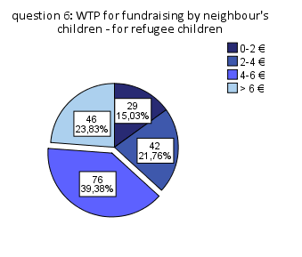

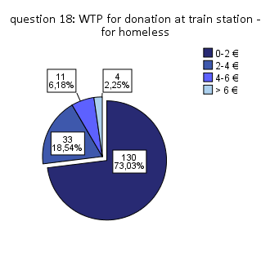

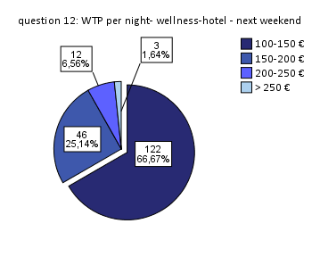

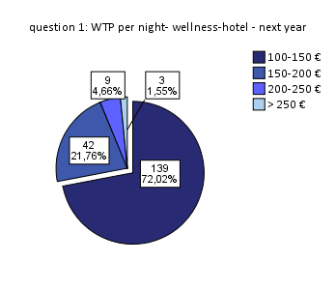

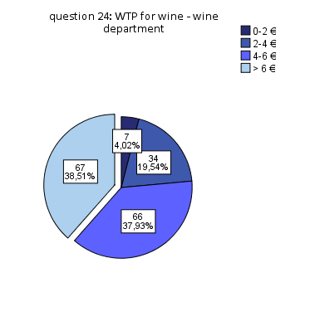

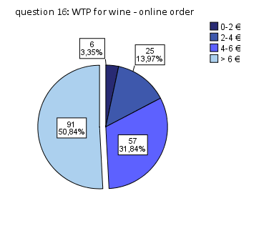

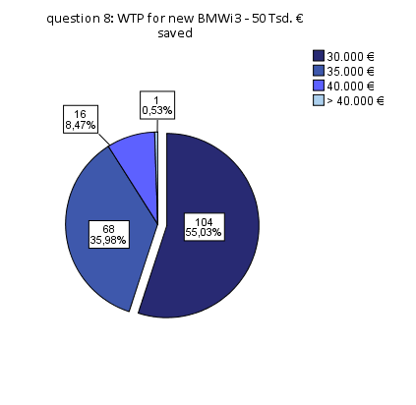

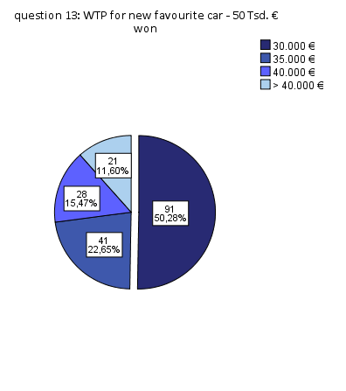

**MITTELWERT UND STANDARDABWEICHUNG**

Social Distance

|  |  |  |  |
| --- | --- | --- | --- |
|  | | Q.6 : WTP donation - refugee children | Q.18: WTP donation - homeless |
| N | Valid | 193 | 178 |
| Missing | 9 | 24 |
| Mean | | 2,72 | 1,37 |
| Std. Deviation | | 0,99 | 0,70 |
| Variance | | 0,98 | 0,49 |
| Minimum | | 1,0 | 1,0 |
| Maximum | | 4,0 | 4,0 |

Temporal Distance

|  |  |  |  |
| --- | --- | --- | --- |
|  | | Q.12: WTP per night-wellness-hotel - next weekend | Q.1: WTP per night-wellness-hotel - next year |
| N | Valid | 183 | 193 |
| Missing | 27 | 16 |
| Mean | | 1,43 | 1,35 |
| Std. Deviation | | 0,69 | 0,64 |
| Variance | | 0,47 | 0,41 |
| Minimum | | 1,0 | 1,0 |
| Maximum | | 4,0 | 4,0 |

SPATIAl Distance

|  |  |  |  |
| --- | --- | --- | --- |
|  | | Q.24: WTP wine - wine department | Q.16: WTP for wine - online order |
| N | Valid | 174 | 179 |
| Missing | 28 | 23 |
| Mean | | 3,10 | 3,30 |
| Std. Deviation | | 0,85 | 0,83 |
| Variance | | 0,73 | 0,69 |
| Minimum | | 1,0 | 1,0 |
| Maximum | | 4,0 | 4,0 |

Hypothetical Distance

|  |  |  |  |
| --- | --- | --- | --- |
|  | | Q.8: WTP new BMWi3 - 50 Thsd. € saved | Q.13: WTP new favourite car - 50 Thsd. € won |
| N | Valid | 189 | 181 |
| Missing | 13 | 21 |
| Mean | | 1,54 | 1,88 |
| Std. Deviation | | 0,67 | 1,05 |
| Variance | | 0,45 | 1,11 |
| Minimum | | 1 | 1 |
| Maximum | | 4 | 4 |

**MANN-WHITNEY U-TEST**

|  |  |  |  |  |  |
| --- | --- | --- | --- | --- | --- |
| Ranks: Social Distance | | | | | |
|  | | gender | N | Mean Rank | Sum of Ranks |
| 6 WTP for fundraising of neighbour's children-for refugee children | | male | 82 | 94,69 | 7764,50 |
| female | 111 | 98,71 | 10956,50 |
| Total | 193 |  |  |
| 18 WTP for donation- for homeless | | male | 71 | 89,69 | 6368,00 |
| female | 107 | 89,37 | 9563,00 |
| Total | 178 |  |  |
| Test Statistics: Social Distancea,b | | | | | |
|  | 6 WTP for fundraising of neighbour's children-for refugee children | | | 18 WTP for donation- for homeless | |
| Mann-Whitney U | 4361,500 | | | 3785,000 | |
| Wilcoxon W | 7764,500 | | | 9563,000 | |
| Z | -,517 | | | -,052 | |
| Asymp. Sig. (2-tailed) | ,605 | | | ,959 | |
| a. Grouping Variable: gender | | | | | |

|  |  |  |  |  |  |
| --- | --- | --- | --- | --- | --- |
| Ranks:Temporal Distance | | | | | |
|  | | gender | N | Mean Rank | Sum of Ranks |
| 12 WTP per night- for wellness-hotel- next weekend | | male | 75 | 108,23 | 8117,00 |
| female | 108 | 80,73 | 8719,00 |
| Total | 183 |  |  |
| 1 WTP per night- for wellness-hotel- next year | | male | 82 | 104,33 | 8555,00 |
| female | 111 | 91,59 | 10166,00 |
| Total | 193 |  |  |
| Test Statistics: Temporal Distancea, | | | | | |
|  | 12 WTP per night- for wellness-hotel- next weekend | | | 1 WTP per night- for wellness-hotel- next year | |
| Mann-Whitney U | 2833,000 | | | 3950,000 | |
| Wilcoxon W | 8719,000 | | | 10166,000 | |
| Z | -4,165 | | | -1,996 | |
| Asymp. Sig. (2-tailed) | ,000 | | | ,046 | |
| a. Grouping Variable: gender | | | | | |

|  |  |  |  |  |  |  |
| --- | --- | --- | --- | --- | --- | --- |
| Ranks: Spatial Distance | | | | | | |
|  | | gender | N | Mean Rank | | Sum of Ranks |
| 24 WTP for wine - wine department | | male | 70 | 96,45 | | 6751,50 |
| female | 104 | 81,48 | | 8473,50 |
| Total | 174 |  | |  |
| 16 WTP for wine - online order | | male | 72 | 100,91 | | 7265,50 |
| female | 107 | 82,66 | | 8844,50 |
| Total | 179 |  | |  |
| Test Statistics: Spatial Distancea | | | | | | | |
|  | 24 WTP for wine - wine department | | | | 16 WTP for wine - online order | | |
| Mann-Whitney U | 3013,500 | | | | 3066,500 | | |
| Wilcoxon W | 8473,500 | | | | 8844,500 | | |
| Z | -2,049 | | | | -2,531 | | |
| Asymp. Sig. (2-tailed) | ,040 | | | | ,011 | | |
| a. Grouping Variable: gender | | | | | | | |

|  |  |  |  |  |  |  |
| --- | --- | --- | --- | --- | --- | --- |
| Ranks: Hypothetical Distance | | | | | | |
|  | | gender | N | Mean Rank | Sum of Ranks | |
| 8 WTP for new BMWi3 - 50 Thsd. € saved | | male | 79 | 84,04 | 6639,50 | |
| female | 110 | 102,87 | 11315,50 | |
| Total | 189 |  |  | |
| 13 WTP for new favourite car - 50 Thsd. € won | | male | 74 | 99,99 | 7399,00 | |
| female | 107 | 84,79 | 9072,00 | |
| Total | 181 |  |  | |
| Test Statistics: Hypothetical Distancea | | | | | |
|  | 8 WTP for new BMWi3 - 50 Thsd. € saved | | | 13 WTP for new favourite car - 50 Thsd. € won | |
| Mann-Whitney U | 3479,500 | | | 3294,000 | |
| Wilcoxon W | 6639,500 | | | 9072,000 | |
| Z | -2,631 | | | -2,074 | |
| Asymp. Sig. (2-tailed) | ,009 | | | ,038 | |
| a. Grouping Variable: gender | | | | | |

**KRUSKAL-WALLIS-TEST**

|  |  |  |  |  |  |  |  |  |  |
| --- | --- | --- | --- | --- | --- | --- | --- | --- | --- |
| Ranks: Social Distance | | | | | | | | | |
|  | | | Ø monthly income in 5 groups | | | N | | Mean Rank | |
| 6 WTP for fundraising of neighbour's children - for refugee children | | | ca. 0-1.000 € | | | 85 | | 89,04 | |
| ca. 1.000-2.000 € | | | 26 | | 99,13 | |
| ca. 2.000-3.000 € | | | 40 | | 108,08 | |
| ca. 3.000-4.000 € | | | 27 | | 95,57 | |
| ca. > 4.000 € | | | 15 | | 111,47 | |
| Total | | | 193 | |  | |
| 18 WTP for donation - for homeless | | | ca. 0-1.000 € | | | 81 | | 85,98 | |
| ca. 1.000-2.000 € | | | 25 | | 82,68 | |
| ca. 2.000-3.000 € | | | 37 | | 102,32 | |
| ca. 3.000-4.000 € | | | 22 | | 89,73 | |
| ca. > 4.000 € | | | 13 | | 87,69 | |
| Total | | | 178 | |  | |
| Test Statistics: Social Distancea,b | | | | | | | | | |
|  | 6 WTP for fundraising of neighbour's children - for refugee children | | | | 18 WTP for donation - for homeless | | | | |
| Chi-Square | 4,785 | | | | 5,175 | | | | |
| df | 4 | | | | 4 | | | | |
| Asymp. Sig. | ,310 | | | | ,270 | | | | |
| a. Kruskal-Wallis-Test | | | | | | | | | |
| b. Grouping Variable: Ø monthly income | | | | | | | | | |
| Ranks: Temporal Distance | | | | | | | | | | |
|  | | Ø monthly income in 5 groups | | | | | N | | Mean Rank | |
| 12 WTP per night - for wellness-hotel - next weekend | | ca. 0-1.000 € | | | | | 82 | | 83,40 | |
| ca. 1.000-2.000 € | | | | | 25 | | 86,18 | |
| ca. 2.000-3.000 € | | | | | 38 | | 94,45 | |
| ca. 3.000-4.000 € | | | | | 24 | | 107,44 | |
| ca. > 4.000 € | | | | | 14 | | 119,64 | |
| Total | | | | | 183 | |  | |
| 1 WTP per night - for wellness-hotel - next year | | ca. 0-1.000 € | | | | | 85 | | 93,63 | |
| ca. 1.000-2.000 € | | | | | 26 | | 83,92 | |
| ca. 2.000-3.000 € | | | | | 40 | | 108,26 | |
| ca. 3.000-4.000 € | | | | | 27 | | 95,57 | |
| ca. > 4.000 € | | | | | 15 | | 111,30 | |
| Total | | | | | 193 | |  | |
| Test Statistics: Temporal Distancea,b | | | | | | |
|  | 12 WTP per night - for wellness-hotel - next weekend | | | 1 WTP per night - for wellness-hotel - next year | | | | |
| Chi-Square | 12,208 | | | 7,080 | | | | |
| df | 4 | | | 4 | | | | |
| Asymp. Sig. | ,016 | | | ,132 | | | | |
| a. Kruskal-Wallis-Test | | | | | | | | |
| b. Grouping Variable: Ø monthly income | | | | | | | | |

|  |  |  |  |  |  |
| --- | --- | --- | --- | --- | --- |
| Ranks: Spatial Distance | | | | | |
|  | | Ø monthly income in 5 groups | | N | Mean Rank |
| 24 WTP for wine - wine department | | ca. 0-1.000 € | | 78 | 76,87 |
| ca. 1.000-2.000 € | | 25 | 102,26 |
| ca. 2.000-3.000 € | | 36 | 100,69 |
| ca. 3.000-4.000 € | | 22 | 81,84 |
| ca. > 4.000 € | | 13 | 95,92 |
| Total | | 174 |  |
| 16 24 WTP for wine - online order | | ca. 0-1.000 € | | 81 | 82,90 |
| ca. 1.000-2.000 € | | 25 | 97,22 |
| ca. 2.000-3.000 € | | 37 | 103,15 |
| ca. 3.000-4.000 € | | 23 | 84,02 |
| ca. > 4.000 € | | 13 | 93,54 |
| Total | | 179 |  |
| Test Statistics: Spatial Distancea,b | | | | |
|  | 24 WTP for wine - wine department | | 16 24 WTP for wine - online order | |
| Chi-Square | 9,911 | | 5,707 | |
| df | 4 | | 4 | |
| Asymp. Sig. | ,042 | | ,222 | |
| a. Kruskal-Wallis-Test | | | | |
| b. Grouping Variable: Ø monthly income | | | | |