
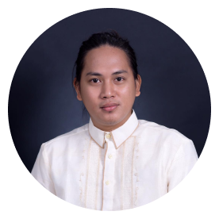



Contact
- +63 9311507116
ghekghek@gmail.com

Education
- Bachelor of Science
Information Technology
Bataan Peninsula
State University
2020

- Electrical Installation & Maintenance NCIl
Tesda
2013

- Computer Hardware
Servicing NC II
Tesda
2011

KEVIN E DIVINAGRACIA

I design a responsive ui/ux
webpage render well on a variety devices and I make a wireframe, prototyping into coding.

I interact to system unit collecting data and information to inspect computer hardware and software to maximize the potential of the system unit.

Skill
- Figma
- Html
- Css
- Scss
- Bootstrap
- Javascript
- Git

- Diagnose and troubleshoot computer systems.
- Maintain Computer systems and peripheral components.
- Install computer hardware and software.

