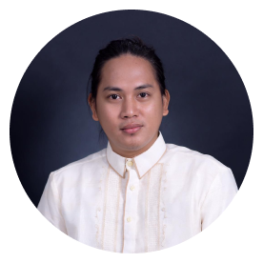

Contact

* +63 9311507116

 ghekghek@gmail.com

Education

* Bachelor of Science

Information Technology

Bataan Peninsula   
State University

2020

* Electrical Installation & Maintenance NCIl

Tesda

2013

* Computer Hardware

Servicing NC II

Tesda

2011

KEVIN E DIVINAGRACIA



I design a responsive ui/ux   
webpage render well on a variety devices and I make a wireframe, prototyping into coding.



I interact to system unit collecting data and information to inspect computer hardware and software to maximize the potential of the system unit.

Skill

* Figma
* Html
* Css
* Scss
* Bootstrap
* Javascript
* Git
* Diagnose and troubleshoot computer systems.
* Maintain Computer systems and peripheral components.
* Install computer hardware and software.