**Input = 20;**

**OUTPUT:**

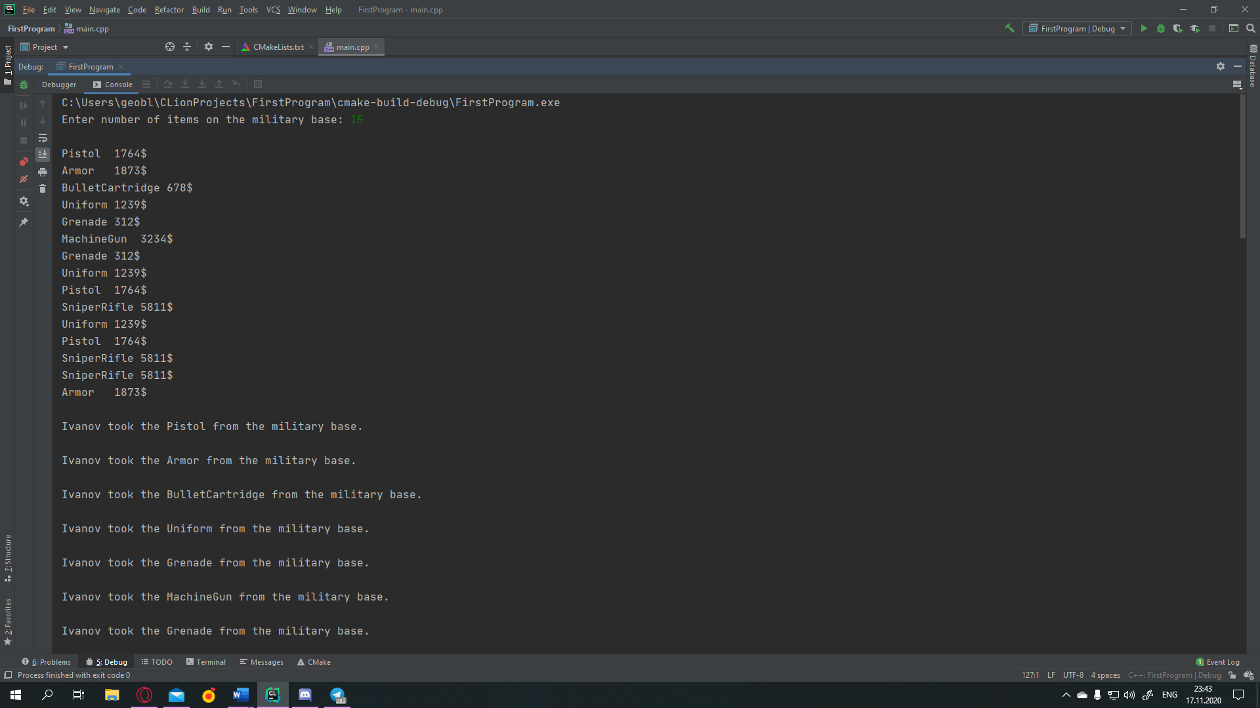 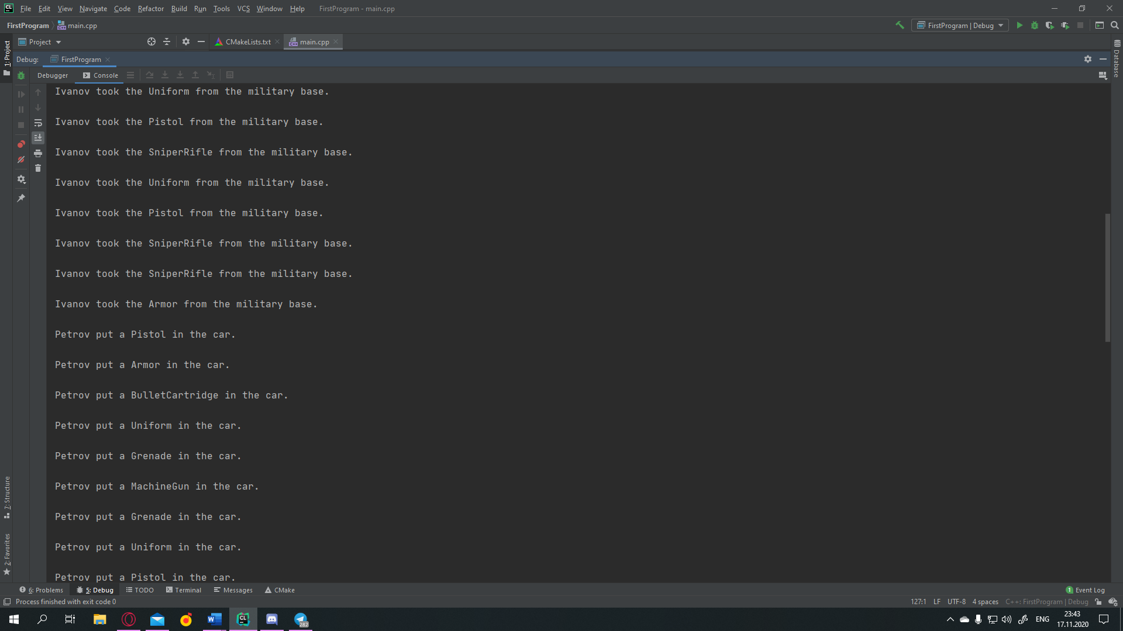 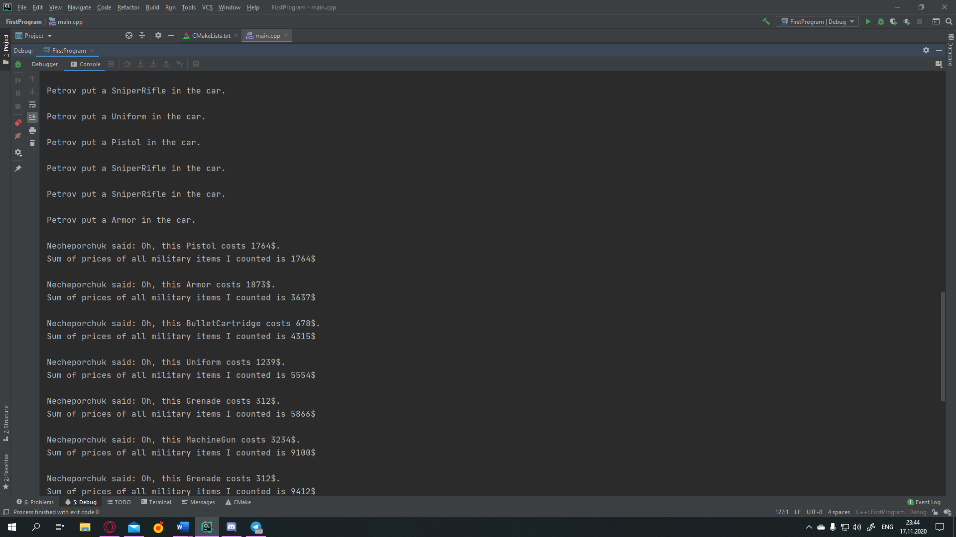 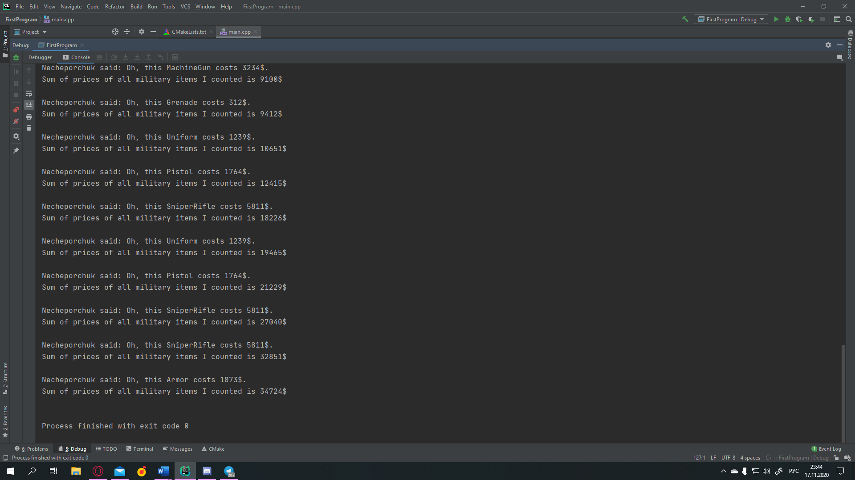

**Input = 1;**

**OUTPUT:**

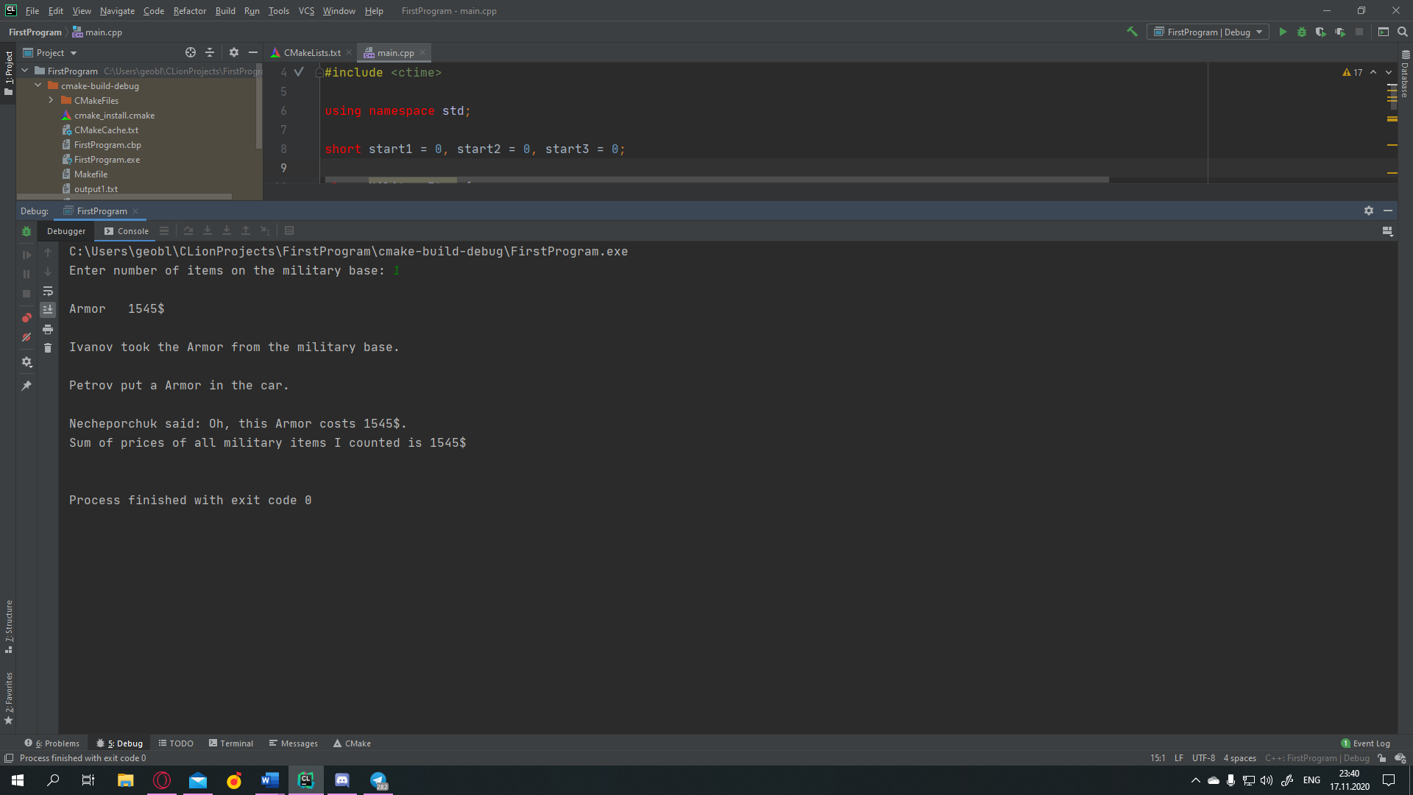

**Input = 200;**

**OUPTUT:**  
https://github.com/gheoblink/hw3v23/blob/main/input200.txt

**Input = 50000;**

**OUPTUT:**

https://github.com/gheoblink/hw3v23/blob/main/input50000.txt