Facultatea Calculatoare, Informatica si

Microelectronica

Universitatea Tehnica a Moldovei

Medii Interactive de Dezvoltare a Produselor Soft

Lucrarea de laborator#2

GUI Development

 | lector asistent:
Autor: | Irina Cojanu
Curca Gheorghe | lector superior:
 | Radu Melnic

Lucrarea de laborator #2

1. Scopul lucrării de laborator

Realizarea unui simplu GUI calculator.

2. Mersul lucrării de laborator

2.1. Cerințele

1.Realizează un simplu GUI calculator care suportă următoare funcții: +, -, /, *, putere, radical,inversare semn(+/-), operații cu numere zecimale. 2.Divizarea proiectului în două module - Interfața grafică(Modul GUI) și Modulul de bază(Core Module).

2.2. Analiza Lucrarii de laborator

În lucrarea dată am folosit programarea în Windows cu ajutorul limbajului

C# pentru a crea calculatorul GUI.
Pentru crearea calculatorului in C# au fost folosite elementele : Panel si Button.

3 Codul Programului in C#

using System;
using System.Collections.Generic;
using System.ComponentModel;
using System.Data;
using System.Drawing;
using System.Globalization;
using System.Linq;
using System.Text;
using System.Threading.Tasks;
using System.Windows.Forms;

namespace MIDPS_Lab2
{
public partial class Form1 : Form
{
public Form1()
{
InitializeComponent();
this.KeyDown += Form1_KeyDown;
}
double a, b, rezult;
string op;
private void Form1_Load(object sender, EventArgs e)
{

}
private void Form1_KeyDown(object sender, KeyEventArgs e)
{
if (e.KeyCode == Keys.NumPad0 || e.KeyCode == Keys.D0)
{
screen.Text += "0";
}
if (e.KeyCode == Keys.NumPad1 || e.KeyCode == Keys.D1)
{
screen.Text += "1";
}
if (e.KeyCode == Keys.NumPad2 || e.KeyCode == Keys.D2)
{
screen.Text += "2";
}
if (e.KeyCode == Keys.NumPad3 || e.KeyCode == Keys.D3)
{
screen.Text += "3";
}
if (e.KeyCode == Keys.NumPad4 || e.KeyCode == Keys.D4)
{
screen.Text += "4";
}
if (e.KeyCode == Keys.NumPad5 || e.KeyCode == Keys.D5)
{
screen.Text += "5";
}
if (e.KeyCode == Keys.NumPad6 || e.KeyCode == Keys.D6)
{
screen.Text += "6";
}
if (e.KeyCode == Keys.NumPad7 || e.KeyCode == Keys.D7)
{
screen.Text += "7";
}
if (e.KeyCode == Keys.NumPad8 || e.KeyCode == Keys.D8)
{
screen.Text += "8";
}
if (e.KeyCode == Keys.NumPad9 || e.KeyCode == Keys.D9)
{
screen.Text += "9";
}
if (e.KeyCode == Keys.Divide)
{
if (screen.Text == "")
{
screen.Text = screen.Text;
}
else
{
semn.Text = "/";
screen.Text = screen.Text;
a = double.Parse(screen.Text);
screen2.Text = a.ToString();
op = "/";
screen.Text = "";
}
}
if (e.KeyCode == Keys.Multiply)
{
if (screen.Text == "")
{
screen.Text = screen.Text;
}
else
{
semn.Text = "*";
screen.Text = screen.Text;
a = double.Parse(screen.Text);
screen2.Text = a.ToString();
op = "*";
screen.Text = "";
}
}
if (e.KeyCode == Keys.Add)
{
if (screen.Text == "")
{
screen.Text = screen.Text;
}
else
{
semn.Text = "+";
screen.Text = screen.Text;
a = double.Parse(screen.Text);
screen2.Text = a.ToString();
op = "+";
screen.Text = "";
}
}
if (e.KeyCode == Keys.Subtract)
{
if (screen.Text == "")
{
screen.Text = screen.Text;
}
else
{
semn.Text = "-";
screen.Text = screen.Text;
a = double.Parse(screen.Text);
screen2.Text = a.ToString();
op = "-";
screen.Text = "";
}
}
if (e.KeyCode == Keys.Decimal)
{
if (screen.Text.Contains(","))
{
screen.Text = screen.Text;
}
else
{
screen.Text += ",";
}
}
if (e.KeyCode == Keys.Enter)
{
egal_Click(sender, e);
}
if (e.KeyCode == Keys.Delete)
{
delete_Click(sender, e);
}
}
private void num_1_Click(object sender, EventArgs e)
{
screen.Text += "1";
}

private void num_2_Click(object sender, EventArgs e)
{
screen.Text += "2";
}

private void num_3_Click(object sender, EventArgs e)
{
screen.Text += "3";
}

private void num_4_Click(object sender, EventArgs e)
{
screen.Text += "4";
}

private void num_5_Click(object sender, EventArgs e)
{
screen.Text += "5";
}

private void num_6_Click(object sender, EventArgs e)
{
screen.Text += "6";
}

private void num_7_Click(object sender, EventArgs e)
{
screen.Text += "7";
}

private void num_8_Click(object sender, EventArgs e)
{
screen.Text += "8";
}

private void num_9_Click(object sender, EventArgs e)
{
screen.Text += "9";
}
private void num_0_Click(object sender, EventArgs e)
{
screen.Text += "0";
}
private void plus_Click(object sender, EventArgs e)
{
if (screen.Text == "")
{
screen.Text = screen.Text;
} else
{
semn.Text = "+";
screen.Text = screen.Text;
a = double.Parse(screen.Text);
screen2.Text = a.ToString();
op = "+";
screen.Text = "";
}
}
private void minus_Click(object sender, EventArgs e)
{
if (screen.Text == "" && !screen.Text.Contains("-"))
{
screen.Text += "-";
}
else
{
semn.Text = "-";
screen.Text = screen.Text;
a = double.Parse(screen.Text);
screen2.Text = a.ToString();
op = "-";
screen.Text = "";
}
}

private void inmultire_Click(object sender, EventArgs e)
{
if (screen.Text == "")
{
screen.Text = screen.Text;
}
else
{
semn.Text = "*";
screen.Text = screen.Text;
a = double.Parse(screen.Text);
screen2.Text = a.ToString();
op = "*";
screen.Text = "";
}
}

private void divizare_Click(object sender, EventArgs e)
{
if (screen.Text == "")
{
screen.Text = screen.Text;
}
else
{
semn.Text = "/";
screen.Text = screen.Text;
a = double.Parse(screen.Text);
screen2.Text = a.ToString();
op = "/";
screen.Text = "";
}
}

private void delete_Click(object sender, EventArgs e)
{
screen.Text = string.Empty;
semn.Text = string.Empty;
a = 0;
b = 0;
}

private void pictureBox1_Click(object sender, EventArgs e)
{
if (panel_function.Visible == true)
{
panel_function.Visible = false;
} else
{
panel_function.Visible = true;
}
}

private void panel_function_disable_Click(object sender, EventArgs e)
{
panel_function.Visible = false;
}
private void n_m_mulitply_Click(object sender, EventArgs e)
{
if (screen.Text.Contains("^"))
{
screen.Text = screen.Text;
}
else
{
semn.Text = "^";
a = double.Parse(screen.Text);
screen2.Text = a.ToString();
op = "^";
screen.Text = "";
}
}

private void radical_Click(object sender, EventArgs e)
{
if (semn.Text.Contains("rad"))
{
screen.Text = screen.Text;
}
else
{
rezult = Math.Sqrt(Convert.ToDouble(screen.Text));
screen.Text = rezult.ToString();
}
}

private void virgula_Click(object sender, EventArgs e)
{
if (screen.Text.Contains(","))
{
screen.Text = screen.Text;
} else
{
screen.Text += ",";
}
}

private void egal_Click(object sender, EventArgs e)
{
if (a == 0.0 && b == 0.0)
{
screen.Text = screen.Text;
}
b = Convert.ToDouble(screen.Text);
screen.Text = "";
semn.Text = "";
screen2.Text = "";
switch (op)
{
case "+":
rezult = a + b;
screen.Text = rezult.ToString();
break;
case "-":
rezult = a - b;
screen.Text = rezult.ToString();
break;
case "*":
rezult = a * b;
screen.Text = rezult.ToString();
break;
case "/":
rezult = a / b;
screen.Text = rezult.ToString();
break;
case "^":
rezult = Math.Pow(a, b);
screen.Text = rezult.ToString();
break;
}
}

}
}

3.1 Screen-ul Programului

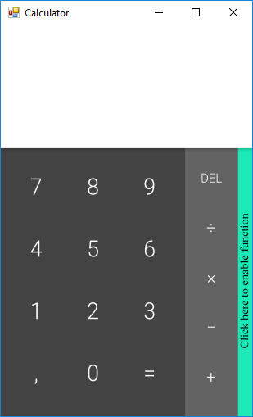
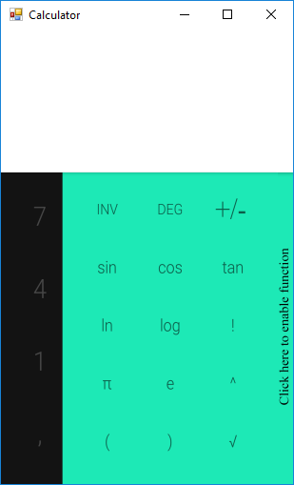

4. Concluzie

În urma efectuării lucrării de laborator,am învățat cum să realizez un simplu GUI calculator care suportă următoarele funcții: +, -, /, *, putere, radical, inversare semn(+/-), operații cu numere zecimale. Am aplicat programarea în Windows,mi-am aprofundat cunoștințele.Am utilizat un IDE pentru limbajele de programare C#.

5

