MB 304L / VIRTUAL PRE-LABORATORY

AquaDissect
User Manual
  - Student · Instructor · Program Head · Administrator
Version 1.0 / 7 November 2026
Use this guide to get into your class, complete or manage learning activities, and find the controls available to your role.

Find your section
Section | What you can do there | Page
Sign in | Use your assigned account or set your first password. | 2
Student | Complete orientation, check access, study and submit work. | 3–6
Instructor | Assign lessons, support students and prepare content. | 7–9
Program Head | Oversee sections and record independent faculty decisions. | 10
Administrator | Manage people, enrollment, publication and activation. | 11–13
Shared tools | Use reports, calendar, notifications and guides. | 14
Troubleshooting | Resolve access problems and open the local demo. | 15

About the screens
Examples come from an isolated AquaDissect demonstration with fictional accounts and sections. The live site could not be reached during preparation. Your school’s accounts, content approvals and section assignments determine what you can open.
Open the AquaDissect sign-in page when using your school account.
ALL ROLES

Sign in and set your password
Start at AquaDissect using the account assigned to you.

Students signing in for the first time
- When your administrator has enabled and initialized student-ID sign-in for your roster account, enter your student ID in Student ID or email. Enter the same ID as your temporary Password, then select Sign in.
- On Choose a new password, enter and confirm a new password. Use at least eight characters, including a letter and a number, and choose a value different from your student ID.
- Select Save new password and continue. On later visits, enter your student ID and the new password.

Returning students and staff
Returning students use their current password. Instructors, Program Heads and Administrators normally use their assigned email and password. An instructor who needs an account can use Request instructor access when available and wait for an administrator’s approval.
If your administrator provided a private setup code, follow Activate student account on the sign-in page. Use Google sign-in only if it is offered for your linked account. The student-ID route can work without email verification.
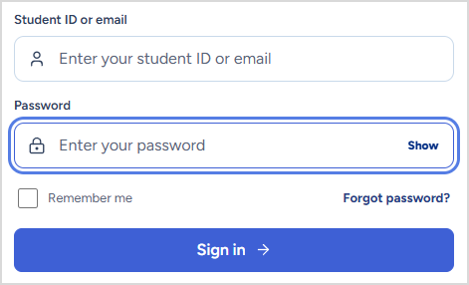
Figure 1 Sign-in fields in the local demonstration.
On a shared device, leave Remember me clear and use Account → Sign out when finished.
STUDENT / 1 OF 4

Orientation and class access
Home shows the next action for your account and for each section.
- On Home, find What must I finish? and choose Start orientation. On the guide card, choose Start walkthrough. Use Next through the five steps and choose Finish guide. Use Continue orientation if you left partway through.
- Select Check my section or open My class. Check the section, academic year and semester. If the section is missing or wrong, ask your instructor or administrator to verify the roster.
- Return to Home to see the status of Safety & Tools and Rabbitfish. If a lesson is locked, read the reason shown for the relevant section.
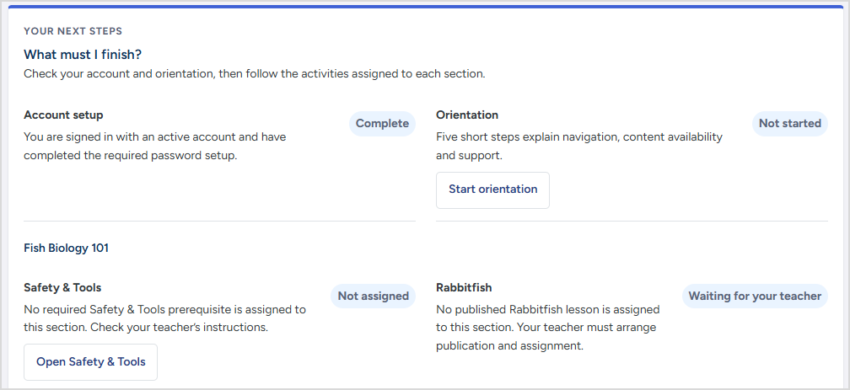
Figure 2 The student readiness checklist in a fictional section.

Read the readiness messages
- Viewed confirms that you finished the orientation guide. Complete any required safety activity separately.
- Not assigned or Waiting for your teacher means there is no activity to open for that section. Ask the instructor which material is currently assigned.
- Locked means an access condition remains. Pending sync means the work is still waiting for the server. Reconnect and check again before relying on the status.
STUDENT / 2 OF 4

Safety and guided dissection

Complete the required Safety & Tools activity
- Open Safety & Tools and choose Start module or Resume module for your assigned version. Follow the steps in order. Select the laboratory items to read their handling and safety guidance.
- Choose Done — continue to complete each step. At Tool-selection check, answer each question and select Submit formative activity. The score provides feedback. Submitting the activity and completing every required step satisfy the prerequisite.
- When online, return to Home or My class and confirm that the required module shows Complete.

Open a species lesson
Go to My lessons, select the assigned species and choose Open lesson. If you have more than one section, open it from the correct section card. Read each step, play the clip when one is attached, and follow the on-screen anatomy prompts. Use the depth, labels and hotspots where available.
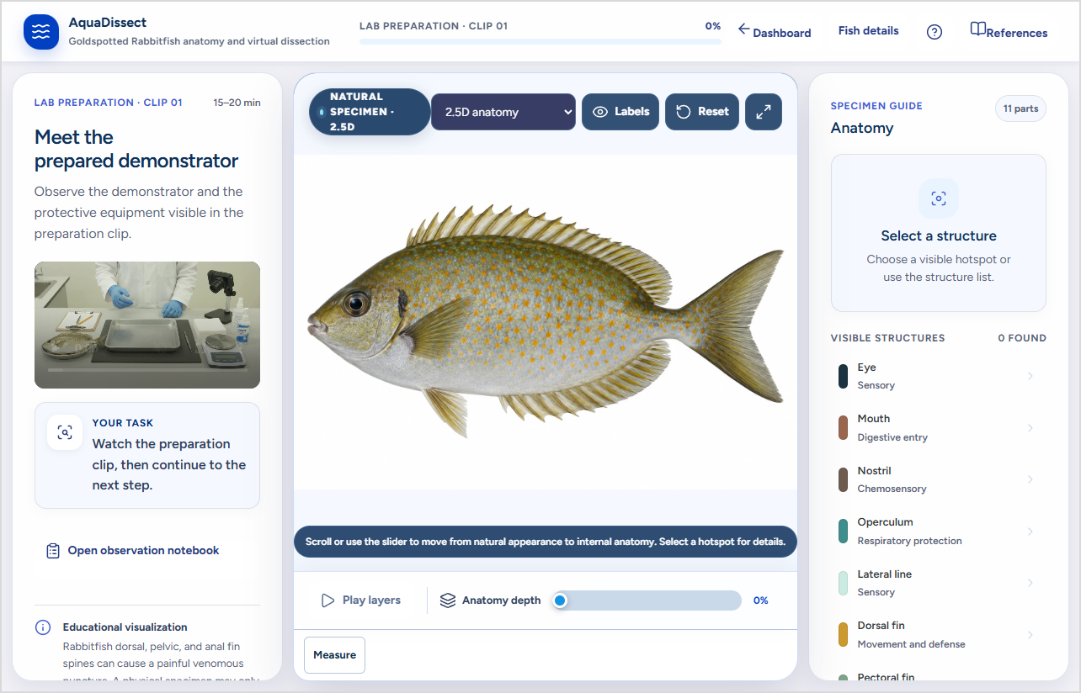
Figure 3 Staff preview of Rabbitfish preparation clip 01 and the anatomy viewer.
This authorized staff preview shows AI-generated educational media from Rabbitfish v1.2.0. Student access requires independent review, publication, section assignment and completion of any applicable prerequisite.
STUDENT / 3 OF 4

Fish details, notes and tests
Keep observations, formative feedback and formal assessment attempts separate.

Read the fish profile and measure an image
- In the lesson, open Fish details to review the available names, fish characteristics and source information for that version. Local names appear when included in the approved lesson.
- If the anatomy viewer offers Measure, select the two endpoints on the same view. Read the unit and measurement basis. Relative values describe the image. A physical-unit estimate applies only within the scope of an approved calibration for that exact image.

Keep a notebook draft
- Choose Open observation notebook in the lesson. Choose an observation, record what you can identify and save your draft. Mark an unknown or unobserved structure accordingly. Record zero only when you observed a zero value.
- Keep your own backup with Download JSON and use the CSV export for a readable copy. Restore only a compatible JSON draft in the correct lesson and section. Keep names, student numbers and consent information out of notes and exports.
Notebook drafts are stored in the current browser. Export a backup before switching devices or clearing site data.

Submit and check results
- Formative quiz. Follow the lesson to its quiz. Submit and review the feedback. Use Reports to check the retained learning result after it has synced.
- Assigned pretest and posttest. If a reviewed pair has been enabled for your section, use My class → Pretest and posttest. Complete the pretest in the assigned window, finish the matching formative lesson, then complete the posttest when it opens. Stay online and check answers before Submit answers. Each phase accepts one scored attempt.
- Score comparison. Read the pretest, posttest and change together. An absent score means an attempt is missing or unavailable.
STUDENT / 4 OF 4

Download and sync offline work
Prepare the same browser and device while you still have a connection.

Before going offline
- Sign in online and open Offline access. Check the section and version before choosing Download for offline on your assigned lesson and the required Safety & Tools module, if one is assigned.
- Wait until the app reports the download is ready. Check for errors and reopen the saved item while still connected. Keep using the same account and browser profile.
- If you need to take a formal pretest or posttest, plan to submit it online.

While offline
Open the saved lesson or module using the same browser. Available content and supported formative work can be used offline. Some actions may show a pending status until the server has received them.

When connected again
- Return online with the original account. Open AquaDissect and let it send pending work. Refresh the status in Offline access, Home or Reports as appropriate.
- If a pending item is rejected or stays unsent, keep the original browser profile and its site data. Record the message and report the section and activity to your instructor. Download or export any available recovery copy without including credentials.
- If sign-out is waiting for a connection, reconnect in the same browser so it can finish. On a shared device, confirm you are back at the sign-in screen before leaving.

Protect work saved on this device
Keep the device and browser profile available until the app confirms the work was saved online. Back up any separate notebook draft using its export control.
INSTRUCTOR / 1 OF 3

Sections and lesson assignments
Work in sections assigned to your instructor account.

Check your section
- Open Class sections and confirm the section name, academic year and semester.
- Select View details for the section and expand View students, safety status, and progress to verify enrollment and current activity. Ask the administrator to correct a missing or incorrect section assignment.
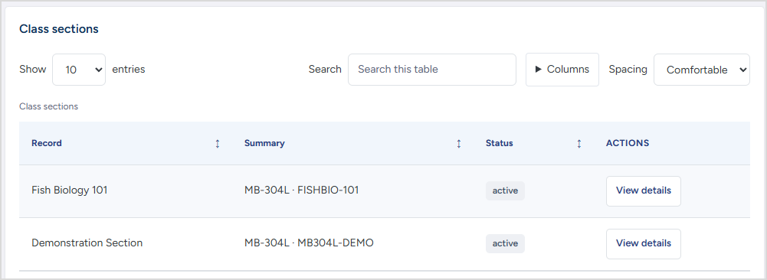
Figure 4 Instructor view of an assigned demonstration section.

Assign a published lesson
- Open Class activities and locate the section card. Under Published species lesson, select the correct fish and version. Set the Due date if needed.
- Choose Assign lesson or Save activity, as shown. Check the section’s current activities and confirm that the expected lesson and date appear.
- Before changing a version, check which students have started. The app keeps started work on its saved version unless you explicitly reassign it. Review the confirmation before changing an active assignment.
When a required Safety & Tools module applies, students must satisfy it for their section before opening the species lesson.
INSTRUCTOR / 2 OF 3

Draft lessons and safety media
Prepare a version for independent review before it is used in a class.

Prepare a species lesson
- Open Species content. To upload a prepared .aqpack, open Advanced: import a prepared lesson file and choose Check and import draft after selecting the file. To update an existing version, choose Revise fish details and imagery.
- Add or correct the species profile, local names and supporting sources. For a local name, record its language, locality and source. Use anatomy images and labels that match the same species, view and learning step.
- If a measurement reference is supplied, attach it to the exact image. Document its source, reference length and approved scope. Choose Save new draft version when revising an existing package.
- Use Preview draft to check the fish profile, labels, anatomy views, lesson steps and any embedded clips. Open the formative quiz and check the media disclosures. Choose Send for faculty review when the version is ready.

Prepare Safety & Tools
- Open Safety & Tools. Select the draft version and check each step’s item identification, handling instructions and formative questions. Use Media details to check the source, permissions and any AI disclosure.
- To write a media prompt, open Create media prompts. Select the draft version, laboratory item, output type, view, teaching focus and PPE. Choose Build prompt, then Copy prompt. To attach it to the draft audit record, select that option before building it.
- Review any media produced with faculty. Add or replace files through the module’s editing controls and preview the complete module. Use Send for faculty review when ready.
A prompt is text for preparing media. The instructor checks the resulting media against the approved procedure before submitting it.
INSTRUCTOR / 3 OF 3

Student support and tests

Check progress before resolving an access issue
- Open Class sections, choose View details and expand View students, safety status, and progress. Check enrollment, the required safety version and its completion state.
- Check Reports for the same section and activity. If a student worked offline, confirm they have reconnected and the activity was accepted.
- Use a prerequisite exception only when authorized. If the section offers this control, choose the learner or section scope and record the reason. Revoke the exception when it is no longer valid. The exception and the student’s safety progress are tracked separately.

Reset a student password when authorized
- In the section’s student list, locate the enrolled student and select Reset password if available. Verify the identity and select the required reason.
- Confirm the reset. Privately tell the student to use their student ID as the temporary password and to set a new password at sign-in. The reset is recorded in the audit history and previous sessions lose course access.

Prepare a paired assessment
- In Class sections, open Pretest and posttest → Prepare a test pair for faculty review. Choose the section and matching lesson version. Enter the test title and instrument version.
- Attach the approved-format pretest and posttest JSON forms. Check equal item counts, equivalent coverage and scoring, and the answer keys. Keep key-bearing files in staff storage.
- Select Save disabled draft. Route it to the authorized independent faculty reviewer. The pair stays unavailable to students until review and administrator activation.
For research use, follow the approved procedure on page 14.
PROGRAM HEAD

Oversight and faculty review

Oversee sections and learning activity
Use Class sections to inspect offerings and learning progress across sections. Use Reports to filter by section, term, version or activity as available. Work with the instructor or administrator when an assignment, enrollment or account needs changing.

Review a submitted lesson or module
- Open Species content or Safety & Tools. Find the item and version in review, then open its details. Choose Preview draft or Preview module to inspect the material before deciding.
- Check curriculum alignment, anatomy, sequence, tools and safe handling. Check the scope and evidence for any measurement, plus media permissions and AI disclosures. Use an independent reviewer if you contributed to the version.
- Enter review notes and an evidence reference, choose Approve for administrator publication or Request changes, and select Record faculty decision. Complete the applicable confirmations. The administrator handles publication.
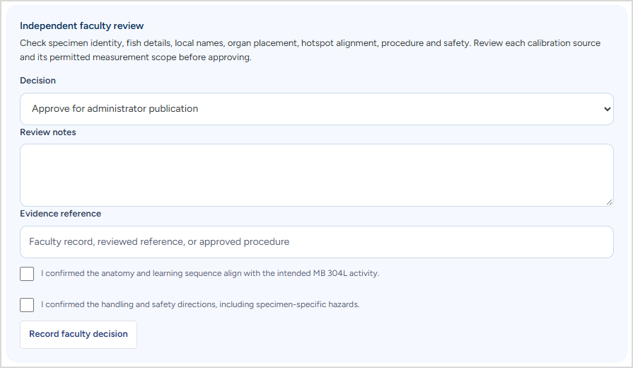
Figure 5 Independent faculty review controls in the local demonstration.

Review a paired assessment
In Class sections → Pretest and posttest, inspect the submitted forms and keys. Record validation evidence for equivalence, scoring, timing and any required permissions using Record faculty approval. Administrator activation is a separate step.
ADMINISTRATOR / 1 OF 3

People, sections and enrollment

Create a section
Open People & sections → Add a section. Enter the academic year, semester, section name and section code. Check that an equivalent offering does not already exist, then save.
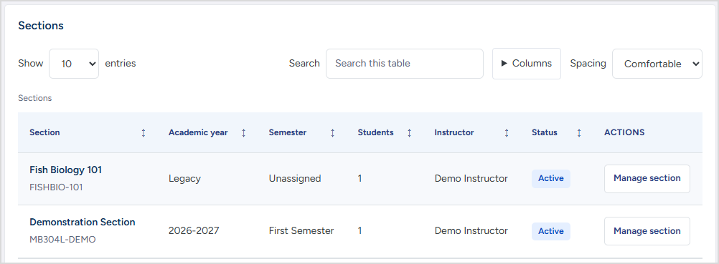
Figure 6 Administrator roster controls in the local demonstration.

Enroll one student
- Choose Add one student. Select the active section and enter the student’s official name and institutional student ID. Use a verified email only if one is available.
- Choose Create or enroll student. Verify the resulting student and offering. If the ID already exists, check the matched roster account before changing or adding enrollment.

Assign and manage staff
On Home, review Pending instructor account requests and choose Approve for a verified request. In People & sections, find the offering and open Manage section. Choose an approved instructor under Assign instructor, select Assign, then confirm the instructor in the section.
For an authorized role change, open Account roles and find Program Head access, select the role, choose Review change, then Apply role change. Verify the entry under Recent role changes. Archive a section only after verifying the offering. Its records remain in the retained history.
ADMINISTRATOR / 2 OF 3

Bulk enrollment and account support

Import a roster from a file
- Open People & sections → Upload students from a file. Choose the roster file. Use text formatting for institutional IDs so leading zeros are preserved.
- Review the detected sheet and header, or choose the correct ones. Map the official names and student ID to the appropriate columns. Map email only when the roster supplies it.
- Review the preview and select the rows to import. Select the destination active section or sections and verify the academic year and semester. Correct conflicts flagged in the preview before proceeding.
- Choose Import selected students. Check the created, matched, enrolled and skipped totals shown in the result. Spot-check the destination roster before distributing access instructions.
Use the official roster and keep the uploaded file private. Existing accounts keep their credentials when they are matched during enrollment.

Handle student access and resets
- First sign-in. Confirm the roster account is in the correct offering and ready for the school’s chosen setup method. If student-ID setup is enabled, confirm the temporary sign-in is ready for the account, then communicate the first-login instructions privately.
- Password reset. Locate the correct student, use Reset password, select the reason and confirm. The student signs in with their ID as the temporary password and then chooses a new password. Use Password history to review authorized setup, reset and change events.
- Keep the same account. Resolve login or identity conflicts on the existing record. Creating a replacement account can separate a student from their enrollment and results.

Use an alternate setup route only when configured
When the portal is configured for a private setup code, provide the code only to the intended student. If email delivery or Google sign-in is enabled at your school, confirm it is ready before directing anyone to that route.
ADMINISTRATOR / 3 OF 3

Publish content and activate tests
Review the version, current faculty decision and intended audience before any release.

Publish an approved species version
- Open Species content and inspect the version’s details. Confirm it is in review and carries a current independent approval for that exact content.
- Choose Publish approved version and review the confirmation. When required, use Set active version to make a published version current. Ask the assigned instructor to check or create the class activity for that version.
- Confirm that the student section has the intended activity and any required safety assignment. Use Archive only for retirement. Restore for fresh review returns a version to the review process.

Publish Safety & Tools for the intended sections
- Open Safety & Tools and confirm the current independent approval. Select the active sections that should receive the required module.
- Choose Publish approved version, check the section list in the confirmation, and select Publish module. With no selected section the version is published without a class assignment.
- Verify the section requirement and retained completion history. A new version may change which requirement applies, so check readiness in each destination section.

Enable a reviewed pretest and posttest
In Class sections → Pretest and posttest, check the approved instrument version, active section, published lesson assignment and approved timing. Confirm the applicable institutional permissions before activating. Choose Activate approved tests for the intended section and verify the student view when appropriate.
Rabbitfish v1.2.0 and its four preparation clips appear in the demonstration as review material. Treat the actual faculty decision and section status as the release record.
ALL ROLES

Reports, calendar and help
Tool | How to use it
Reports | Choose the section, term, version and activity filters that apply. Students see their own records. Instructors see assigned sections. Program Heads and Administrators have broader oversight. Use an available export only for an authorized purpose.
Calendar | Check section activity dates and events. Instructors can manage events for assigned sections. Administrators can manage events in their permitted sections. Program Heads and students can view events available to them.
Notifications | Open the message and follow its link to the activity or section. Use Mark all read when appropriate.
Help & guide | Open a guide for your role or search for a page or help topic. If the app reports a guide did not save, retry when connected.
Account | Check the signed-in role when an expected menu is missing. Use Sign out before another person uses the same browser.

Interpret results in context
- Check whether a record is formative, a formal paired assessment or a safety completion. For a scored pair, compare the pretest and posttest using the units displayed. Percentage-point change is the difference between the two percentages.
- Keep unavailable scores separate from zero. Older activity without a section match may appear outside a section-filtered result. Check the filters and the activity version before escalating.

Protect course and research records
Share student-level records only with authorized staff. Use the institution’s approved research process, including any required ethics clearance, permissions and informed consent, before research use. Keep research assessment results separate from course grading under the approved protocol.
REFERENCE

Troubleshooting and local demo
What you see | What to check
The sign-in fails | Check the website or demo you opened and your assigned account. Students should use the current password unless staff just initialized or reset it. Ask authorized staff for help if it still fails.
Your section is missing | Confirm the correct student or staff account, academic year and semester. Ask the administrator to check the active enrollment or instructor assignment.
Safety or Rabbitfish is locked | Check whether the correct version was published and assigned. For Rabbitfish, check the required Safety & Tools status and whether progress is still pending sync.
A result is missing | Check your section, lesson version and activity filters. If the activity was done offline, reconnect with the original account and wait for sync.
A roster import shows a conflict | Check the sheet, mapped columns, IDs and target offering. Resolve flagged conflicts in the preview and verify the resulting roster after importing.
A review or publish button is absent | Check the signed-in role and exact version status. Confirm the reviewer is independent and a current approval exists where required.

Practice with the local Windows demo
Use the fictional demo accounts provided in the demo instructions. Demo credentials are for the local demonstration and school accounts use their own credentials.
Local Windows demo instructions · Reference source revision

Administrator source access
If Source Structure is enabled for your administrator account, use its preview or download controls for the prepared source copy. The public demo and the live portal use separate accounts.

