Anaconda Installation Guide for Windows

1. Download the Anaconda installer from the following link :

<https://www.anaconda.com/products/individual#windows>

1. Double click the installer to launch.
2. Click Next.
3. Read the terms and license and click “I Agree”
4. Select “Just Me” or all users for the installing option and click Next.
5. Select destination folder to install Anaconda and click Next Button. Install Anaconda to a directory path that does not contain spaces or unicode characters. (C:\Users\{user_name}\anaconda3)

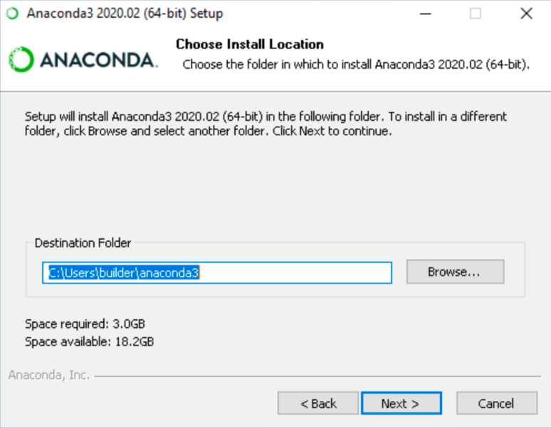

1. We recommend not adding Anaconda to PATH environtment variable, since this can potentially interfere with other software. Instead we can use Anaconda software by opening Anaconda Navigator or Anaconda prompt to run the Python file.
2. Choose whether to register Anaconda as your default Python. Unless you using multiple versions of Python, accept the default and leave the box checked and click Install.

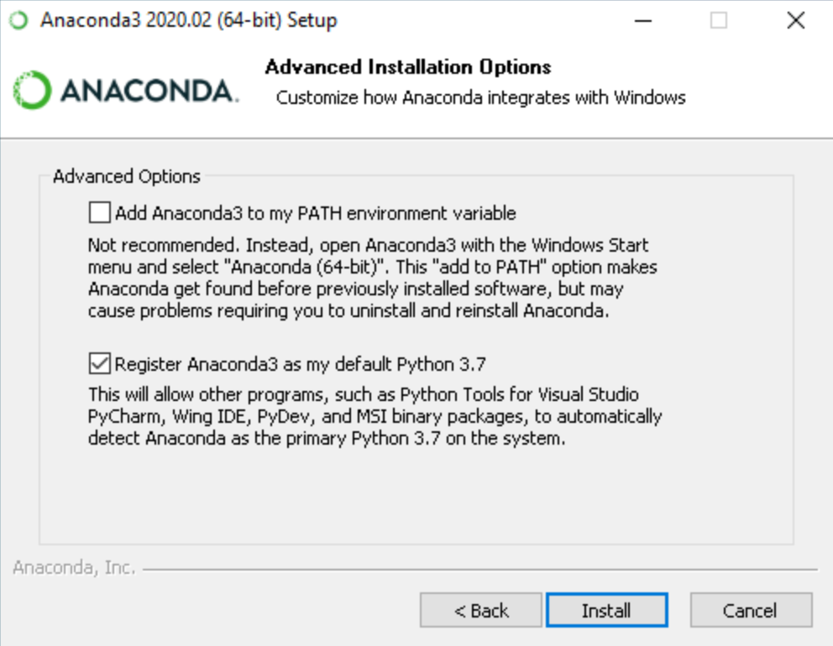

1. Click Next
2. Click Next Again.
3. After a successful installation you will see the “Thanks for installing Anaconda” dialog box.

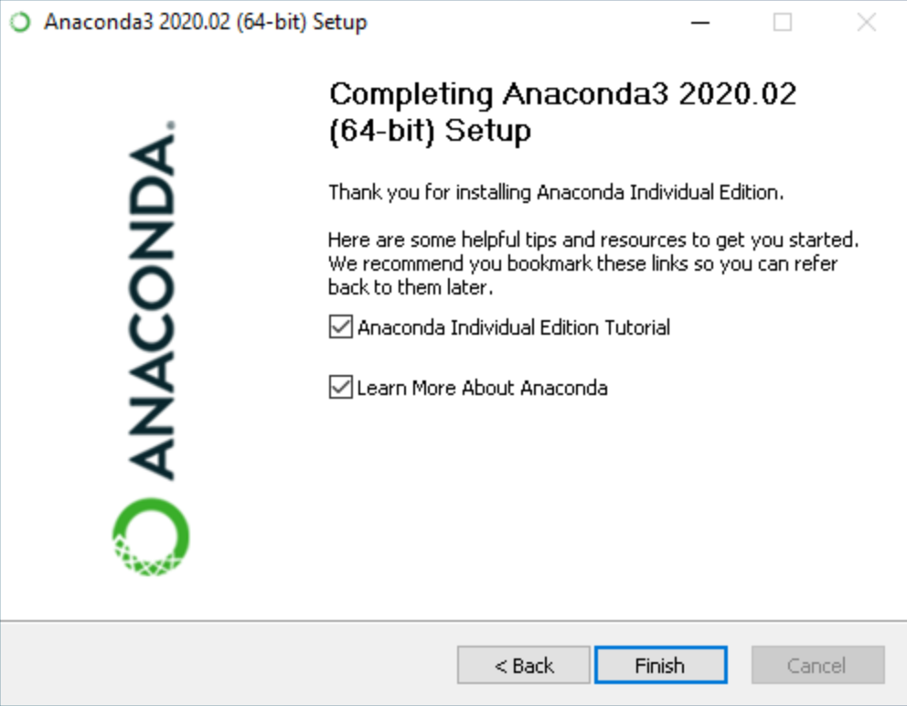

1. Leave the two dialog boxes unchecked and click Finish.
2. Verify your Installation by checking in the Start Windows, search for Anaconda Navigator and Anaconda Prompt.
3. Launch the Anaconda Navigator and click Launch Jupyter Notebook.

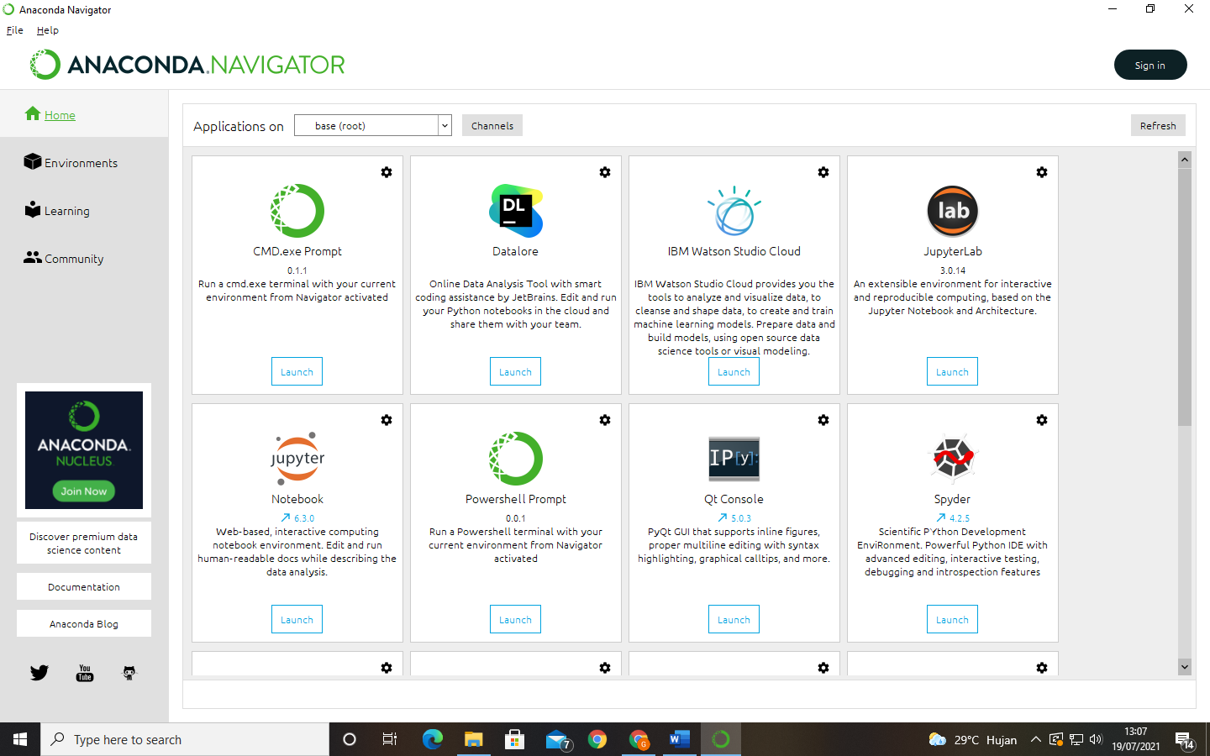

Click Here

1. The Jupyter Notebook will launch at your browser.