1811ICT Programming Principles Assignment 1

Name: LNZHI Liu SdentID:220252924

姓名：刘瀚之 学号：2202502924

Before you start: This comprehensive mid-semester assignment package is designed to evaluate both theoretical comprehension（理解）and practical application of foundational computer science workflows in Python.（ ） The assignment consists of 20 questions in total, divided evenly into two major components worth a combined sum of 30 marks. Part A contains 10 technical short-answer questions (weighted at 1 mark each) focusing on core conceptual paradigms, memory logistics, and syntax rules extracted from your course lecture notes and laboratory workshops. Part B presents 10 practical programming challenges (weighted at 2 marks each) that require algorithmic problem-solving using structured logic, arithmetic manipulation, and module management. For every programming question, students are strictly required to furnish their solution in two segments: the source script file block and a screenshot showing the verbatim text output window extracted directly from the running VS Code integrated terminal environment (or similar IDE terminals).

Part A: Short Answer Questions (10 marks in total, 1 mark each)
Answer all questions briefly. Base your definitions and technical explanations precisely on the 1811ICT lecture notes and workshop materials.

- Language Paradigms: Python is described as a hybrid language. Based on your lecture notes, list three programming paradigms that Python successfully combines.
过程式编程（Procedural Programming）
Python hybrid combines： 面向对象编程（Object-Oriented Programming）
• 函数式编程（Functional Programming）

- Compilation vs. Interpretation: What is the operational difference between an interpreter and a compiler regarding when code is translated? Which one translates code line-by-line during runtime, and which one translates it beforehand to achieve faster execution speeds?
解释器在运行时逐行翻译代码；编译器在运行前一次性全部翻译为机器码。逐行运行：解释器；预先翻译、执行更快：编译器
The compilation of the code when they run line by line ; Interpretation alters the machine ID when it is run to translate all by one time . Runing line by line: compilation ; pre-translate.

- Interactive Environments: Define what a REPL is. State what each letter in the acronym stands for, and explain how a programmer utilizes it for interactive testing.
R=read E=evaluable P=print L=loop(循环)
程序员可实时输入代码、立即执行并查看结果，用于快速测试与调试。

- Variable Allocation Dynamics: In Python, do variables have fixed types, or do the types belong strictly to the objects and values themselves? Contrast this with compiled languages that are statically typed at compile time.
In Python ,the variable haven’t the types.The types belong to itselves which cannot alther.
Python 变量没有固定类型，类型严格属于对象 / 值本身。静态类型语言在编译时就确定变量类型，且不可随意改变

- Memory Management and Immutability: If you run the built-in id() function on a string variable, concatenate it with another string using the + operator, and run id() again, the memory address changes. Explain why this happens, explicitly referencing a core property of the str data type.
字符串（str）是不可变数据类型，无法原地修改。使用 + 拼接会创建新对象，因此内存地址（id）改变。
The ‘+’ cannot run successfully.Simultanously,the ID will change.

- Data Type Constructor Validation: If a developer tries to multiply the output of an input prompt directly (e.g., score = input("Enter score: ") * 2), Python replicates the text characters instead of performing math. Explain why this occurs and how to fix it using an explicit type constructor.
Reason: The input() returns a string type.
Change:Use int()/float() for explicit conversion. For example, score = int(input('Enter score:')).

- Pre-tested Conditions: A while loop is formally classified as a pre-tested loop. What does this term mean regarding the minimum number of times a while loop body can possibly execute?
Run must be after the distinguish, 先判断条件，再执行循环体。
Tip:If the condition is not satisifiction , the loop body is zero.

- Loop Control Mechanics: In the context of creating structured while loops, define the roles of loop initialization and loop incrementing/updating. What hazardous condition occurs if a developer forgets to provide the update step?
- Initialization: Assign an initial value to the loop variable to determine the starting point of the loop.
- Update: Modify the variable after each iteration to make the condition tend towards non-fulfillment.
- Lack of update will lead to: an infinite loop.

- Sequence Architecture & The Reference Trap: Contrast a Python list with a Python tuple by listing two key differences regarding memory mutability and literal syntax representation. What is meant by the term aliasing (the reference trap) when assigning one list directly to another?
The difference:
- List can alter but tuple not.
- List uses[ ] ,tuple uses ( ).
- There are influence to each others.

- Functional Scope Architecture: Why are students strictly instructed to avoid referencing or altering global variables inside custom function bodies? State two specific benefits related to modularity, debugging, or code reusability achieved by eliminating global variable dependencies.
The benefits:
- Enhance modularity, making functions more independent and portable.
- Simplify debugging by avoiding unintended changes to external states.
- Improve reusability, as functions can operate without relying on external environments.

Part B: Programming Questions (20 marks in total, 2 marks each)
Submission Requirement: For each question below, you must provide your answer in two parts:
- The Source Code: Paste your clean, runnable Python code script block.
- The Terminal Output（终端输出）: Take a screenshot of the exact text output displayed in your VS Code terminal when running that specific block of code.（运行那段特定代码块时，截取你的VS Code终端中显示的确切文本输出内容的截图。）
To receive full marks, your program code must initialize（初始化） your unique identification credentials as shown in Question 1. All subsequent tasks must actively derive their math limits, string boundaries, conditional paths, or loop conditions from your personal student ID variable.

Question 1: Environment Setup & String-to-Integer Sequence Casting
At the absolute top of your script file, declare your identity tracking variables:
- id_StudentGivenName initialized as a string containing your actual student ID (e.g., id_leo = "0123456789").打印姓名和ID，把每个学号转成整数，存入digits_list
- name_StudentGivenName initialized as a string containing your given name (e.g., name_leo = "Leo").打印digits_list
Write a script that:
- Prints a dynamically formatted message: "Hello, my name is [Name] and my 1811ICT student ID is [ID]."
- Uses a definite loop (for) or a sequence comprehension to cast each single numeric character of your string ID into actual integer elements inside a sequence list named digits_list.
- Prints digits_list to verify the transformation.
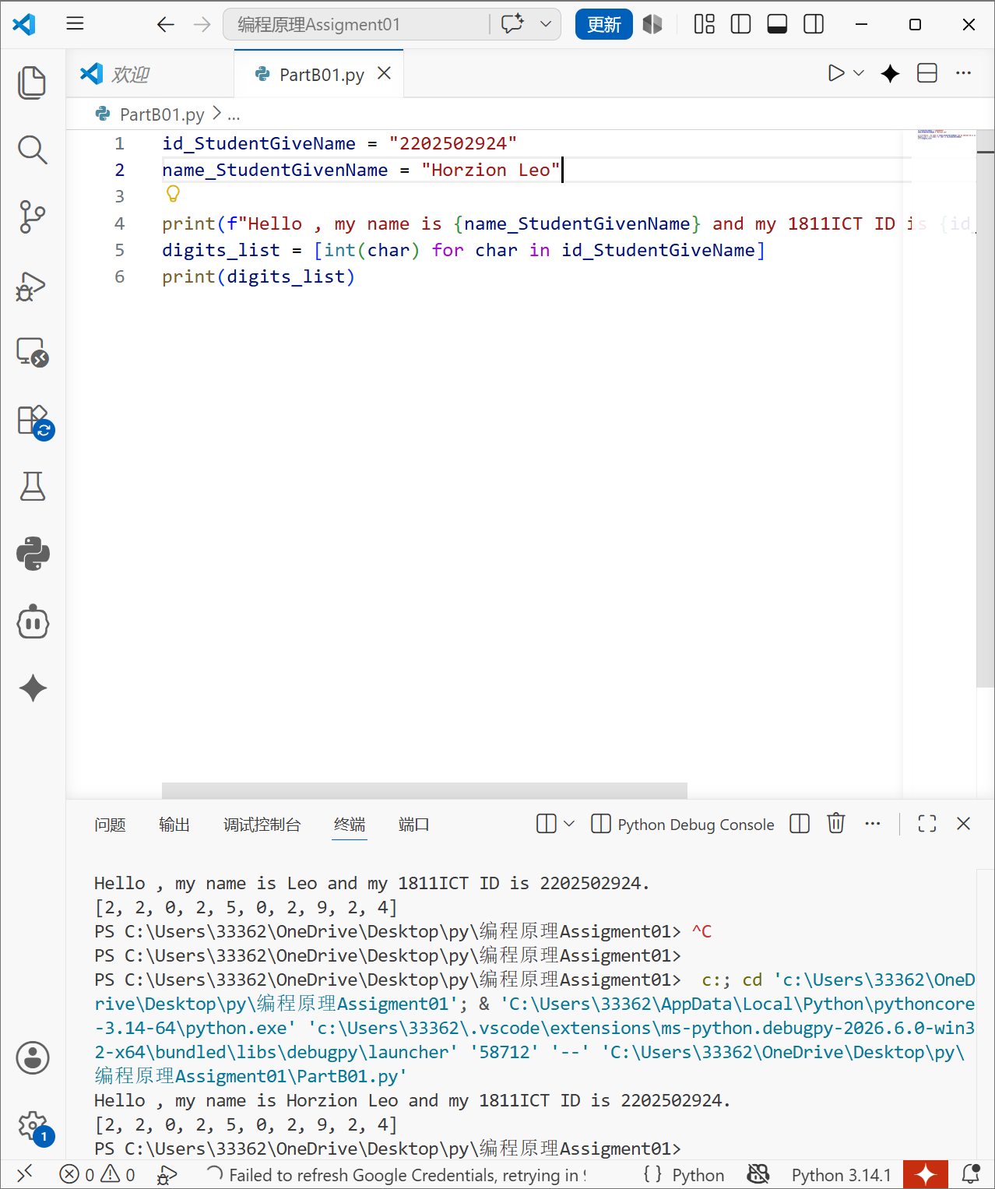

Question 2: Algorithmic Selectors and Type Inspection
Using the variables established in Question 1:
- Isolate the very last digit of your student ID list using negative sequence indexing.
- Construct an if-else branching control block:
  - If your last digit is an even number, create a variable named calc_val and store your full student ID cast as a float divided by 1000.
  - If your last digit is an odd number, store your full student ID cast as a float divided by 500.
- Print out the absolute data type of calc_val using a built-in inspector function, followed by printing the value itself formatted explicitly to 4 decimal places using the .format() string method.
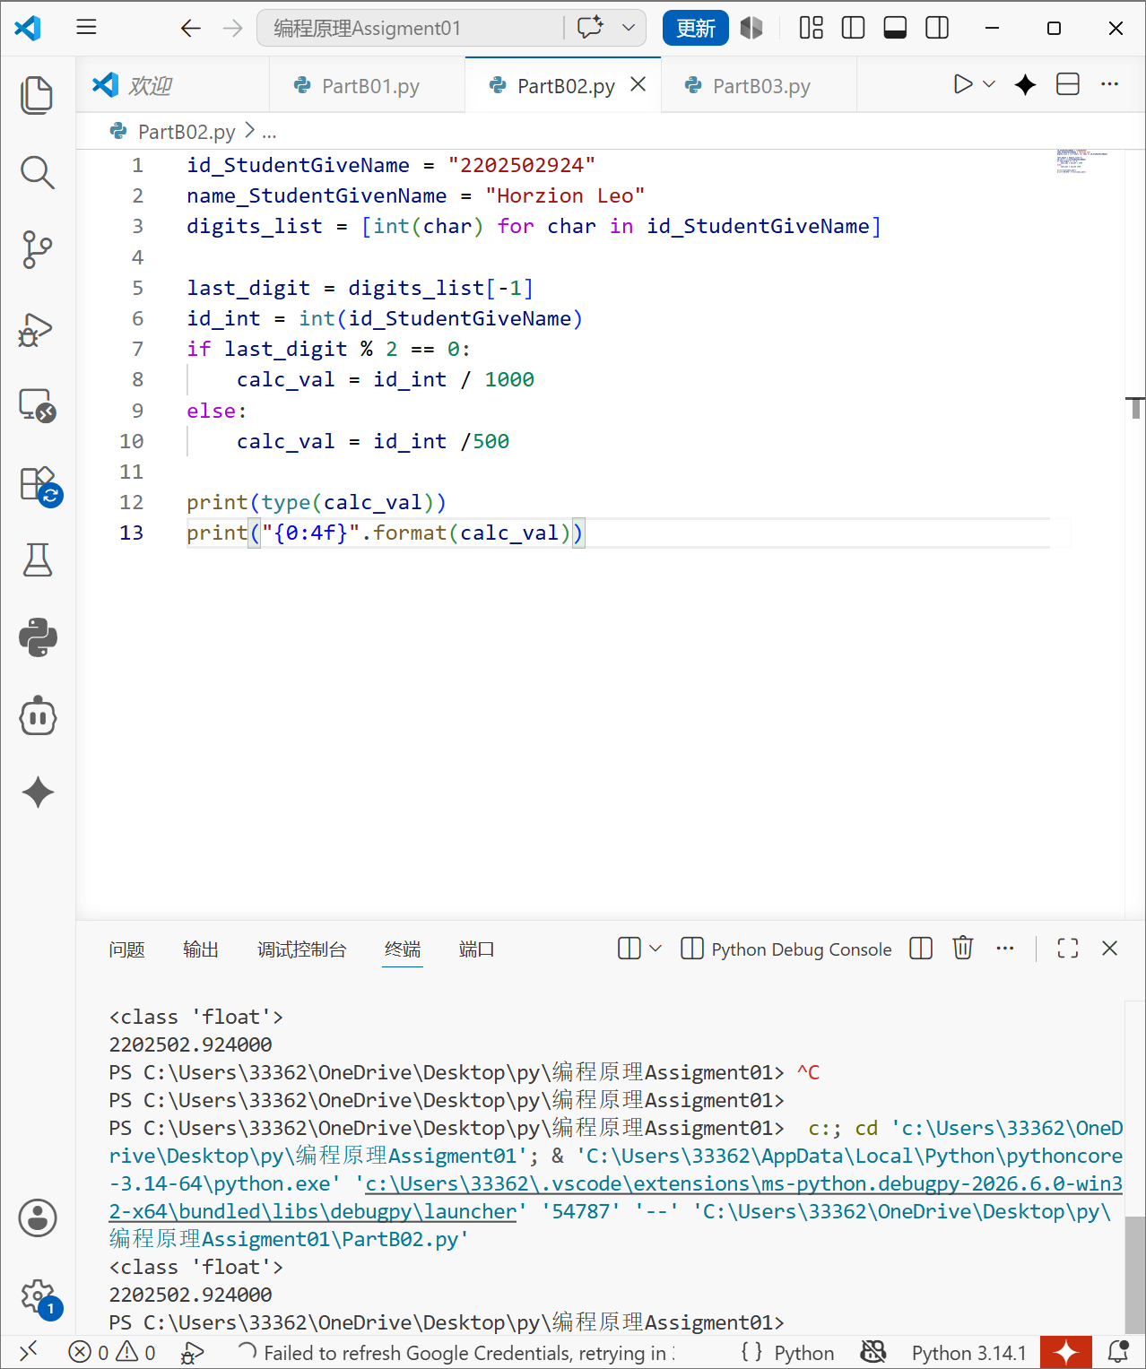

Question 3: Indefinite Loop Threshold Verification (The Safe Input Logger)
Use the third digit of your student ID sequence (index position 2) to establish a dynamic loop termination threshold:
- Initialize an indefinite data monitoring sequence using a while loop.
- Inside the loop body, repeatedly prompt the user to input any integer using input().
- The loop must continue to prompt the user while the integer they enter remains strictly less than your ID's third digit value.
- Track the number of invalid entries made, and print a summary statement once the pre-test condition safely terminates the loop.
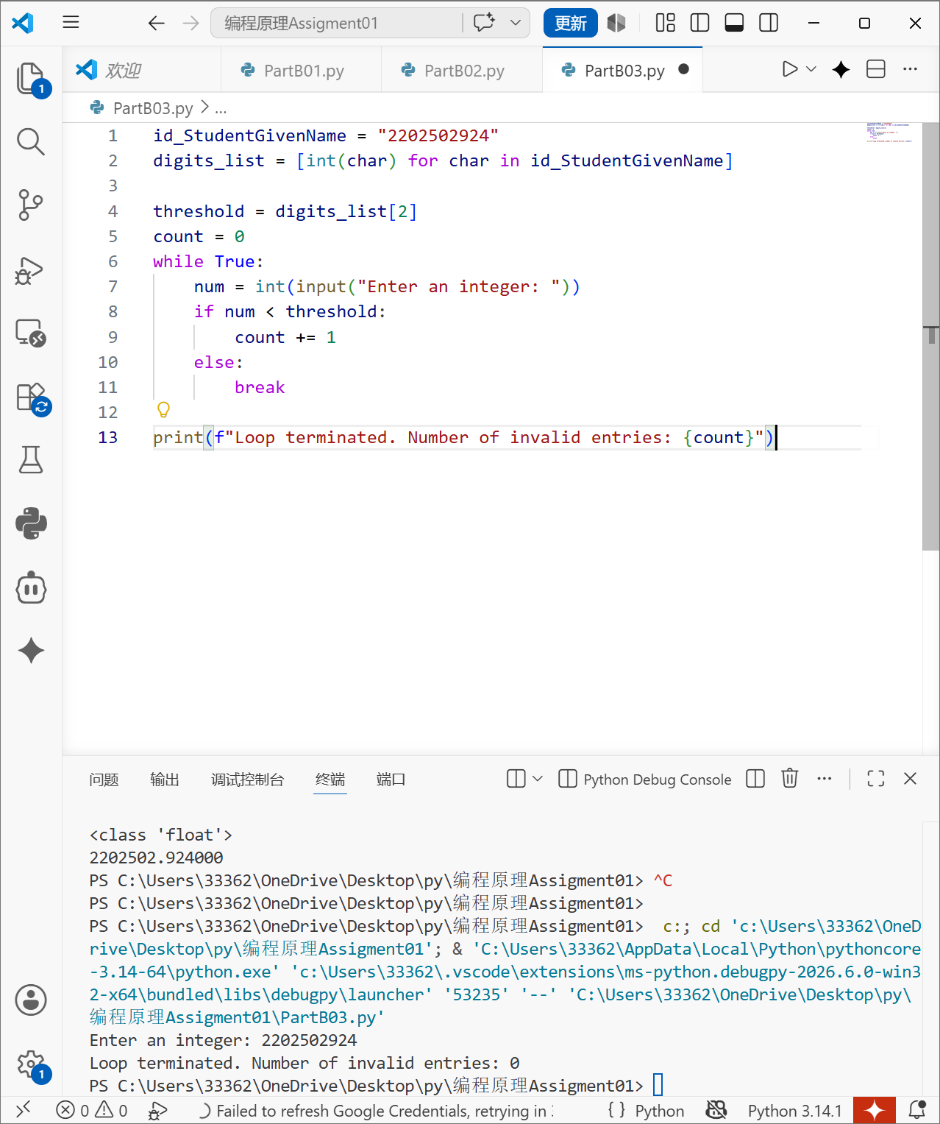

Question 4: String Slicing Bounds and Identity Verification
Using your initial string variable id_StudentGivenName:
- Use sequence slicing syntax to extract two distinct slices: one containing the first three characters, and another containing the last three characters.
- Concatenate these two segments together separated cleanly by a hyphen string ("-").
- Print the resulting text string.
- Demonstrate that the original string object was completely unaffected in memory by passing id_StudentGivenName to the built-in id() function before and after the slice concatenation, printing both memory locations.
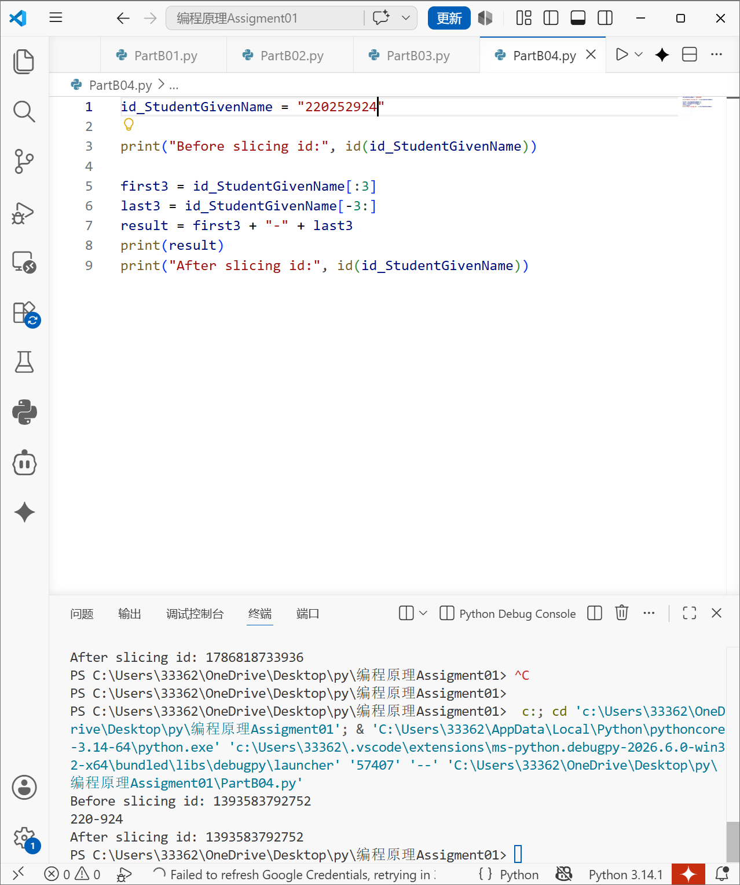

Question 5: List Cloning Mechanics & Structural Protection
Using your original digits_list from Question 1:
- Create a true isolated copy of the list named working_digits using standard list-cloning/slicing mechanics (to avoid the Reference Trap).
- Use a list method to append a new element to the end of working_digits containing the sum of your ID's first and last numbers.
- Use a sequence positioning method to insert your favourite integer value precisely into index position 1 of working_digits.
- Simultaneously print the original digits_list and your mutated working_digits list to prove your original structural data remains protected.
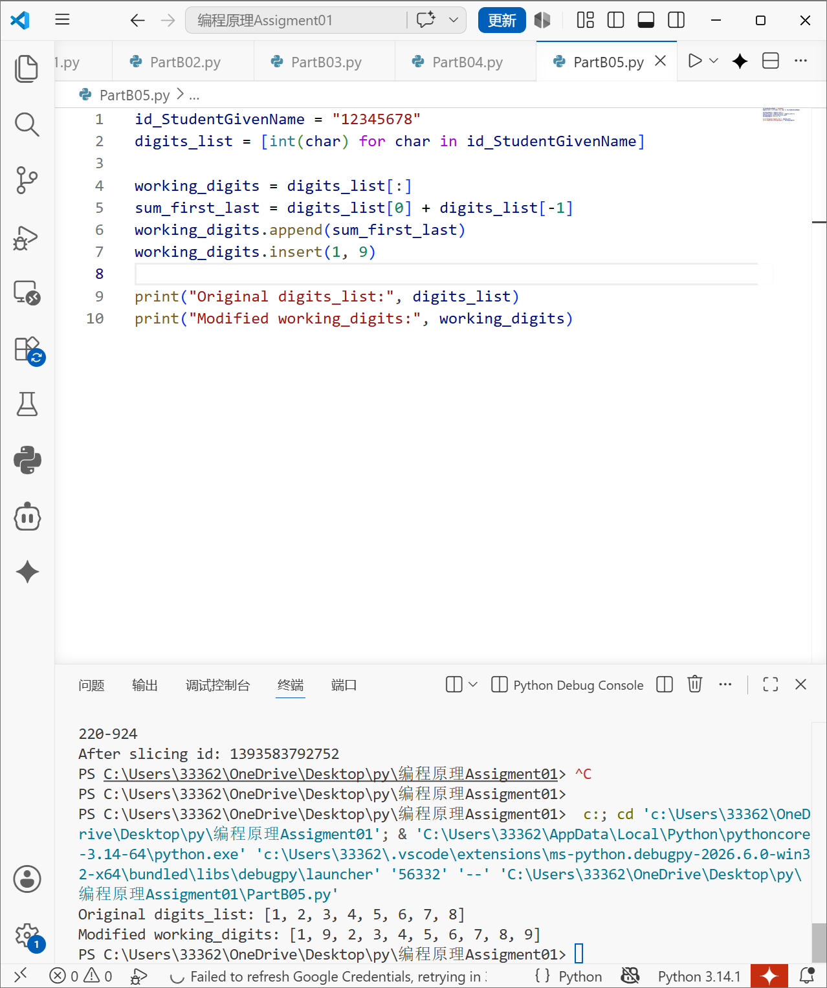

Question 6: Definite Processing & Compound Iteration Arithmetic
Write a program that explicitly reads your unique digits_list using a definite sequence loop (for) to evaluate the following composite calculations:
- The total cumulative sum of all digits making up your ID.
- The continuous product of all non-zero digits making up your ID (ignore any 0 values so your product is not multiplied by zero).
- Output both metrics clearly labelled with descriptive textual annotations.
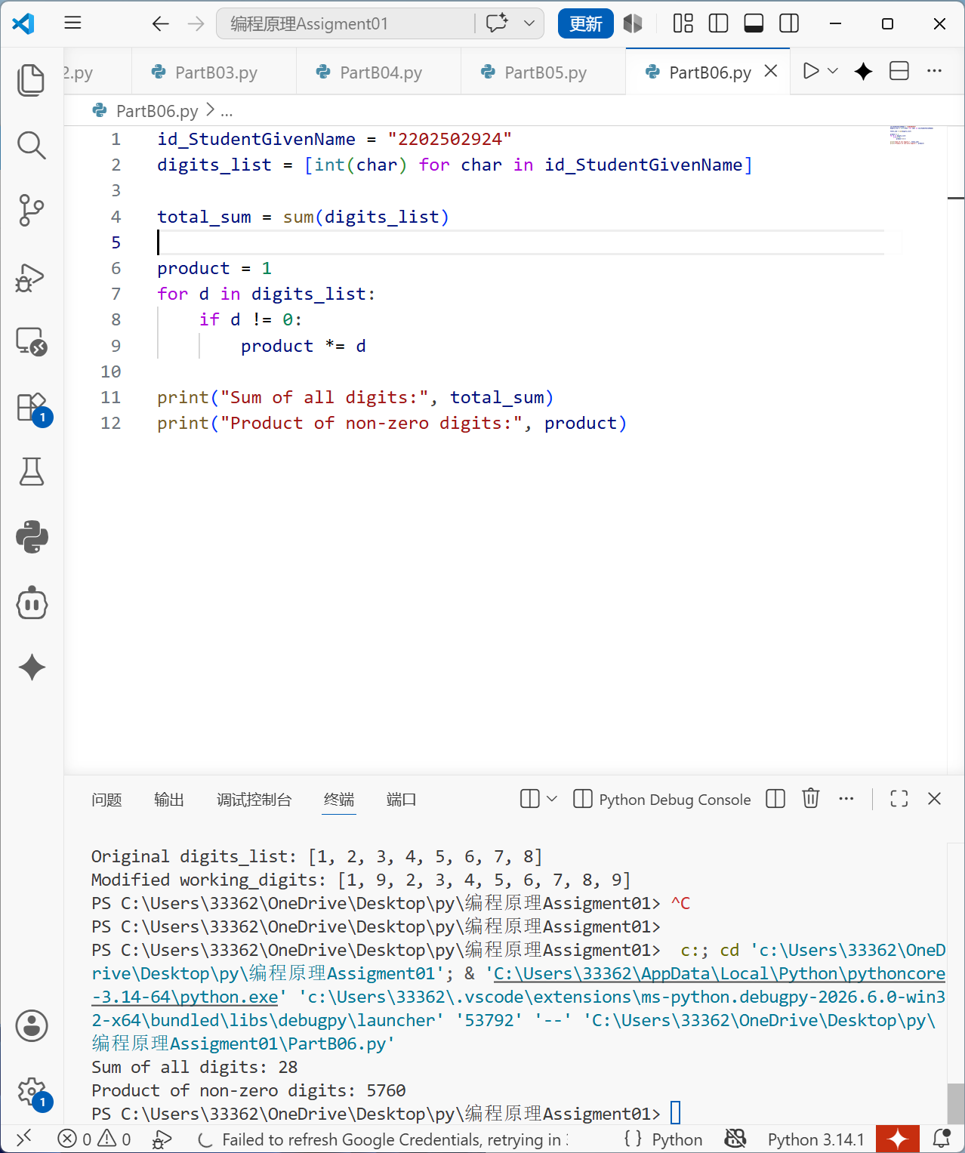

Question 7: Tuple Packaging & Unpacking Mechanics
- Design a custom function named parse_id_metrics that takes a single string parameter representing a student ID.
- Inside the function body, calculate three metrics: the total character length of the string, the highest digit value (as an integer), and the lowest digit value (as an integer).
- Return all three calculated insights simultaneously inside a single packaged tuple.
- Call your function passing your custom id_StudentGivenName variable, and use multiple variable assignment syntax to map the returned tuple values directly into three descriptive local scope variables in a single code line. Print the local variables.
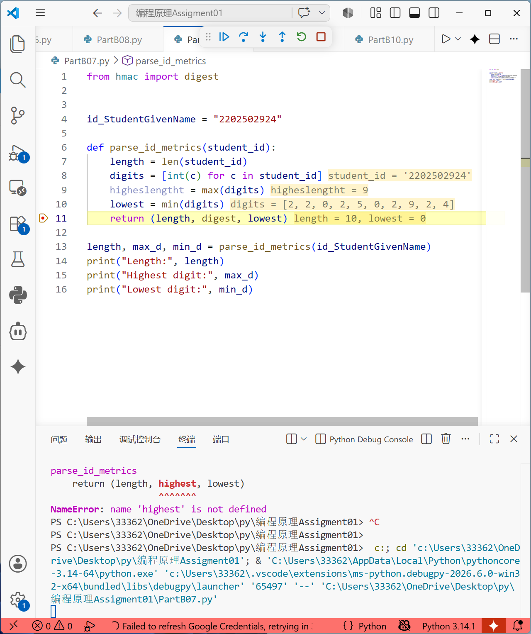

Question 8: Unqualified Namespace Module Imports (The Ceil/Floor Master)
- Write an import statement utilizing the from module convention to pull the ceil and floor functions from the built-in math module so they can be run unqualified.
- Calculate the exact mathematical square root of your complete student ID integer value.
- Pass your calculated floating-point square root through both the ceil() and floor() functions.
- Output both numbers, demonstrating how they bind fractional values to upper and lower integer boundaries.
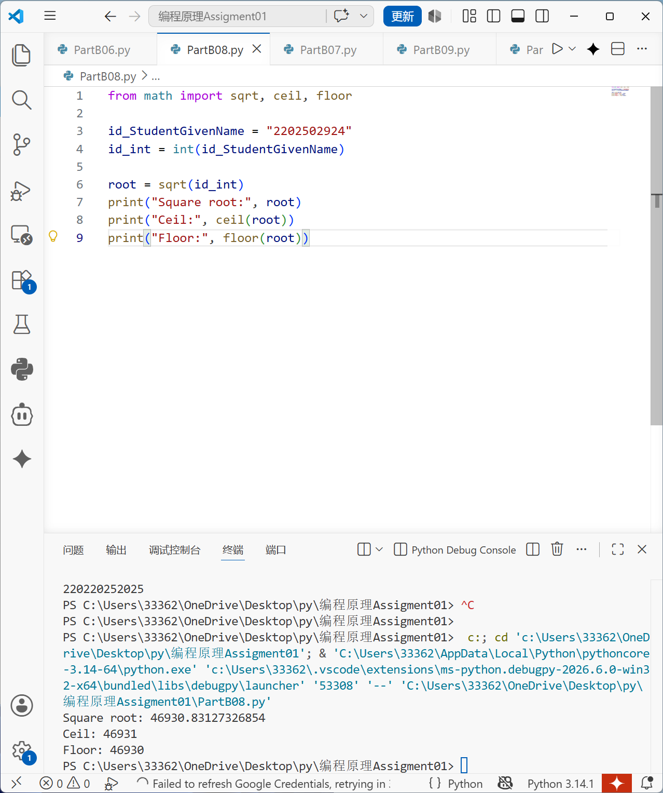

Question 9: Conditional Comprehension Filtering
Using your unique digits_list as the input sequence domain:
- Write a single-line sequence list comprehension that creates a brand-new processed collection.
- The comprehension must mathematically square ($x^2$) each digit element, but it must only include squares for numbers that are strictly greater than 2 within your ID list.
- Output your filtered results collection.
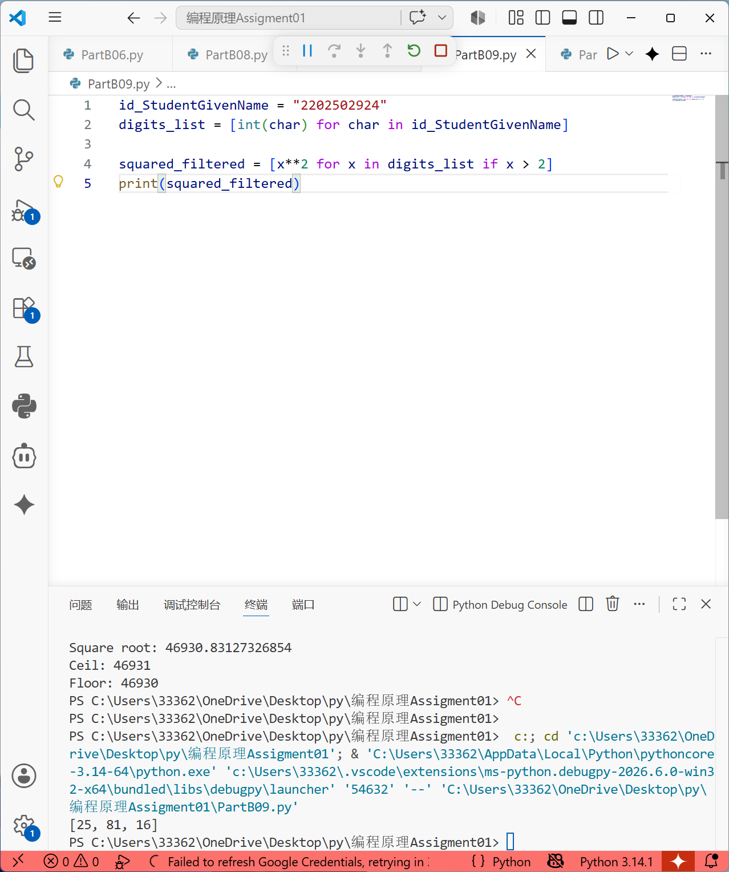

Question 10: Functional Scope and Parameter Isolation
Create a program demonstrating functional isolation and parameter bounds:
- Define a global reference tracking variable in your script: factor = 10.
- Write a pure function named scale_id_digits(target_list, multiplier). The function must loop through target_list and return a new list where each element is scaled by the multiplier.
- Constraint: You are strictly forbidden from reading or mentioning the global variable factor inside your function scope.
- Execute the function by explicitly passing your unique digits_list and a local factor value (e.g., local factor is 4) of your choice as explicit positional arguments. Print the results to show total scope isolation.
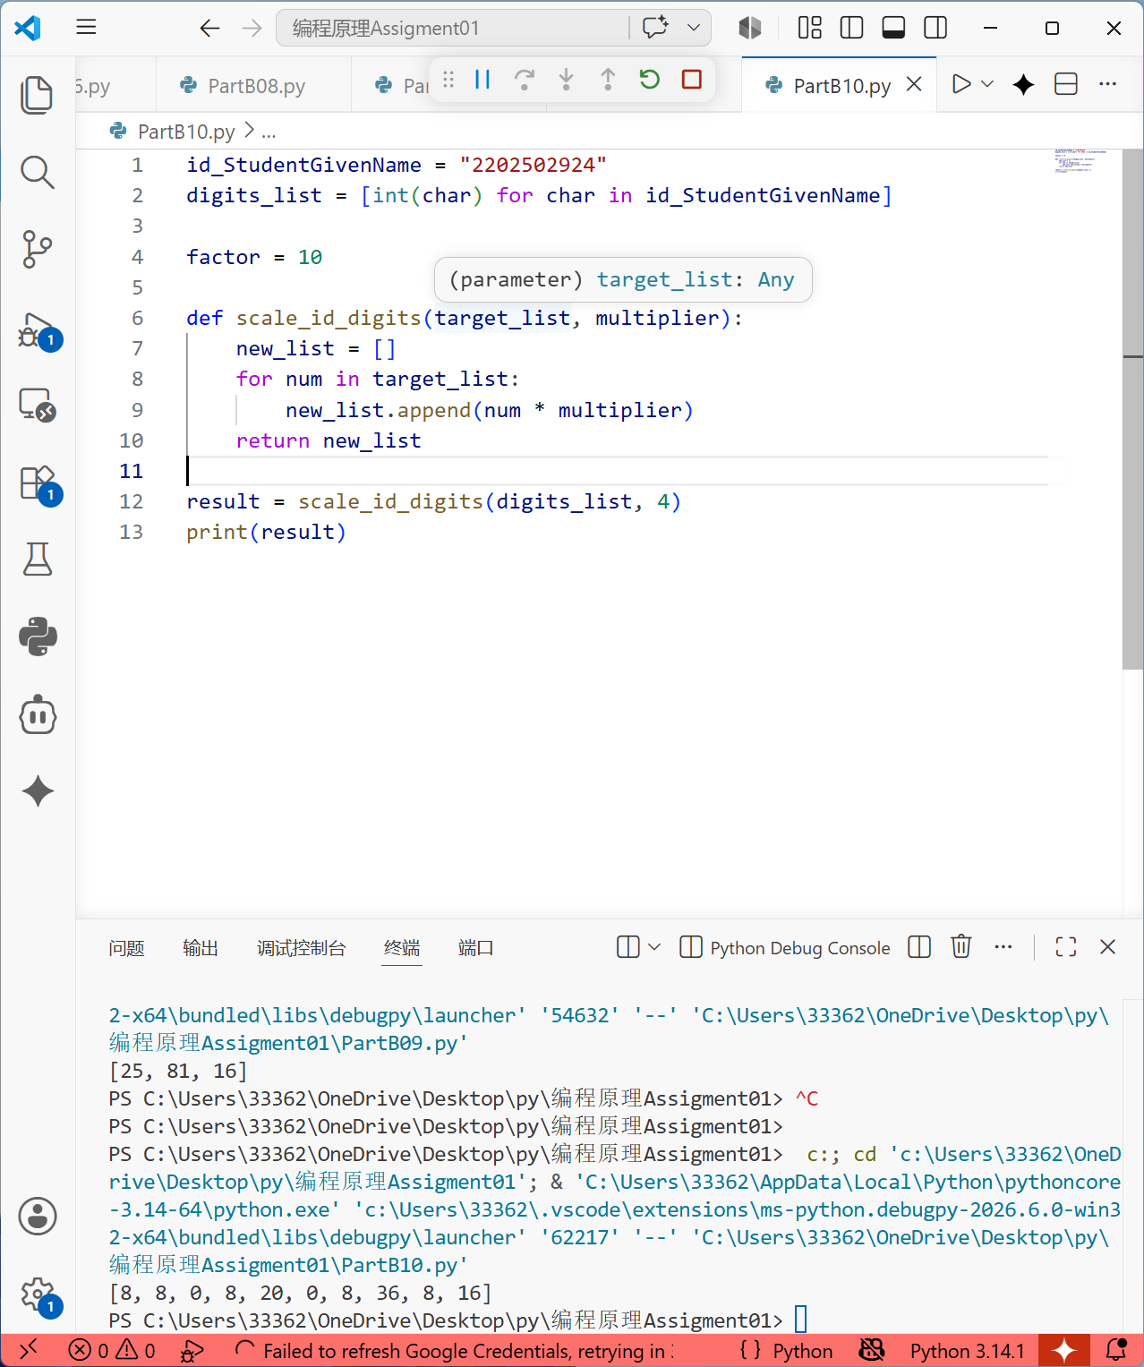
Concluding Remars结语：综上所述，我说提交的代码均由我本人思考，用gemini进行修改润色，通过代码实现上述assignment，并且通过test进行测验，发现了我自身的不足之处，以及暴露的problem，我会强加study和request，最终figure out !

