**Major Project**

**Date : 30-04-2023**

**Project Done by : Ghevaram Suthar**

**Project Title : eCommerce Website Using HTML, CSS, JavaScript.**

**Web-Page Name : 1© Store**

**Project given by : Interns Elite**

**Here are the details of my web page -**

1. **Login Popup:**

When we open the page and after loading of page is done a login pop-up will appear after 1second this is achieved by using JavaScript where timer of 1 second is given so that when the page is loaded there will be a pop-up of login so it feels dynamic to the user.

This pop-up contains an email text-box, password text-box and a remember me check-box.

It also contains a login button where user can login to the account further.

The image displaying beside the login pop-up has a dynamic animation when this pop-up appears the image in the background starts to zoom in and out this effect is achieved by CSS animation style.

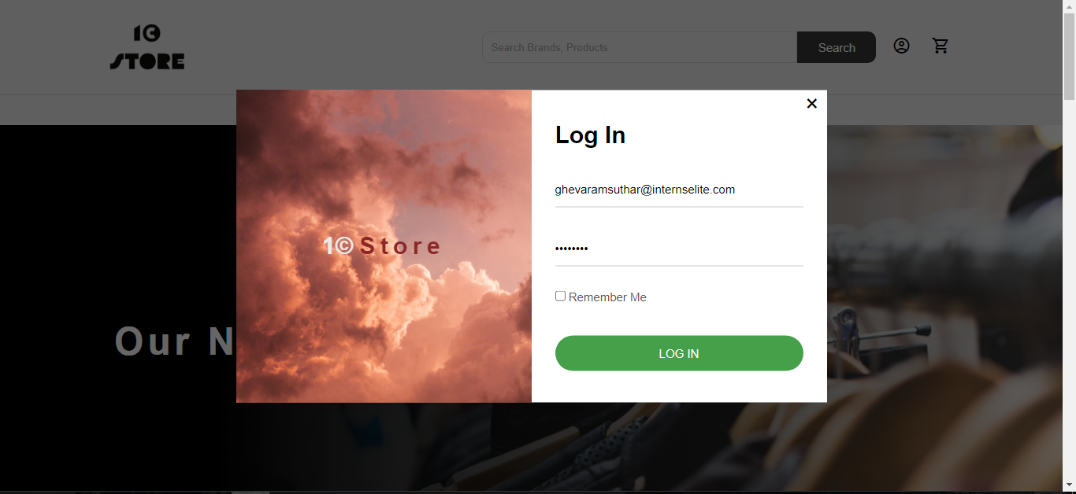

Picture – 1.1

1. **Home Page:**

This is the home page of my designed e-commerce site.

The top section to be considered as navigation bar. Navigation section is kept sticky for home page so that it always shows on top while scrolling.

It has a logo in left side which I designed in MS paint. It has a search box and search button.

In right side of the navigation bar, it has a user and cart icon and is clickable.

The navigation bar has options like Home, Products, Shopping cart, Checkout, About us, Contact us. These buttons have hovering effect when cursor is pointed.

The section below the navigation bar is the section for new designs showing that new designs are coming soon.

This section has background image and this image is given a linear gradient style to right so that the image has a black like effect in background of the text written.

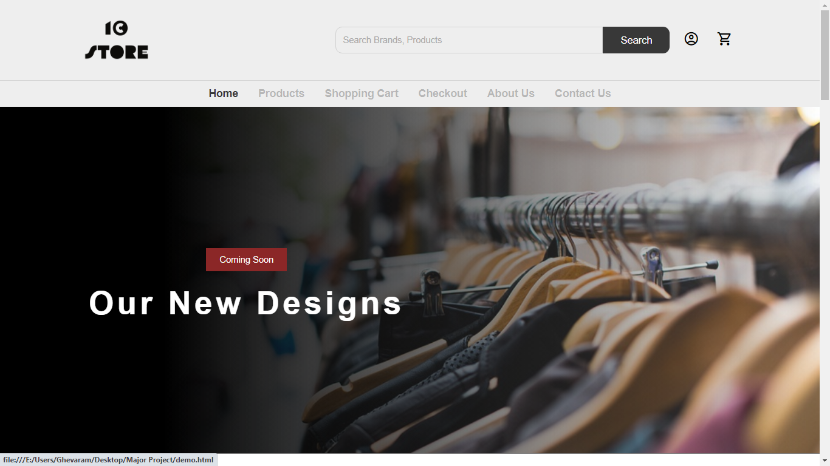

Picture – 2.1

1. **Products Page:**

This is our products page section, clicking on products button in navigation bar will take us to this page.

This page has all the products available at this site. It has various sections like new arrivals, premium hand tailored, etc. As shown in pictures below.

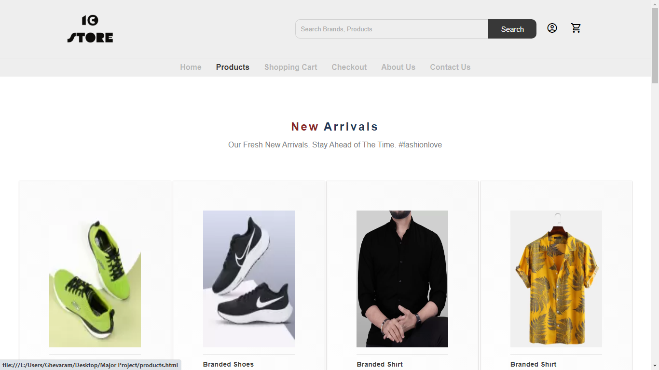

Picture – 3.1

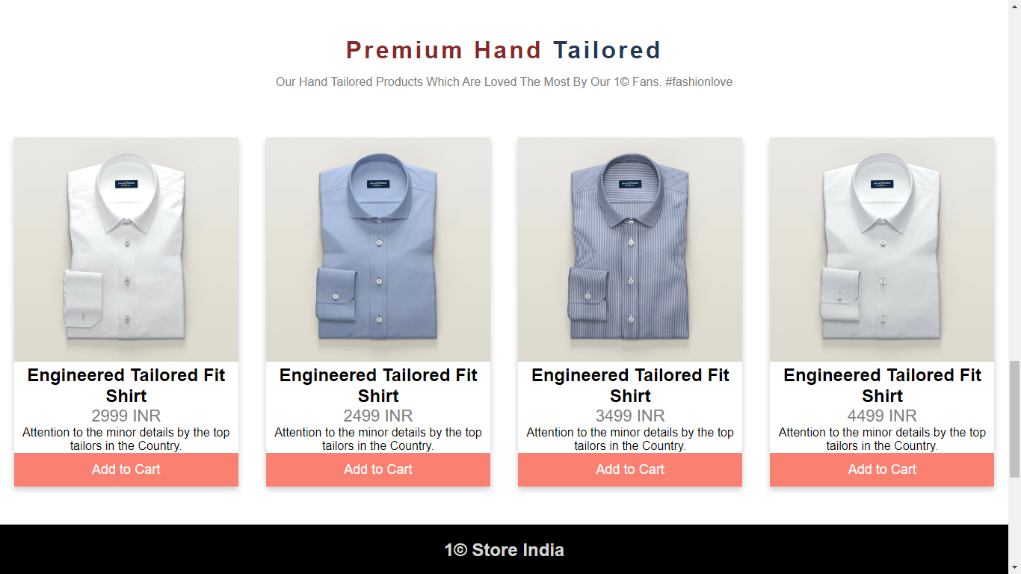

Picture – 3.2

1. **My Cart Page :**

This is cart page where user has added the products and this page displays the bill amount and products count.

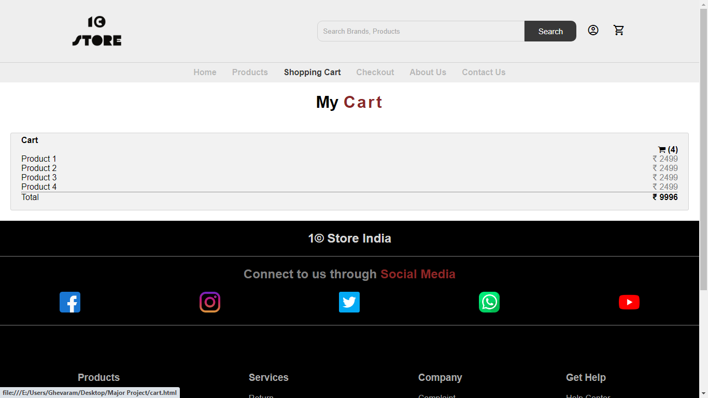

Picture – 4.1

1. **Checkout Page:**

This is checkout page where user has various options for checking out the products by paying bill using various options.

It has a side product cart where is shows the user their product details.

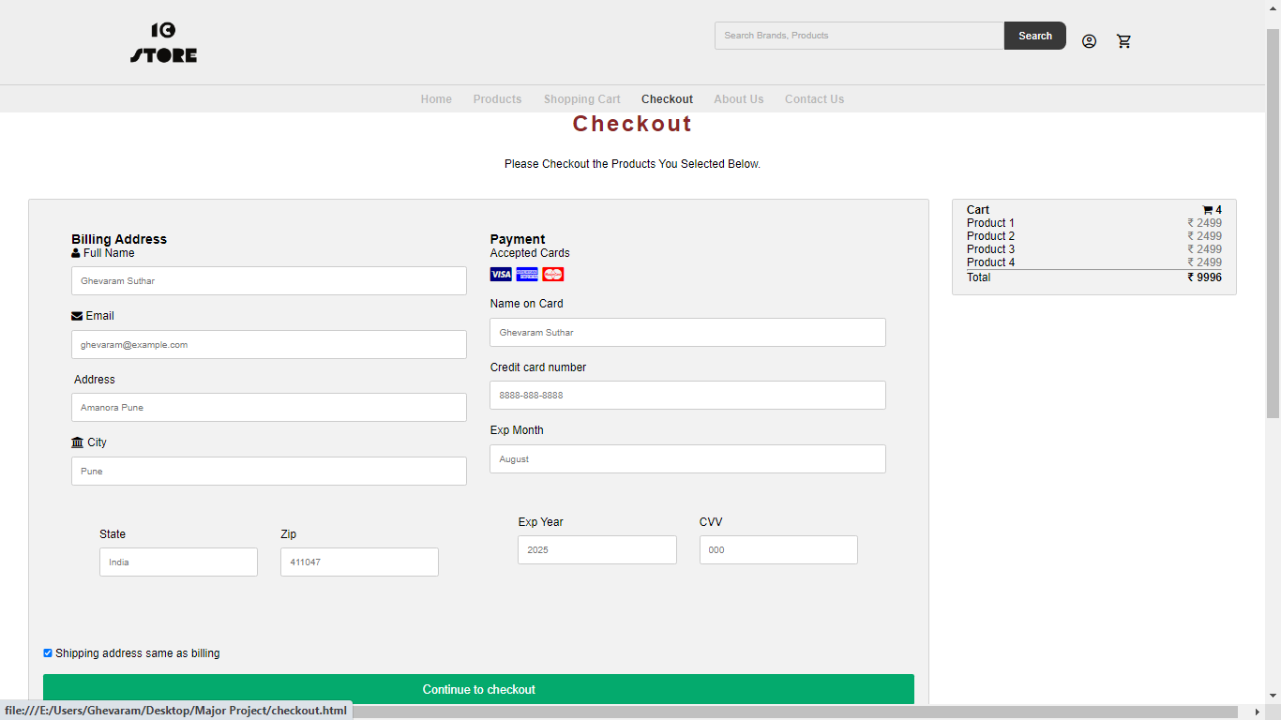

Picture – 5.1

1. **About Us Page:**

This is about us page where it displays the details of our site.

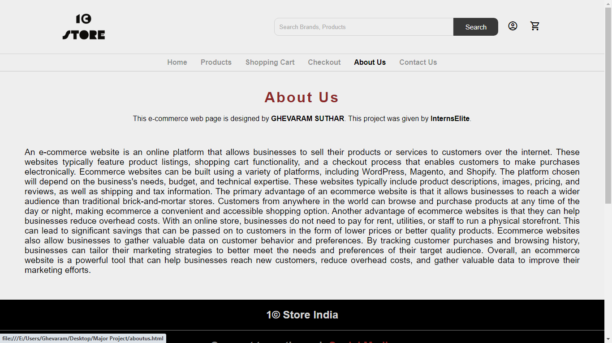

Picture – 6.1

1. **Contact Us Page:**

This is contact us page where a form displays user details like name, country, subject, etc.

Where a user can submit their queries or can submit feedback.

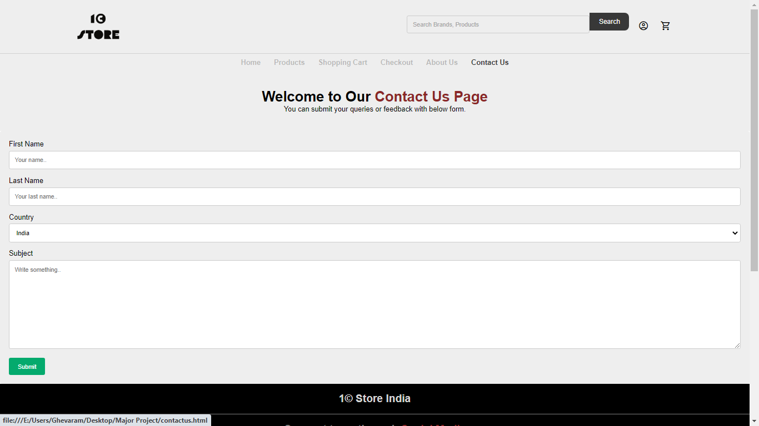

Picture – 7.1

1. **Account Login Page:**

The user icon located at right side of navigation bar displays this login page when clicked.

It has various options for logging in with Facebook, Twitter, Google, Yahoo or manually. As shown in picture - 8.1. If user is not registered or don’t have an account can register using signup button.

This signup button takes the user to the register new user page where user can register their new account by filling the details in below text box. As shown in picture – 8.2.

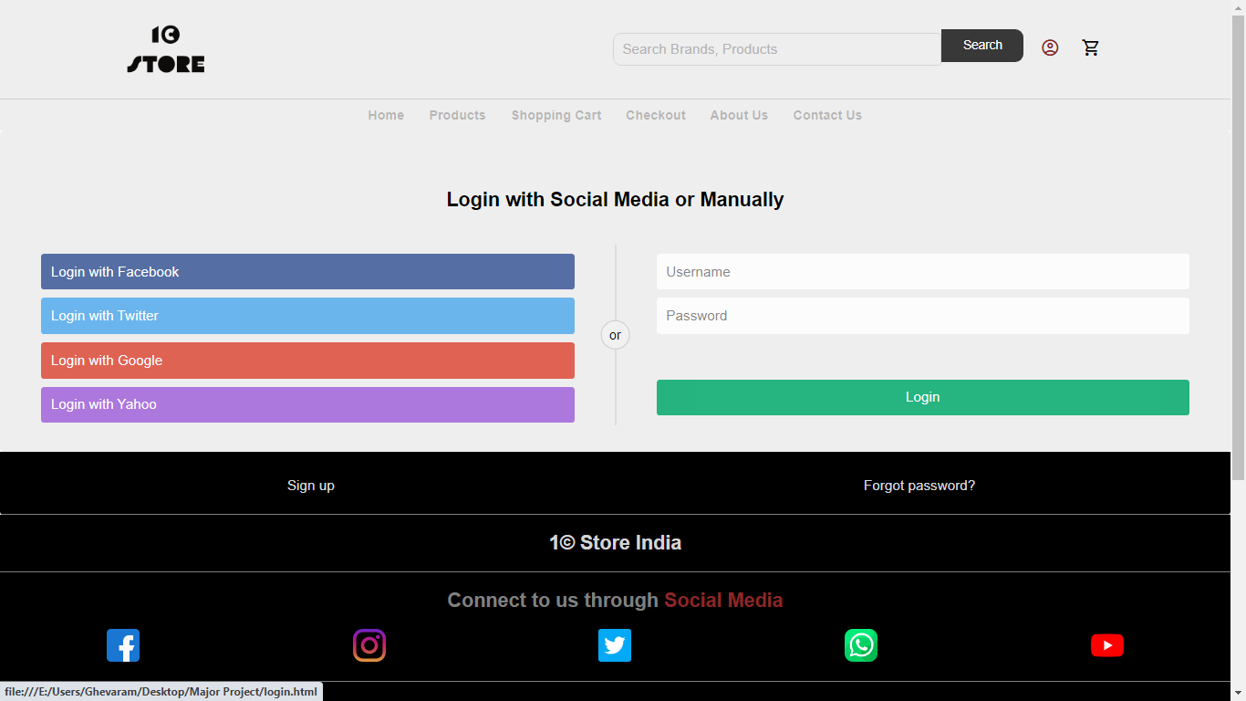

Picture – 8.1

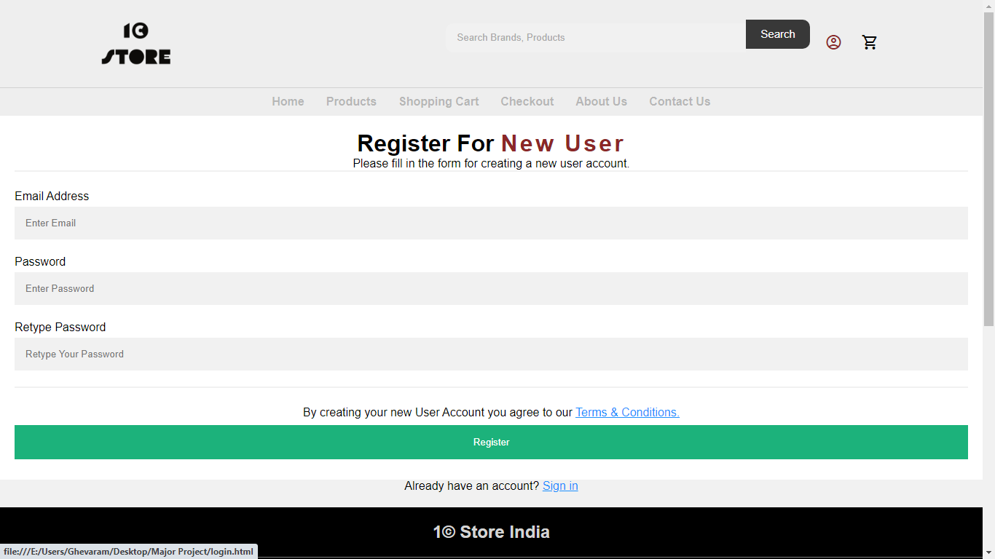

Picture – 8.2

1. **Footer :**

This is the end part of our web page.

This footer section has been divided into various parts.

First part has social media links where user can connect with us and these social media icon has hovering effect when we point cursor on them.

Second part of footer has various links related to products, services, company and get help these links change colour when cursor is pointed.

Last part of footer is the language picker which is on left side of the page and left side has a text that shows copyright text.

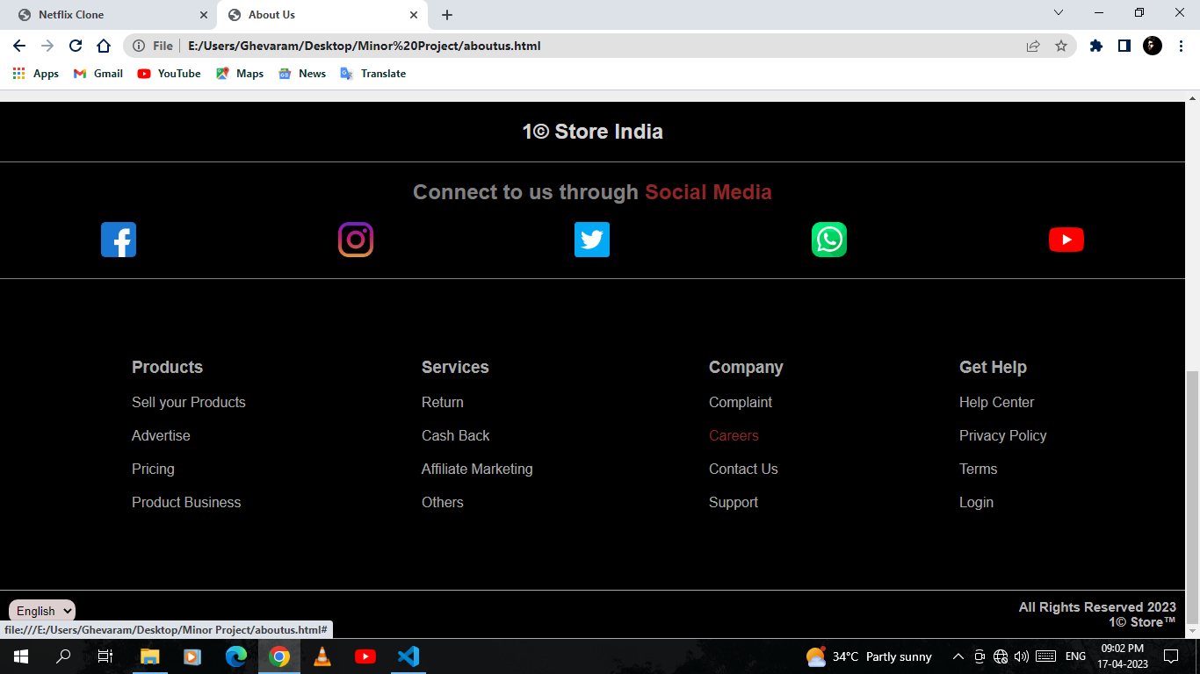

Picture – 9.1