Data Engineering Careers at Insurance Carriers: A Career Evaluation Product
  - AD688 Project Group 3 final report
Gabriel, Genevieve and Haben
2026-10-11
Table of contents

1. Product framing
Target user. Students and early-career analysts who want to move into data engineering.
Career pathway. Data Engineer and closely related roles (analytics engineer, data platform engineer, ETL engineer and data warehouse engineer).
Industry. Insurance carriers, NAICS 5241. These are the companies that sell and underwrite insurance policies.
The question the product answers. Which skills make someone the most qualified for a Data Engineer job at an insurance carrier, and which of them pay off?

Our project focuses on building a career evaluation tool for students targeting Data Engineer roles in the Insurance industry. Our final product aims to answer what skills make someone the most qualified for Data Engineer roles in this industry. This topic is important because data science, risk mitigation, and data analysis are all becoming increasingly important in the Insurance industry. Understanding what skills are desired will help applicants to stand out and break into the industry. We expect to learn about desired skills, salary and experience trends, and how to identify where applicants can upskill to focus their efforts on bettering their resumes for this target career in the Insurance industry.

1.1 Sources
- 365 Data Science
- Discover Data Science
- The Institutes: Associate in Insurance Data Analytics

2. Scope and data

2.1 Data Filtering
To start, we filtered our data to the NAICS code 5241 for the Insurance industry.

2.2 Core Fields
We added a role match field that has a value of 1 when any of the following phases appear in role titles in order to encompass all Data Engineer roles: - Data Engineer - Analytics Engineer - ETL - Data Pipeline - Data Platform - Big Data - Ml Engineer - Machine Learning Engineer - Data Architect - Database - Data Scientist - Data Science - Data Analyst - Business Intelligence - BI - Data Governance - Data Management
We included the following as core identifiers and for metadata - ID - POSTED - EXPIRED - DURATION - URL
We included three versions of titles - TITLE_RAW - TITLE_NAME - TITLE_CLEAN,
We included the following employer information - COMPANY_NAME - COMPANY_IS_STAFFING - EMPLOYMENT_TYPE_NAME - NAICS_2022_4 - SOC_2021_4_NAME - ONET_NAME
And the following position details and requirements - MIN_YEARS_EXPERIENCE - MAX_YEARS_EXPERIENCE - IS_INTERNSHIP - MIN_EDULEVELS_NAME - MAX_EDULEVELS_NAME - SALARY - SALARY_FROM - SALARY_TO - ORIGINAL_PAY_PERIOD - REMOTE_TYPE_NAME - LOCATION - CITY_NAME - STATE_NAME - MSA_NAME - SKILLS_NAME - SPECIALIZED_SKILLS_NAME - COMMON_SKILLS_NAME - SOFTWARE_SKILLS_NAME - CERTIFICATIONS_NAME

2.3 Handling of Erroneous data
We deleted any duplicates based on the ID field.
Missing salary and experience information was left as missing as opposed to fully deleting these records and instead of attempting to impute values.
Skill fields are converted from stored list strings into individual skills so that the most frequently requested skills can be identified across the data-related postings

3. Market baseline

This market baseline examines Data Engineer-related job postings within the Insurance Carrier industry (NAICS 5241). The analysis focuses on job volume, salary, location, experience requirements, work arrangement, hiring patterns, and specialized skills.
It uses the 2024 Insurance Carrier dataset from Step 3 (1,908 postings in total). To match the Skill Gap Analysis page, the dataset was filtered to Data Engineer-related roles: Data Engineering, Analytics Engineer, Data Platform Engineer, ETL Engineer, and Data Warehouse Engineer titles. Every number on this page is calculated from that filtered data.
The team identified 29 Data Engineer-related postings from the 2024 Insurance Carrier dataset after applying the project role filter, out of 1,908 postings in total.

3.1 Job Volume by Title
The filtered dataset contains 29 postings spread across 10 distinct title variations. The most common title is “data analytics engineer” with 8 postings. Titles are variations of Data Engineer, Analytics Engineer, and Data Engineering Analyst roles.

3.2 Salary Distribution
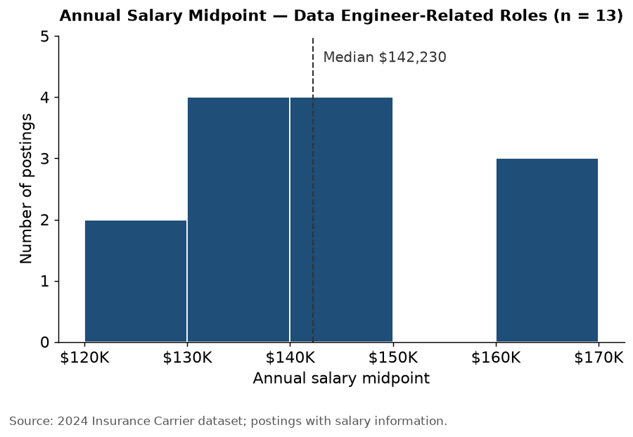
Salary information was available for 13 of the 29 postings. The median annual salary midpoint was approximately $142,230, and the average was approximately $140,990. The salary midpoint ranged from approximately $127,000 to $161,625.
Only 6 distinct salary values appear among those 13 postings, so several postings repeat the same salary range. Because salary information was missing for 16 postings and the remaining sample is small, these results should be interpreted cautiously.

3.3 Location Patterns
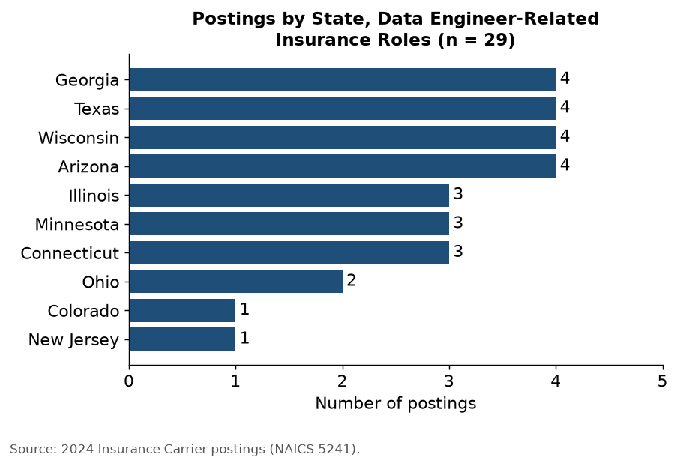
Valid state information was available for 29 of the 29 postings, covering 10 states. Texas, Georgia, Wisconsin, and Arizona each had the most postings, with 4 each, together accounting for about 55% of the filtered postings. At the metropolitan-area level, the largest concentrations (4 postings each) were in Dallas-Fort Worth-Arlington, TX, Atlanta-Sandy Springs-Alpharetta, GA, Milwaukee-Waukesha, WI, and Phoenix-Mesa-Chandler, AZ. The state is the location listed on the posting, which may not be where remote work is actually done.
The state ranking largely reflects office footprint rather than hiring demand by state. State Farm supplies 15 of the postings and lists the same roles at its offices in Arizona, Georgia, Illinois, and Texas, so those states rank high mostly because of one employer. In total, the 29 postings are only 13 distinct jobs (see Limitations).
One Travelers posting is listed in Hartford, Wisconsin. The same title, salary, and 8-year experience requirement also appear in a Travelers posting for Hartford, Connecticut, which suggests the Wisconsin label is a location error in the source data. The posting is counted as listed, so Wisconsin’s count of 4 includes it; it was not reassigned.

3.4 Experience Requirements
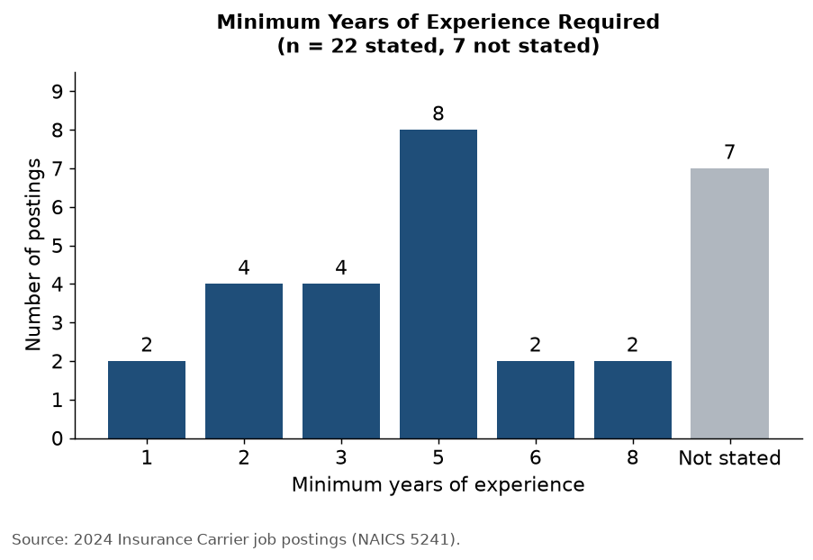
A minimum experience requirement was stated for 22 of the 29 postings. The typical (median) requirement was 5 years of experience, and requirements ranged from 1 to 8 years. About 55% of the postings that state a requirement (12 of 22) ask for 5 or more years, so these roles lean toward experienced hires. The 7 postings with no stated requirement were kept as missing rather than estimated.

3.5 Remote vs. On-Site Work
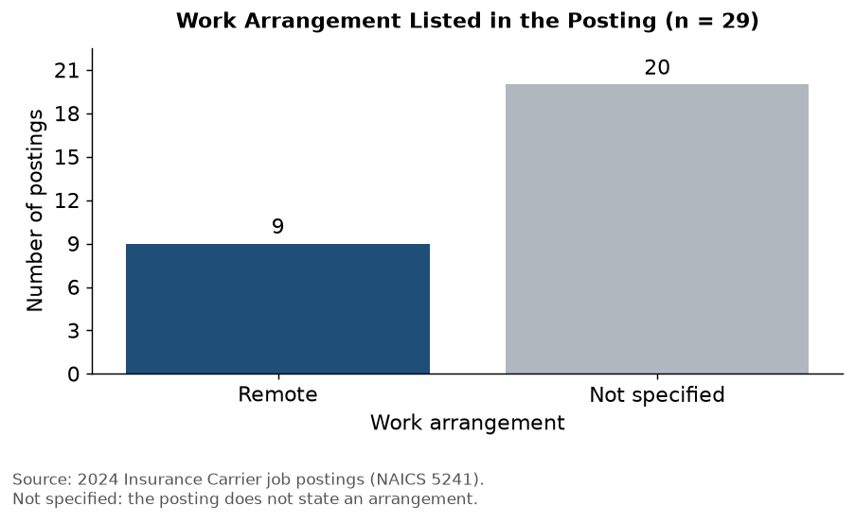
The filtered postings included:
- 9 remote (about 31%)
- 20 with no work arrangement stated
- No postings labeled hybrid or on-site in the work-arrangement field
Remote was the only work arrangement stated for these postings. The remaining postings do not state an arrangement, so they cannot be counted as on-site. 2 of those postings include the word “hybrid” in their job title, which suggests the field understates hybrid work; those postings were not reclassified.

3.6 Top Employers
Employer | Postings | Postings (%)
State Farm | 15 | 51.7%
UnitedHealth Group | 3 | 10.3%
Northwestern Mutual | 3 | 10.3%
Nationwide | 2 | 6.9%
Optum | 2 | 6.9%
Travelers | 2 | 6.9%
Selective Insurance | 2 | 6.9%
The 29 postings come from only 7 employers. State Farm alone accounts for 15 of them (about 52%), so the sample reflects a small group of large insurers rather than the whole industry.

3.7 Top Specialized Skills
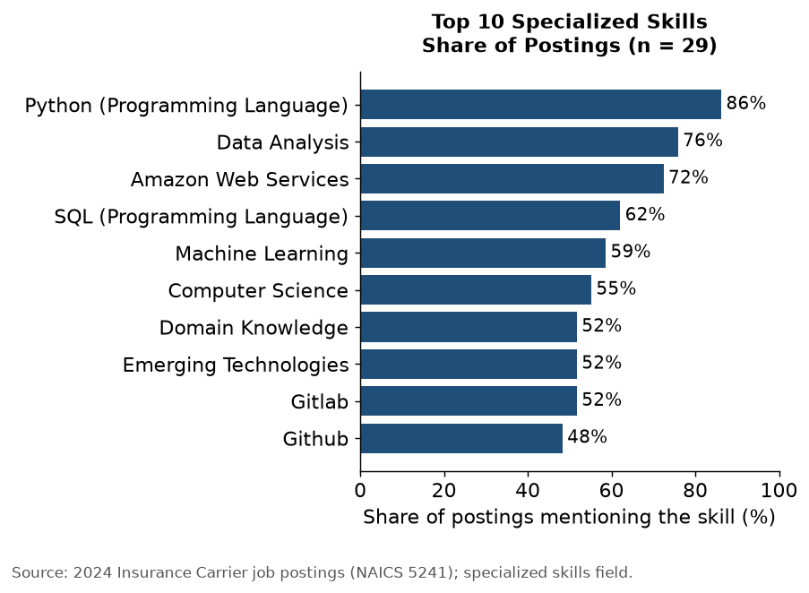
Skills information was more complete than salary, experience, and work-arrangement information. “Data Engineering” is left out of the chart because it appears in all 29 postings.
The share for SQL here (18 of 29, 62%) counts only postings tagged with the exact skill “SQL (Programming Language)”. The Skill Gap Analysis page searches all skill columns for any mention of SQL, which also catches Microsoft SQL Servers, and so reports a higher share (22 of 29, 76%). Both figures are correct for the method each page uses.
The strongest specialized-skill signals were:
- Python (Programming Language) - 86.2%
- Data Analysis - 75.9%
- Amazon Web Services - 72.4%
- SQL (Programming Language) - 62.1%
- Machine Learning - 58.6%

3.8 Key Findings and Limitations
The 2024 Insurance sample contained 29 Data Engineer-related postings. Their median annual salary midpoint was approximately $142,230, the most postings were in Texas, Georgia, Wisconsin, and Arizona, the typical minimum experience requirement was 5 years, and 31% of postings stated that the role is remote.
Limitations:
- Small salary sample. Salary was listed for only 13 of 29 postings, with 6 distinct salary values, so the salary figures are not representative of the entire Insurance Carrier data-job market.
- Duplicate listings. The 29 postings are only 13 distinct jobs, because employers such as State Farm post the same job at several offices. A distinct job here means the same employer, the same title, and the same salary (a missing salary counts as one value). Among the 13 distinct jobs, 8 list a salary, and their median annual salary midpoint is approximately $136,415, compared with $142,230 across all postings. The charts above count every posting.
- Few employers. The 29 postings come from 7 employers, and State Farm supplies about 52% of them.
- Missing experience and work-arrangement information. Minimum experience was missing for 7 postings and no work arrangement was stated for 20; neither was estimated.
- Location is the posting location. Remote roles may be done from anywhere, so state counts show where the posting is listed, not where work must be done.
Skills information was more complete than salary and work-arrangement information. Python (Programming Language), Data Analysis, Amazon Web Services, and SQL (Programming Language) were among the most frequently identified specialized skills in the filtered postings. These findings provide a useful starting point for the project’s Skill Gap Analysis, although the small, employer-concentrated sample limits broader generalization.

4. Skill-gap analysis
This analysis evaluates how well the team’s current skills align with the skills most frequently requested for Data Engineer-related roles in the Insurance industry.
The analysis began with 1,908 Insurance industry job postings. To focus on our target career, the dataset was filtered to Data Engineer and closely related positions, including Data Engineering, Analytics Engineer, Data Platform Engineer, ETL Engineer, and Data Warehouse Engineer roles. This resulted in 29 Data Engineer-related job postings used for the market skill analysis.
The analysis focused on the following Data Engineering skills:
Python, SQL, ETL/Pipelines, Cloud Computing, Spark/PySpark, Databricks, Data Modeling, Databases/Snowflake, Git/CI-CD, and Data Quality/Governance.

4.0.1 Scoring Method
Each team member rated their current proficiency using a 1–5 scale:
- 1 = Beginner
- 2 = Basic Knowledge
- 3 = Intermediate
- 4 = Advanced
- 5 = Expert
The individual ratings were averaged to calculate the Team Average for each skill.
Market demand was calculated by measuring the percentage of the 29 relevant job postings that mentioned each skill. The percentages were then converted to a 1–5 market-demand scale:
- 1 = Less than 20% of postings
- 2 = 20%–39.9%
- 3 = 40%–59.9%
- 4 = 60%–79.9%
- 5 = 80%–100%
The Market Score measures how frequently employers request a skill; it does not represent the proficiency level employers expect.
The skill gap was calculated as:
Skill Gap = Market Score − Team Average
If the Team Average was greater than the Market Score, the gap was recorded as zero.
Development priority was classified as:
- High Priority: Skill Gap ≥ 2
- Moderate Priority: Skill Gap ≥ 1 and < 2
- Low Priority: Skill Gap < 1
A larger gap therefore represents a skill that appears frequently in the analyzed job postings but where the team’s current proficiency is comparatively lower.

4.1 Team Skill Levels
Each team member assessed their proficiency in Data Engineering-related skills using a 1–5 scale, ranging from Beginner to Expert. These ratings provide the foundation for calculating the team’s average proficiency and identifying development priorities.
Name | Python | SQL | ETL / Pipelines | Cloud | Spark | Databricks | Data Modeling | DB / Snowflake | Git / CI-CD | Data Quality | Insurance
Haben Gebre | 2 | 3 | 2 | 2 | 1 | 1 | 2 | 1 | 2 | 3 | 1
Genevieve Heydt | 1 | 4 | 3 | 1 | 1 | 1 | 3 | 2 | 2 | 3 | 4
Gabriel Gonzalez Brito | 1 | 3 | 2 | 1 | 1 | 1 | 3 | 3 | 2 | 3 | 1

4.2 Team Skills vs. Market Demand
The chart compares the team’s average proficiency with market demand converted to a 1–5 scale. Market demand reflects how frequently each skill appears in the Data Engineer-related job postings, not the level of proficiency required by employers.

4.3 Skill Gap Summary
The table below shows the exact Team Average, Market Demand, Market Score, Skill Gap, and Development Priority for each skill.
Skill | Team Average | Market Demand | Market Score | Skill Gap | Priority
Python | 1.33 | 86% | 5 | 3.67 | High
Cloud | 1.33 | 93% | 5 | 3.67 | High
Git / CI-CD | 2.00 | 93% | 5 | 3.00 | High
Spark / PySpark | 1.00 | 62% | 4 | 3.00 | High
ETL / Pipelines | 2.33 | 62% | 4 | 1.67 | Moderate
SQL | 3.33 | 76% | 4 | 0.67 | Low
Data Quality | 3.00 | 41% | 3 | 0.00 | Low
Data Modeling | 2.67 | 34% | 2 | 0.00 | Low
DB / Snowflake | 2.00 | 34% | 2 | 0.00 | Low
Databricks | 1.00 | 17% | 1 | 0.00 | Low

4.4 Key Findings
The Skill Gap Analysis identified several important areas for technical skill development among the team. Cloud Computing and Python showed the largest measured skill gaps (3.67 each), followed by Git/CI-CD and Spark/PySpark (3.00 each). These skills appeared frequently in the analyzed job postings, while the team’s current proficiency ratings were relatively low, making them the highest priorities for further development.
ETL/Pipelines showed a moderate skill gap of 1.67, with market demand of 62% and a team average proficiency of 2.33. In comparison, SQL was one of the team’s stronger technical skills, with a team average of 3.33 and a relatively small measured gap of 0.67. Data Quality, Data Modeling, DB/Snowflake, and Databricks showed no measured gaps under the current scoring method. However, a zero gap does not necessarily indicate that the team has mastered these skills or meets every employer’s expectations.
Insurance Knowledge was included in the team’s self-assessment but excluded from the quantitative skill-gap comparison because the structured job-posting data did not provide a directly comparable measure of industry-specific knowledge.
The analysis was based on 29 Data Engineer-related job postings in the Insurance Carrier industry (NAICS 5241), published between May and September 2024. Market demand was converted into a 1–5 score based on how frequently each skill appeared in the postings, rather than the proficiency level required by employers. Therefore, the calculated skill gaps should be interpreted as indicators of development priorities rather than direct measurements of employer-required proficiency. These findings reflect the analyzed sample and should not be generalized to the entire insurance industry.

5. Final analytics
This page answers the project question with a model. Which skills and job features go with higher pay for data jobs at insurance carriers (NAICS 5241)? A job seeker can use the answer to decide which skill to learn next and to judge whether an advertised salary is fair for what the posting asks.
We used Option A (Regression). It is a linear model that predicts a posting’s advertised annual salary from the skills it asks for, the experience it requires, the seniority of the title and the work arrangement.

5.1 The data behind the model
Step | Postings
All insurance carrier data postings in the 2024 dataset | 1,908
Postings that state a salary | 1,204
After removing internships | 1,196
Distinct jobs used in the model (repeat listings removed) | 395
The model uses the full 1,908-post insurance file and not only the 29 Data Engineer postings because 29 jobs with only 13 listing pay is too few to fit a trustworthy model. All of these jobs are in the same data occupation family (government occupation group Data Scientists which includes analysts, engineers and architects) so what drives pay here is a fair guide for a Data Engineer job seeker in the same industry.
Many employers post the same job in dozens of cities with the same title and pay. We kept one copy of each employer, title and salary combination. Without this step the model would mostly learn from a handful of heavily reposted jobs and copies of the same job would show up on both sides of the accuracy test, which makes the model look better than it is.

5.2 What the model uses
Variable | What it captures
Advertised salary (what we predict) | Annual salary from the posting. The model works on its logarithm, so each result reads as a percentage difference in pay.
10 skill flags | Whether the posting asks for each of the ten Data Engineering skills from our Skill Gap Analysis, using the same matching rules.
Years of experience | Minimum years the posting requires (capped at 15). Missing values were filled with the median and flagged.
Senior title / junior title | Title words such as senior, lead, principal, manager or architect, versus junior, associate, entry or assistant.
Fully remote / hybrid | Work arrangement, compared with on-site or not stated.
Degree required | The posting asks for a bachelor’s degree or higher.
Core data role | The posting’s title matched the core data-role list from Step 3.
Each result compares two otherwise similar postings. For example a posting that asks for cloud skills is compared with one that has the same experience, seniority and other skills but does not ask for cloud.

5.3 How we checked it
We tested the model on jobs it had not seen. We split the 395 jobs into five groups and trained on four and predicted the fifth, then rotated through all five and repeated the whole test ten times with different shuffles. The table compares the model with the simplest possible guess which is predicting the middle (median) salary for every job.
Measure | Salary model | Median guess
Typical error, MAE (average dollars off) | $21,011 | $27,740
RMSE (penalizes big misses more) | $27,203 | $35,511
R² (share of pay differences explained) | 0.37 | 0.00
On jobs it had not seen the model’s typical miss is about $21,011 which is 24% smaller than guessing the median. It explains about 37% of the differences in pay between jobs. That makes it a useful guide to what matters but not an exact salary calculator. The rest of the variation comes from things a posting does not show like the employer’s pay bands, the city and the negotiation.
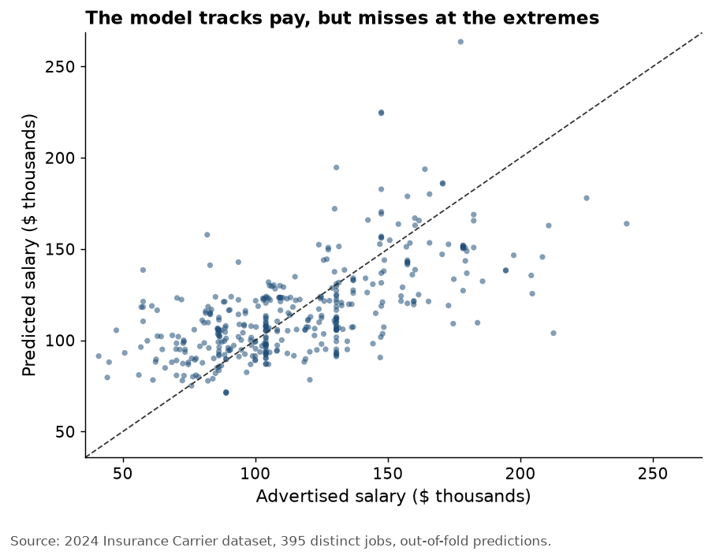
Figure 1: Predicted versus advertised salary for jobs the model had not seen. Points on the diagonal line are perfect predictions.
The model pulls predictions toward the middle. It clearly underestimates the best-paid jobs and overestimates the lowest-paid ones so for a job seeker it is more reliable for typical mid-career postings than for the extremes.

5.4 What goes with higher pay
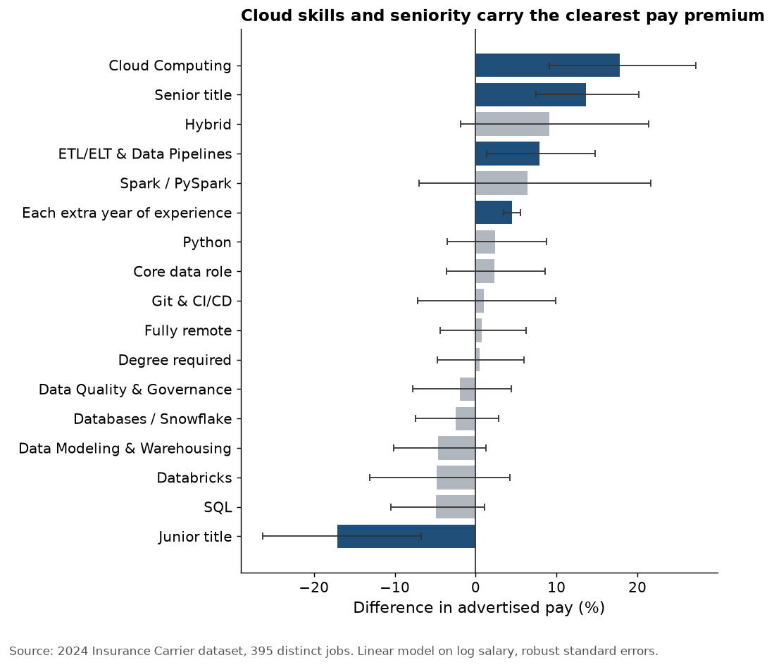
Figure 2: Estimated pay difference for each feature, holding the others equal. Lines show the 95% confidence range and dark blue bars are features whose range does not cross zero.
Feature | Pay difference | 95% range | Clear signal
Cloud Computing | +17.8% | +9.1% to +27.3% | Yes
Senior title | +13.7% | +7.5% to +20.2% | Yes
Hybrid | +9.1% | -1.9% to +21.4% | No
ETL/ELT & Data Pipelines | +7.9% | +1.4% to +14.8% | Yes
Spark / PySpark | +6.4% | -7.0% to +21.6% | No
Years of experience | +4.5% | +3.4% to +5.5% | Yes
Python | +2.4% | -3.5% to +8.8% | No
Core data role | +2.3% | -3.6% to +8.6% | No
Git & CI/CD | +1.0% | -7.2% to +9.9% | No
Fully remote | +0.8% | -4.4% to +6.3% | No
Degree required | +0.4% | -4.8% to +5.9% | No
Data Quality & Governance | -1.9% | -7.8% to +4.4% | No
Databases / Snowflake | -2.5% | -7.5% to +2.8% | No
Data Modeling & Warehousing | -4.6% | -10.1% to +1.2% | No
Databricks | -4.8% | -13.1% to +4.2% | No
SQL | -4.9% | -10.5% to +1.1% | No
Junior title | -17.1% | -26.4% to -6.7% | Yes
What this means for a job seeker
- Cloud computing is the skill with the clearest pay premium. Postings that ask for AWS, Azure or Google Cloud advertise about 18% more than similar postings that do not. Cloud is also one of our team’s two largest skill gaps (team average 1.3 out of 5) so it is the best first skill to invest in.
- Data pipeline skills (ETL/ELT) add about 8%. This is the everyday work of a Data Engineer. The effect is smaller and less certain than cloud (its range starts just above zero) but it points the same way.
- Experience and seniority matter most overall. Each extra year of required experience goes with about 4% more pay. A senior title goes with about 14% more and a junior title with about 17% less. Entry-level offers will sit well below the market median and pay grows quickly in the first years.
- SQL and Python are the entry ticket, not a pay premium. Once the other features are accounted for neither one moves pay by a clear amount. SQL appears in about 52% of these jobs and Python in about 25% including lower-paid analyst roles so they get you hired more than they get you paid more. They are still required.
- Remote work does not cost pay. Fully remote postings advertise about the same as on-site ones (+0.8%) so a job seeker can target remote roles without expecting a pay cut.
- Spark, Databricks, Git and the other skills show no clear effect. Few postings in this sample ask for them (Spark appears in about 3% of jobs) so the model cannot tell their effect apart from zero. That is a gap in the evidence and not proof that they do not matter.

5.5 What-if: pay for a job seeker profile
The model can price a specific kind of posting. Each row below is a Data Engineer type posting (core data role, bachelor’s degree, fully remote and no senior or junior title unless the row says so) that asks for SQL and Python. We then add skills and experience one step at a time.
Posting asks for SQL and Python, plus… | Predicted advertised salary
Entry level: junior title, 1 year | $74,866
2 years of experience | $94,350
2 years, plus cloud | $111,160
2 years, plus cloud and pipelines | $119,902
5 years, plus cloud and pipelines | $136,711
Senior title, 7 years, cloud and pipelines | $169,592
For a graduate with about two years of relevant experience adding cloud and pipeline skills moves the predicted advertised salary from about $94,350 to about $119,902. That is roughly $25,552 more a year. These are estimates of what employers advertise with a typical error of about $21,011 and not guaranteed offers.

5.6 Limitations of the model
- It shows association, not cause. Postings that ask for cloud skills may also be at better-paying teams. Learning cloud makes a candidate eligible for those postings and does not raise pay on its own.
- A few employers dominate. UnitedHealth Group (with its Optum unit) and Humana posted the largest share of the jobs so their pay practices shape the results.
- Advertised pay is not offered pay. Only postings that state a salary are included and the figure is usually the midpoint of the advertised range.
- It is less accurate for employers it has never seen. When whole employers are left out of training the typical miss grows to about $23,000.
- Rare skills cannot be measured well. Spark, Databricks and Git appear in too few postings for the model to estimate their effect.
- It covers 2024 insurance carriers only. Results may not carry over to other industries or later years.

5.7 Career evaluation overview
This project focuses on Data Engineering and related career opportunities in the Insurance Carrier industry (NAICS 5241). The goal is to evaluate the career’s opportunities, challenges, and accessibility for entry-level applicants. The evaluation is based on a combination of job market data, skill gap analysis, and industry trends.
Data Engineers design, develop, and maintain the systems and infrastructure needed to collect, store, process, and transform large volumes of data. Their work ensures that organizations have reliable and accessible data for analysis, reporting, and decision-making. As organizations increasingly rely on data-driven operations, Data Engineering has become an important technical career pathway (Snowflake; Magnet (2026)).
According to 365 Data Science (2026), citing StartUs, the Data Engineering sector employs more than 150,000 professionals, with over 20,000 new jobs created in the preceding year (Magnet (2026)). These figures highlight broader Data Engineering career opportunities but are not specific to the Insurance Carrier industry (NAICS 5241).
The insurance industry depends heavily on data to assess risk, develop pricing models, detect fraud, and improve business decisions. Advances in big data analytics and telematics have expanded the information insurers can use to understand customer behavior and evaluate potential risks. As a result, Data Engineering plays an important role in supporting modern insurance operations (365 Data Science; Discover Data Science).
This career evaluation examines salary potential, employment opportunities, experience requirements, and technical skill readiness to assess whether Data Engineering is an attractive and attainable career path for entry-level applicants.

5.8 Career Evaluation Scorecard
The following scorecard provides an overview of Data Engineering career opportunities and entry-level readiness in the Insurance Carrier industry (NAICS 5241).
It highlights six important career factors: salary potential, job availability, work flexibility, experience requirements, technical skill gaps, and existing technical strengths.
Together, these findings help job seekers understand the potential benefits of pursuing Data Engineering and the challenges they may face when entering the profession.
Category | Career Factor | Evidence | Evaluation
Career Opportunity | Salary Potential | $142,230 median midpoint | Attractive advertised pay
 | Job Availability | 13 estimated distinct jobs; 7 employers | Limited observed opportunities
 | Work Flexibility | 9 remote; 20 unspecified | Uncertain flexibility
Career Readiness | Experience Requirements | 5-year median minimum | Challenging for beginners
 | Technical Skill Gaps | Python (3.67), Cloud (3.67), Git / CI-CD (3.00), Spark / PySpark (3.00) | Technical development needed
 | Existing Technical Strength | SQL team average: 3.33/5 | SQL foundation

5.9 Career Opportunities
Data Engineering in the Insurance Carrier industry (NAICS 5241) offers promising earning potential, although job availability and work flexibility present some limitations. The median advertised annual salary midpoint was approximately $142,230, suggesting attractive compensation for qualified professionals. However, this figure should not be considered representative of entry-level salaries. The 29 relevant job postings represented approximately 13 estimated distinct positions across seven employers, indicating that opportunities in the analyzed market were concentrated among a relatively small number of employers.
Work flexibility also remains uncertain. Nine postings explicitly mentioned remote work, while the remaining 20 did not specify a work arrangement. Although remote opportunities exist, the findings do not establish how widely flexible working arrangements are available. Overall, Data Engineering presents attractive earning potential, but applicants should consider the limited observed openings and explore opportunities across different employers and related data roles.

5.10 Career Readiness
While Data Engineering offers promising career opportunities, entering the field can be challenging for students and entry-level job seekers. The median minimum experience requirement was five years among the 22 postings that specified experience, indicating that employers often seek candidates with previous professional experience. These requirements create barriers for beginners and suggest that gaining practical experience through internships, projects, or related entry-level positions may improve career readiness.
Technical skills are another important factor in career preparation. The team’s Skill Gap Analysis identified the largest gaps in Python, Cloud Computing, Git / CI-CD, and Spark / PySpark, highlighting areas that require further development. However, SQL emerged as a relative strength, with an average team proficiency of 3.33 out of 5. This foundation can support further learning in databases, data pipelines, and cloud-based data processing. Overall, strengthening technical skills and gaining hands-on experience would help applicants become better prepared for Data Engineering positions in the insurance industry.

5.11 Conclusion
The findings suggest that Data Engineering is an attractive long-term career pathway in the Insurance Carrier industry (NAICS 5241), but entering the field can be challenging for entry-level applicants. Competitive advertised salaries make the profession appealing, while experience requirements, technical skill gaps, and the limited number of observed opportunities present barriers for beginners.
Despite these challenges, Data Engineering remains a realistic career goal with the right preparation. Applicants can improve their readiness by strengthening Python, Cloud Computing, Git / CI-CD, and Spark / PySpark, while building on their existing SQL knowledge. Developing practical projects, pursuing internships, and gaining experience in related entry-level positions can help bridge the gap between current qualifications and employer expectations.
Overall, Data Engineering offers promising career potential, but success requires continuous technical development and practical experience.

5.12 References
365 Data Science. “How to Become a Data Scientist in Insurance,”
Amazon Web Services. “AWS Skill Builder,”
Apache Software Foundation. “Apache Spark Documentation,”
DataCamp. “Introduction to Python,”
---. “Intermediate Python,”
---. “Intermediate SQL,”
Discover Data Science. “Data Science in Insurance,”
Magnet, S. (2026): “Data Engineer Job Outlook 2026,”
Snowflake. “Evolution of the Data Engineer,”

6. Recommendations
This section provides career recommendations for students and entry-level applicants pursuing Data Engineering opportunities in the Insurance Carrier industry (NAICS 5241). The recommendations focus on suitable career pathways, employment locations, potential employers, and technical skill development.
The findings indicate that Data Engineering offers attractive earning potential, but experience requirements and technical skill gaps can make direct entry challenging. Therefore, the recommendations emphasize practical ways to build qualifications, identify relevant opportunities, and prepare for long-term career growth.
The recommendations build on the Career Evaluation, Market Baseline, and Skill Gap Analysis findings.

6.1 Career Pathways
Based on the Career Evaluation and Skill Gap Analysis findings, entering Data Engineering directly may be challenging for students and entry-level applicants. The analyzed positions had a median minimum experience requirement of five years, while several important technical skills require further development. Therefore, applicants should consider related entry-level positions that can provide practical experience before transitioning into Data Engineering.
Data Analyst is a recommended starting point for applicants with existing SQL knowledge. This role can help develop experience in querying databases, cleaning data, preparing reports, and working with business information. It provides a foundation for understanding how organizations use data to support decisions.
Junior Data Engineer is a more direct career pathway for applicants who have developed foundational Python, SQL, and ETL skills. Entry-level engineering responsibilities can help build experience with data pipelines, databases, and cloud technologies, preparing candidates for more advanced Data Engineering positions.
Business Intelligence (BI) Analyst is another potential entry-level pathway. This role provides opportunities to strengthen SQL, data modeling, reporting, and data visualization skills while gaining experience working with business stakeholders.
Overall, Data Analyst and BI Analyst positions are practical starting points, while Junior Data Engineer is the most direct pathway toward a long-term Data Engineering career. Applicants should prioritize roles that offer opportunities to develop Python, SQL, cloud computing, and data pipeline skills.

6.2 Locations
Location is an important consideration for applicants pursuing Data Engineering careers in the Insurance Carrier industry (NAICS 5241). The Market Baseline identified relevant job postings across 10 states, indicating that opportunities are geographically distributed rather than limited to a single location.
For entry-level applicants, the recommended approach is to prioritize locations with the highest concentration of relevant job postings, while also considering access to internships, related data positions, and professional development opportunities. Areas with multiple potential employers may provide greater flexibility when searching for an initial position or transitioning into Data Engineering.
Remote work should also be considered when evaluating opportunities. Nine of the 29 analyzed postings explicitly mentioned remote work, while 20 did not specify a work arrangement. Applicants should therefore explore remote opportunities but verify each position’s location and work requirements before applying.
Overall, applicants should focus on locations where relevant opportunities are available while remaining flexible about relocation, hybrid arrangements, and related entry-level roles. A broader geographic search may increase access to potential career pathways.

6.3 Employers
The Market Baseline identified seven employers advertising Data Engineering and related positions within the Insurance Carrier industry (NAICS 5241). These findings suggest that applicants should consider both the number of available opportunities and the experience requirements when selecting potential employers.
State Farm is an important employer to consider because it accounted for approximately 52% of the 29 analyzed job postings. This indicates a strong presence in the observed job market, although repeated advertisements do not necessarily represent separate vacancies. Applicants should review State Farm’s opportunities while paying particular attention to required experience, technical skills, and entry-level eligibility.
Rather than focusing exclusively on one employer, applicants should also explore the other insurance companies represented in the dataset. A diversified employer search may provide access to different technologies, work arrangements, and career-development opportunities. Applicants should prioritize organizations offering internships, junior-level positions, or related data roles that provide opportunities to develop practical Data Engineering skills.
Overall, State Farm is a priority employer to investigate based on posting volume, but applicants should compare multiple organizations and focus on positions that align with their current qualifications and long-term career goals.

6.4 Skill Development Priorities
The Skill Gap Analysis identified Cloud Computing, Python, Git & CI/CD, and Spark / PySpark as the highest-priority areas for technical development. These skills appeared frequently in the analyzed Data Engineering job postings, while the team’s self-reported proficiency remained relatively low. Addressing these gaps would help improve readiness for Data Engineering careers in the Insurance Carrier industry.
Python and Cloud Computing should be primary development priorities because they are important for building data pipelines, automating processing tasks, and managing cloud-based data infrastructure. Applicants should gain practical experience through programming exercises, cloud training, and projects involving data storage and transformation.
Git & CI/CD and Spark / PySpark should also receive significant attention. Git supports collaboration and version control, while CI/CD practices help automate development workflows. Spark and PySpark provide experience processing larger datasets, making them valuable skills for more advanced Data Engineering responsibilities.
Applicants should also strengthen ETL/ELT and data pipeline development, while building on their existing SQL knowledge. Combining these skills in practical projects can demonstrate the ability to collect, transform, validate, and manage data.
Overall, the recommended approach is to prioritize the largest skill gaps, develop hands-on projects, and build a portfolio demonstrating technical proficiency. This provides a structured path toward stronger qualifications and greater career readiness.

6.4.1 Team Skill Readiness Matrix
Skill | Haben | Genevieve | Gabriel | Team Avg | Postings | Priority
Python | 2 / 3 | 1 / 4 | 1 / 4 | 1.33 | 86% | High
Cloud Computing | 2 / 3 | 1 / 4 | 1 / 4 | 1.33 | 93% | High
Spark / PySpark | 1 / 3 | 1 / 3 | 1 / 3 | 1.00 | 62% | High
Git & CI/CD | 2 / 3 | 2 / 3 | 2 / 3 | 2.00 | 93% | High
ETL/ELT & Data Pipelines | 2 / 2 | 3 / 1 | 2 / 2 | 2.33 | 62% | Moderate
SQL | 3 / 1 | 4 / 0 | 3 / 1 | 3.33 | 76% | Low
Databricks | 1 / 0 | 1 / 0 | 1 / 0 | 1.00 | 17% | Low
Data Modeling & Warehousing | 2 / 0 | 3 / 0 | 3 / 0 | 2.67 | 34% | Low
Databases / Snowflake | 1 / 1 | 2 / 0 | 3 / 0 | 2.00 | 34% | Low
Data Quality & Governance | 3 / 0 | 3 / 0 | 3 / 0 | 3.00 | 41% | Low
Each team member’s score is shown as Skill Rating / Skill Gap. For example, 2 / 3 means a self-assessed skill rating of 2 out of 5 and a calculated gap of 3. Larger gaps indicate higher development priorities.

6.4.2 Gabriel — Technical Development Plan
Gabriel should prioritize Python and Cloud Computing, where his individual skill gaps are highest, followed by Spark / PySpark and Git & CI/CD. His existing intermediate skills in SQL, Data Modeling & Warehousing, Databases / Snowflake, and Data Quality & Governance provide a foundation for developing more advanced Data Engineering capabilities.
He should begin with DataCamp’s Introduction to Python, followed by Intermediate Python, to strengthen his programming foundation (DataCamp; DataCamp). He can then apply these skills by developing reusable data-cleaning scripts and an ETL pipeline using Python and SQL. He should also gain practical cloud experience through AWS Skill Builder (Amazon Web Services) and introductory Amazon S3 and EC2 exercises. As his programming skills improve, he can explore Spark / PySpark and GitHub-based collaboration.
Development goal: Build and document an end-to-end Python and SQL data pipeline on GitHub, incorporating cloud storage and progressing toward intermediate proficiency in his highest-priority skills.

6.4.3 Genevieve — Technical Development Plan
Genevieve should prioritize Python and Cloud Computing, where her individual skill gaps are highest, followed by Spark / PySpark and Git & CI/CD. Her existing strengths in SQL, ETL/ELT, Data Modeling & Warehousing, Data Quality & Governance, and Insurance Knowledge provide a foundation for developing more advanced Data Engineering skills.
She should begin with DataCamp’s Introduction to Python, followed by Intermediate Python, to strengthen her programming abilities (DataCamp; DataCamp). She can continue developing cloud knowledge through AWS Skill Builder (Amazon Web Services) and hands-on exercises involving Amazon EC2 and S3. With her existing SQL proficiency, Intermediate SQL (DataCamp) can provide opportunities to strengthen advanced querying skills. She should also practice integrating Python and SQL into cloud-based data pipelines.
Development goal: Build and document a cloud-based data pipeline using Python, AWS, and SQL, demonstrating data ingestion, transformation, and storage while progressing toward intermediate proficiency in her highest-priority skills.

6.4.4 Haben — Technical Development Plan
Haben should prioritize Spark / PySpark, Python, Cloud Computing, and Git & CI/CD, where his individual skill gaps are highest. His existing intermediate skills in SQL and Data Quality & Governance provide a foundation for developing stronger Data Engineering capabilities, particularly in large-scale data processing and cloud-based systems.
He should strengthen his programming skills through DataCamp’s Introduction to Python and Intermediate Python (DataCamp; DataCamp), while advancing his SQL knowledge through Intermediate SQL (DataCamp). Building on his experience from the Module 5 Spark Machine Learning assignment, he should develop additional PySpark pipelines using the Apache Spark documentation (Apache Software Foundation). He can also expand his cloud experience through hands-on AWS EC2 and S3 projects and use GitHub for version control and collaborative development.
Development goal: Build and document an end-to-end data pipeline using Python, PySpark, SQL, and AWS, demonstrating data ingestion, transformation, validation, and cloud-based processing while progressing toward intermediate proficiency in his highest-priority skills.

6.4.5 Shared Team Development Plan
The Individual Skill Gap Matrix identifies Git & CI/CD as a shared development priority, with all three team members reporting a proficiency level of 2 out of 5 and an individual skill gap of 3. Improving collaboration and version-control practices will help the team develop technical skills that are relevant to professional Data Engineering environments.
The team should use GitHub branches, pull requests, and peer code reviews when collaborating on technical projects. Members can strengthen these skills through GitHub Skills and gradually introduce GitHub Actions to automate basic testing and validation. Each member should also contribute to a shared data pipeline project, applying Python, SQL, PySpark, and cloud technologies while documenting the development process.

6.4.6 Development Timeline
The following timeline outlines the team’s academic milestones and longer-term skill development goals. Each member aims to reach Level 3 — Intermediate in selected high-priority skills.
Period | Development Activities | Expected Outcome
October 1–7, 2026 | Complete Spark ML assignment and AWS Academy coursework | Establish technical foundations
October 8–14, 2026 | Complete the final report (October 12), prepare for the presentation (October 14), and demonstrate initial skill-development activities | Final project submission and presentation
October 15–November 15, 2026 | Develop first-priority skills through Python, AWS, PySpark, and Git projects | Progress toward Level 3; reassess skills November 15
November 16–December 15, 2026 | Strengthen second-priority skills, expand portfolio projects, and continue collaborative development | Reassess skills December 15 and compare results with the baseline
Progress Measurement: Preserve the original team ratings as the baseline and record future assessments separately. Evaluate progress using completed projects, demonstrated technical abilities, and updated self-assessments.

6.4.7 Collaborative Skill Development
As the project concludes, team members can continue supporting each other’s professional development by sharing their existing strengths and knowledge. Haben can contribute his intermediate skills in SQL and Data Quality & Governance, while Genevieve can share her stronger knowledge of SQL, ETL/ELT, and the insurance industry. Gabriel can contribute his strengths in SQL, Data Modeling & Warehousing, Databases / Snowflake, and Data Quality & Governance. Since all three members have beginner-level proficiency in Spark / PySpark, they can continue learning together through practical exercises and shared projects. By maintaining this collaboration beyond the course, the team can address individual skill gaps, strengthen technical abilities, and improve long-term career readiness.

6.5 Limitations
The career and skill-development recommendations are based on 29 Data Engineering-related job postings from the Insurance Carrier industry (NAICS 5241). Because the sample represents a limited number of employers and positions, the findings may not reflect the entire insurance job market or current hiring conditions.
The Skill Gap Analysis uses self-reported proficiency ratings from three team members on a scale of 1 to 5. These ratings have not been independently validated through technical assessments or professional evaluations. Additionally, the market demand scores are derived from how frequently skills appear in job postings, rather than the proficiency levels employers explicitly require. Therefore, the calculated skill gaps should be interpreted as development indicators, not direct measures of job qualifications.
Insurance Knowledge was included in the team’s self-assessment but excluded from the quantitative Skill Gap Matrix because a comparable market demand score was not available.
The recommended career pathways, locations, and employers are based on the available market evidence and should not be treated as guarantees of employment. Applicants should review current job requirements, verify work arrangements, and consider their individual qualifications when making career decisions.

7. Limitations
The product gives a student a grounded starting point but it does not yet do the following things well.
- The Data Engineer sample is small. Only 29 postings matched our strict Data Engineer definition and only 13 of them list a salary. The market snapshot and skill gap describe those 29 jobs. The salary model uses the wider set of 395 distinct insurance data jobs because 29 is too few to model.
- One company shapes the results. State Farm posted 15 of the 29 Data Engineer postings. UnitedHealth Group (with its Optum unit) and Humana posted the largest share of the wider salary sample.
- Advertised pay is not offered pay. Salaries come from postings that chose to list one. The model explains about 37% of pay differences between jobs and its typical miss on new jobs is about $21,000.
- The model shows association and not cause. Cloud skills go with higher advertised pay but part of that may come from the better-paying teams that ask for cloud.
- Skill ratings are self-reported. The team’s 1 to 5 ratings were not checked by a test so the skill gaps are development signals and not measures of job readiness.
- The data is one year from one industry. All results come from 2024 postings at insurance carriers and may not hold for other industries or later years.

