Muhammad Farrukh Mehmood:-
(CEO & Founder at 11Values)


Lauchpad7 is a professional co-working space. Its good for small companies especially startups, freelancers and work from home people. By opting the facility of launchpad7, you don't have to spend energy in operational and administrative challenges attached to an office space and you can concentrate fully on your product/service/business. Also, by having similar sort of people around you, you can get benefit from learning and challenging environment.

Moazzam Arsalan Bhatti:-
(Founder, CEO at Alfoze Technologies)

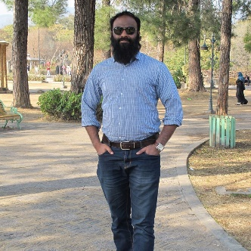
Launchpad 7 is much more than a Co-Working Space . It is part of vision of JumpStart Pakistan to create an Entrepreneurial Eco System in Pakistan and bringing change through Entrepreneurship. If you are looking for a cool , economical work place right in heart of city , I Launchpad 7 is best choice.

Danish Sattar:-
(Operations Manager/Coordinator at Moosh Digital)


LaunchPad7 is friendly and most supportive environment!
especially grooming sessions and activities!

Ghulam Shabbir:-

Launchpad7 is one of the few platforms engaged truly in developing and nurturing a new generations of Entrepreneurs. Its a great great place to work, learn and excel

