1) Unzip the software from Zip file (**This is important!!!!**)

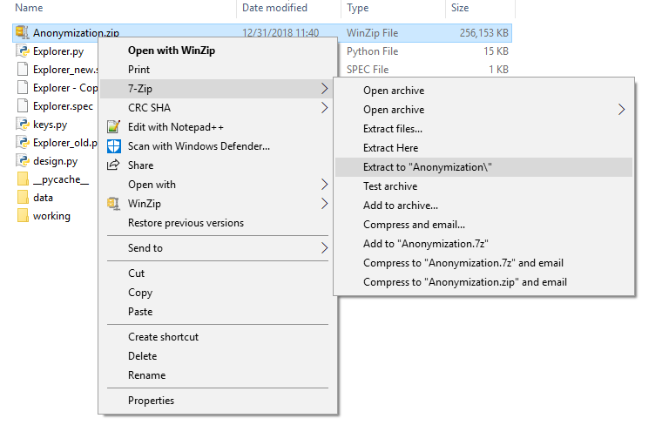

Folder Structure

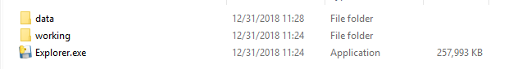

2) Click on the Explorer icon to startup

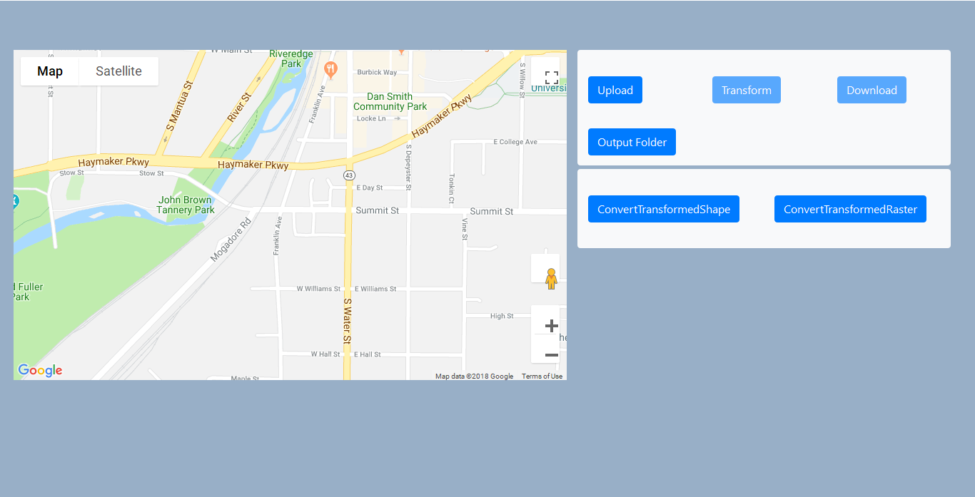

3) Set the output folder (where all the files will be downloaded)

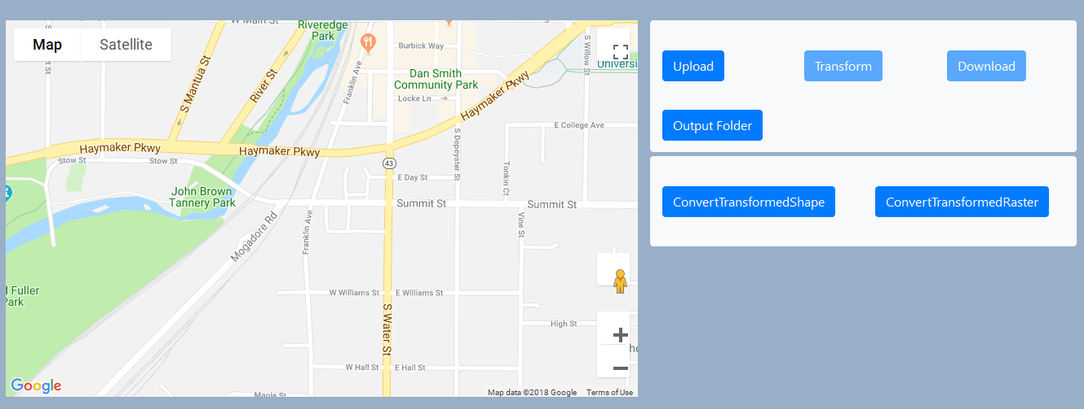

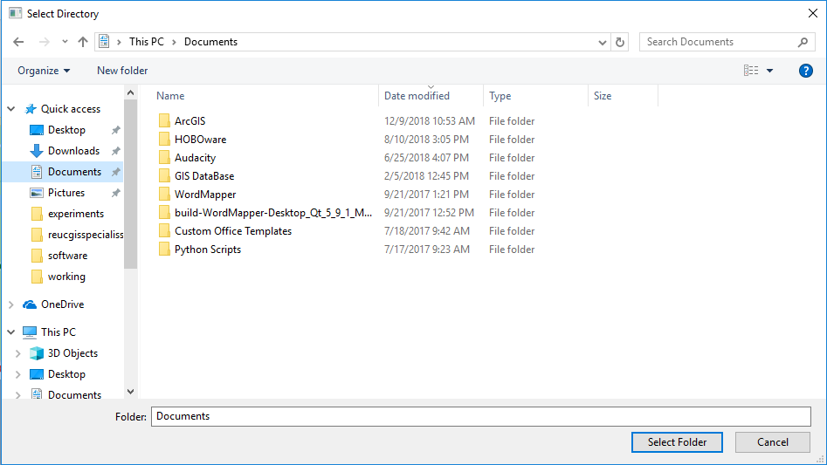

4) Upload a file

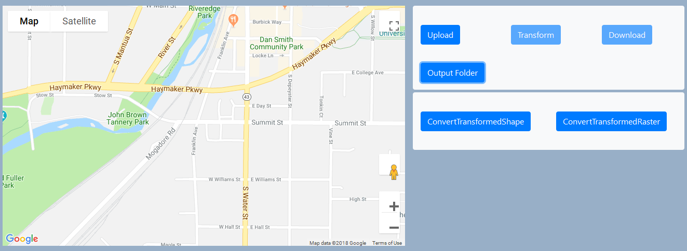

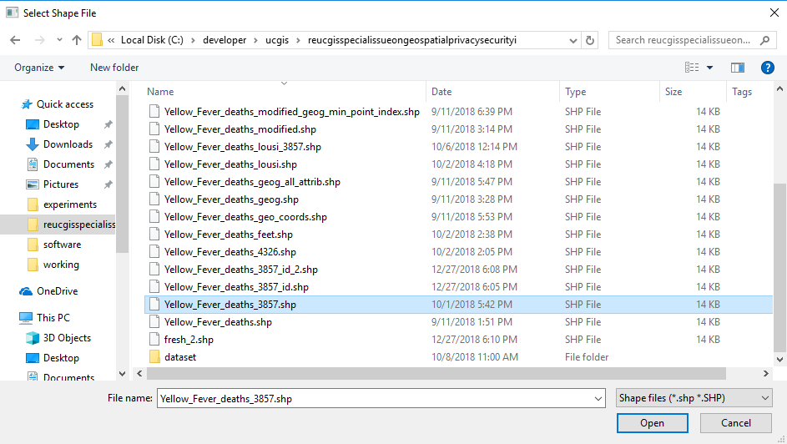

The uploaded data gets displayed on the map

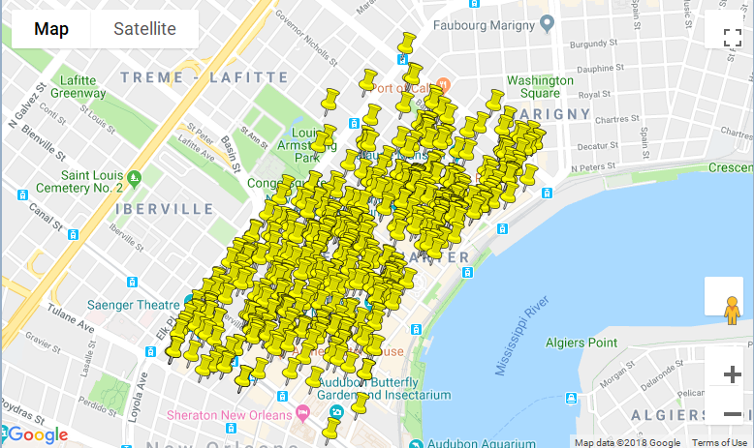

5) **Click on Transform to obfuscate the uploaded point. You can see the transformed points in the map**

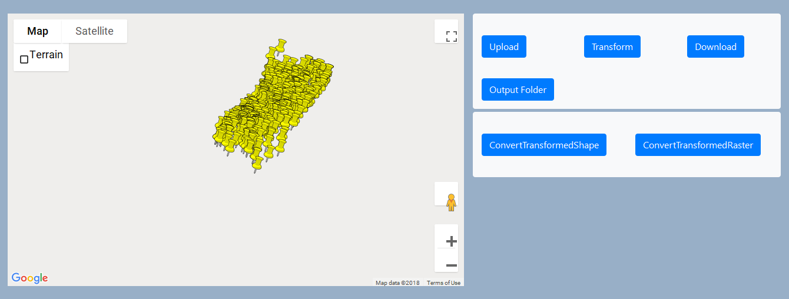

Click on transform multiple times to generate another obfuscated pattern.

6) Click on download button to download the obfuscated point data as a shapefile.



6.1) **Create a key while downloading (Important)**

**a)** For creating a new key you can type in the key name to text box

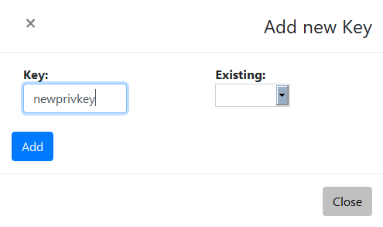

In this example a new key with name ‘newprivkey’ will be generated.

**a.1)** To use an already existing key you can select from the drop down. This facility is particularly useful if you want to use the same transformation rule for another point data. An example would be, 911 call record data with same obfuscation scheme as already obfuscated crime data.

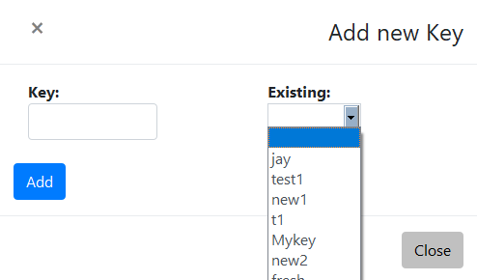

b) Click on add button.

c) Type in any filename that you want for the new point data shapefile (no need to type **.shp**)

The file will be downloaded to the output folder that has already been set.

An example of transformed and real file

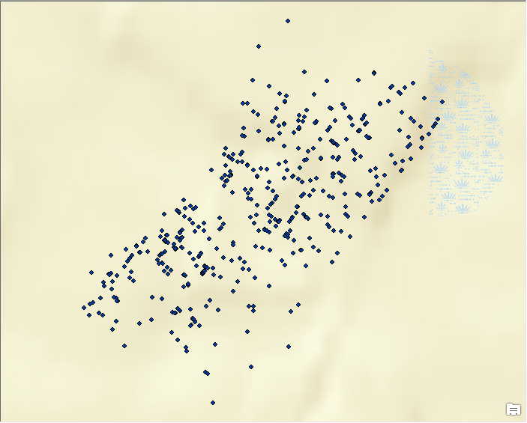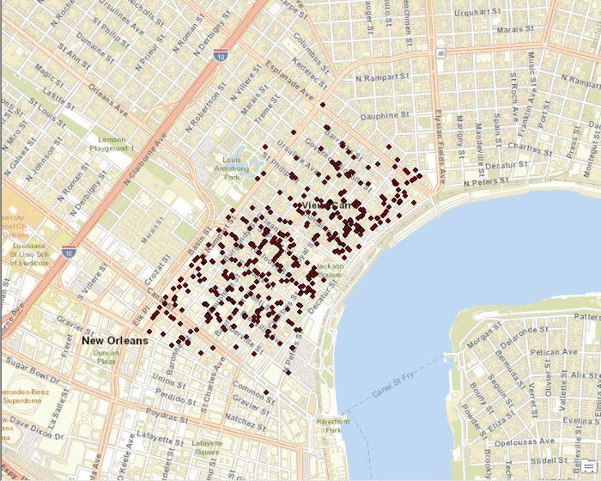

7) **Re-transform the obfuscated file**

**1) Shapefile**

1) Click on the ConvertTransformedShape

**Select the key you have used for transformation**

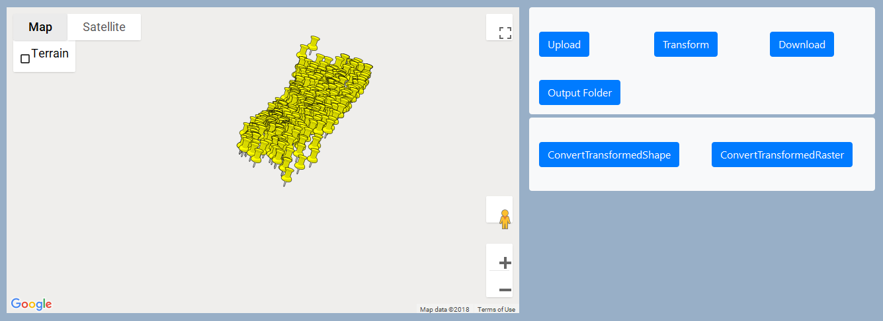

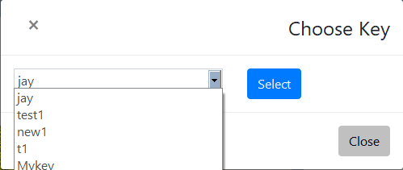

2) Click on select . Enter the filename and then select the file you want to re-transform

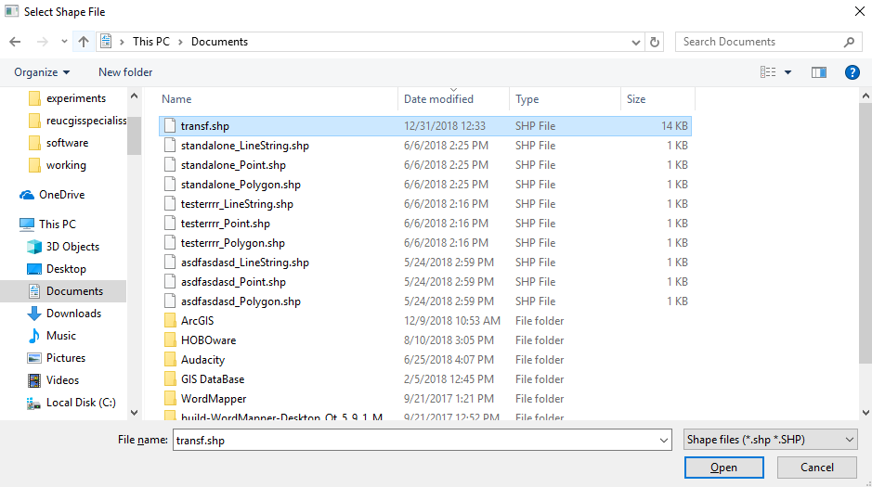

3) The file will be downloaded to the output folder

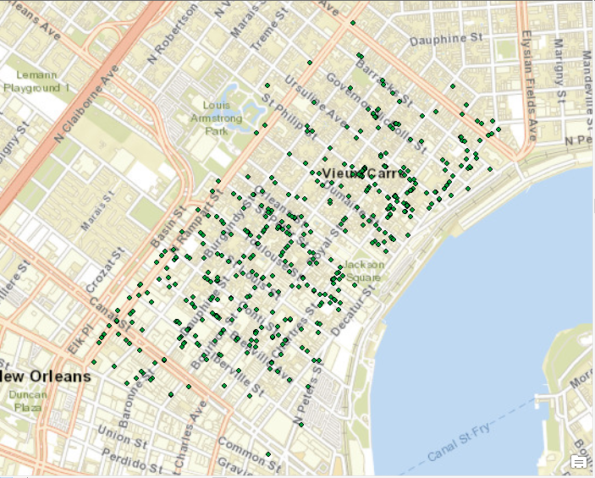

**2) Raster**

1) Click on the ConvertTransformedRaster

**Select the key you have used for transformation and select .tif file for reconversion**