Оглавление

ЗАДАНИЕ 4

Введение 4

1. Реализация таблиц и связей 5

2. Реализация запросов 6

3. Реализация индексов. 7

4. Реализация индексов 8

5. Реализация процедур 9

6. Реализация составной транзакции 14

7. Реализация курсора на обновления 15

8. Реализация функций 15

9. Реализация распределения прав 16

Интерфейс приложения 16

Листинг кода 20

Вывод 47

Источники 47

# 

# ЗАДАНИЕ

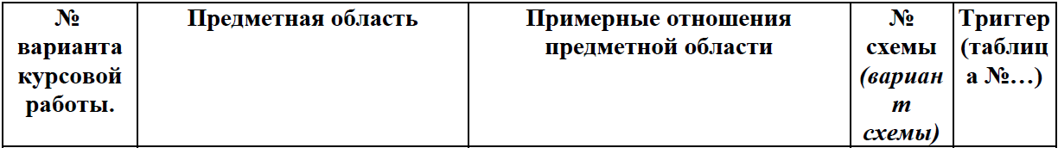

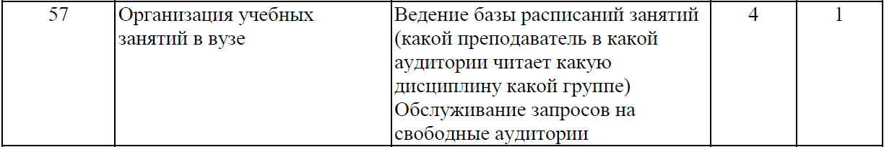

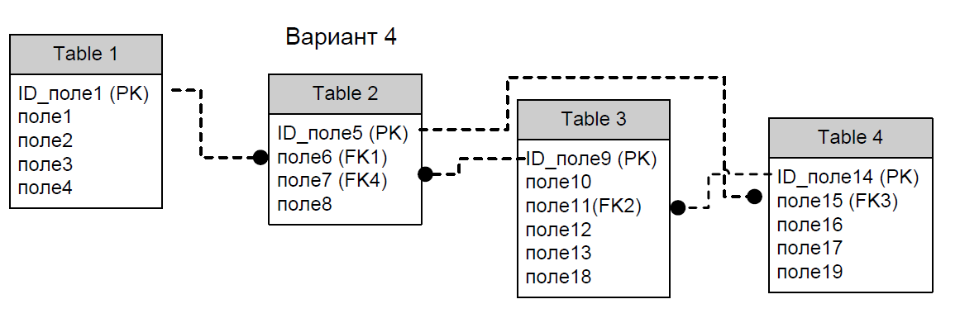

Разработать клиент-серверное приложение, серверная часть которой реализована на любом SQL сервере, представляющая собой модель предметной области в соответствии с вариантом задания. В рамках заданной предметной области реализовать заданную (по варианту) схему отношений, т.е. выделить сущности и их атрибуты, так чтобы связи между сущностями соответствовали представленной схеме.

# Введение

Базы данных — это совокупность структур, предназначенных для хранения больших объемов информации и программных модулей, осуществляющих управление данными, их выборку, сортировку и другие подобные действия.

Информация базы данных хранится в одной или нескольких таблицах. Любая таблица с данными состоит из набора однотипных записей, расположенных друг за другом. Они представляют собой строки таблицы, которые можно добавлять, удалять или изменять.

Каждая запись является набором именованных полей, или ячеек, которые могут хранить самую разнообразную информацию, начиная от даты рождения и заканчивая подробным описанием кулинарного рецепта. Однотипные поля разных записей образуют столбец таблицы.

Создав одну таблицу, вы уже получаете полноценную базу данных. Однако в реальной жизни структуры баз данных, а соответственно и способы их создания, намного сложнее.

# РЕАЛИЗАЦИЯ ТАБЛИЦ И СВЯЗЕЙ

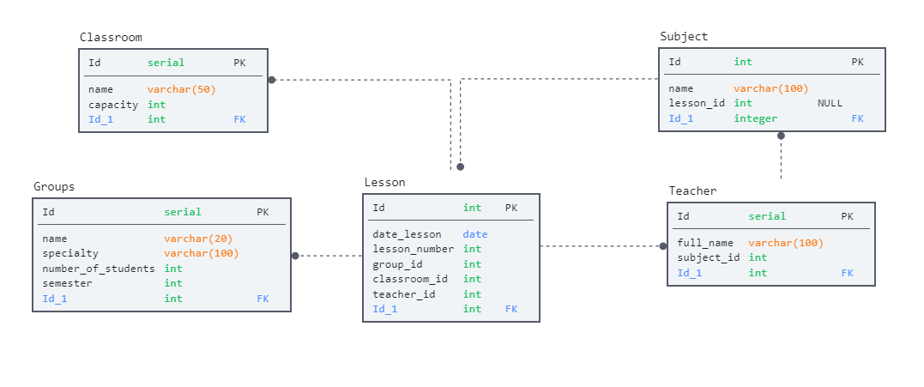

# 1. Постоянные таблицы и связи между ними, количество таблиц и наличие связей должно соответствовать заданию, допускается увеличение числа таблиц и их полей для более адекватного представления предметной области.

create table Groups

(

    Id serial primary key,

    name varchar(20) not null unique,

    specialty varchar(100) not null,

    number_of_students int not null,

    semester int not null

);

create table Classroom

(

    Id serial primary key,

    name varchar(50) not null unique,

    capacity int not null

);

create table Subject

(

    Id serial primary key,

    name varchar(100) not null unique

);

create table Teacher

(

    Id serial primary key,

    full_name varchar(100) not null,

    subject_id integer references Subject(Id)

);

create table Lesson

(

    Id serial primary key,

    date_lesson date not null,

    lesson_number int not null,

    group_id integer references Groups(Id) not null,

    classroom_id integer references Classroom(Id) not null,

    teacher_id integer references Teacher(Id) not null

);

alter table Subject

add lesson_id integer references Lesson(Id) default null

# 2. В приложении реализовать не менее пяти запросов, включая (для демонстрации навыков работы)

**a. Составной многотабличный запрос с параметром, включающий соединение таблиц и CASE-выражение;**

select Lesson.Id, Lesson.date_lesson, Lesson.lesson_number, Groups.name as group_name, Classroom.name as classsroom_name,

       (case when Groups.number_of_students > Classroom.capacity then 'students will not fit in the classroom'

        else 'students will fit in the classroom' end) as capacity_check

from Lesson

     join Groups on Lesson.group_id = Groups.Id

     join Classroom on Lesson.classroom_id = Classroom.Id

**b. На основе обновляющего представления (многотабличного VIEW), в котором критерий упорядоченности задает пользователь при выполнении;**

create or replace view lesson_veiw as

    select Lesson.Id, Lesson.date_lesson, Lesson.lesson_number, Groups.name as group_name,

           Groups.specialty, Classroom.name as classroom_name, Teacher.full_name, Subject.name as subject_name

from Lesson

      join Groups on Lesson.group_id = Groups.Id

      join Classroom on Lesson.classroom_id = Classroom.Id

      join Teacher on Lesson.teacher_id = Teacher.Id

      join Subject on Teacher.subject_id = Subject.Id

order by Lesson.date_lesson

**c. Запрос, содержащий коррелированные и некоррелированные подзапросы в разделах SELECT, FROM и WHERE (в каждом хотя бы по одному);**

select Lesson.Id, Lesson.date_lesson, Lesson.lesson_number,

        (select Groups.name from Groups

            where Groups.Id = group_id) as group_name,

        (select Classroom.name from Classroom

            where Classroom.Id = classroom_id) as classroom_name,

        (select Teacher.full_name from Teacher

            where Teacher.Id = teacher_id) as teacher_name

from (select * from Lesson

        where lesson_number < 4) as Lesson

where (select Classroom.capacity from Classroom

            where Classroom.Id = classroom_id) >

       (select Groups.number_of_students from Groups

            where Groups.Id = group_id)

**d. Многотабличный запрос, содержащий группировку записей, агрегативные функции и параметр, используемый в разделе HAVING;**

select Lesson.Id, Lesson.date_lesson, Lesson.lesson_number, Groups.name as group_name,

       min(Groups.number_of_students) as number_of_students

from Lesson, Groups

    where Groups.Id = Lesson.group_id

group by Lesson.Id, Groups.name

    having (min(Groups.number_of_students) < 26);

**e. Запрос, содержащий предикат ANY(SOME) или ALL;**

select Lesson.Id, Lesson.date_lesson, Lesson.lesson_number, Classroom.name as classroom_name

from Lesson

     join Classroom on Lesson.classroom_id = Classroom.Id

     where Lesson.classroom_id = any

     (select Classroom.Id from Classroom where Classroom.name = '321b')

# 3. Создать индексы для увеличения скорости выполнения запросов.

create index i_group_name on Groups using btree(name);

create index i_classroom_name on Classroom using btree(name);

create index i_Teacher_full_name on Teacher using btree(full_name);

create index i_subject_name on Subject using btree(name);

# 4. В таблице (в соответствии с вариантом) предусмотреть поле, которое заполняется автоматически по срабатыванию триггера при добавлении, обновлении и удалении данных, иметь возможность продемонстрировать работу триггера при работе приложения. Триггеры должны обрабатывать только те записи, которые были добавлены, изменены или удалены в ходе текущей операции (транзакции).

create table History

(

    Id serial primary key,

    group_id int not null,

    operation varchar(100) not null,

    group_name varchar(100) not null,

    create_at date not null default current_date

);

/* добавление новой группы */

create or replace function Groups_add_history()

returns trigger

language plpgsql

as $function$

begin

    insert into History(group_id, operation, group_name)

    values (new.Id, 'add group ',new.name);

    return new;

end;

$function$;

create trigger tr_group_add

after insert on Groups

for each row execute procedure Groups_add_history()

/* удаление группы */

create or replace function Groups_deletion_history()

returns trigger

language plpgsql

as $function$

begin

    insert into History(group_id, operation, group_name)

    values (old.Id, 'deleting a group ' , old.name);

    return old;

end;

$function$;

create trigger tr_group_deletion

after delete on Groups

for each row execute procedure Groups_deletion_history()

/* изменение группы */

create or replace function Groups_update_history()

returns trigger

language plpgsql

as $function$

begin

    insert into History(group_id, operation, group_name)

    values (new.Id, 'group update ' , new.name);

    return new;

end;

$function$;

create trigger tr_group_update

after update on Groups

for each row execute procedure Groups_update_history()

# 5. Операции добавления, удаления и обновления реализовать в виде хранимых процедур (с параметрами) хотя бы для одной таблицы; для остальных допустимо использовать возможности связывания полей ввода в приложении с полями БД.

/* добавление группы */

create or replace function add_group(_name text, _specialty text, _number_of_students int, _semester int)

returns boolean

language plpgsql

as $$

declare

checker boolean:= true;

begin

    insert into Groups(name, specialty, number_of_students, semester)

                values(_name, _specialty, _number_of_students, _semester);

    return checker;

end;

$$;

/* изменение группы */

create or replace function update_group(_Id int, _name text, _specialty text, _number_of_students int, _semester int)

returns boolean

language plpgsql

as $$

declare

checker boolean:= true;

begin

    update Groups

        set name = _name,

            specialty = _specialty,

            number_of_students = _number_of_students,

            semester = _semester

        where Id = _Id;

    return checker;

end;

$$;

/* удаление группы */

create or replace function delete_group(_Id int)

returns boolean

language plpgsql

as $$

declare

checker boolean:= true;

begin

    delete from Groups

        where Id = _Id;

    return checker;

end;

$$;

/* добавление аудитории */

create or replace function add_classroom(_name text, _capacity int)

returns boolean

language plpgsql

as $$

declare

checker boolean:= true;

begin

    insert into Classroom(name, capacity)

                values(_name, _capacity);

    return checker;

end;

$$;

/* изменение аудитории */

create or replace function update_classroom(_Id int, _name text, _capacity int)

returns boolean

language plpgsql

as $$

declare

checker boolean:= true;

begin

    update Classroom

        set name = _name,

            capacity = _capacity

        where Id = _Id;

    return checker;

end;

$$;

/* удаление аудитории */

create or replace function delete_classroom(_Id int)

returns boolean

language plpgsql

as $$

declare

checker boolean:= true;

begin

    delete from Classroom

        where Id = _Id;

    return checker;

end;

$$;

/* добавление дисциплины */

create or replace function add_subject(_name text, _lesson_id int default null)

returns boolean

language plpgsql

as $$

declare

checker boolean:= true;

begin

    insert into Subject(name, lesson_id)

                values(_name, _lesson_id);

    return checker;

end;

$$;

/* изменение дисциплины */

create or replace function update_subject(_Id int, _name text, _lesson_id int default null)

returns boolean

language plpgsql

as $$

declare

checker boolean:= true;

begin

    update Subject

        set name = _name,

            lesson_id = _lesson_id

        where Id = _Id;

    return checker;

end;

$$;

select update_subject(2,'Линейная алгебра')

/* удаление дисциплины */

create or replace function delete_subject(_Id int)

returns boolean

language plpgsql

as $$

declare

checker boolean:= true;

begin

    delete from Subject

        where Subject.Id = _Id;

    return checker;

end;

$$;

/* добавление преподователя */

create or replace function add_teacher(_full_name text, _subject_id int)

returns boolean

language plpgsql

as $$

declare

checker boolean:= true;

begin

    insert into Teacher(full_name, subject_id)

                values(_full_name, _subject_id);

    return checker;

end;

$$;

/* изменение преподователя */

create or replace function update_teacher(_Id int, _full_name text, _subject_id int)

returns boolean

language plpgsql

as $$

declare

checker boolean:= true;

begin

    update Teacher

        set full_name = _full_name,

            subject_id = _subject_id

        where Id = _Id;

    return checker;

end;

$$;

/* удаление преподователя */

create or replace function delete_teacher(_Id int)

returns boolean

language plpgsql

as $$

declare

checker boolean:= true;

begin

    delete from Teacher

        where Id = _Id;

    return checker;

end;

$$;

/* добавление пары */

create or replace function add_Lesson(_date_lesson date, _lesson_number int, _group_id int, _classroom_id int, _teacher_id int)

returns boolean

language plpgsql

as $$

declare

checker boolean:= true;

begin

    if (_lesson_number > 10 or _lesson_number < 1) then

    raise exception 'неверно указан номер пары';

    checker := false;

    end if;

    if(checker = true) then

    insert into Lesson(date_lesson, lesson_number, group_id, classroom_id ,teacher_id)

                values(_date_lesson, _lesson_number, _group_id, _classroom_id, _teacher_id);

    end if;

    return checker;

end;

$$;

/* изменение пары */

create or replace function update_Lesson(_Id int, _date_lesson date, _lesson_number int, _group_id int, _classroom_id int, _teacher_id int)

returns boolean

language plpgsql

as $$

declare

checker boolean:= true;

begin

    if (_lesson_number > 10 or _lesson_number < 1) then

    raise exception 'неверно указан номер пары';

    checker := false;

    end if;

    if(checker = true) then

    update Lesson

        set date_lesson = _date_lesson,

            lesson_number = _lesson_number,

            group_id = _group_id,

            classroom_id = _classroom_id,

            teacher_id = _teacher_id

        where Id = _Id;

    end if;

    return checker;

end;

$$;

/* удаление пары */

create or replace function delete_Lesson(_Id int)

returns boolean

language plpgsql

as $$

declare

checker boolean:= true;

begin

    delete from Lesson

        where Lesson.Id = _Id;

    return checker;

end;

$$;

# 6. Реализовать отдельную хранимую процедуру, состоящую из нескольких отдельных операций в виде единой транзакции, которая при определенных условиях может быть зафиксирована или откатана.

create or replace procedure next_year_groups(group_id int)

language plpgsql

as $$

declare

    current_year int;

begin

    select Groups.year into current_year from Groups where Groups.Id = group_id;

    if current_year < 5  then

            update Groups

            set Groups.year = Groups.yaer + 1 where Groups.Id = group_id;

    else

            delete from Groups

                where Groups.Id = group_id;

    end if;

end; $$

# 7. В триггере или хранимой процедуре реализовать курсор на обновления отдельных данных.

create or replace function group_update(

    _id int,

    _name text,

    _specialty text,

    _number_of_students int,

    semester int

)

returns boolean

language plpgsql

as $$

declare

checker boolean := true;

_cursor cursor (cursor_id bigint) for select * from Groups where Groups.Id = cursor_id;

begin

    open _cursor(cursor_id := _id);

    move first from _cursor;

    update Groups

        set

            Groups.name = _name,

            Groups.specialty = _specialty,

            Groups.number_of_students = _number_of_students,

            Groups.semester = _semestr

    where current of _cursor;

    close _cursor;

return checker;

end;

$$;

# 8. В запросе (из пункта 2 или в дополнительном к тому перечню) использовать собственную скалярную функцию, а в хранимой процедуре – векторную (или табличную) функцию. Функции сохранить в базе данных.

/* Скалярная функция*/

create or replace function get_number_of_students(group_name text)

returns int

language plpgsql

as $$

declare

_number_of_students int;

begin

    select Groups.number_of_students into _number_of_students from Groups

        where Groups.name = group_name;

    return _number_of_students;

end;

$$;

/* Табличная функция */

create or replace function return_table_group(group_name text)

returns table (_id int, _name text, _specialty text)

language plpgsql

as $$

begin

    select Groups.Id, Groups.name, Groups.specialty from Groups

        where Groups.name = group_name;

end;

$$;

# 9. Распределение прав пользователей: предусмотреть не менее двух пользователей с разным набором привилегий. Каждый набор привилегий оформить в виде роли.

create role Timetable_Teacher;

create role Timetable_Student;

create role Timetable_Admin;

grant select, insert on all tables in schema public to Timetable_Teacher;

grant select on all tables in schema public to Timetable_Student;

grant select, update, insert, delete on all tables in schema public to Timetable_Admin;

grant usage, select on all sequences in schema public to Timetable_Admin;

create user T_Teacher password '12345';

create user T_Student password '12345';

create user T_Admin password 'admin';

grant Timetable_Teacher to T_Teacher;

grant Timetable_Student to T_Student;

grant Timetable_Admin to T_Admin;

# Интерфейс приложения

Клиентское приложение реализовано на языке C# с использованием фреймворка WPF. Для взаимодействия приложения с бд использовалась технология ADO.NET

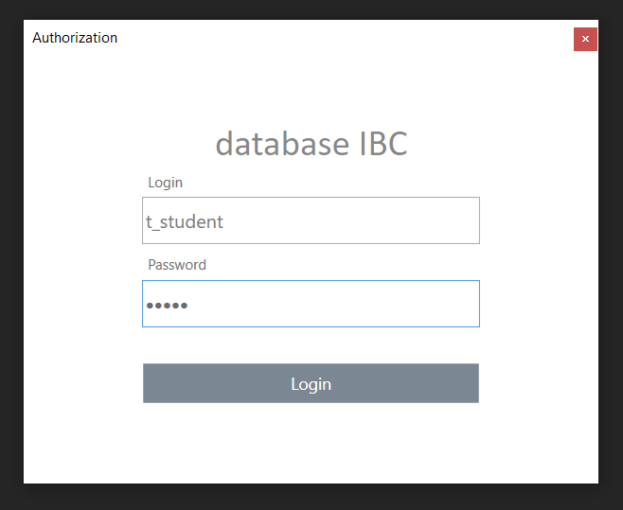

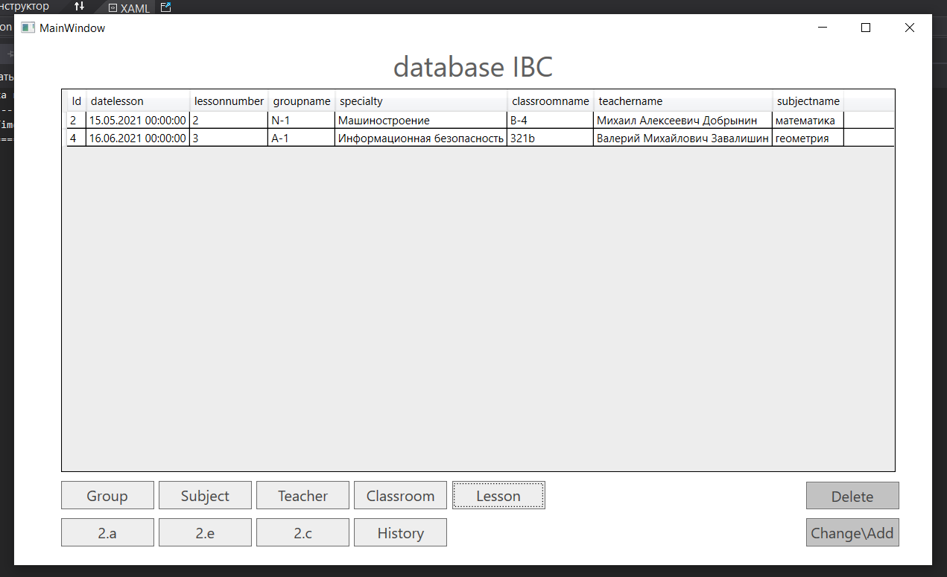

При нажатии на кнопки с названием таблиц, данные из бд отобразятся в DataGrid.

Для изменения записи нужно нажать на номер записи и после нажать на кнопку Change/Add.

После этого откроется специальное окно

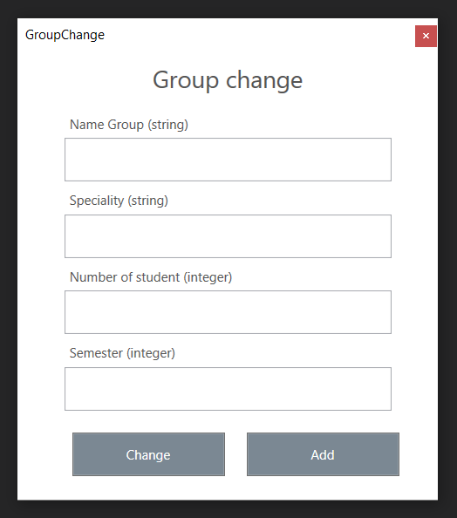

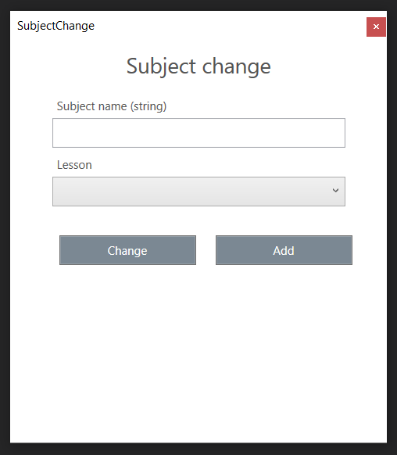

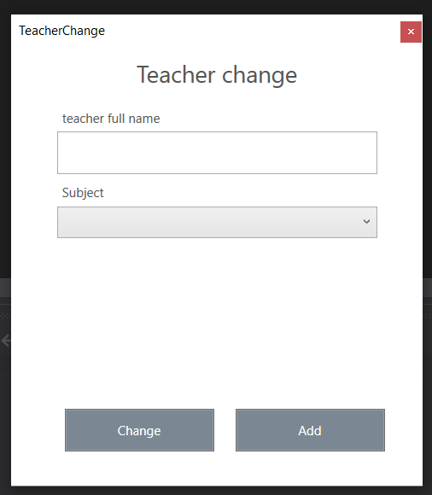

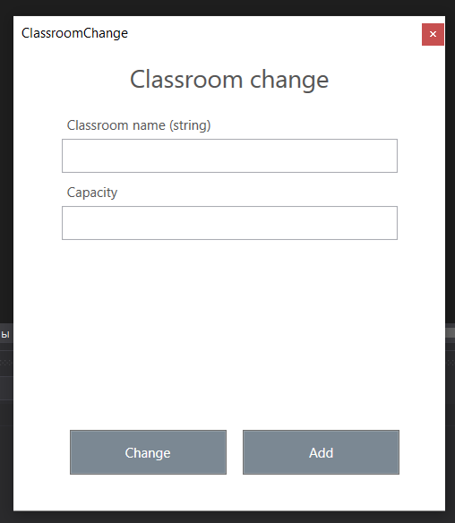

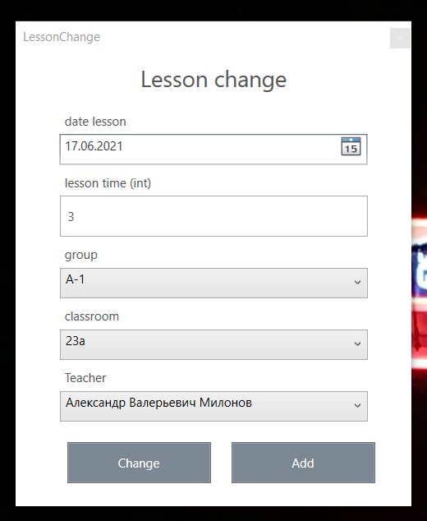

После заполнения полей можно изменить выбранную запись или добавить новую

# Листинг кода

Authorization.xaml

<Window x:Class="Timetable_of_classes.Authorization"

xmlns="http://schemas.microsoft.com/winfx/2006/xaml/presentation"

xmlns:x="http://schemas.microsoft.com/winfx/2006/xaml"

xmlns:d="http://schemas.microsoft.com/expression/blend/2008"

xmlns:mc="http://schemas.openxmlformats.org/markup-compatibility/2006"

xmlns:local="clr-namespace:Timetable_of_classes"

mc:Ignorable="d"

Title="Authorization" Height="400" Width="500" MinHeight="400" MinWidth="500" MaxHeight="400" MaxWidth="500" WindowStyle="ToolWindow">

<Grid>

<StackPanel Margin="100,50,100,50">

<Label Height="40" Margin="0" Content="database IBC" VerticalContentAlignment="Top" HorizontalContentAlignment="Center" FontSize="31" FontFamily="Calibri" Opacity="0.5" Foreground="#FF0C0C0C" Background="White" />

<Label Height="30" Content="Login" VerticalContentAlignment="Bottom" HorizontalContentAlignment="Left" Foreground="#FF6C6C6C"></Label>

<TextBox x:Name="textBoxLogin" VerticalContentAlignment="Center" Margin="0,0,0,0" Height="40" FontSize="16" BorderThickness="1" Foreground="#FF797979" />

<Label Height="30" Content="Password" VerticalContentAlignment="Bottom" HorizontalContentAlignment="Left" Foreground="#FF6C6C6C"></Label>

<PasswordBox x:Name="textBoxPassword" Margin="0,0,0,15" Height="40" VerticalContentAlignment="Center" Foreground="#FF6C6C6C" SelectionTextBrush="#FF6C6C6C" SelectionBrush="#FF6C6C6C" />

<Button x:Name="authorizationButoom" Content="Login" Margin="0,15,0,15" Height="35" Background="#FF7B8893" BorderBrush="{x:Null}" ScrollViewer.VerticalScrollBarVisibility="Disabled" FontSize="14" Foreground="White" Click="authorizationButoom_Click"/>

</StackPanel>

</Grid>

</Window>

Authorization.xaml.cs

using System;

using System.Text;

using System.Windows;

namespace Timetable_of_classes

{

/// <summary>

/// Логика взаимодействия для Authorization.xaml

/// </summary>

public partial class Authorization : Window

{

MainWindow window;

public Authorization(MainWindow mainWindow)

{

InitializeComponent();

window = mainWindow;

}

private void authorizationButoom_Click(object sender, RoutedEventArgs e)

{

try

{

Connection.connectionString = $"Server=localhost;Port=5432;User Id={this.textBoxLogin.Text};Password={this.textBoxPassword.Password};Database=Timetable;";

byte[] bytes = Encoding.Default.GetBytes(Connection.connectionString);

Connection.connectionString = Encoding.UTF8.GetString(bytes);

Connection.sqlConnection = new Npgsql.NpgsqlConnection(Connection.connectionString);

Connection.sqlConnection.Open();

this.Close();

window.Show();

}

catch (Exception ex)

{

MessageBox.Show(ex.Message);

}

}

}

}

Classroom.cs

using System;

using System.Collections.Generic;

using System.Linq;

namespace Timetable_of_classes

{

public class Classroom

{

public Classroom(int id, string name, int capacity)

{

this.id = id;

this.name = name;

this.capacity = capacity;

}

public int id { get; set; }

public string name { get; set; }

public int capacity { get; set; }

}

}

ClassroomChange.xaml

<Window x:Class="Timetable_of_classes.ClassroomChange"

xmlns="http://schemas.microsoft.com/winfx/2006/xaml/presentation"

xmlns:x="http://schemas.microsoft.com/winfx/2006/xaml"

xmlns:d="http://schemas.microsoft.com/expression/blend/2008"

xmlns:mc="http://schemas.openxmlformats.org/markup-compatibility/2006"

xmlns:local="clr-namespace:Timetable_of_classes"

mc:Ignorable="d"

Title="ClassroomChange" Height="450" Width="400" MinHeight="450" MinWidth="400" MaxHeight="450" MaxWidth="400" WindowStyle="ToolWindow">

<Grid>

<StackPanel>

<Label Content="Classroom change" HorizontalAlignment="Center" VerticalAlignment="Top" Width="300" Height="50" Foreground="#FF545454" HorizontalContentAlignment="Center" VerticalContentAlignment="Center" FontSize="22"/>

<Label Content="Classroom name (string)" HorizontalAlignment="Center" VerticalAlignment="Top" Width="300" Height="30" Foreground="#FF545454" VerticalContentAlignment="Bottom"/>

<TextBox x:Name="classroomNameTextBox" HorizontalAlignment="Center" Height="30" TextWrapping="Wrap" VerticalAlignment="Top" Width="300" SelectionBrush="#FF5D5D5D" Foreground="#FF545454" VerticalContentAlignment="Center" Padding="5,0,0,0"/>

<Label Content="Capacity" HorizontalAlignment="Center" VerticalAlignment="Top" Width="300" Height="30" Foreground="#FF545454" VerticalContentAlignment="Bottom"/>

<TextBox x:Name="classroomCapacityTextBox" Margin="0,0,0,170" HorizontalAlignment="Center" Height="30" TextWrapping="Wrap" VerticalAlignment="Top" Width="300" SelectionBrush="#FF5D5D5D" Foreground="#FF545454" VerticalContentAlignment="Center" Padding="5,0,0,0"/>

<StackPanel Orientation="Horizontal">

<Button Content="Change" Margin="50,0,0,0" HorizontalAlignment="Left" VerticalAlignment="Top" Width="140" Height="40" Foreground="White" Background="#FF7B8893" Click="Button_Click"/>

<Button Content="Add" Margin="15,0,0,0" HorizontalAlignment="Center" VerticalAlignment="Top" Width="140" Height="40" Foreground="White" Background="#FF7B8893" Click="Button_Click_1"/>

</StackPanel>

</StackPanel>

</Grid>

</Window>

ClassroomChange.xaml.cs

using Npgsql;

using System;

using System.Windows;

namespace Timetable_of_classes

{

/// <summary>

/// Логика взаимодействия для ClassroomChange.xaml

/// </summary>

public partial class ClassroomChange : Window

{

public ClassroomChange()

{

InitializeComponent();

}

private async void Button_Click(object sender, RoutedEventArgs e)

{

try

{

string sqlExpression = $"select update_classroom({Connection.currentId}, '{this.classroomNameTextBox.Text}', {this.classroomCapacityTextBox.Text})";

NpgsqlCommand command = new NpgsqlCommand(sqlExpression, Connection.sqlConnection);

await command.ExecuteNonQueryAsync();

Connection.GroupGrid.ItemsSource = Connection.SelectFromClassroom();

this.Close();

}

catch(Exception ex)

{

MessageBox.Show(ex.Message);

}

}

private async void Button_Click_1(object sender, RoutedEventArgs e)

{

try

{

string sqlExpression = $"select add_classroom('{this.classroomNameTextBox.Text}', {this.classroomCapacityTextBox.Text})";

NpgsqlCommand command = new NpgsqlCommand(sqlExpression, Connection.sqlConnection);

await command.ExecuteNonQueryAsync();

Connection.GroupGrid.ItemsSource = Connection.SelectFromClassroom();

this.Close();

}

catch (Exception ex)

{

MessageBox.Show(ex.Message);

}

}

}

}

Connection.cs

using Npgsql;

using System;

using System.Collections.Generic;

using System.Windows;

using System.Windows.Controls;

namespace Timetable_of_classes

{

public enum ObjectName { Classroom, Group, Lesson, Teacher, Subject }

public static class Connection

{

public static ObjectName objectName;

public static DataGrid GroupGrid;

public static string connectionString { get; set; }

public static NpgsqlConnection sqlConnection { get; set; }

public static int currentId { get; set; }

public static List<Group> SelectFromGroup()

{

List<Group> groups = new List<Group>();

try

{

string sqlExpression = "SELECT * FROM Groups";

NpgsqlCommand command = new NpgsqlCommand(sqlExpression, Connection.sqlConnection);

NpgsqlDataReader reader = command.ExecuteReader();

while (reader.Read())

{

int id = (int)reader.GetValue(0);

string name = (string)reader.GetValue(1);

string specialty = (string)reader.GetValue(2);

int number_of_students = (int)reader.GetValue(3);

int semester = (int)reader.GetValue(4);

groups.Add(new Group(id, name, specialty, number_of_students, semester));

}

reader.Close();

objectName = ObjectName.Group;

}

catch (Exception ex)

{

MessageBox.Show(ex.Message);

return null;

}

return groups;

}

public static List<Lesson> SelectfromLesson()

{

List<Lesson> lesson = new List<Lesson>();

try

{

string sqlExpression = "SELECT * FROM lesson_veiw";

NpgsqlCommand command = new NpgsqlCommand(sqlExpression, Connection.sqlConnection);

NpgsqlDataReader reader = command.ExecuteReader();

while (reader.Read())

{

int id = (int)reader.GetValue(0);

string date_lesson = reader.GetValue(1).ToString();

int lesson_number = (int)reader.GetValue(2);

string group_name = reader.GetValue(3).ToString();

string specialty = reader.GetValue(4).ToString();

string classroom_name = reader.GetValue(5).ToString();

string teacher_name = reader.GetValue(6).ToString();

string subject_name = reader.GetValue(7).ToString();

lesson.Add(new Lesson(id, date_lesson, lesson_number, group_name, specialty, classroom_name, teacher_name, subject_name));

}

reader.Close();

objectName = ObjectName.Lesson;

}

catch (Exception ex)

{

MessageBox.Show(ex.Message);

return null;

}

return lesson;

}

public static List<Subject> SelectfromSubject()

{

List<Subject> subjects = new List<Subject>();

try

{

string sqlExpression = "SELECT * FROM Subject";

NpgsqlCommand command = new NpgsqlCommand(sqlExpression, Connection.sqlConnection);

NpgsqlDataReader reader = command.ExecuteReader();

while (reader.Read())

{

int id = (int)reader.GetValue(0);

string name = reader.GetValue(1).ToString();

string subject_id = reader.GetValue(2).ToString();

subjects.Add(new Subject(id, name, subject_id));

}

reader.Close();

objectName = ObjectName.Subject;

}

catch (Exception ex)

{

MessageBox.Show(ex.Message);

return null;

}

return subjects;

}

public static List<Teacher> SelectFromTeacher()

{

List<Teacher> teachers = new List<Teacher>();

try

{

string sqlExpression = "select Teacher.Id, Teacher.full_name, Subject.name " +

"from Teacher " +

"left join Subject on Teacher.subject_id = Subject.Id";

NpgsqlCommand command = new NpgsqlCommand(sqlExpression, Connection.sqlConnection);

NpgsqlDataReader reader = command.ExecuteReader();

while (reader.Read())

{

int id = (int)reader.GetValue(0);

string full_name = reader.GetValue(1).ToString();

string subject_name = reader.GetValue(2).ToString();

teachers.Add(new Teacher(id, full_name, subject_name));

}

reader.Close();

objectName = ObjectName.Teacher;

}

catch (Exception ex)

{

MessageBox.Show(ex.Message);

return null;

}

return teachers;

}

public static List<Classroom> SelectFromClassroom()

{

List<Classroom> classrooms = new List<Classroom>();

try

{

string sqlExpression = "select * from Classroom";

NpgsqlCommand command = new NpgsqlCommand(sqlExpression, Connection.sqlConnection);

NpgsqlDataReader reader = command.ExecuteReader();

while (reader.Read())

{

int id = (int)reader.GetValue(0);

string name = reader.GetValue(1).ToString();

int capacity = (int)reader.GetValue(2);

classrooms.Add(new Classroom(id, name, capacity));

}

reader.Close();

objectName = ObjectName.Classroom;

}

catch (Exception ex)

{

MessageBox.Show(ex.Message);

return null;

}

return classrooms;

}

public static T ConvertFromDBVal<T>(object obj)

{

if (obj == null || obj == DBNull.Value)

{

return default(T);

}

else

{

return (T)obj;

}

}

public static List<A2Class> A2()

{

List<A2Class> ts = new List<A2Class>();

try

{

string sqlExpression = $"select Lesson.Id, Lesson.date_lesson, Lesson.lesson_number, Groups.name as group_name, Classroom.name as classsroom_name, " +

"(case when Groups.number_of_students > Classroom.capacity then 'students will not fit in the classroom' " +

"else 'students will fit in the classroom' end) as capacity_check " +

"from Lesson " +

"join Groups on Lesson.group_id = Groups.Id " +

"join Classroom on Lesson.classroom_id = Classroom.Id";

NpgsqlCommand command = new NpgsqlCommand(sqlExpression, Connection.sqlConnection);

NpgsqlDataReader reader = command.ExecuteReader();

while (reader.Read())

{

int Id = (int)reader.GetValue(0);

string date_lesson = reader.GetValue(1).ToString();

int lesson_number = (int)reader.GetValue(2);

string group_name = reader.GetValue(3).ToString();

string classsroom_name = reader.GetValue(4).ToString();

string capacity_check = reader.GetValue(5).ToString();

ts.Add(new A2Class(Id, date_lesson, lesson_number, group_name, classsroom_name, capacity_check));

}

reader.Close();

}

catch(Exception ex)

{

MessageBox.Show(ex.Message);

}

return ts;

}

public static List<D2Class> D2()

{

List<D2Class> ts = new List<D2Class>();

try

{

string sqlExpression = "select Lesson.Id, Lesson.date_lesson, Lesson.lesson_number, Groups.name as group_name, " +

"min(Groups.number_of_students) as number_of_students " +

"from Lesson, Groups " +

"where Groups.Id = Lesson.group_id " +

"group by Lesson.Id, Groups.name " +

"having(min(Groups.number_of_students) < 25); ";

NpgsqlCommand command = new NpgsqlCommand(sqlExpression, Connection.sqlConnection);

NpgsqlDataReader reader = command.ExecuteReader();

while (reader.Read())

{

int Id = (int)reader.GetValue(0);

string date_lesson = reader.GetValue(1).ToString();

int lesson_number = (int)reader.GetValue(3);

string group_name = reader.GetValue(4).ToString();

int number_of_students = (int)reader.GetValue(5);

ts.Add(new D2Class(Id, date_lesson, lesson_number, group_name, number_of_students));

}

reader.Close();

}

catch (Exception ex)

{

MessageBox.Show(ex.Message);

}

return ts;

}

public static List<E2Class> E2()

{

List<E2Class> ts = new List<E2Class>();

try

{

string sqlExpression = "select Lesson.Id, Lesson.date_lesson, Lesson.lesson_number, Classroom.name as classroom_name " +

"from Lesson " +

"join Classroom on Lesson.classroom_id = Classroom.Id " +

"where Lesson.classroom_id = any " +

"(select Classroom.Id from Classroom where Classroom.name = '34a')";

NpgsqlCommand command = new NpgsqlCommand(sqlExpression, Connection.sqlConnection);

NpgsqlDataReader reader = command.ExecuteReader();

while (reader.Read())

{

int Id = (int)reader.GetValue(0);

string date_lesson = reader.GetValue(1).ToString();

int lesson_number = (int)reader.GetValue(2);

string classroom_name = reader.GetValue(3).ToString();

ts.Add(new E2Class(Id, date_lesson, lesson_number, classroom_name));

}

reader.Close();

}

catch (Exception ex)

{

MessageBox.Show(ex.Message);

}

return ts;

}

public static List<History> histories()

{

List<History> history = new List<History>();

try

{

string sqlExpression = "SELECT * FROM History";

NpgsqlCommand command = new NpgsqlCommand(sqlExpression, Connection.sqlConnection);

NpgsqlDataReader reader = command.ExecuteReader();

while (reader.Read())

{

int Id = (int)reader.GetValue(0);

int groupId = (int)reader.GetValue(1);

string operation = (string)reader.GetValue(2);

string createAt = (string)reader.GetValue(3).ToString();

history.Add(new History(Id, groupId, operation, createAt));

}

reader.Close();

}

catch (Exception ex)

{

MessageBox.Show(ex.Message);

}

return history;

}

}

}

Group.cs

namespace Timetable_of_classes

{

public class Group

{

public Group(int Id, string name, string specialty, int number_of_students, int semester)

{

this.Id = Id;

this.name = name;

this.specialty = specialty;

this.number_of_students = number_of_students;

this.semester = semester;

}

public int Id { get; set; }

public string name { get; set; }

public string specialty { get; set; }

public int number_of_students { get; set; }

public int semester { get; set; }

}

}

GroupChange.xaml

<Window x:Class="Timetable_of_classes.GroupChange"

xmlns="http://schemas.microsoft.com/winfx/2006/xaml/presentation"

xmlns:x="http://schemas.microsoft.com/winfx/2006/xaml"

xmlns:d="http://schemas.microsoft.com/expression/blend/2008"

xmlns:mc="http://schemas.openxmlformats.org/markup-compatibility/2006"

xmlns:local="clr-namespace:Timetable_of_classes"

mc:Ignorable="d"

Title="GroupChange" Height="450" Width="400" MinHeight="450" MinWidth="400" MaxHeight="450" MaxWidth="400" WindowStyle="ToolWindow">

<Grid>

<StackPanel>

<Label Content="Group change" HorizontalAlignment="Center" VerticalAlignment="Top" Width="300" Height="50" Foreground="#FF545454" HorizontalContentAlignment="Center" VerticalContentAlignment="Center" FontSize="22"/>

<Label Content="Name Group (string)" HorizontalAlignment="Center" VerticalAlignment="Top" Width="300" Height="30" Foreground="#FF545454" VerticalContentAlignment="Bottom"/>

<TextBox x:Name="nameGroupTextBox" HorizontalAlignment="Center" Height="40" TextWrapping="Wrap" VerticalAlignment="Top" Width="300" SelectionBrush="#FF5D5D5D" Foreground="#FF545454" VerticalContentAlignment="Center" Padding="5,0,0,0"/>

<Label Content="Speciality (string)" HorizontalAlignment="Center" VerticalAlignment="Top" Width="300" Height="30" Foreground="#FF545454" VerticalContentAlignment="Bottom"/>

<TextBox x:Name="specialityTextBox" HorizontalAlignment="Center" Height="40" TextWrapping="Wrap" VerticalAlignment="Top" Width="300" Foreground="#FF545454" SelectionBrush="#FF5D5D5D" VerticalContentAlignment="Center" Padding="5,0,0,0"/>

<Label Content="Number of student (integer)" HorizontalAlignment="Center" VerticalAlignment="Top" Width="300" Height="30" Foreground="#FF545454" VerticalContentAlignment="Bottom"/>

<TextBox x:Name="numberOfStudentTextBox" HorizontalAlignment="Center" Height="40" TextWrapping="Wrap" VerticalAlignment="Top" Width="300" Foreground="#FF545454" SelectionBrush="#FF5D5D5D" VerticalContentAlignment="Center" Padding="5,0,0,0"/>

<Label Content="Semester (integer)" HorizontalAlignment="Center" VerticalAlignment="Top" Width="300" Height="30" Foreground="#FF545454" VerticalContentAlignment="Bottom"/>

<TextBox x:Name="semesterTextBox" HorizontalAlignment="Center" Height="40" Margin="0,0,0,20" TextWrapping="Wrap" VerticalAlignment="Top" Width="300" Foreground="#FF545454" SelectionBrush="#FF5D5D5D" VerticalContentAlignment="Center" Padding="5,0,0,0"/>

<StackPanel Orientation="Horizontal">

<Button Content="Change" HorizontalAlignment="Left" Margin="50,0,0,0" VerticalAlignment="Top" Width="140" Height="40" Foreground="White" Background="#FF7B8893" Click="Button_Click"/>

<Button Content="Add" HorizontalAlignment="Left" Margin="20,0,0,0" VerticalAlignment="Top" Width="140" Height="40" Foreground="White" Background="#FF7B8893" Click="Button_Click_1"/>

</StackPanel>

</StackPanel>

</Grid>

</Window>

GroupChange.xaml.cs

using Npgsql;

using System;

using System.Data.SqlClient;

using System.Windows;

namespace Timetable_of_classes

{

/// <summary>

/// Логика взаимодействия для GroupChange.xaml

/// </summary>

public partial class GroupChange : Window

{

string nameGroup;

string speciality;

int numberOfStudent;

int semester;

private string sqlExpression;

public GroupChange()

{

InitializeComponent();

}

private void Button_Click(object sender, RoutedEventArgs e)

{

UpdateOrAdd("update_group");

}

private void Button_Click_1(object sender, RoutedEventArgs e)

{

UpdateOrAdd("add_group");

}

private async void UpdateOrAdd(string EXEC)

{

try

{

if (!string.IsNullOrEmpty(this.nameGroupTextBox.Text))

{

this.nameGroup = this.nameGroupTextBox.Text;

}

else

{

MessageBox.Show("name group is empty");

return;

}

if (!string.IsNullOrEmpty(this.specialityTextBox.Text))

{

this.speciality = this.specialityTextBox.Text;

}

else

{

MessageBox.Show("speciality is empty");

return;

}

if (!int.TryParse(this.numberOfStudentTextBox.Text, out numberOfStudent))

{

MessageBox.Show("number Of Student is empty");

return;

}

if (!int.TryParse(this.semesterTextBox.Text, out semester))

{

MessageBox.Show("semester is empty");

return;

}

if (EXEC == "update_group")

{

sqlExpression = $"select update_group ({Connection.currentId},'{this.nameGroup}', '{this.speciality}',{this.numberOfStudent},{this.semester})";

}

else if (EXEC == "add_group")

{

sqlExpression = $"select add_group ('{this.nameGroup}', '{this.speciality}',{this.numberOfStudent},{this.semester})";

}

NpgsqlCommand command = new NpgsqlCommand(sqlExpression, Connection.sqlConnection);

await command.ExecuteNonQueryAsync();

Connection.GroupGrid.ItemsSource = Connection.SelectFromGroup();

this.Close();

}

catch (Exception ex)

{

MessageBox.Show(ex.Message);

}

}

}

}

HelperClasses.cs

using System;

namespace Timetable_of_classes

{

public class A2Class

{

public A2Class(int Id, string date_lesson, int lesson_number, string group_name, string classsroom_name, string capacity_check)

{

this.Id = Id;

this.date_lesson = date_lesson;

this.lesson_number = lesson_number;

this.group_name = group_name;

this.classsroom_name = classsroom_name;

this.capacity_check = capacity_check;

}

public int Id { get; set; }

public string date_lesson { get; set; }

public int lesson_number { get; set; }

public string group_name { get; set; }

public string classsroom_name { get; set; }

public string capacity_check { get; set; }

}

public class D2Class

{

public D2Class(int Id, string date_lesson, int lesson_number, string group_name, int number_of_students)

{

this.Id = Id;

this.date_lesson = date_lesson;

this.lesson_number = lesson_number;

this.group_name = group_name;

this.number_of_students = number_of_students;

}

public int Id { get; set; }

public string date_lesson { get; set; }

public int lesson_number { get; set; }

public string group_name { get; set; }

public int number_of_students { get; set; }

}

public class C2Class

{

public C2Class(int Id, string classroomName, int capacity, string groupName, string fullNameTeacher)

{

this.Id = Id;

this.classroomName = classroomName;

this.capacity = capacity;

this.groupName = groupName;

this.fullNameTeacher = fullNameTeacher;

}

public int Id { get; set; }

public string classroomName { get; set; }

public int capacity { get; set; }

public string groupName { get; set; }

public string fullNameTeacher { get; set; }

}

public class History

{

public History(int Id, int groupId, string operation, string createAt)

{

this.Id = Id;

this.groupId = groupId;

this.operation = operation;

this.createAt = createAt;

}

public int Id { get; set; }

public int groupId { get; set; }

public string operation { get; set; }

public string createAt { get; set; }

}

public class E2Class

{

public E2Class(int Id, string date_lesson, int lesson_number, string classroom_name)

{

this.Id = Id;

this.date_lesson = date_lesson;

this.lesson_number = lesson_number;

this.classroom_name = classroom_name;

}

public int Id { get; set; }

public string date_lesson { get; set; }

public int lesson_number { get; set; }

public string classroom_name { get; set; }

}

}

Lesson.cs

namespace Timetable_of_classes

{

public class Lesson

{

public Lesson(int Id, string date_lesson, int lesson_number, string group_name, string specialty, string classroom_name, string teacher_name, string subject_name)

{

this.Id = Id;

this.date_lesson = date_lesson;

this.lesson_number = lesson_number;

this.group_name = group_name;

this.specialty = specialty;

this.classroom_name = classroom_name;

this.teacher_name = teacher_name;

this.subject_name = subject_name;

}

public int Id { get; set; }

public string date_lesson { get; set; }

public int lesson_number { get; set; }

public string group_name { get; set; }

public string specialty { get; set; }

public string classroom_name { get; set; }

public string teacher_name { get; set; }

public string subject_name { get; set; }

}

}

LessonChange.xaml

<Window x:Class="Timetable_of_classes.LessonChange"

xmlns="http://schemas.microsoft.com/winfx/2006/xaml/presentation"

xmlns:x="http://schemas.microsoft.com/winfx/2006/xaml"

xmlns:d="http://schemas.microsoft.com/expression/blend/2008"

xmlns:mc="http://schemas.openxmlformats.org/markup-compatibility/2006"

xmlns:local="clr-namespace:Timetable_of_classes"

mc:Ignorable="d"

Title="LessonChange" Height="480" Width="400" MinHeight="480" MinWidth="400" MaxHeight="480" MaxWidth="400" WindowStyle="ToolWindow">

<Grid>

<StackPanel>

<Label Content="Lesson change" HorizontalAlignment="Center" VerticalAlignment="Top" Width="300" Height="50" Foreground="#FF545454" HorizontalContentAlignment="Center" VerticalContentAlignment="Center" FontSize="22"/>

<Label Content="date lesson" HorizontalAlignment="Center" VerticalAlignment="Top" Width="300" Height="30" Foreground="#FF545454" VerticalContentAlignment="Bottom"/>

<DatePicker x:Name="calendar" IsDropDownOpen="True" SelectedDateFormat="Short" Width="300" Height="30" SelectedDateChanged="calendar_SelectedDateChanged" />

<Label Content="lesson time (int)" HorizontalAlignment="Center" VerticalAlignment="Top" Width="300" Height="30" Foreground="#FF545454" VerticalContentAlignment="Bottom"/>

<TextBox x:Name="timeTextBox" HorizontalAlignment="Center" Height="40" TextWrapping="Wrap" VerticalAlignment="Top" Width="300" Foreground="#FF545454" SelectionBrush="#FF5D5D5D" VerticalContentAlignment="Center" Padding="5,0,0,0"/>

<Label Content="group" HorizontalAlignment="Center" VerticalAlignment="Top" Width="300" Height="30" Foreground="#FF545454" VerticalContentAlignment="Bottom"/>

<ComboBox x:Name="comboBoxGroupId" HorizontalAlignment="Center" Width="300" Height="30" SelectionChanged="comboBoxGroupId_SelectionChanged"/>

<Label Content="classroom" HorizontalAlignment="Center" VerticalAlignment="Top" Width="300" Height="30" Foreground="#FF545454" VerticalContentAlignment="Bottom"/>

<ComboBox x:Name="comboBoxClassroomId" HorizontalAlignment="Center" Width="300" Height="30" SelectionChanged="comboBoxClassroomId_SelectionChanged"/>

<Label Content="Teacher" HorizontalAlignment="Center" VerticalAlignment="Top" Width="300" Height="30" Foreground="#FF545454" VerticalContentAlignment="Bottom"/>

<ComboBox x:Name="comboBoxTeacherId" HorizontalAlignment="Center" Width="300" Height="30" Margin="0,0,0,20" SelectionChanged="comboBoxTeacherId_SelectionChanged"/>

<StackPanel Orientation="Horizontal">

<Button Content="Change" HorizontalAlignment="Left" Margin="50,0,0,0" VerticalAlignment="Top" Width="140" Height="40" Foreground="White" Background="#FF7B8893" Click="Button_Click" />

<Button Content="Add" HorizontalAlignment="Left" Margin="20,0,0,0" VerticalAlignment="Top" Width="140" Height="40" Foreground="White" Background="#FF7B8893" Click="Button_Click_1" />

</StackPanel>

</StackPanel>

</Grid>

</Window>

LessonChange.xaml.cs

using Npgsql;

using System;

using System.Collections.Generic;

using System.Linq;

using System.Windows;

using System.Windows.Controls;

namespace Timetable_of_classes

{

/// <summary>

/// Логика взаимодействия для LessonChange.xaml

/// </summary>

public partial class LessonChange : Window

{

Dictionary<int, string> keyValueGroup;

Dictionary<int, string> keyValueClassroom;

Dictionary<int, string> keyValueTeacher;

string currentGroup = null;

string currentClassroom = null;

string currentTeacher = null;

string currentDate = null;

string sqlExpression;

public LessonChange()

{

InitializeComponent();

this.keyValueGroup = new Dictionary<int, string>();

this.keyValueClassroom = new Dictionary<int, string>();

this.keyValueTeacher = new Dictionary<int, string>();

sqlExpression = "SELECT * FROM Groups";

NpgsqlCommand command = new NpgsqlCommand(sqlExpression, Connection.sqlConnection);

NpgsqlDataReader reader = command.ExecuteReader();

while (reader.Read())

{

int id = (int)reader.GetValue(0);

string nameGroup = (string)reader.GetValue(1);

this.keyValueGroup.Add(id, nameGroup);

}

reader.Close();

this.comboBoxGroupId.ItemsSource = this.keyValueGroup.Values;

sqlExpression = "SELECT * FROM Classroom";

NpgsqlCommand command1 = new NpgsqlCommand(sqlExpression, Connection.sqlConnection);

NpgsqlDataReader reader1 = command1.ExecuteReader();

while (reader.Read())

{

int id = (int)reader1.GetValue(0);

string nameClassroom = (string)reader1.GetValue(1);

this.keyValueClassroom.Add(id, nameClassroom);

}

reader.Close();

this.comboBoxClassroomId.ItemsSource = this.keyValueClassroom.Values;

sqlExpression = "SELECT * FROM Teacher";

NpgsqlCommand command2 = new NpgsqlCommand(sqlExpression, Connection.sqlConnection);

NpgsqlDataReader reader2 = command2.ExecuteReader();

while (reader.Read())

{

int id = (int)reader2.GetValue(0);

string nameTeacher = (string)reader2.GetValue(1);

this.keyValueTeacher.Add(id, nameTeacher);

}

reader.Close();

this.comboBoxTeacherId.ItemsSource = this.keyValueTeacher.Values;

}

private void calendar_SelectedDateChanged(object sender, SelectionChangedEventArgs e)

{

DateTime selectedDate = (DateTime)calendar.SelectedDate;

this.currentDate = selectedDate.ToString("yyyy-MM-dd");

}

private void comboBoxGroupId_SelectionChanged(object sender, SelectionChangedEventArgs e)

{

this.currentGroup = this.comboBoxGroupId.SelectedItem.ToString();

}

private void comboBoxClassroomId_SelectionChanged(object sender, SelectionChangedEventArgs e)

{

this.currentClassroom = this.comboBoxClassroomId.SelectedItem.ToString();

}

private void comboBoxTeacherId_SelectionChanged(object sender, SelectionChangedEventArgs e)

{

this.currentTeacher = this.comboBoxTeacherId.SelectedItem.ToString();

}

private async void UpdateOdAddTeacher(string EXEC)

{

int groupt_id = keyValueGroup.FirstOrDefault(x => x.Value == this.currentGroup).Key;

int classroom_id = keyValueClassroom.FirstOrDefault(x => x.Value == this.currentClassroom).Key;

int teacher_id = keyValueTeacher.FirstOrDefault(x => x.Value == this.currentTeacher).Key;

if (EXEC == "update_lesson")

{

sqlExpression = $"select {EXEC} ({Connection.currentId},'{this.currentDate}',{this.timeTextBox.Text},{groupt_id},{classroom_id},{teacher_id})";

}

else if (EXEC == "add_lesson")

{

sqlExpression = $"select {EXEC} ('{this.currentDate}',{this.timeTextBox.Text},{groupt_id},{classroom_id},{teacher_id})";

}

NpgsqlCommand command = new NpgsqlCommand(sqlExpression, Connection.sqlConnection);

await command.ExecuteNonQueryAsync();

Connection.GroupGrid.ItemsSource = Connection.SelectfromLesson();

this.Close();

}

private void Button_Click(object sender, RoutedEventArgs e)

{

UpdateOdAddTeacher("update_lesson");

}

private void Button_Click_1(object sender, RoutedEventArgs e)

{

UpdateOdAddTeacher("add_lesson");

}

}

}

MainWindows.xaml

<Window x:Class="Timetable_of_classes.MainWindow"

xmlns="http://schemas.microsoft.com/winfx/2006/xaml/presentation"

xmlns:x="http://schemas.microsoft.com/winfx/2006/xaml"

xmlns:d="http://schemas.microsoft.com/expression/blend/2008"

xmlns:mc="http://schemas.openxmlformats.org/markup-compatibility/2006"

xmlns:local="clr-namespace:Timetable_of_classes" xmlns:col="clr-namespace:System.Collections;assembly=mscorlib"

mc:Ignorable="d"

Title="MainWindow" Height="600" Width="1000" Closing="Window_Closing">

<Grid Background="White">

<Label Content="database IBC" HorizontalAlignment="Center" VerticalAlignment="Top" FontSize="30" Foreground="#FF5F5F5F" Margin="401,0,352,0" Width="231"/>

<DataGrid x:Name="GroupGrid" Margin="50,50,39.5,100.4" BorderBrush="Black" Background="#FFEDEDED" MouseUp="GroupGrid_MouseUp"/>

<Button Content="Group" HorizontalAlignment="Left" Margin="50,0,0,60.4" VerticalAlignment="Bottom" Width="100" Height="30" Background="#FFEEEEEE" Foreground="#FF404040" FontSize="16" Click="Button_Click"/>

<Button Content="Subject" HorizontalAlignment="Left" Margin="155,0,0,60.4" VerticalAlignment="Bottom" Width="100" Height="30" Background="#FFEEEEEE" Foreground="#FF404040" FontSize="16" Click="Button_Click_2"/>

<Button Content="Teacher" HorizontalAlignment="Left" Margin="260,0,0,60.4" VerticalAlignment="Bottom" Width="100" Height="30" Background="#FFEEEEEE" Foreground="#FF404040" FontSize="16" Click="Button_Click_3"/>

<Button Content="Classroom" HorizontalAlignment="Left" Margin="365,0,0,60.4" VerticalAlignment="Bottom" Width="100" Height="30" Background="#FFEEEEEE" Foreground="#FF404040" FontSize="16" Click="Button_Click_4"/>

<Button Content="Lesson" HorizontalAlignment="Left" Margin="470,0,0,60.4" VerticalAlignment="Bottom" Width="100" Height="30" Background="#FFEEEEEE" Foreground="#FF404040" FontSize="16" Click="Button_Click_13"/>

<Button Content="Change\Add" HorizontalAlignment="Left" Margin="850,0,0,20.4" VerticalAlignment="Bottom" Width="100" Height="30" Background="#FFC2C2C2" Foreground="#FF404040" FontSize="16" Click="Button_Click_5"/>

<Button Content="Delete" HorizontalAlignment="Left" Margin="850,0,0,60" VerticalAlignment="Bottom" Width="100" Height="30" Background="#FFC2C2C2" Foreground="#FF404040" FontSize="16" Click="Button_Click_7"/>

<Button Content="2.a" HorizontalAlignment="Left" Margin="50,0,0,20.4" VerticalAlignment="Bottom" Width="100" Height="30" Background="#FFEEEEEE" Foreground="#FF404040" FontSize="16" Click="Button_Click_8"/>

<Button Content="2.c" HorizontalAlignment="Left" Margin="260,0,0,20.4" VerticalAlignment="Bottom" Width="100" Height="30" Background="#FFEEEEEE" Foreground="#FF404040" FontSize="16" Click="Button_Click_10"/>

<Button Content="History" HorizontalAlignment="Left" Margin="365,0,0,20.4" VerticalAlignment="Bottom" Width="100" Height="30" Background="#FFEEEEEE" Foreground="#FF404040" FontSize="16" Click="Button_Click_11"/>

<Button Content="2.e" HorizontalAlignment="Left" Margin="155,0,0,20.4" VerticalAlignment="Bottom" Width="100" Height="30" Background="#FFEEEEEE" Foreground="#FF404040" FontSize="16" Click="Button_Click_12"/>

</Grid>

</Window>

MainWindow.xaml.cs

using Npgsql;

using System;

using System.Data.SqlClient;

using System.Windows;

namespace Timetable_of_classes

{

/// <summary>

/// Логика взаимодействия для MainWindow.xaml

/// </summary>

//public enum ObjectName { Classroom, Group, LessonNumber, Teacher, Subject }

public partial class MainWindow : Window

{

Authorization authorization;

GroupChange groupChange;

SubjectChange subjectChange;

TeacherChange teacherChange;

ClassroomChange classroomChange;

LessonChange lessonChange;

private string sqlExpression;

public MainWindow()

{

InitializeComponent();

this.authorization = new Authorization(this);

this.authorization.Show();

Connection.GroupGrid = this.GroupGrid;

this.Hide();

}

private void Button_Click(object sender, RoutedEventArgs e)

{

this.GroupGrid.ItemsSource = Connection.SelectFromGroup();

}

private void Button_Click_2(object sender, RoutedEventArgs e)

{

this.GroupGrid.ItemsSource = Connection.SelectfromSubject();

}

private void Button_Click_3(object sender, RoutedEventArgs e)

{

this.GroupGrid.ItemsSource = Connection.SelectFromTeacher();

}

private void Button_Click_4(object sender, RoutedEventArgs e)

{

this.GroupGrid.ItemsSource = Connection.SelectFromClassroom();

}

private void Window_Closing(object sender, System.ComponentModel.CancelEventArgs e)

{

Connection.sqlConnection.Close();

}

private void GroupGrid_MouseUp(object sender, System.Windows.Input.MouseButtonEventArgs e)

{

if (Connection.objectName == ObjectName.Classroom)

{

if (GroupGrid.SelectedItem is Classroom)

{

Classroom path = GroupGrid.SelectedItem as Classroom;

MessageBox.Show("id: " + path.id.ToString());

Connection.currentId = path.id;

Connection.objectName = ObjectName.Classroom;

return;

}

}

if (Connection.objectName == ObjectName.Group)

{

if (GroupGrid.SelectedItem is Group)

{

Group path = GroupGrid.SelectedItem as Group;

MessageBox.Show("id: " + path.Id.ToString());

Connection.currentId = path.Id;

Connection.objectName = ObjectName.Group;

return;

}

}

if (Connection.objectName == ObjectName.Subject)

{

if (GroupGrid.SelectedItem is Subject)

{

Subject path = GroupGrid.SelectedItem as Subject;

MessageBox.Show("id: " + path.id.ToString());

Connection.currentId = path.id;

Connection.objectName = ObjectName.Subject;

return;

}

}

if (Connection.objectName == ObjectName.Teacher)

{

if (GroupGrid.SelectedItem is Teacher)

{

Teacher path = GroupGrid.SelectedItem as Teacher;

MessageBox.Show("id: " + path.id.ToString());

Connection.currentId = path.id;

Connection.objectName = ObjectName.Teacher;

return;

}

}

}

private void Button_Click_5(object sender, RoutedEventArgs e)

{

if (Connection.objectName == ObjectName.Group)

{

this.groupChange = new GroupChange();

this.groupChange.Owner = this;

this.groupChange.Show();

}

if (Connection.objectName == ObjectName.Subject)

{

this.subjectChange = new SubjectChange();

this.subjectChange.Owner = this;

this.subjectChange.Show();

}

if (Connection.objectName == ObjectName.Teacher)

{

this.teacherChange = new TeacherChange();

this.teacherChange.Owner = this;

this.teacherChange.Show();

}

if (Connection.objectName == ObjectName.Classroom)

{

this.classroomChange = new ClassroomChange();

this.classroomChange.Owner = this;

this.classroomChange.Show();

}

if (Connection.objectName == ObjectName.Lesson)

{

this.lessonChange = new LessonChange();

this.lessonChange.Owner = this;

this.lessonChange.Show();

}

}

private async void Button_Click_7(object sender, RoutedEventArgs e)

{

try

{

if (Connection.objectName == ObjectName.Classroom)

{

if (GroupGrid.SelectedItem is Classroom)

{

Classroom path = GroupGrid.SelectedItem as Classroom;

Connection.currentId = path.id;

Connection.objectName = ObjectName.Classroom;

sqlExpression = $"select delete_classroom ({path.id})";

NpgsqlCommand command = new NpgsqlCommand(sqlExpression, Connection.sqlConnection);

await command.ExecuteNonQueryAsync();

Connection.GroupGrid.ItemsSource = Connection.SelectFromClassroom();

return;

}

}

if (Connection.objectName == ObjectName.Group)

{

if (GroupGrid.SelectedItem is Group)

{

Group path = GroupGrid.SelectedItem as Group;

Connection.currentId = path.Id;

Connection.objectName = ObjectName.Group;

sqlExpression = $"select delete_group ({path.Id})";

NpgsqlCommand command = new NpgsqlCommand(sqlExpression, Connection.sqlConnection);

await command.ExecuteNonQueryAsync();

Connection.GroupGrid.ItemsSource = Connection.SelectFromGroup();

return;

}

}

if (Connection.objectName == ObjectName.Subject)

{

if (GroupGrid.SelectedItem is Subject)

{

Subject path = GroupGrid.SelectedItem as Subject;

Connection.currentId = path.id;

Connection.objectName = ObjectName.Subject;

sqlExpression = $"select delete_subject ({path.id})";

NpgsqlCommand command = new NpgsqlCommand(sqlExpression, Connection.sqlConnection);

await command.ExecuteNonQueryAsync();

Connection.GroupGrid.ItemsSource = Connection.SelectfromSubject();

return;

}

}

if (Connection.objectName == ObjectName.Teacher)

{

if (GroupGrid.SelectedItem is Teacher)

{

Teacher path = GroupGrid.SelectedItem as Teacher;

Connection.currentId = path.id;

Connection.objectName = ObjectName.Teacher;

sqlExpression = $"select delete_teacher ({path.id})";

NpgsqlCommand command = new NpgsqlCommand(sqlExpression, Connection.sqlConnection);

await command.ExecuteNonQueryAsync();

Connection.GroupGrid.ItemsSource = Connection.SelectFromTeacher();

return;

}

}

if (Connection.objectName == ObjectName.Lesson)

{

if (GroupGrid.SelectedItem is Lesson)

{

Lesson path = GroupGrid.SelectedItem as Lesson;

Connection.currentId = path.Id;

Connection.objectName = ObjectName.Lesson;

sqlExpression = $"select delete_lesson ({path.Id})";

NpgsqlCommand command = new NpgsqlCommand(sqlExpression, Connection.sqlConnection);

await command.ExecuteNonQueryAsync();

Connection.GroupGrid.ItemsSource = Connection.SelectFromTeacher();

return;

}

}

}

catch(Exception ex)

{

MessageBox.Show(ex.Message);

}

}

private void Button_Click_8(object sender, RoutedEventArgs e)

{

Connection.GroupGrid.ItemsSource = Connection.A2();

}

private void Button_Click_11(object sender, RoutedEventArgs e)

{

Connection.GroupGrid.ItemsSource = Connection.histories();

}

private void Button_Click_12(object sender, RoutedEventArgs e)

{

Connection.GroupGrid.ItemsSource = Connection.E2();

}

private void Button_Click_13(object sender, RoutedEventArgs e)

{

Connection.GroupGrid.ItemsSource = Connection.SelectfromLesson();

}

}

}

Subject.cs

namespace Timetable_of_classes

{

public class Subject

{

public Subject(int id, string name, string classroom_id = null)

{

this.id = id;

this.name = name;

this.classroom_id = classroom_id;

}

public int id { get; set; }

public string name { get; set; }

public string classroom_id { get; set; }

}

}

SubjectChange.xaml.cs

<Window x:Class="Timetable_of_classes.SubjectChange"

xmlns="http://schemas.microsoft.com/winfx/2006/xaml/presentation"

xmlns:x="http://schemas.microsoft.com/winfx/2006/xaml"

xmlns:d="http://schemas.microsoft.com/expression/blend/2008"

xmlns:mc="http://schemas.openxmlformats.org/markup-compatibility/2006"

xmlns:local="clr-namespace:Timetable_of_classes"

mc:Ignorable="d"

Title="SubjectChange" Height="450" Width="400" MinHeight="450" MinWidth="400" MaxHeight="450" MaxWidth="400" WindowStyle="ToolWindow">

<Grid>

<StackPanel>

<Label Content="Subject change" HorizontalAlignment="Center" VerticalAlignment="Top" Width="300" Height="50" Foreground="#FF545454" HorizontalContentAlignment="Center" VerticalContentAlignment="Center" FontSize="22"/>

<Label Content="Subject name (string)" HorizontalAlignment="Center" VerticalAlignment="Top" Width="300" Height="30" Foreground="#FF545454" VerticalContentAlignment="Bottom"/>

<TextBox x:Name="nameSubjectTextBox" HorizontalAlignment="Center" Height="30" TextWrapping="Wrap" VerticalAlignment="Top" Width="300" SelectionBrush="#FF5D5D5D" Foreground="#FF545454" VerticalContentAlignment="Center" Padding="5,0,0,0"/>

<Label Content="Lesson" HorizontalAlignment="Center" VerticalAlignment="Top" Width="300" Height="30" Foreground="#FF545454" VerticalContentAlignment="Bottom"/>

<ComboBox x:Name="comboBoxLessonId" HorizontalAlignment="Center" Width="300" Height="30" Margin="0,0,0,30" SelectionChanged="comboBoxLessonId_SelectionChanged"/>

<StackPanel Orientation="Horizontal">

<Button Content="Change" HorizontalAlignment="Left" Margin="50,0,0,0" VerticalAlignment="Top" Width="140" Height="30" Foreground="White" Background="#FF7B8893" Click="Button_Click"/>

<Button Content="Add" HorizontalAlignment="Left" Margin="20,0,0,0" VerticalAlignment="Top" Width="140" Height="30" Foreground="White" Background="#FF7B8893" Click="Button_Click_1"/>

</StackPanel>

</StackPanel>

</Grid>

</Window>

SubjectChange.cs

using Npgsql;

using System;

using System.Collections.Generic;

using System.Data.SqlClient;

using System.Linq;

using System.Text;

using System.Threading.Tasks;

using System.Windows;

using System.Windows.Controls;

using System.Windows.Data;

using System.Windows.Documents;

using System.Windows.Input;

using System.Windows.Media;

using System.Windows.Media.Imaging;

using System.Windows.Shapes;

namespace Timetable_of_classes

{

/// <summary>

/// Логика взаимодействия для SubjectChange.xaml

/// </summary>

public partial class SubjectChange : Window

{

string nameSubject;

public Dictionary<int, string> keyValueLesson;

string currentLesson = null;

private string sqlExpression;

public SubjectChange()

{

InitializeComponent();

try

{

this.keyValueLesson = new Dictionary<int, string>();

string sqlExpression = "SELECT * FROM Lesson";

NpgsqlCommand command = new NpgsqlCommand(sqlExpression, Connection.sqlConnection);

NpgsqlDataReader reader = command.ExecuteReader();

while (reader.Read())

{

int id = (int)reader.GetValue(0);

string date_lesson = (string)reader.GetValue(1).ToString();

int lesson_number = (int)reader.GetValue(2);

this.keyValueLesson.Add(id, date_lesson + " " + lesson_number.ToString());

}

reader.Close();

this.comboBoxLessonId.ItemsSource = this.keyValueLesson.Values;

}

catch(Exception ex)

{

MessageBox.Show(ex.Message);

}

}

private void Button_Click(object sender, RoutedEventArgs e)

{

UpdateOrAddSubject("update_subject");

}

private void Button_Click_1(object sender, RoutedEventArgs e)

{

UpdateOrAddSubject("add_subject");

}

private async void UpdateOrAddSubject(string EXEC)

{

try

{

if (!string.IsNullOrEmpty(this.nameSubjectTextBox.Text))

{

this.nameSubject = this.nameSubjectTextBox.Text;

}

else

{

MessageBox.Show("name subject is empty");

return;

}

if (EXEC == "update_subject")

{

if (string.IsNullOrEmpty(this.comboBoxLessonId.Text))

{

sqlExpression = $"select {EXEC} ({Connection.currentId},'{this.nameSubject}')";

}

else

{

int subjectId = keyValueLesson.FirstOrDefault(x => x.Value == this.currentLesson).Key;

sqlExpression = $"select {EXEC} ({Connection.currentId},'{this.nameSubject}',{subjectId})";

}

NpgsqlCommand command = new NpgsqlCommand(sqlExpression, Connection.sqlConnection);

await command.ExecuteNonQueryAsync();

Connection.GroupGrid.ItemsSource = Connection.SelectfromSubject();

this.Close();

}

else if(EXEC == "add_subject")

{

if (string.IsNullOrEmpty(this.comboBoxLessonId.Text))

{

sqlExpression = $"select {EXEC} ('{this.nameSubject}')";

}

else

{

int subjectId = keyValueLesson.FirstOrDefault(x => x.Value == this.currentLesson).Key;

sqlExpression = $"select {EXEC} ('{this.nameSubject}',{subjectId})";

}

NpgsqlCommand command2 = new NpgsqlCommand(sqlExpression, Connection.sqlConnection);

await command2.ExecuteNonQueryAsync();

Connection.GroupGrid.ItemsSource = Connection.SelectfromSubject();

this.Close();

}

}

catch (Exception ex)

{

MessageBox.Show(ex.Message);

}

}

private void comboBoxLessonId_SelectionChanged(object sender, SelectionChangedEventArgs e)

{

this.currentLesson = this.comboBoxLessonId.SelectedItem.ToString();

}

}

}

Teacher.cs

namespace Timetable_of_classes

{

public class Teacher

{

public Teacher(int id, string full_name, string subject_name)

{

this.id = id;

this.full_name = full_name;

this.subject_name = subject_name;

}

public int id { get; set; }

public string full_name { get; set; }

public string subject_name { get; set; }

}

}

TeacherChange.xaml.cs

<Window x:Class="Timetable_of_classes.TeacherChange"

xmlns="http://schemas.microsoft.com/winfx/2006/xaml/presentation"

xmlns:x="http://schemas.microsoft.com/winfx/2006/xaml"

xmlns:d="http://schemas.microsoft.com/expression/blend/2008"

xmlns:mc="http://schemas.openxmlformats.org/markup-compatibility/2006"

xmlns:local="clr-namespace:Timetable_of_classes"

mc:Ignorable="d"

Title="TeacherChange" Height="500" Width="450" MinHeight="550" MinWidth="400" MaxHeight="550" MaxWidth="400" WindowStyle="ToolWindow">

<Grid>

<StackPanel>

<Label Content="Teacher change" HorizontalAlignment="Center" VerticalAlignment="Top" Width="300" Height="50" Foreground="#FF545454" HorizontalContentAlignment="Center" VerticalContentAlignment="Center" FontSize="22"/>

<Label Content="teacher full name" HorizontalAlignment="Center" VerticalAlignment="Top" Width="300" Height="30" Foreground="#FF545454" VerticalContentAlignment="Bottom"/>

<TextBox x:Name="teacherFullName" HorizontalAlignment="Center" Height="40" TextWrapping="Wrap" VerticalAlignment="Top" Width="300" SelectionBrush="#FF5D5D5D" Foreground="#FF545454" VerticalContentAlignment="Center" Padding="5,0,0,0"/>

<Label Content="Subject" HorizontalAlignment="Center" VerticalAlignment="Top" Width="300" Height="30" Foreground="#FF545454" VerticalContentAlignment="Bottom"/>

<ComboBox x:Name="comboBoxSubjects" HorizontalAlignment="Center" Width="300" Height="30" Margin="0,0,0,30" SelectionChanged="comboBoxSubjects_SelectionChanged" />

<StackPanel Orientation="Horizontal">

<Button Content="Change" HorizontalAlignment="Left" Margin="50,0,0,0" VerticalAlignment="Top" Width="140" Height="40" Foreground="White" Background="#FF7B8893" Click="Button_Click"/>

<Button Content="Add" HorizontalAlignment="Left" Margin="20,0,0,0" VerticalAlignment="Top" Width="140" Height="40" Foreground="White" Background="#FF7B8893" Click="Button_Click_1"/>

</StackPanel>

</StackPanel>

</Grid>

</Window>

TeacherChange.cs

using Npgsql;

using System;

using System.Collections.Generic;

using System.Data.SqlClient;

using System.Linq;

using System.Text;

using System.Threading.Tasks;

using System.Windows;

using System.Windows.Controls;

namespace Timetable_of_classes

{

/// <summary>

/// +

/// Логика взаимодействия для TeacherChange.xaml

/// </summary>

public partial class TeacherChange : Window

{

Dictionary<int, string> keyValueSubject;

string currentSubject = null;

private string sqlExpression;

public TeacherChange()

{

InitializeComponent();

this.keyValueSubject = new Dictionary<int, string>();

string sqlExpression = "SELECT * FROM Subject";

NpgsqlCommand command = new NpgsqlCommand(sqlExpression, Connection.sqlConnection);

NpgsqlDataReader reader = command.ExecuteReader();

while (reader.Read())

{

int id = (int)reader.GetValue(0);

string nameSubject = (string)reader.GetValue(1);

this.keyValueSubject.Add(id, nameSubject);

}

reader.Close();

this.comboBoxSubjects.ItemsSource = this.keyValueSubject.Values;

}

private void Button_Click(object sender, RoutedEventArgs e)

{

UpdateOdAddTeacher("update_teacher");

}

private void Button_Click_1(object sender, RoutedEventArgs e)

{

UpdateOdAddTeacher("add_teacher");

}

private async void UpdateOdAddTeacher(string EXEC)

{

if (string.IsNullOrEmpty(currentSubject) || string.IsNullOrEmpty(this.teacherFullName.Text))

{

MessageBox.Show("Subject is empty");

}

else

{

if (EXEC == "update_teacher")

{

int subjectId = keyValueSubject.FirstOrDefault(x => x.Value == this.currentSubject).Key;

sqlExpression = $"select {EXEC} ({Connection.currentId},'{this.teacherFullName.Text}',{subjectId})";

}

else if (EXEC == "add_teacher")

{

int subjectId = keyValueSubject.FirstOrDefault(x => x.Value == this.currentSubject).Key;

sqlExpression = $"select {EXEC} ('{this.teacherFullName.Text}',{subjectId})";

}

NpgsqlCommand command = new NpgsqlCommand(sqlExpression, Connection.sqlConnection);

await command.ExecuteNonQueryAsync();

Connection.GroupGrid.ItemsSource = Connection.SelectFromTeacher();

this.Close();

}

}

private void comboBoxSubjects_SelectionChanged(object sender, SelectionChangedEventArgs e)

{

this.currentSubject = comboBoxSubjects.SelectedItem.ToString();

}

}

}

# Вывод

Написав данную курсовую работу я получил основные навыки по созданию баз данных и написанию sql запросов. Эти навыки безусловно помогут мне в будущем, т.к. практически в каждой IT сфере навыки работы с базами данных необходимы.

# Источники

1. <https://metanit.com/sharp/>
2. <https://info-comp.ru/>
3. <https://www.postgresql.org/docs/>