**Program STM32F4xx with UART**

STM32F4xx devices have great feature. They can be programed with only USB to UART converter. Each device has bootloader inside, which supports UART programming.

This is not very great method for Discovery boards, because they have better and faster solution on board, ST-link.

In this tutorial, go through step-by-step how to program device with USB-UART converter.

This will work on all STM32F4xx boards (Discovery, Nucleo).

Step-by-step how to :

Insert you USB to UART converter to computer.

Install drivers if necessary, prepare it to work, and go to device manager and get COMx number.

[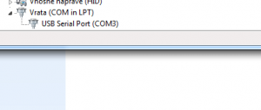](http://stm32f4-discovery.com/wp-content/uploads/usb-uart-bootloader-recognized-device.png)Connect on PC your USB-SERIAL converter, and you will get result as picture below.

Download [Flash Loader Demonstrator](http://www.st.com/web/en/catalog/tools/PF257525) from ST’s official site.

**Install Flash Loader.**

By default, there is no specific settings to set. It should be understandable how to install.

Before we can continue with loader program, we have to prepare hardware for UART bootloader.

**Get your board in hands and do stuff:**

Find **BOOT0** pin and set it to **HIGH**.

(VDD pin is near BOOT0 pin, so if you have jumper, just put it on).

Find **PB2** (**BOOT1**) pin and set it **LOW**.

(GND pin is near PB2 pin, so if you have jumper, just put it on).

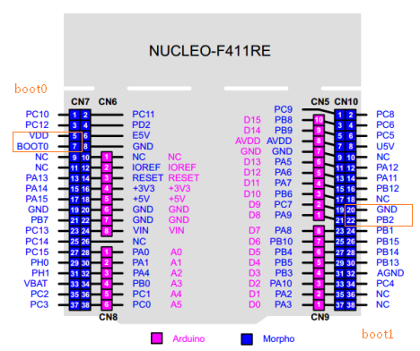 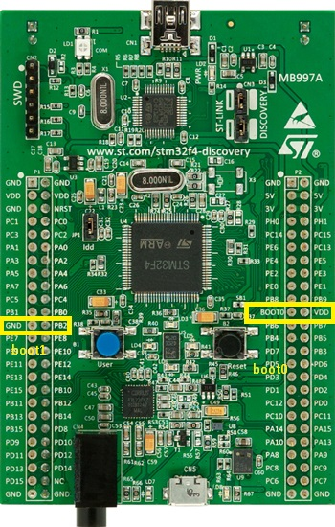

STM32F4xx supports many UART combinations.

* + 1. TX: **PA9**; RX: **PA10**
    2. TX: **PB10**; RX: **PB11**
    3. TX: **PC10**; RX: **PC11**

I tested with these pins, maybe there are more pins.

If you are working with STM32F4-Discovery, then maybe the pins **PA9** and **PA10** will **not** work, because they have capacitor for USB connected to this pin.

**Use any combination that work for you.**

Connect STM32F4xx with USB UART converter in this way:

|  |  |
| --- | --- |
| STM32F4xx | UART USB |
| TX (PA9) or (PB10) or (PC10) | RX |
| RX (PA10) or (PB11) or (PC11) | TX |
| GND | GND |
| 3.3V | 3.3V |
| 5V | N/A |

Now open loader. You should get something like on image below.

[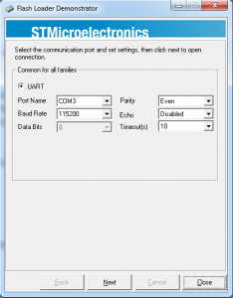](http://stm32f4-discovery.com/wp-content/uploads/usb-uart-bootloader-flash-loader-demonstrator-opened.png)

Leave settings as they are, just change “**Port Name**“, to your port name.

Example this picture show COM3.

[](http://stm32f4-discovery.com/wp-content/uploads/usb-uart-bootloader-recognized-device.png)

Hit “Next”

If you have lucky, then you can go to point B.

If you are not lucky, then you will probably get an error like one below:

[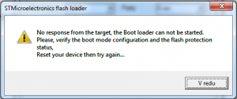](http://stm32f4-discovery.com/wp-content/uploads/usb-uart-bootloader-not-started.png)

If you get this, first make sure that you have correct pinout. Also, make sure that BOOT pins are set correct.

Then, disconnect your board from power (USB probably on discovery) and put power back, and in program test again. It should work and you should go to the next step.

**B.**

When you are OK with detection, you will get window like one below. Hit “Next”.

[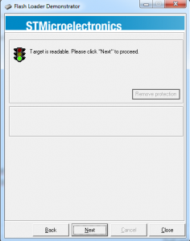](http://stm32f4-discovery.com/wp-content/uploads/usb-uart-bootloader-flash-loader-device-readable.png)

You will get a new window, where you have to select target.

You have to take a value, for your device. If you have 1MB flash size, select STM32F4_1024K for STM32F4-Discovery select **STM32F4_1024K**

**REMARKS :**

**STM32F429-Discovery is not supported, because there is processor with 2MB flash. This size is not supported by ST’s loader tool.**

**SELECT your target**

[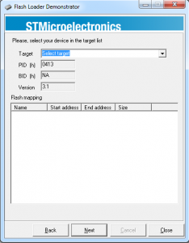](http://stm32f4-discovery.com/wp-content/uploads/usb-uart-bootloader-flash-loader-select-target.png)

“after selecting your target” Hit “Next”

**New window will open.**

There you have to select on of your .hex, .bin or .s19 file.

* Select file under “Download to device” section.
* Leave other settings as they are.
* [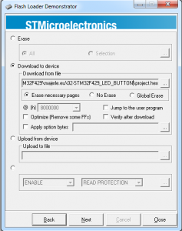](http://stm32f4-discovery.com/wp-content/uploads/usb-uart-bootloader-flash-loader-demonstrator-select-hex-file.png)Hit “Next”. Program will automatically start with downloading data to STM32F4.

Correct written data will be shown with window like my below.

[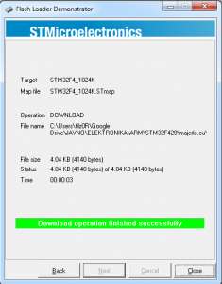](http://stm32f4-discovery.com/wp-content/uploads/usb-uart-bootloader-flash-loader-download-ok.png)

Hit **Close**.

Program is written to device, but if you try to reset device, it will not work. You have to remove jumpers and reset, so that program will boot from flash and not waiting for UART.

* Actually, only BOOT0 has to be set back to LOW

PB2 (BOOT1) does not matter where it is, program will still boot.