Identification of a Pediatric Acute Hypoxemic Respiratory Failure Signature in Peripheral Blood Leukocytes at 24 Hours Post-ICU Admission with Machine Learning
Jocelyn R. Grunwell, MD, PhD*^{1,2}, Milad G. Rad, MS*³, Nadir Yehya^{4,5}, and Rishikesan Kamaleswaran, PhD^{2,3}

Supplementary Data
eFigures.
eFigure 1. Machine Learning Feature Selection Pipeline
eFigure 2. Volcano plots of A) mild pediatric acute respiratory distress syndrome (PARDS; P/F = 200-300) from GSE147902 compared with healthy controls from GSE66099, and B) moderate/severe PARDS (P/F < 200) from GSE147902 compared with healthy controls from GSE66099.

eFiles.
eFile 1. PANEV first-level (1L) gene list for mild pediatric acute respiratory distress syndrome (PARDS; P/F = 200-300) from GSE147902 compared with healthy controls from GSE66099.
eFile 2. PANEV second-level (2L) gene list for mild pediatric acute respiratory distress syndrome (PARDS; P/F = 200-300) from GSE147902 compared with healthy controls from GSE66099.
eFile 3. Summary of genes corresponding to the second-level (2L) PANEV pathways for mild pediatric acute respiratory distress syndrome (PARDS; P/F = 200-300) from GSE147902 compared with healthy controls from GSE66099.
eFile 4. PANEV first-level (1L) gene list for moderate/severe PARDS (P/F < 200) from GSE147902 compared with healthy controls from GSE66099.
eFile 5. PANEV second-level (2L) gene list for moderate/severe PARDS (P/F < 200) from GSE147902 compared with healthy controls from GSE66099.
eFile 6. Summary of genes corresponding to the second-level (2L) PANEV pathways for moderate/severe PARDS (P/F < 200) from GSE147902 compared with healthy controls from GSE66099.
eFile 7. PANEV first-level (1L) gene list for moderate/severe pediatric acute respiratory distress syndrome (PARDS; P/F < 200) versus mild PARDS (P/F = 200-300) from GSE147902.
eFile 8. PANEV second-level (2L) gene list for moderate/severe pediatric acute respiratory distress syndrome (PARDS; P/F < 200) versus mild PARDS (P/F = 200-300) from GSE147902.
eFile 9. PANEV third-level (3L) gene list for moderate/severe pediatric acute respiratory distress syndrome (PARDS; P/F < 200) versus mild PARDS (P/F = 200-300) from GSE147902.
eFile 10. PANEV network (first-, second-, and third-level) for moderate/severe pediatric acute respiratory distress syndrome (PARDS; P/F < 200) versus mild PARDS (P/F = 200-300) from GSE147902.
eFile 11. PANEV first-level (1L) gene list for the overlap of stability selection ranked genes from GSE 147902 and GSE66099 comparing children with a P/F < 200 with a P/F ≥ 200.
eFile 12. PANEV second-level (2L) gene list for the overlap of stability selection ranked genes from GSE 147902 and GSE66099 comparing children with a P/F < 200 with a P/F ≥ 200.
eFile 13. PANEV second-level (3L) gene list for the overlap of stability selection ranked genes from GSE 147902 and GSE66099 comparing children with a P/F < 200 with a P/F ≥ 200.
eFile 14. PANEV network (first-, second-, and third-level) of the common stability selection ranked genes from GSE 147902 and GSE66099 comparing children with a P/F < 200 with a P/F ≥ 200.

eFigure 1.
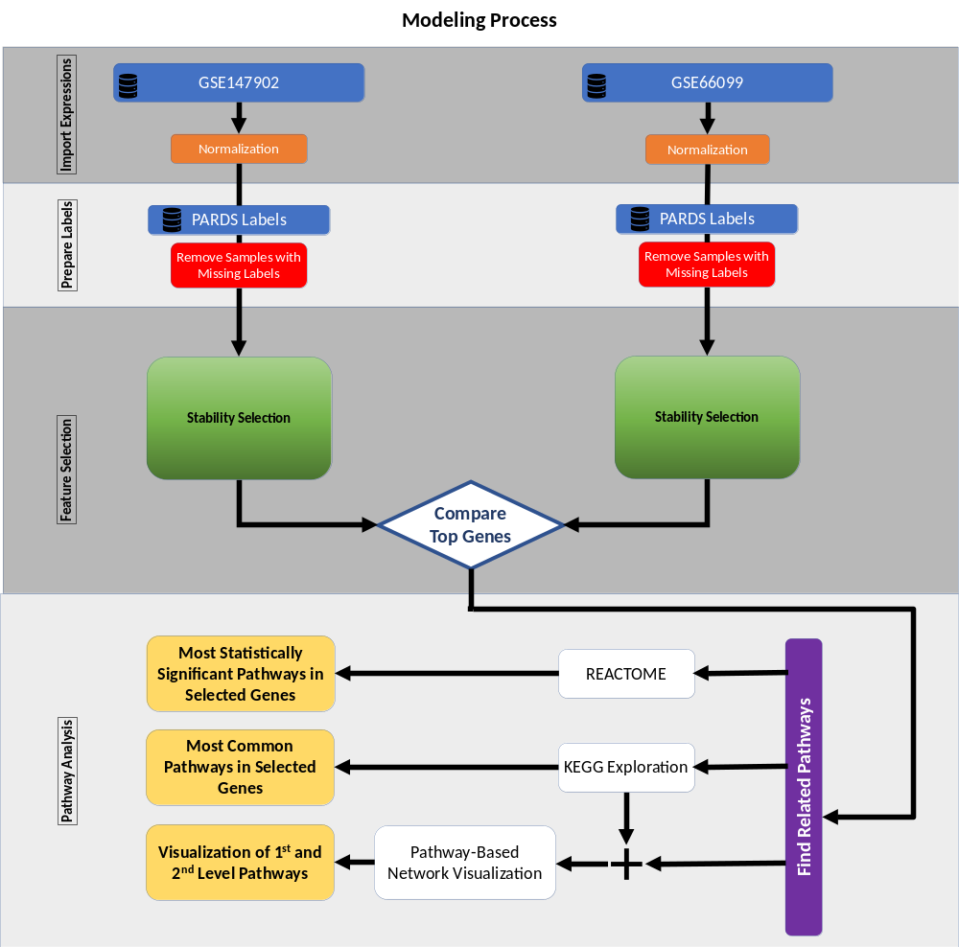

eFigure 2.
