# **Tugas Simple Query MySQL Bagian 2**

1. SELECT * FROM kustomer;

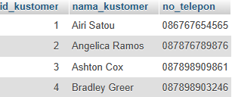

1. SELECT * FROM kustomer WHERE id_kustomer = 1;



1. SELECT * FROM kasir;

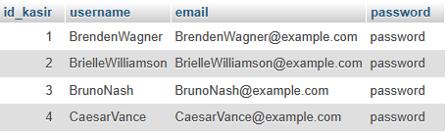

1. SELECT username, email FROM kasir WHERE username = 'CaesarVance';



1. SELECT * FROM jenis_obat;

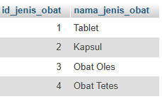

1. SELECT * FROM jenis_obat WHERE nama_jenis_obat LIKE '%Tablet%';



1. SELECT * FROM obat;

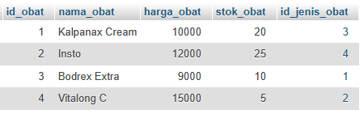

1. SELECT * FROM obat WHERE harga_obat > 10000;

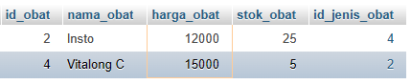

1. SELECT * FROM obat WHERE stok_obat < 10;

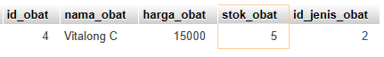

1. SELECT * FROM transaksi;

