Simple Query MYSQL (bagian 2)

1. SELECT * FROM obat ORDER BY id_kategori DESC

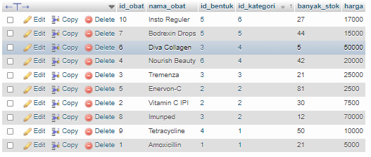

1. SELECT nama_obat, id_bentuk FROM obat ORDER BY nama_obat ASC

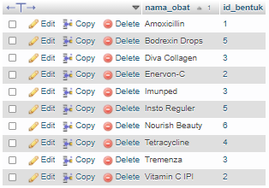

1. SELECT * FROM obat WHERE nama_obat LIKE '%Tetra%'



1. SELECT * FROM obat WHERE nama_obat LIKE '%Bodrex%'



1. SELECT id_kategori, SUM(banyak_stok) as total FROM obat GROUP BY id_kategori

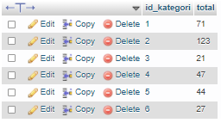

1. SELECT id_bentuk, SUM(banyak_stok) as total FROM obat GROUP BY id_bentuk

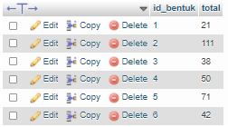

1. SELECT id_operator, SUM(total_harga) as total_transaksi FROM transaksi GROUP BY id_operator



1. SELECT id_operator, SUM(total_harga) as total_transaksi FROM transaksi WHERE total_harga < 100000 GROUP BY id_operator ORDER BY total_transaksi DESC



1. SELECT id_kategori, SUM(banyak_stok) as total FROM obat GROUP BY id_kategori ORDER BY total DESC

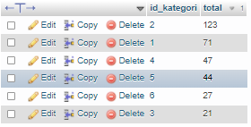

1. SELECT id_kategori, SUM(banyak_stok) as total FROM obat GROUP BY id_kategori ORDER BY id_kategori ASC

