AI-Driven SOC Platform
  - Commercial Architecture & Value Proposition

Executive Summary
The AI-Driven SOC Platform is a next-generation security operations solution designed for Managed Security Service Providers (MSSPs). Unlike traditional SOCs that rely heavily on manual analyst effort, this platform leverages Autonomous AI Agents and the Model Context Protocol (MCP) to deliver scalable, high-speed threat detection and response.
This document outlines the commercial architecture, enabling MSSPs to transform their business model from "hours-based" to "outcome-based" security services.
---

1. The Business Value Proposition
🚀 For the MSSP (The Provider)
- Infinite Scalability: The multi-tenant architecture allows you to onboard hundreds of clients without linearly increasing headcount.
- Higher Margins: Automate Tier 1 and Tier 2 analysis (90% of workload), reducing operational costs by up to 70%.
- New Revenue Streams: Sell "AI-Agent-as-a-Service" and premium "Autonomous Response" capabilities.
- Future-Proofing: Built on MCP (Model Context Protocol), enabling seamless integration with future AI tools and LLMs.
🛡️ For the Client (The End User)
- Mean Time to Respond (MTTR) in Seconds: AI agents detect and contain threats instantly, 24/7.
- Transparency: Real-time dashboards show exactly what the AI is doing, building trust.
- Cost-Effective: Enterprise-grade security at a fraction of the cost of building an internal SOC.

2. Commercial Architecture
The platform is architected to support a multi-tiered service model.
Tier 1: "Essential" (Automated Detection)
- Features:
* Event Ingestion via API.
* ADA (Anomaly Detection Agent) scanning.
* Basic Email Alerts.
- Target: SMEs needing compliance and basic monitoring.
- Tech Stack: BigQuery + ADA Service.
Tier 2: "Professional" (AI Analysis)
- Features:
* All Tier 1 features.
* TAA (Triage & Analysis Agent): AI investigates alerts, reducing false positives.
* MCP Integration: AI queries external threat intel (VirusTotal, AbuseIPDB) automatically.
* Interactive Customer Portal.
- Target: Mid-market companies requiring active defense.
- Tech Stack: ADA + TAA + MCP Server.
Tier 3: "Enterprise" (Autonomous Response)
- Features:
* All Tier 2 features.
* CRA (Containment Response Agent): Automated blocking of IPs, isolation of hosts.
* CLA (Continuous Learning Agent): Custom model training on client data.
* Dedicated Tenant Resources.
- Target: Large enterprises with critical infrastructure.
- Tech Stack: Full Multi-Agent Swarm (ADA, TAA, CRA, CLA).
---

3. Technical Architecture for Sales
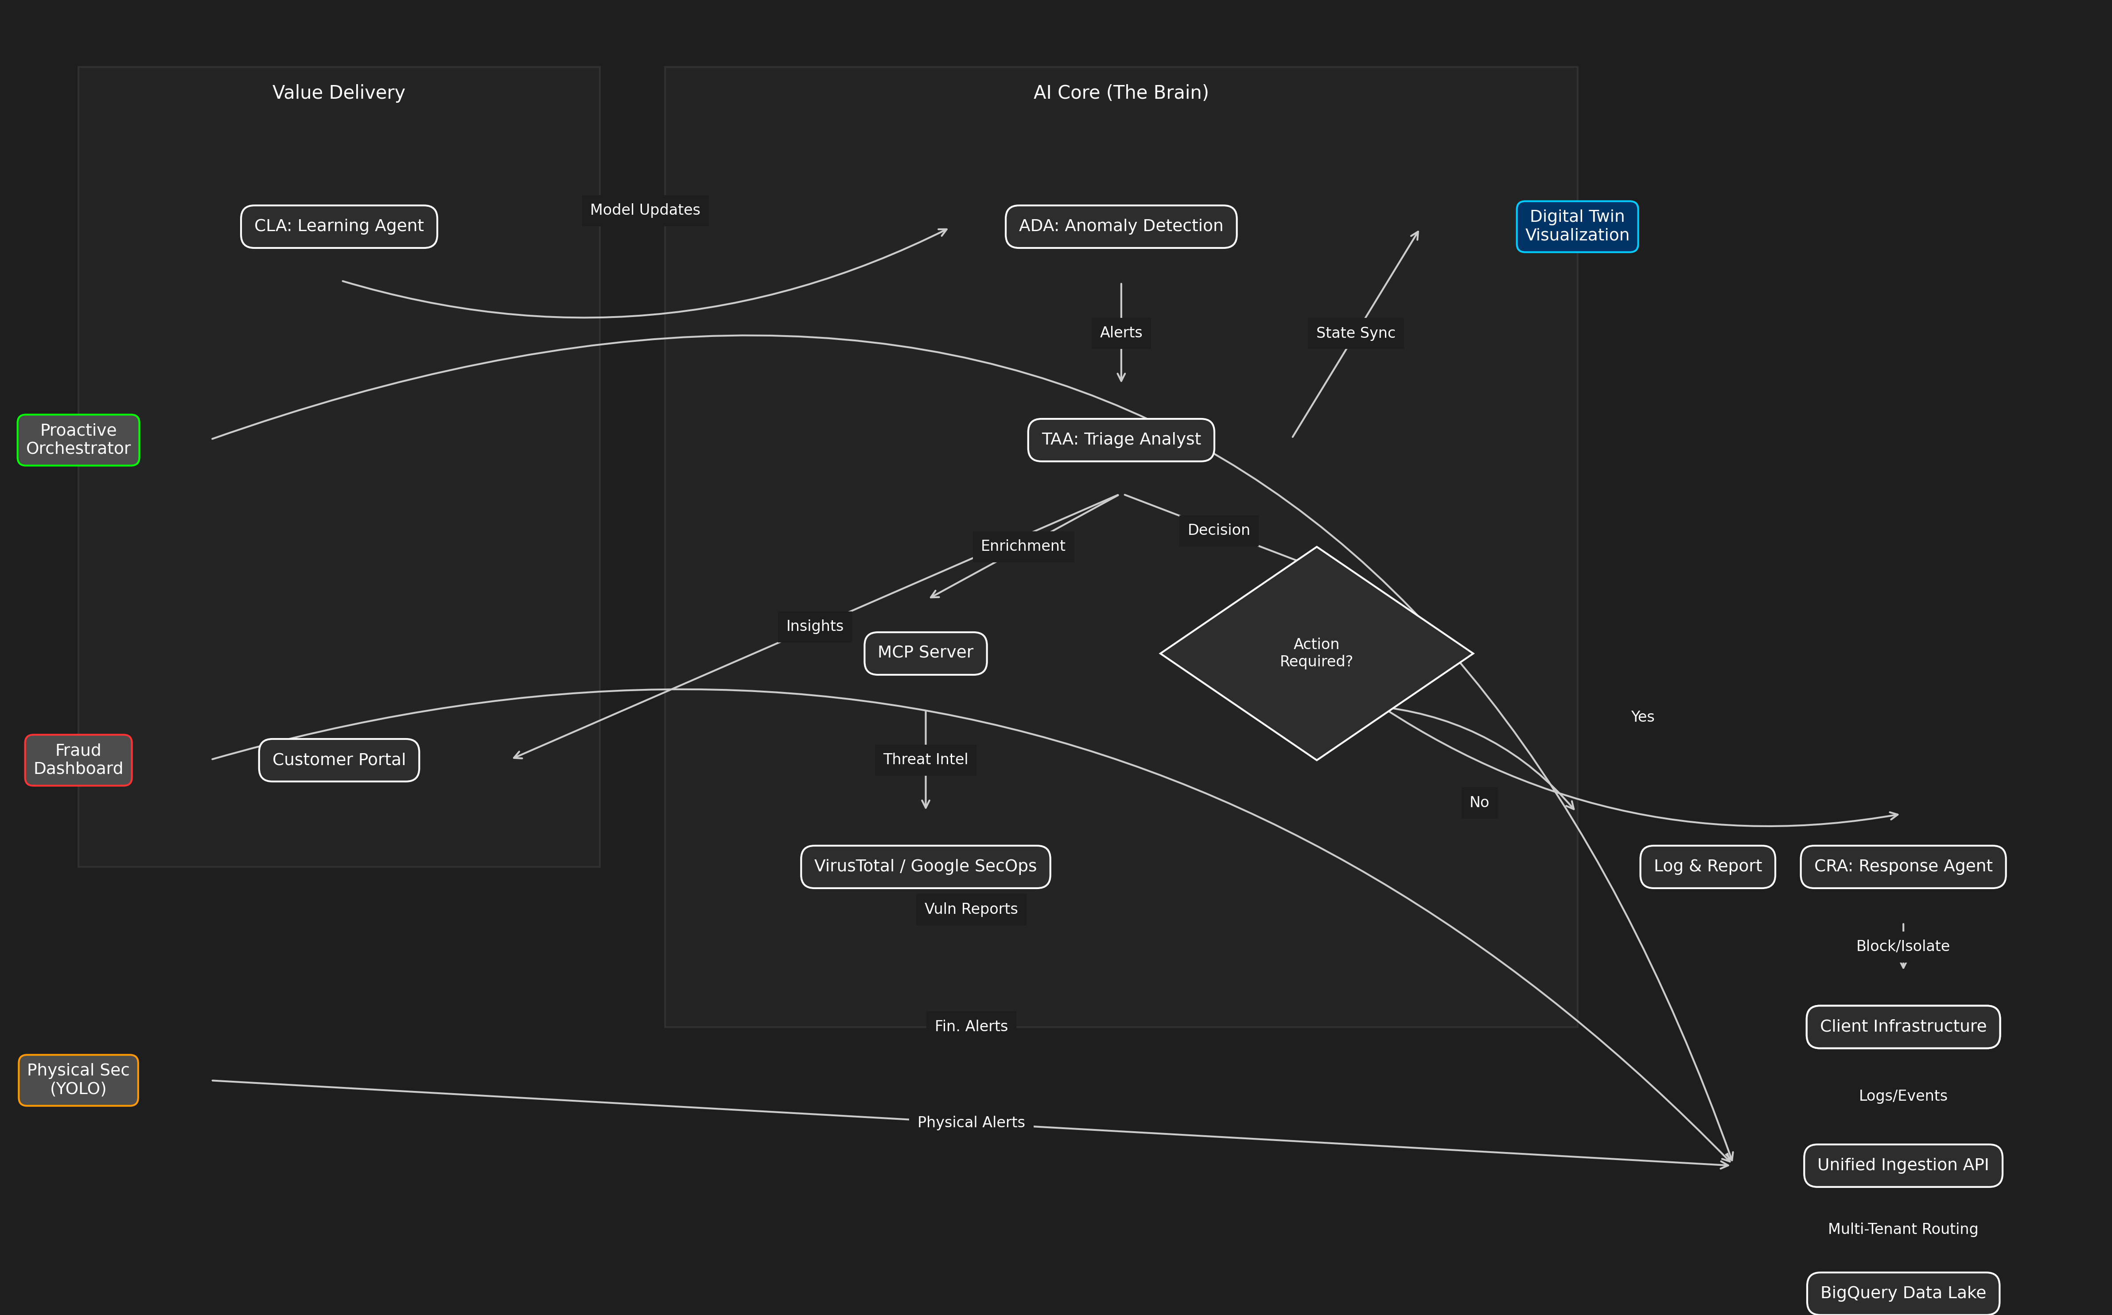
This diagram illustrates how the platform delivers value at every stage of the security lifecycle.
graph TD
Client[Client Infrastructure] -->|Logs/Events| Ingest[Unified Ingestion API]
Ingest -->|Multi-Tenant Routing| BQ[(BigQuery Data Lake)]
subgraph "AI Core (The Brain)"
ADA[ADA: Anomaly Detection] -->|Alerts| TAA[TAA: Triage Analyst]
TAA -->|Enrichment| MCP[MCP Server]
MCP <-->|Threat Intel| Ext[VirusTotal / Google SecOps]
TAA -->|Decision| Router{Action Required?}
end
Router -->|No| Log[Log & Report]
Router -->|Yes| CRA[CRA: Response Agent]
CRA -->|Block/Isolate| Client
subgraph "Value Delivery"
TAA -->|Insights| Portal[Customer Portal]
CLA[CLA: Learning Agent] -->|Model Updates| ADA
end
Key Differentiators (Sales Talking Points)
1. The "Agentic" Advantage: We don't just run scripts; we deploy **AI Agents**.
* Analogy: Scripts are like a checklist; Agents are like an employee who can think, research, and make decisions.
* Benefit: Handles complex, novel threats that rules-based systems miss.
2. Model Context Protocol (MCP):
* What it is: A universal standard for AI tools.
* Why it matters: It means our platform isn't a "walled garden." We can plug in *any* security tool (Chronicle, Splunk, CrowdStrike) and our AI agents can immediately use it.
3. Continuous Learning (CLA)cc:
* The system gets smarter with every alert. If a human analyst marks a false positive, the CLA retrains the models overnight. Your security posture improves daily, automatically.
---

4. Monetization Strategy
API-First Integration
The MSSP Platform Server exposes a clean REST API (`/api/v1/events`, `/api/v1/tenants`).
- Sell Integration: Charge setup fees to integrate with client's existing IT stack.
- Volume Pricing: Charge per GB of ingested logs or per EPS (Events Per Second).
Agentic Add-Ons
- "Investigate with AI" Button: Charge per on-demand deep investigation triggered by the client.
- Custom Compliance Reports: AI-generated reports for GDPR/SOC2, sold as a monthly add-on.
---

5. Advanced Ecosystem Integrations
Expand your service portfolio with our cutting-edge ecosystem modules:
🌐 Digital Twin SOC (Situational Awareness)
- What it is: A real-time 3D visualization of your client's entire network and security posture.
- Value: Transforms abstract logs into a visual "War Room" experience. Instantly spot compromised nodes and attack paths in a 3D space.
- Reference: [Digital Twin Showcase](https://github.com/ghifiardi/digital_twin_SOC_sowcase)
🛡️ Proactive Security Orchestrator (DevSecOps)
- What it is: A "Shift-Left" engine that integrates directly into the client's development pipeline (CI/CD).
- Value: Stops vulnerabilities *before* they reach production. Uses Semgrep and Gitleaks to audit code and secrets automatically.
- Reference: [Proactive Orchestrator](https://github.com/ghifiardi/proactive-security-orchestrator)
👁️ Unified Cyber-Physical Defense (YOLO)
- What it is: AI-powered computer vision integration for physical security feeds (CCTV) and customer touchpoints.
- Use Case: **Fraud & Social Engineering Defense** (Telco/Banking).
- Key Capabilities:
* Face Spoofing & Liveness Detection: Prevents identity fraud using photo/video replay or masks.
* Device Presence Detection: Detects unauthorized recording devices (phones/cameras) pointing at agent screens, a key indicator of **SIM Swap Fraud** or coercion.
* Contextual Risk Signals: Correlates physical behaviors with KYC data to flag high-risk interactions in real-time.
- Value: Bridges the gap between cyber and physical worlds. Detects unauthorized physical access or security breaches that could precede a cyber attack.
- Reference: [YOLO Integration](https://github.com/ghifiardi/YOLO)
🏦 AI Fraud Modelling Dashboard (Banking & Fintech)
- What it is: A specialized module for real-time transaction monitoring and fraud detection.
- Use Case: Financial Crime Prevention & Blockchain Analytics.
- Key Capabilities:
* Multi-Agent Intelligence Network: Connects with regional agents (Jakarta Bank Consortium, Singapore Regional Agent) to share fraud patterns like BI-FAST abuse and money laundering.
* Real-Time Risk Scoring: Uses ensemble models (Random Forest, Isolation Forest) to score transactions in milliseconds.
* Blockchain Integration: Capable of monitoring crypto-asset flows and correlating them with fiat transactions for comprehensive AML (Anti-Money Laundering).
- Value: Reduces false positives in transaction monitoring and enables collaborative defense against global financial fraud rings.
- Reference: [Fraud Modelling Dashboard](https://github.com/ghifiardi/fraud_modelling_dashboard)
---

6. Conclusion
This architecture is not just a tool; it is a business enabler. It allows MSSPs to break the linear relationship between revenue and headcount, delivering superior security outcomes with software economics.

