Problem set 2:

- Throw a (6-face) fair dice twice independently. Let A be the point we get in the first throw, and B be the point we get in the second throw. Let X = A − B be the difference between two points, and Y = A+B be the sum of the two points.
  - Find the range of X and Y.
  - Find pX|Y (x|Y=8).
  - Find E[Y |X ≥ 4].
2. If the probability density function (pdf) of a random variable is given by:

Find a) the expectation E[x], b) variance Var[x]

3. Which of the following are not probability density functions. State why?
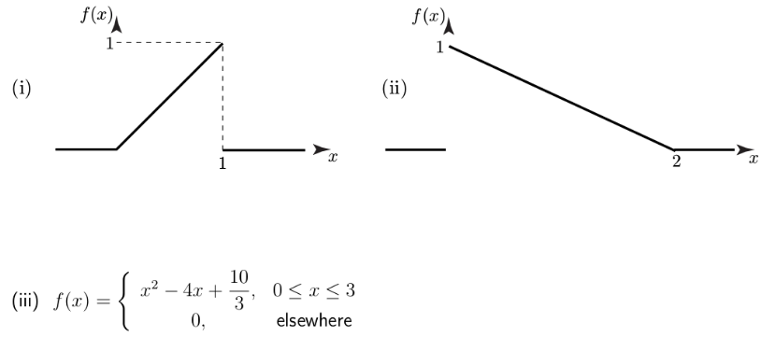

4. If cumulative density function (cdf) of a random variable is given by:

Find a) the probability density function (pdf) p(x), b) the cdf F(x > 2) and c) F(-3 ≤ x ≤ 4)

5. If x and y have the joint probability density function (pdf) given by:

Find a) the conditional probability p(y | x),
b) the cumulative density

