McGill University, Department of Neurology & Neurosurgery
NEUR 531-603

Introduction to Computational Neuroscience
Lab #3: Reverse correlation and visual receptive fields

Part 1: Reverse correlation with a one-dimensional input
The function oned.m simulates the response of a neuron to a stimulus sequence at a single point in space: It takes a one-dimensional temporal input and returns a one-dimensional temporal output. Specifically, the neuron filters the input, applies a static nonlinearity, and returns the result. You should be able to recover both the filter and the nonlinearity, using the methods described in the lecture and in more detail in Chapter 2 of Dayan & Abbott.

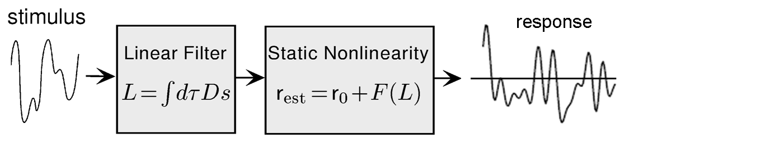

Recovering the filter
- Create a white noise input, using the rand function in Matlab. The input should be a vector of length 1000 with all values between -1 and 1.
- Feed this input into the model neuron by calling the function oned with the noise input.
- Recover the linear filter by computing the cross-correlation of the input and the output. This is described in equation 1.21 of the textbook. The xcorr function in Matlab will be helpful here, but note that it does not perform the normalization necessary to recover the kernel accurately.
- Normalize the filter by the duration of the experiment and by the standard deviation of the input (squared), as in equation 2.6 from Dayan & Abbott. You will notice that the output of xcorr is very long and symmetrical. However, the actual filter is a vector of length 50, so you will need to extract the relevant part from the full cross-correlation. Plot the resulting filter.
  - The previous step requires an understanding of cross-correlation and its implementation in Matlab. Many people are baffled by it. If you are one of those people, read and ponder the Matlab reference on xcorr. If you are still confused, you can do the following simple experiment:
    - Create a vector of 50 zeros; set the first entry to 1.
    - Create a vector of 1000 zeros; set the 333rd entry to 1.
    - Plot the cross-correlation of the two vectors. There will be only one non-zero value, corresponding to the overlap of the two 1s in the vectors. From the position of this non-zero value, you can infer the relevant operations used by xcorr.
- Use convolution to calculate the predicted output of your filter for the white noise stimulus used in the previous step. Superimpose the predicted output upon the real output obtained from oned.m.
- Visualize the static nonlinearity by plotting the output values predicted by the linear filter with the actual observed output values for the same input, as in Figure 2.2 of Dayan & Abbott.

Testing the filter
- Compute the mean squared error between the estimated and observed responses (equation 2.3 of Dayan & Abbott) for various lengths of the input vector. Try input vector lengths of 100, 500, 1000, 2000, 5000. (For better results, compute the mean squared error several times for each input vector length and take the average.)
- Find the parameters of the static nonlinearity (equation 2.10 of Dayan & Abbott) that best fit the static nonlinearity in the model. You can do this by eye or alternatively by function optimization. Apply the static nonlinearity to the predicted output and show how it affects the mean squared error for the same range of input vector lengths used above.

Part 2: Spike-triggered averaging with a three-dimensional input
The function threed.m contains a simulated V1 simple cell. It has a two-dimensional spatial receptive field, and a temporal response that is the same as the one-dimensional filter obtained in Part 1. You should be able to recover the spatial structure of the receptive field using spike-triggered averaging, as described in Chapter 1 of Dayan & Abbott.
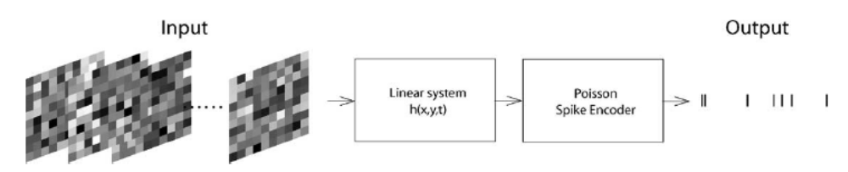

Recovering the filter
- Create a white noise input, using the rand function in Matlab. The input should be a three-dimensional matrix, in which the first two indices refer to space and the third to time. The point is to stimulate the neuron with a series of random images. The function threed expects each spatial image to be square (same number of rows and columns) for this assignment. Thus your white noise matrix should have size (s,s,len), where len is the length. Try an image size of s = 20 and a length of len = 12000.
- Feed this input into the model neuron by calling function threed with the noise input.
- The output will be a one-dimensional vector that contains ones and zeros. The ones correspond to spikes. Calculate the spike-triggered average of the spatial receptive field at the peak of the temporal response, using equation 1.19 from Dayan & Abbott. What is the preferred orientation of the neuron?
- Evaluate the spatial receptive field at the trough of the temporal response. What has changed compared to the peak of the response?

