**ENGR 330**

**Engineering Systems Analysis and Design**

**Project I**

**Report Prepared By:**

**Dai, Yiqiu**

**Ghimire, Mukesh**

**Submission Date: 10/31/2018**

**Introduction**

The main objectives of this project were to design and optimize forces acting on a rider and the settling time of a motor bike going over a bump on the road. A simplified model for the chair and the bike was given and shown in figure 1. Mathematical model for driver, seat and the bike were developed and Simulink model was created accordingly.



Figure 1: Bike (left) and its simplified model (right) along with bump (three period of sine wave)

**Procedure**

At first the mathematical model was derived for driver, chair, and the bike. The models are illustrated below.

Assuming, h > h0 > h1 > h2

The values of constant provided in the problem statement are tabulated in table 1.

Table 1: Parameters for the model

|  |  |  |
| --- | --- | --- |
| Masses (kg) | Spring Constants (N/m) | Damping Constants (N∙s/m) |
| Mass of bike (m) = 150 | K = 25,000 | b = 220 |
| Mass of seat (m1) = 125 | K­1= 4,000 | b1 = 170 |
| Mass of driver (m2) = 75 | K2 = 6,000 | b2 = 10 |

Furthermore, the given bump was simulated using a sine function with amplitude, Y = 0.35m and wavelength, L = 0.65m as shown below:

$$h=Ysin\left(\frac{2∙π∙v}{L}∙t\right)$$ $$h=0.35sin\left(\frac{2∙π∙v}{L}∙t\right)$$

where, $ω= \frac{2∙π∙v}{L}$ is the angular frequency of the input displacement.

As per the requirement of the problem, the sine wave was to start after 2 seconds of the simulation which was done by implementing phase shift to the function shown above as:

$$h=0.35sin\left(\frac{2∙π∙v}{L}∙t-∅\right)$$

where, $∅=2 seconds ∙ ω$

**Results**

1. When the velocity of the bike was 45 miles per hour

Displacement and Force plots with respect to time was plotted using the Simulink when the velocity of the bike was taken to be 45 miles per hour. It can be seen in figure 2 that the displacement for the driver settles down around 12 seconds when the displacement was less than 1mm.

Similarly, the maximum force that the driver experiences when passing this bump at a speed of 45 MPH was found out to be approximately 87.9237 Newtons. This can also be seen in figure 3. The force also gradually decreases and settles down at similar time.

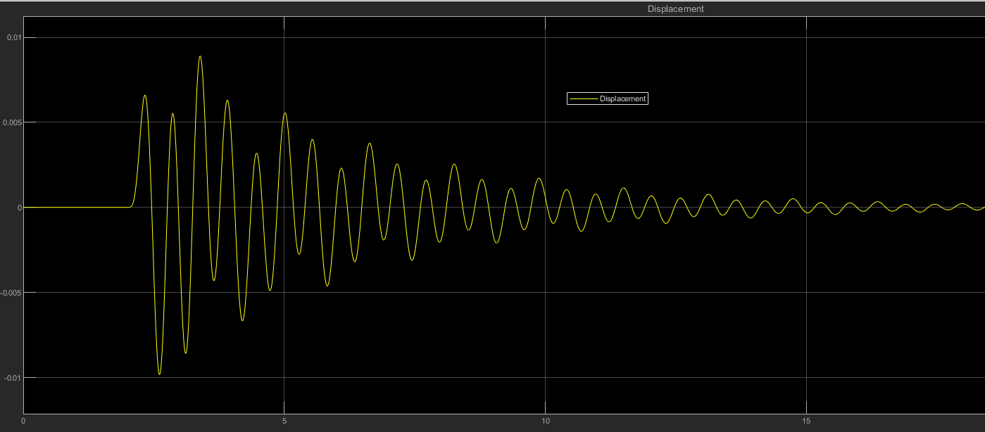

Figure 2: Displacement vs Time graph at 45 MPH

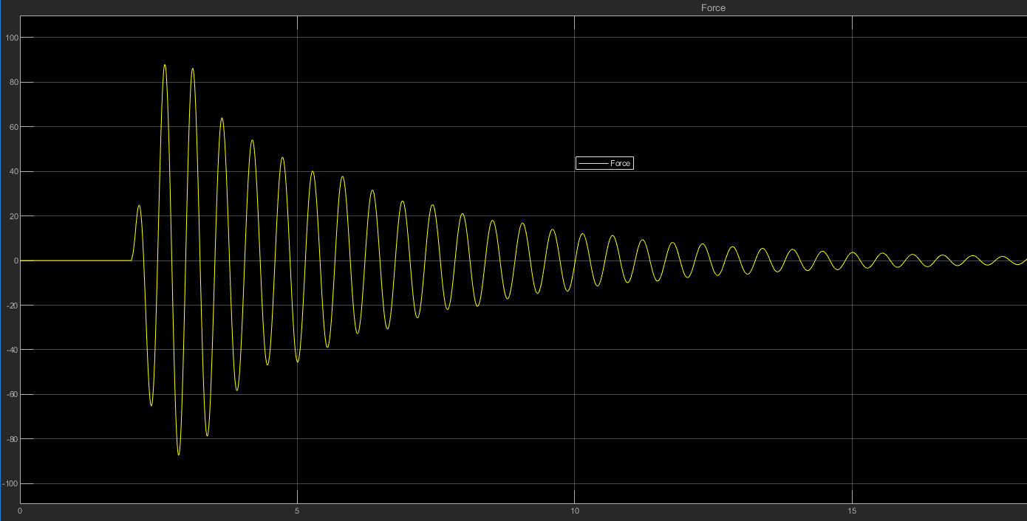

Figure 3: Force vs TIme graph at 45 MPH

1. When the speed of the bike was 100 miles per hour

Similar to above situation, displacement and force graphs with respect to time was plotted and shown in figure 4 and 5. The settling time was found out to be approximately 6 seconds. The maximum force that the driver experiences passing at this speed was found out to be 19.3495 Newtons.

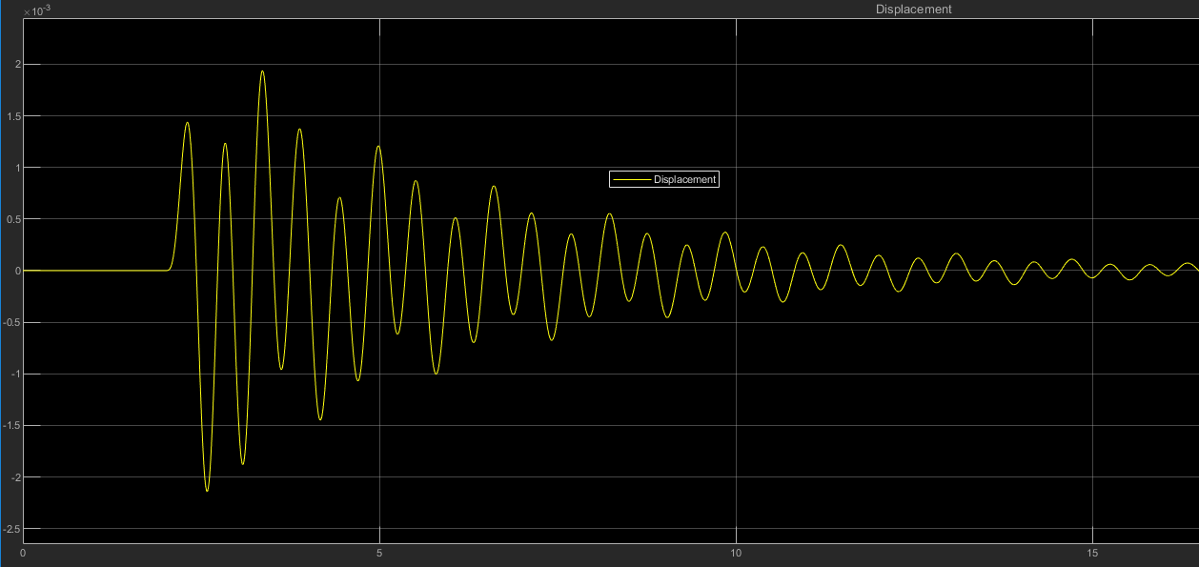

Figure 4: Displacement vs Time at 100 MPH

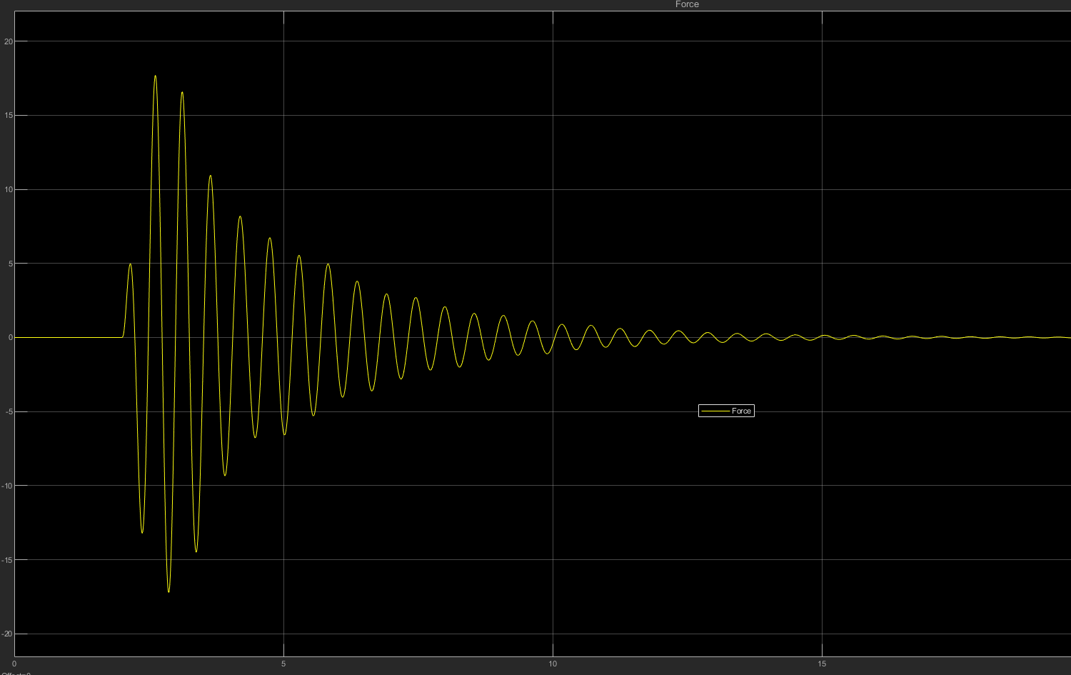

Figure 5: Force vs Time at 100 MPH

**Design Specification**

1. Commuter Bike

The values of k2 and b2 were changed to determine the better design for a commuter bike designed to operate at a lower speed compared to a race bike. Commuter bike is generally made taking luxury into account. When varying the spring constant and keeping the damping coefficient same, it was observed that the force experienced by the driver was greatly minimized. A sample simulation is shown when k2 was set to 1000 N/m compared to the given value of 6000 N/m. The maximum force on the driver was found out to be approximately 9.94 Newtons which was approximately ${\frac{1}{9}}^{th}$ of the force for k2 = 6000 N/m.

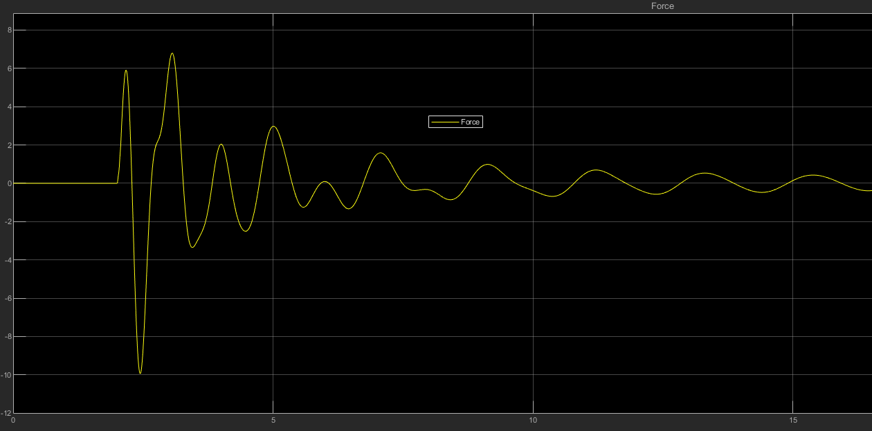

Figure 6: Force vs Time at 45 MPH and k2 = 1000 N/m & b2 = 10 Ns/m

Changing the damping coefficient had very less effect as compared to the spring constant. Keeping the spring-constant the same and increasing the damping coefficient to 100, a simulation was run. Hence, for the commuter bike, the chair should be softer in order to minimize force on the driver and provide comfort while riding the bike.

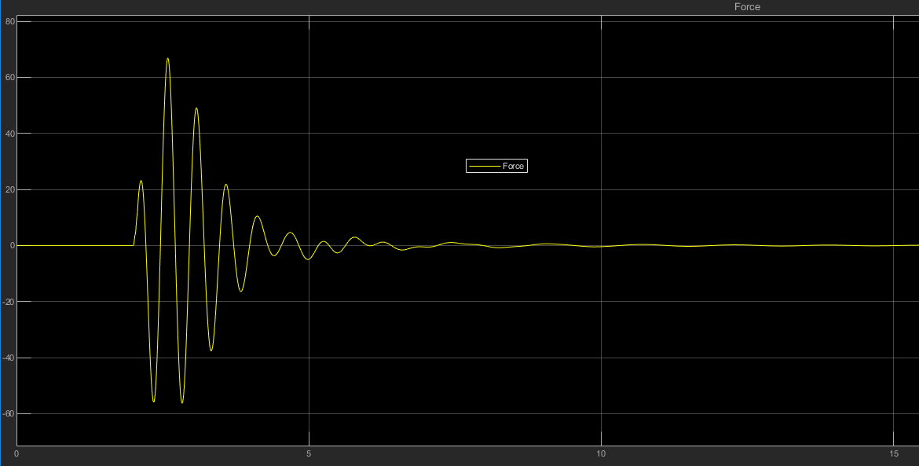

Figure 7: Force vs Displacement at 45 MPH k2 = 6000 N/m & b2 = 100 Ns/m

The results obtained due to these changes are compared below in table 2.

Table 2: Force on driver on changing b2 and k2 at 45 MPH

|  |  |  |
| --- | --- | --- |
| K2 (N/m) | b2 (Ns/m) | Force on the driver (N) |
| 6000 | 10 | 88 |
| 10000 | 10 | 151.3 |
| 6000 | 100 | 66.8 |
| 1000 | 10 | 9.9 |

It can be seen that keeping the damping coefficient constant and decreasing the spring-constant resulted in less force on the driver. This also made sense since low stiffness is generally desired on a commuter bike. Increasing the damping coefficient by a factor of 10 only reduced the force by a factor of 1.3. Hence, increasing the spring constant (k2) and keeping the damping coefficient (b2) the same is the best design for the commuter bike.

1. Race Bike

In the case of race bike, comfort is not what consumer or a bike racer is looking for. A bike racer generally looks for less disturbance and high speed. From design standpoint, a race bike should have high stiffness in spring which causes an increase in force experienced by the driver. In order to compensate for that increase in force the damping coefficient should be increased. A simulation was run with stiffness of spring (k2) set to 8000 N/m and the damping coefficient (b2) set to 350 Ns/m. The maximum force on the driver was found out to be approximately 12 Newtons and the settling time was around 3 seconds. Hence, the disturbance was decreased and the force was also minimized by almost a half.

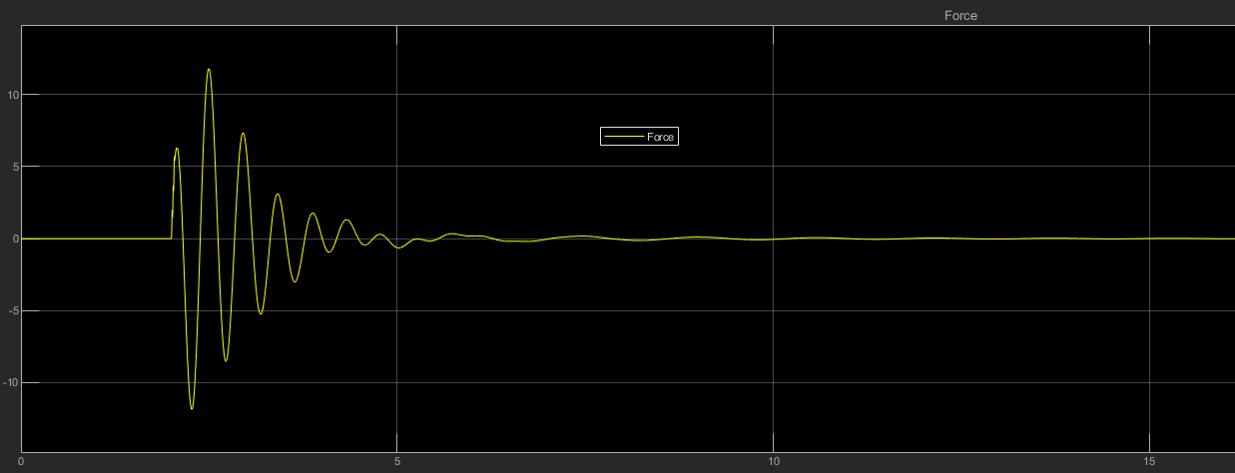

Figure 8: Force vs Time for k2 = 8000 N/m & b2 = 350 Ns/m at 100 MPH

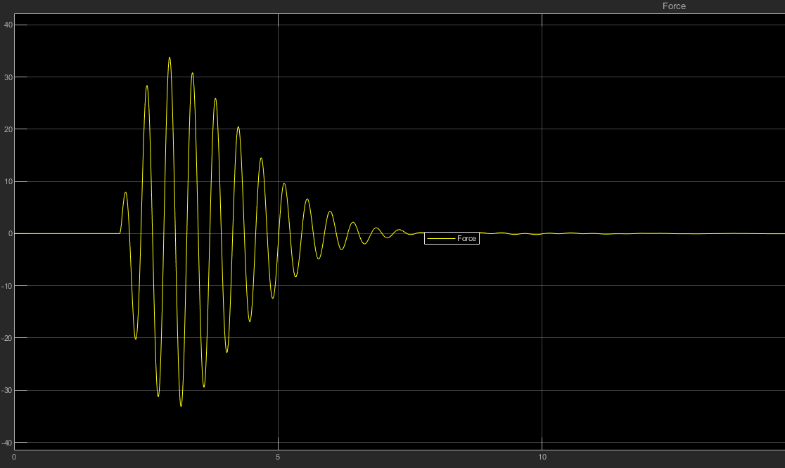

Figure 9: Force vs Time for k2 = 10000 N/m & b2 = 10 Ns/m

The above results are summarized in table 3.

Table 3: Force on the driver at different k2 and b2 at 100 MPH

|  |  |  |
| --- | --- | --- |
| K2 (N/m) | b2 (Ns/m) | Force on the driver (N) |
| 6000 | 10 | 19.4 |
| 10000 | 10 | 33.8 |
| 6000 | 100 | 14.7 |
| 8000 | 350 | 11.9 |

For race car, it was seen that increasing the stiffness while keeping the damping coefficient constant resulted in higher force on the driver. Since it is required for a race car to have higher stiffness for better performance, the increase in force should be compensated by using damper with high damping coefficient. When the stiffness was set to 8000 N/m and the damping coefficient to 350 Ns/m, a force of 11.9 Newtons was exerted to the driver. Hence, a race car should have both higher stiffness and damping coefficient.

**Conclusion**

Hence, by deriving the mathematical model of the system and designing the Simulink model the optimum design parameter for a commuter bike and a race bike was determined. It was observed that commuter bike was not greatly affected by the damping coefficient of the damper. So, an optimum design for a commuter bike was speculated to have relatively low stiffness and an average damping coefficient. Whereas for the race bike, high stiffness is required so as to fulfil the purpose which causes the force to increase. This is then compensated by using a damper with relatively high damping coefficient.

In order to get accurate values for the displacement and force the step time was to be taken very low which increased the processing time for the simulation. In order to reduce the simulation time and obtain the result in less time, the step was kept at a higher value which decreased the accuracy by some amount. By using a powerful machine, the processing time could be reduced and much accurate results can be obtained. However, for this project, which was a simplified model, the results obtained was a good approximation.

Finally, this project provided with an insight about the use of Simulink and MATLAB to visualize an engineering system and quantify the dynamic nature of the system.