Stakeholder Analysis
The stakeholder analysis identifies the main people affected by the proposed Restaurant Table Reservation System and describes their interests and influence. Requirement gathering was carried out using interviews, a questionnaire, observation, document analysis, and brainstorming so that the needs of different stakeholders could be considered.
Stakeholder Analysis
Stakeholder | Role / Interest | Influence
Restaurant Owner/Manager | Oversees operations and needs demand visibility, accurate reporting, table configuration, and staffing information. | High
Host/Hostess | Front-line daily user responsible for reservations, seating, walk-ins, and table status. | High
Customer | End user who searches for and books tables and expects a fast and reliable booking experience. | High
Kitchen Staff | Indirectly affected by reservation volume and timing, which influences food preparation and ticket pacing. | Medium
Servers | Affected by table turnover and assignment, although they are not primary system users. | Low-Medium

Requirement Gathering Techniques
Five complementary requirement-gathering techniques were used to understand the existing reservation process and identify the requirements for the proposed system. These techniques allowed information from one method to be cross-checked against the findings from other methods.
Technique | Purpose | Participants / Source
Interviews | Obtain in-depth qualitative information about daily booking workflows and operational problems. | Restaurant manager, one host, one regular customer
Questionnaire / Google Forms | Gather broader quantitative feedback about the current reservation process and desired system features. | 40 customers and 6 staff respondents
Observation | Observe actual service operations and identify problems that may not be mentioned during interviews. | Front-of-house operations over 3 dinner services, including one Friday peak
Document Analysis | Examine existing records to identify and quantify reservation-related problems. | Two months of reservation diary and walk-in whiteboard records
Brainstorming | Generate and prioritize possible system features with restaurant staff. | Manager, hosts, server representative, and kitchen lead

Interviews
Interviews were conducted with the restaurant manager, one host, and one regular customer. The interviews focused on the current reservation workflow, operational difficulties, table availability, and improvements expected from a digital reservation system.
The interview findings identified problems including manual phone reservations, double-booking risks, lack of a live table-status view, and difficulty producing accurate reservation information for management.
Questionnaire / Google Forms
A questionnaire was used to gather broader feedback from customers and staff. The questionnaire results included responses from 40 customers and 6 staff members. Questions focused on the existing reservation process, customer preferences, and problems experienced during busy periods.
Finding | Result
Customers preferring online booking | 30 of 40 customers (75%)
Customers finding phone booking inconvenient or very inconvenient | 26 of 40 customers (65%)
Customers who would use a mobile-friendly booking page | 24 of 40 customers (60%)
Staff identifying reservation calls during service as a major distraction | 5 of 6 staff (83%)

The questionnaire results indicate strong demand for an online reservation process. Most responding customers preferred online booking, while a majority also considered the existing phone-based process inconvenient. Staff responses showed that handling reservation calls during service was a significant distraction from table-side duties.
Observation
Direct observation was carried out during three dinner services, including one Friday peak period. The observation identified problems with walk-in wait-time estimates and concurrent reservation entries. During the observed Friday service, two separate double-booking incidents occurred within the same 15-minute window, and several walk-in parties received wait-time estimates that later changed by more than 15 minutes.
Document Analysis
Two months of the restaurant's paper reservation diary and walk-in whiteboard records were reviewed. The analysis identified an average of 11 illegible or ambiguous entries per week that required follow-up calls. The records also did not provide a reliable method for calculating the restaurant's no-show rate.
Brainstorming
A brainstorming session was used to generate and prioritize candidate features for the proposed system. Participants included the manager, hosts, a server representative, and the kitchen lead. The discussion supported features such as table search and booking, live table-status management, reservation history, reminders, reporting, and role-based staff access.
Overall Findings
The combined findings from stakeholder analysis and requirements gathering show that the existing manual reservation process creates avoidable operational problems. The most significant issues are double-booking, lack of real-time table visibility, interruptions caused by phone reservations, difficulty producing reservation reports, and the absence of automated reminders. These findings support the proposed Restaurant Table Reservation System and its functional and non-functional requirements.
Questionnaire and Google Forms Screenshots
The following screenshots provide visual evidence of the customer questionnaire and the collected Google Forms responses used during requirement gathering.
Figure 1: Questionnaire / Google Forms screenshot
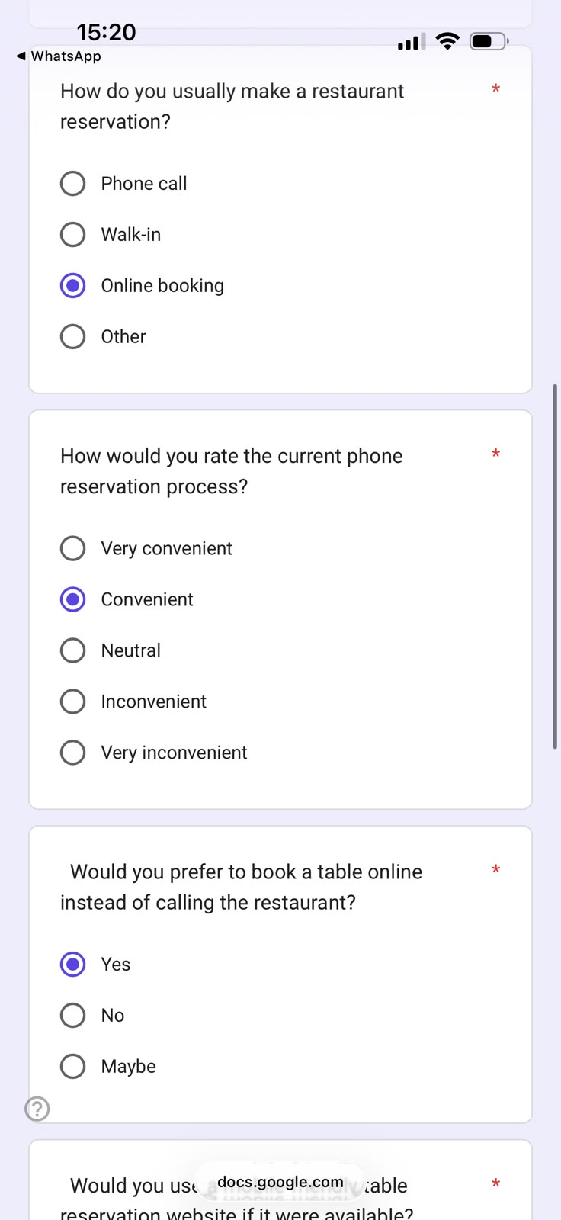

Figure 2: Questionnaire / Google Forms screenshot
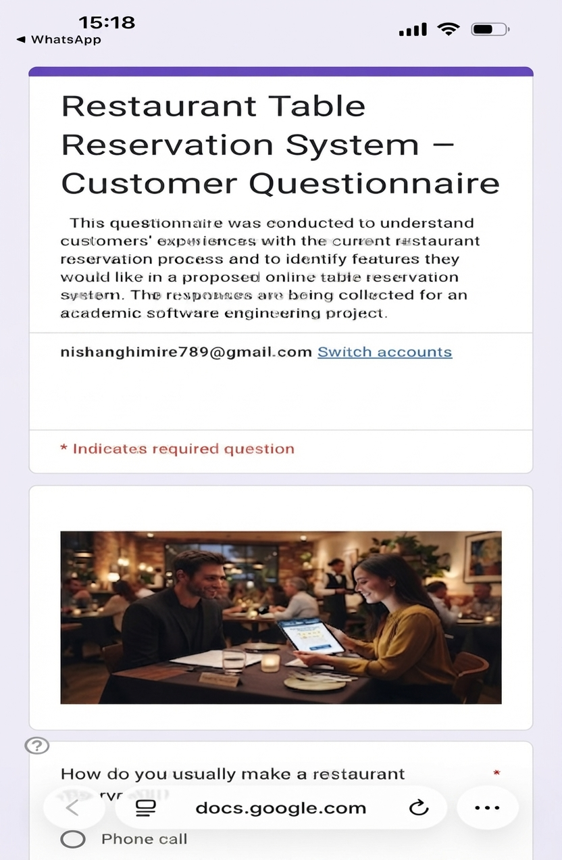

Figure 3: Questionnaire / Google Forms screenshot
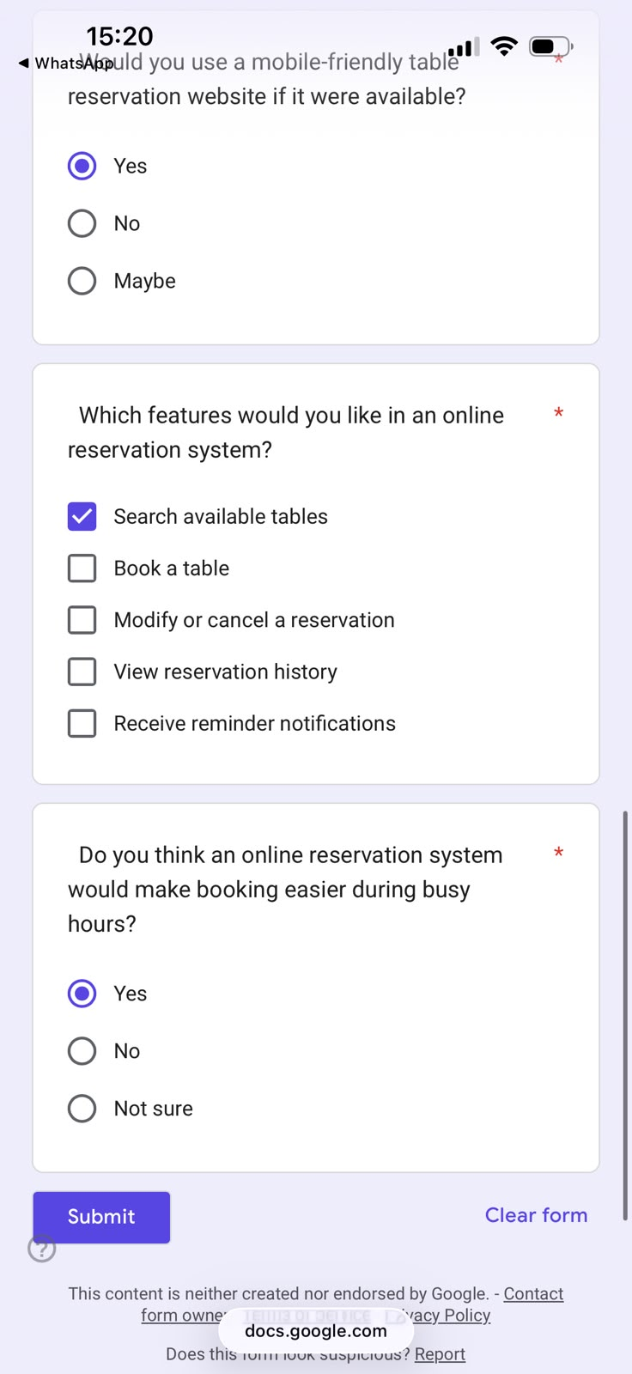

Figure 4: Questionnaire / Google Forms screenshot

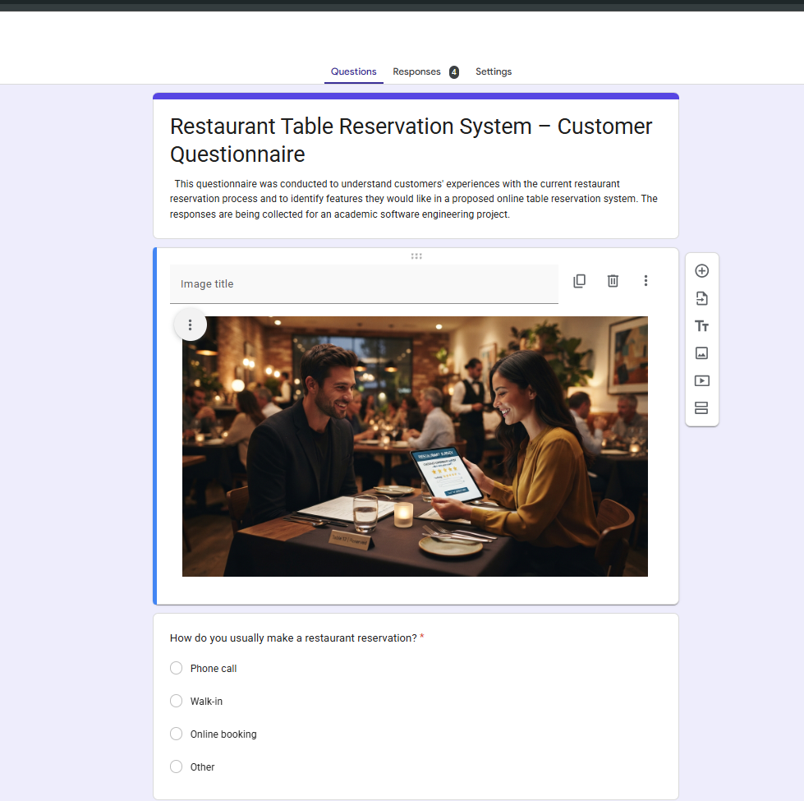

Figure 5: Questionnaire / Google Forms screenshot

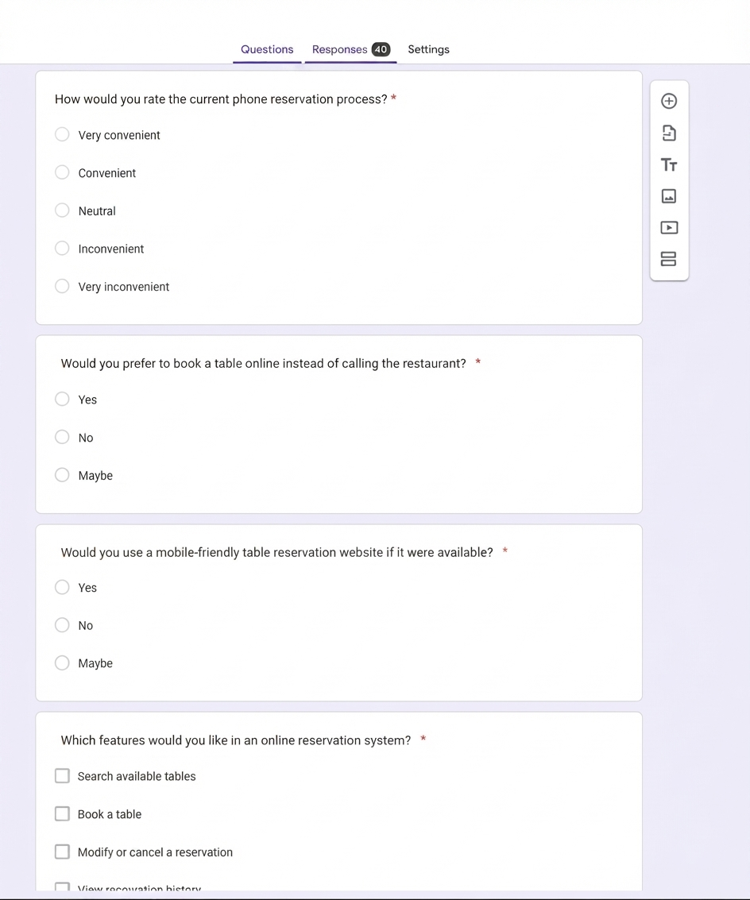

Figure 6: Questionnaire / Google Forms screenshot

