

**Tribhuvan University**

**Faculty of Humanities and Social Sciences**

**CROCHET E-COMMERCE SYSTEM**

**A PROJECT REPORT**

**Submitted to:**

**Department of Computer Application**

**Bhaktapur Multiple Campus**

***In partial fulfillment of the requirements for the degree of Bachelor of Computer Applications***

**Submitted by:**

**Pramisha Paudel (6-2-20-19-2022)**

**Nirjala Ghimire (6-2-20-17-2022)**

March,2025

**Under the Supervision of**

**Mr. Madan Nath**



**Tribhuvan University**

**Faculty of Humanities and Social Sciences**

**Bhaktapur Multiple Campus**

**Supervisor’s Recommendation**

I hereby recommend that this project prepared under my supervision by Pramisha Paudel and Nirjala Ghimire entitled “**Crochet E-Commerce System**” in partial fulfillment of the requirements for the degree of Bachelor of Computer Application is recommended for final evaluation.

**Mr. Madan Nath**

Supervisor/ Coordinator

Department of Computer Application

Bhaktapur Multiple Campus



**Tribhuvan University**

**Faculty of Humanities and Social Sciences**

**Bhaktapur Multiple Campus**

**LETTER OF APPROVAL**

This is to certify that this project prepared by **Pramisha Paudel**  and **Nirjala Ghimire** entitled " **Crochet E-Commerce System**" in partial fulfillment of the requirements for the degree of Bachelor in Computer Application has been evaluated. In our opinion it is satisfactory in the scope and quality as a project for the required degree.

|  |  |
| --- | --- |
| Mr. Madan Nath  Supervisor/Coordinator  Bhaktapur Multiple Campus  Dudhpati Bhaktapur,Nepal | |
| **Internal Examiner** | **External Examiner** |

# ABSTRACT

The Crochet E-Commerce System is an online platform designed to support crochet artisans in Nepal by enabling them to showcase and sell their handmade products efficiently. The system provides simple interface for managing inventory, processing orders, and managing customers. Developed using HTML, CSS, and JavaScript for the frontend and PHP for backend operations, the system ensures secure handling of customer data and transactions with MySQL as the database. The methodology involves designing a user-friendly interface, implementing a structured database schema, and integrating order and inventory management functionalities. The system includes an admin panel for managing products and orders, while customers can browse items, place orders, and create accounts. Authentication is handled using PHP’s ‘password_hash’ function to ensure secure login credentials. The system was tested for functionality and usability, verifying smooth navigation, accurate inventory tracking, and secure authentication. The results demonstrate that the system simplifies online selling for artisans, improves customer accessibility, and contributes to the growth of Nepal’s crochet community.

***Keywords: Crochet System, Online Store, Handmade Products, Inventory Tracking, Simple Web Application***

# ACKNOWLEDGEMENT

We would like to express our sincere gratitude to the faculty members of the BCA department for their guidance and support throughout this project. We extend our heartfelt appreciation to **Bhaktapur Multiple Campus** for providing us with the opportunity and resources to undertake this project. A special note of thanks goes to our project coordinator and supervisor, **Mr. Madan Nath**, whose invaluable guidance, encouragement, and insightful suggestions greatly contributed to the successful completion of this project and its documentation. We are also deeply grateful to our teachers for their continuous support and knowledge-sharing, which have been instrumental in our academic growth. Furthermore, we would like to acknowledge our parents for their unwavering encouragement and support throughout this journey. Lastly, we sincerely thank our friends for their collaboration and motivation, which have made this experience even more valuable.

Pramisha Paudel (6-2-20-19-2022)

Nirjala Ghimire(6-2-20-17-2022)

## LIST OF ABBREVIATIONS

BCA Bachelor’s in Computer Applications

CASE Computer Aided Software Engineering

CSS Cascading Stylesheet

DFD Data Flow Diagram

ERD Entity Relation Diagram

HTML Hypertext Markup Language

JS Java Script

MYSQL My Structured Query Language

PHP Hypertext Preprocessor

UI User Interface

## LIST OF FIGURES

**Figure 3.1: Use Case Diagram** 15

**Figure 3.3 ER Diagram** 17

**Figure 3.4 DFD 0 Diagram** 18

**Figure 3.5 DFD 1 Diagram** 18

**Figure 3.6 System Architectural Design** 19

**Figure 3.7 Database Schema** 20

## List of Table

**Table 4.1: Test case of Crochet Ecommerce System Admin Login** 32

**Table 4.2: Test case of Crochet Ecommerce User Login** 33

**Table 4.3: Test case of Crochet Ecommerce System Registration** 33

**Table 4.4: Test case of Crochet Ecommerce System** 34

**Table of Contents**

ABSTRACT iv

ACKNOWLEDGEMENT v

LIST OF ABBREVIATIONS vi

LIST OF FIGURES vii

List of Table 8

CHAPTER 1: Introduction 11

1.2 Problem Statement 11

1.3 Objectives 12

1.4 Scope and Limitation 12

1.4.1 Scope of the project: 12

1.5 Report Organization 12

CHAPTER 2: Background Study and Literature Review 13

2.1 Background Study 13

2.2 Literature Review 14

CHAPTER 3: System Analysis and Design 14

3.1 System Analysis 14

3.1.1 Requirement Analysis 15

3.1.2 Feasibility Study 17

3.1.3 Data Modeling: E-R Diagram 18

3.1.4 Process Modeling 19

3.2 System Design 21

3.2.1 Architectural Design 21

3.2.2 Database Schema Design 22

3.2.3 Interface Design 22

3.2.4 Activity diagram 23

CHAPTER 4: Implementation and Testing 25

4.1 Implementation 25

4.1.1 Tools Used 25

4.1.2 Implementation Details of Modules 26

4.2 Testing 27

4.2.1 Test Case for Unit Testing 27

4.2.2 Test Case for System Testing 29

5.1 Lesson Learnt/ Outcome 31

5.2 Conclusion 31

5.3 Future Recommendation 31

References 33

# CHAPTER 1: Introduction

* 1. **Introduction**

The Crochet E-Commerce System is a web-based platform designed to manage and promote the crochet items. Unlike general e-commerce platforms, this system is tailored to meet the specific needs of a single business, helping streamline operations and improve customer experience.

The platform features a customer-friendly interface where the shop owner can upload crochet products, manage inventory, and process customer orders. Customers can browse the available products, place orders, and enjoy a seamless shopping experience. The system also provides tools to track sales and manage customer interactions, making it easier to handle day-to-day business operations efficiently.

The goal of this system is to provide an effective digital solution for managing the sales, improving its online presence, and reaching more customers. With its simple design and essential features, the Crochet E-Commerce System offers a practical and efficient way to enhance business operations.

## 1.2 Problem Statement

In today’s digital era, managing a business efficiently requires robust tools for handling customer interactions, inventory, and order processing. However, the crochet artists faces significant challenges in selling their items due to the absence of a dedicated digital E-Commerce system.

The struggles with manual customer management, leading to delays in responding to inquiries and difficulties in maintaining consistent communication. Order placement and tracking processes are time-consuming and prone to errors, which affects customer satisfaction. Additionally, inventory management relies on traditional methods, making it difficult to update stock levels in real-time, leading to issues such as overstocking or unintentional stock outs.

These inefficiencies hinder the ability to provide a seamless shopping experience for customers and limit its growth potential in the competitive market. To address these challenges, the Crochet E-Commerce System will provide an integrated solution, streamlining customer management, order processing, and inventory tracking to ensure smoother operations and improved customer satisfaction.

## 1.3 Objectives

The main objective of Crochet E-Commerce System are:

* To develop web based e-commerce system for crochet items.

## 1.4 Scope and Limitation

Our future plan for this system is to ensure that the website is available, accessible and reachable to every customer who prefers to buy crochet items. In the future this system will fulfill the necessity in a speedy manner.

### 1.4.1 Scope of the project:

* Maintain customers data and orders record.
* Customers can feel easy, fast and reliable to use system.

**1.4.2 Limitation of the project:**

* **Limited Features**: Focuses mainly on order management and inventory, not offering other crochet-related resources (e.g., tutorials or designs).
* **Internet Dependence**: Requires a stable internet connection for placing orders and updating records.
* **No Customer-Generated Content**: Customers can only browse and purchase pre-listed yarn and supplies; no option to add personal items.

## 1.5 Report Organization

In Chapter 1: Introduction, It explains the overview, introduction, problem statement, objectives, scope and limitation and development methodology of the proposed system.

In Chapter 2: Background Study and Literature Review, It covers background study and literature reviews.

In Chapter 3: System Analysis and Design, It explains the basic requirements of the system with system design.

In Chapter 4: Implementation and Testing, It covers implementation and testing.

In Chapter 5: Conclusion and Future Recommendation, It covers future recommendations and conclusions.

# CHAPTER 2: Background Study and Literature Review

## 2.1 Background Study

The **Crochet E-Commerce System** is a web-based platform designed to streamline the E-Commerce of crochet products and enhance the customer experience. Similar to other e-commerce solutions, this system offers a customer-friendly interface that allows shop owners to manage inventory, process orders, and track sales. For customers, it simplifies the process of browsing products, placing orders, and tracking purchases, ensuring a seamless shopping experience. By integrating order management and real-time inventory updates, the system aims to overcome the inefficiencies associated with manual management, improve customer satisfaction, and facilitate business growth for Crochet items. This approach not only enhances operational efficiency but also provides a practical solution for small businesses in the crochet industry.

## 2.2 Literature Review

Handicrafts In Nepal, an online platform, facilitates the sale of Nepali handmade products, including crochet items, targeting wholesale buyers [1]. The website offers a catalog of handicrafts with detailed product descriptions and supports bulk orders, demonstrating a practical approach to e-commerce for artisans in Nepal. This highlights the potential for niche platforms to connect local crochet sellers with broader markets.

Swodeshi, another Nepali e-commerce site, promotes "Made in Nepal" products, including handicrafts like crochet goods, with a focus on worldwide delivery [2].Launched over three years ago, it provides a user-friendly interface for browsing and purchasing, emphasizing accessibility for international customers. This model suggests that crochet e-commerce systems can expand market reach beyond Nepal’s borders.

These sources collectively illustrate the growing role of e-commerce in promoting Nepali handicrafts, including crochet products. The Crochet E-Commerce System builds on these examples by offering a tailored solution with real-time inventory management, order processing, and a sales dashboard, addressing manual inefficiencies and enhancing the shopping experience for crochet customers in Nepal.

# CHAPTER 3: System Analysis and Design

## 3.1 System Analysis

The **Crochet E-Commerce System** is designed to simplify order placement, tracking, and inventory management for both customers and the shop owner. Customers can browse and select from a list of pre-listed crochet products, view their details, and place orders through a simple and secure process. The system focuses on providing an easy, fast, and reliable experience without the ability for customers to generate content or add new products, adhering to the project’s limitations. For the shop owner, the system tracks inventory and orders, offering a streamlined way to manage stock and sales. The system is dependent on a stable internet connection and focuses solely on basic order and inventory management, without additional features like tutorials or advanced product categorization.

### 3.1.1 Requirement Analysis

#### Functional Requirement

The **Crochet E-Commerce System** must provide the following essential services to ensure smooth operation for both shop owners and customers. These requirements define the core functions and how the system should interact with customers:

• **User Registration and Login:** New users must register before placing order, they can log in using their phone number and password.

• **Admin Management:** The admin is pre-registered and has the authority to manage products, users, and orders.

• **Product Management:** The admin can add, edit, and delete crochet items available for sales.

• **User Management:** The admin can view registered users and has the ability to delete users if necessary.

• **Order Management:** The admin can accept or delete customer orders based on availability and other factors.

• **Logout:** Both the admin and users can log out of the system after completing their tasks.

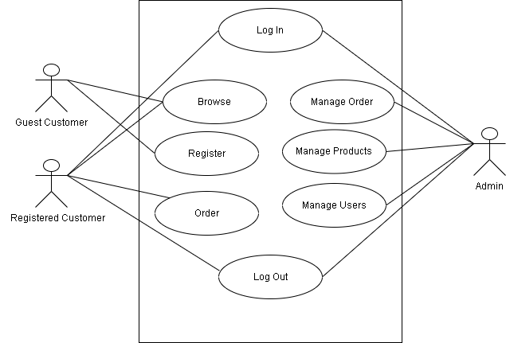

**Figure 3.1: Use Case Diagram**

#### Non-functional Requirements

**Availability:**

The system should be highly available, ensuring that the website is always accessible to users. Downtime should be minimized, and the system should consistently perform essential functions without errors, offering reliable user experience.

**Efficiency:**

The website should ensure fast loading times for product pages, search results, and order processing. It should be optimized for efficient performance, even when the website experiences high traffic or many concurrent users.

**Usability:**

The system should offer an intuitive and accessible interface for both customers and administrators. It should allow customers to easily browse crochet items and complete purchases while also providing admins with simple tools to manage products, orders, and customers.

**Scalability:**

The system should be scalable, capable of handling an increasing number of users, products, and transactions as the website grows. It should accommodate future expansions, such as the addition of new features or increased traffic during promotional events.

**Maintainability:**

The system should be easy to maintain, with clear code structure and documentation. This will ensure that future updates, bug fixes, or feature enhancements can be carried out efficiently.

These non-functional requirements ensure that the Book Ordering System is fast, secure, reliable, and easy to use, providing an optimal shopping experience for customers while allowing administrators to manage the platform effectively.

### 3.1.2 Feasibility Study

A feasibility study is an evaluation and analysis of a project or system that somebody has proposed.

#### ****Technical Feasibility****

The system is designed to manage orders, inventory, and customer records easily. It uses **PHP** for backend processing, **MySQL** for secure data storage, and **HTML, CSS, and JavaScript** for an interactive and customer-friendly interface. The technology stack is robust and scalable, ensuring smooth operations and easy maintenance.

#### ****Operational Feasibility****

The system offers a simple, intuitive interface for both shop owners and customers, requiring minimal technical expertise to operate. It is accessible on devices with basic hardware and software configurations, making it feasible for widespread use. The design ensures it effectively meets the objectives of order placement, tracking, and inventory management.

#### ****Economic Feasibility****

The project utilizes open-source tools, keeping development costs minimal. No additional software or hardware purchases are necessary, making it highly cost-effective while delivering essential features to meet business needs efficiently.

#### Schedule Analysis

The project had followed a well-structured timeline, ensuring its completion within 12 weeks. It had begun with planning and analysis, followed by system design and development. Testing had run parallel to later development stages to ensure quality, while documentation had been prepared after the project's completion. The schedule had been realistic, allowing sufficient time for each phase, making the project feasible within the given timeframe.

### 3.1.3 Data Modeling: E-R Diagram

Designing an Entity-Relationship (ER) diagram for a crochet ordering involves identifying and defining the entities, relationships, and attributes relevant to the system. So here is an ER diagram for Crochet E-Commerce System.

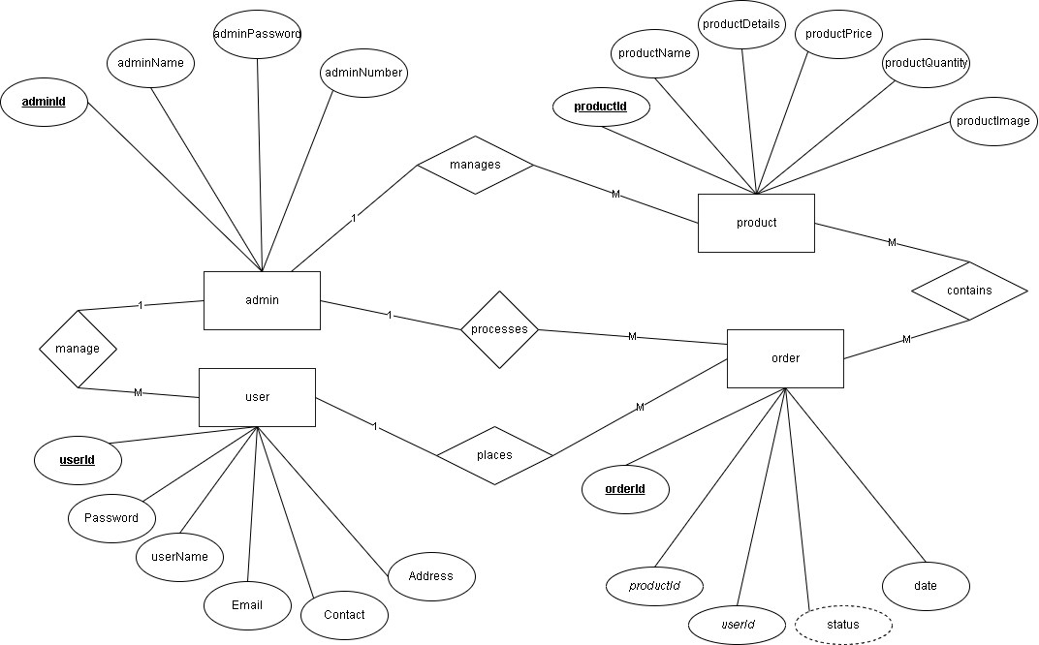

**Figure 3.3 ER Diagram**

### 3.1.4 Process Modeling

#### Context Level Diagram

The context level diagram offers a clear picture of how the system interacts with customers. Customers can view products, make purchases and create their customer account in the system. Admin panel serves as a gateway for administrators to manage the product catalog. Administrators, as internal customers, can add products, delete it and edit the existing products.

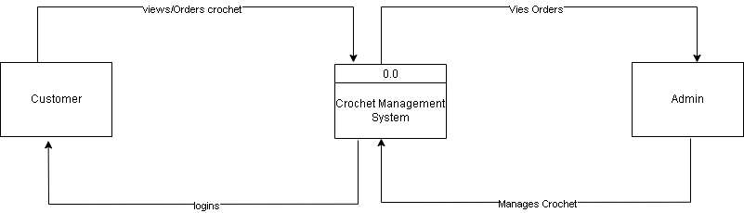

**Figure 3.4 DFD 0 Diagram**

#### Data Flow Diagram

In the level 1 DFD. We dive deeper into the functionalities into the Crochet E-Commerce System. Website, focusing on the data flow between various components. After customer’s login to the system, it interacts with the product database to buy products and update the order database. When admin add, delete, edit products, it interacts with product database. Admin can view the order after customer add products to cart and proceed for buying.

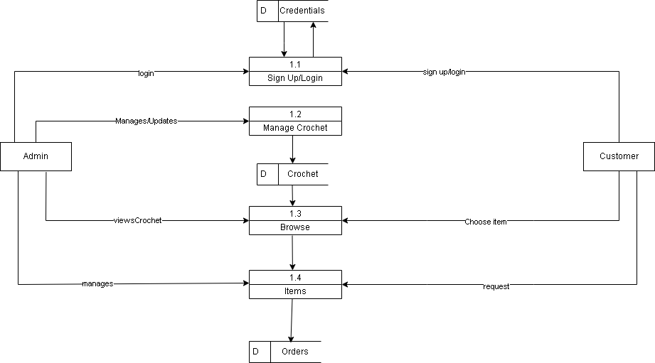

**Figure 3.5 DFD 1 Diagram**

## 3.2 System Design

### 3.2.1 Architectural Design

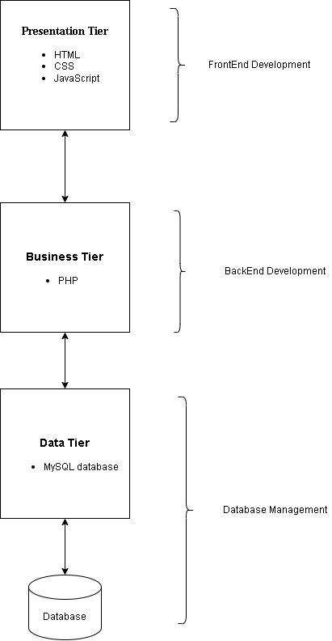

**Figure 3.6 System Architectural Design**

### 3.2.2 Database Schema Design

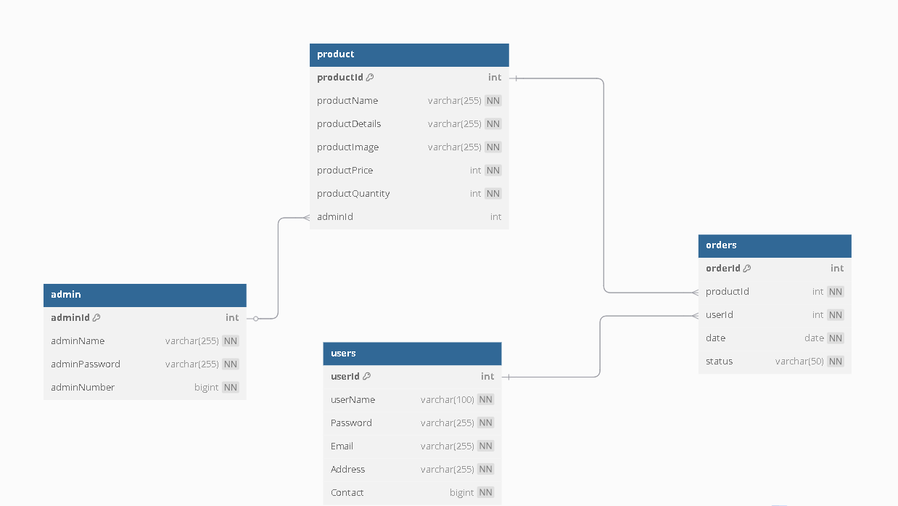

**Figure 3.7 Database Schema**

### 3.2.3 Interface Design

1. **Registration Page**

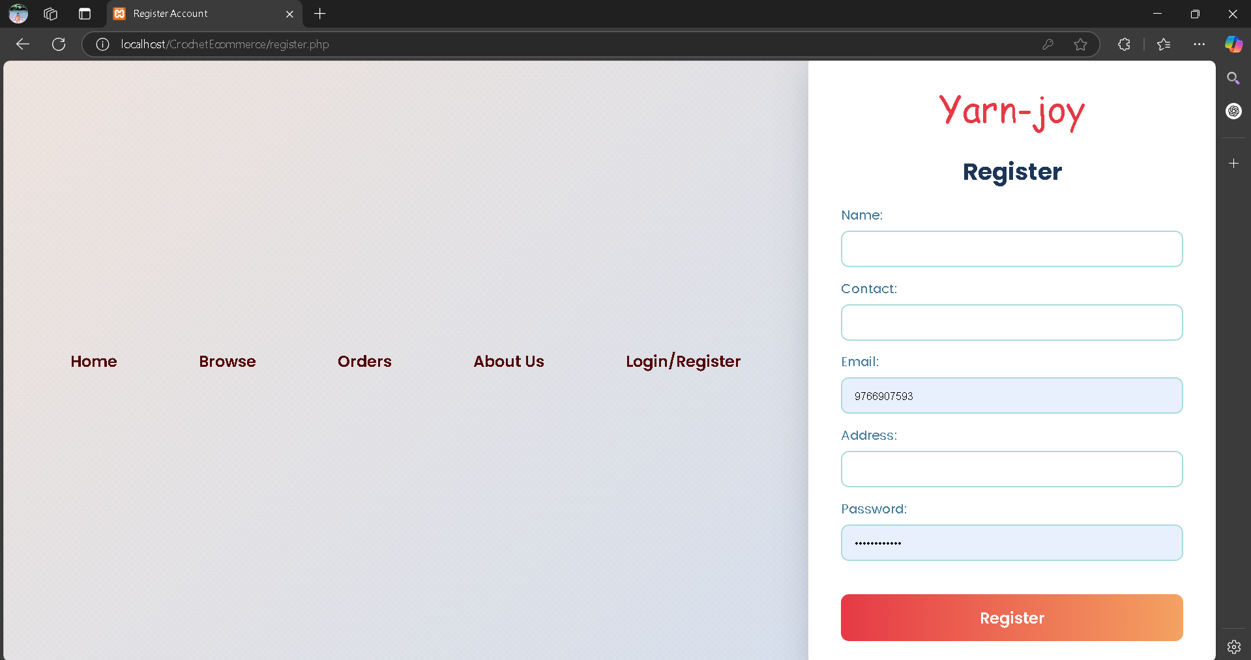

1. **Login Page**

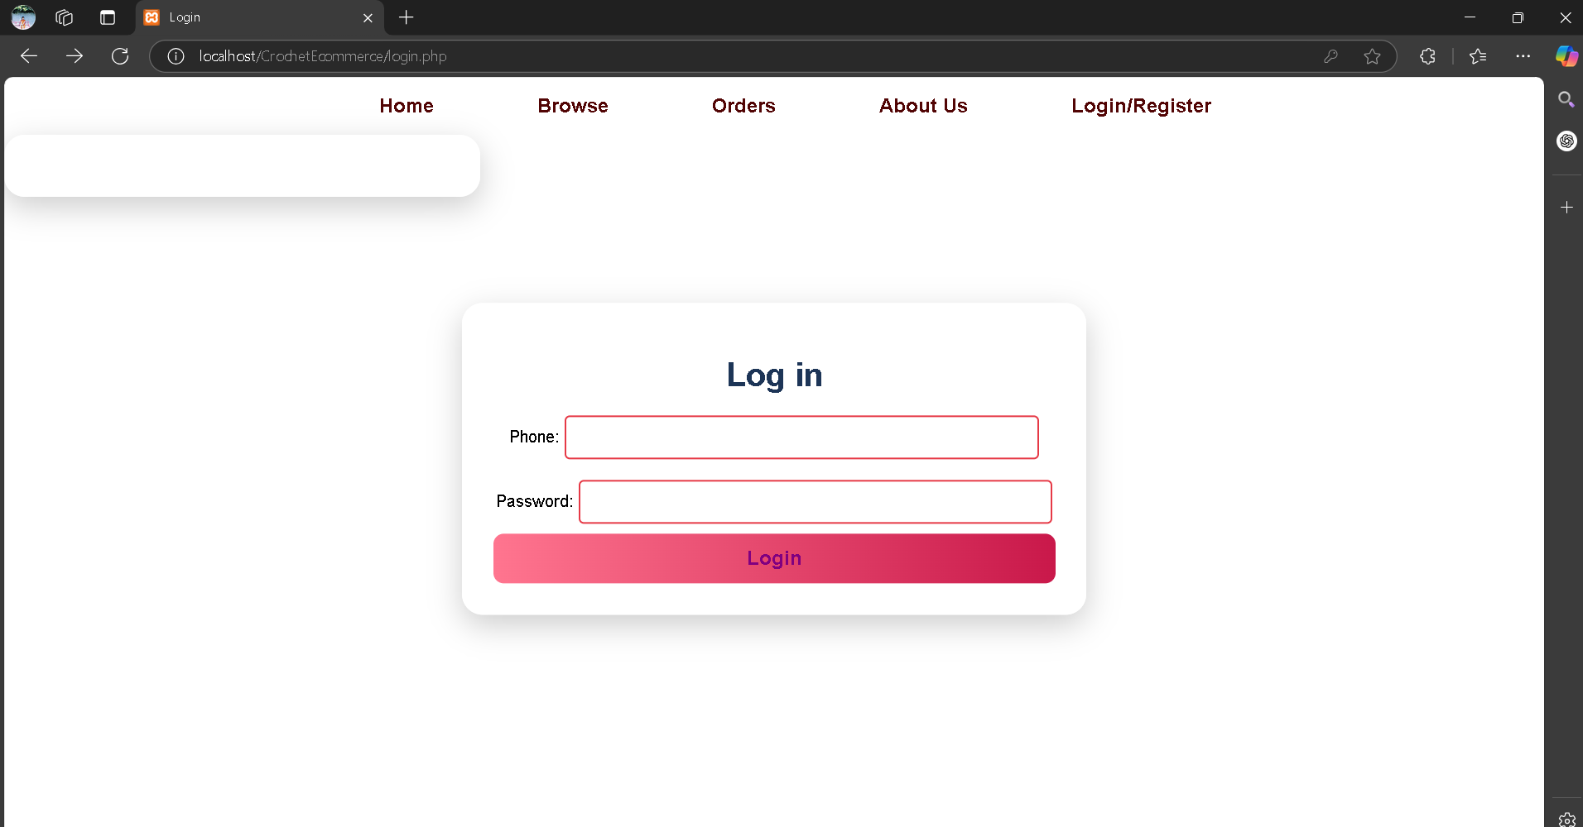

1. **Home Page**

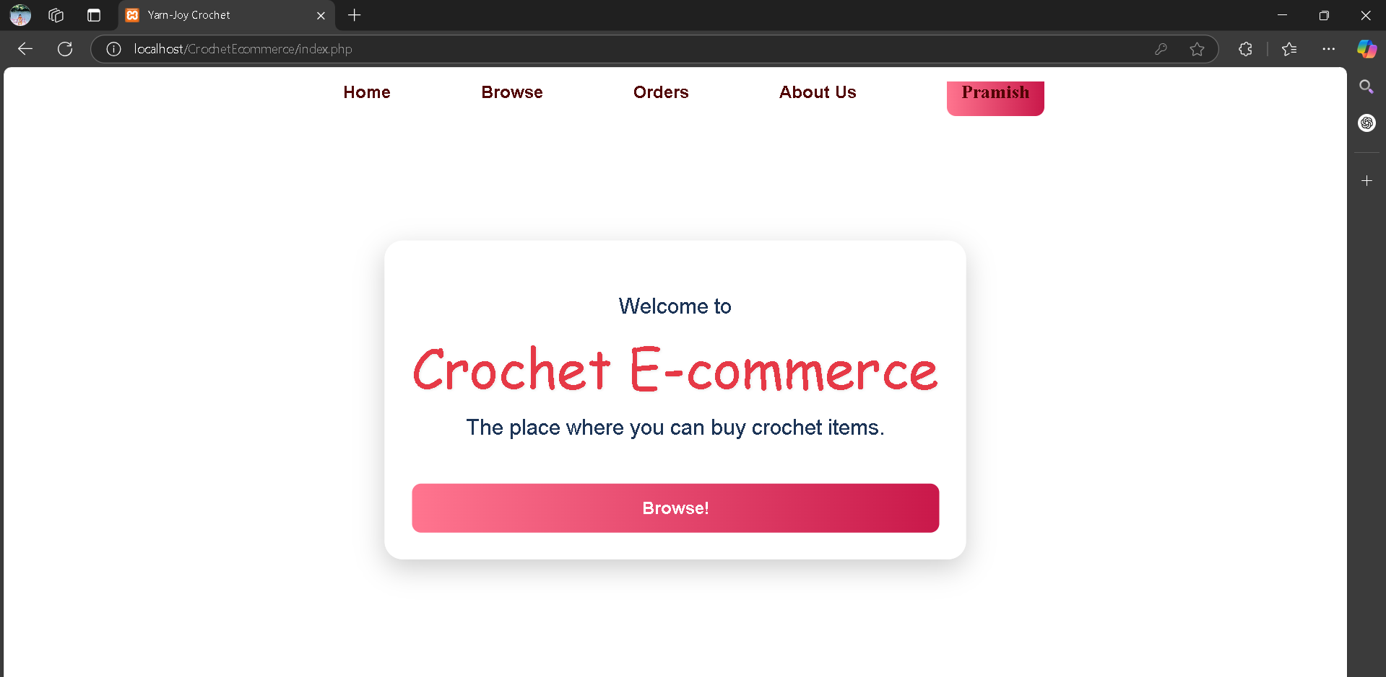

1. **User Login Details**

* User when not logged in

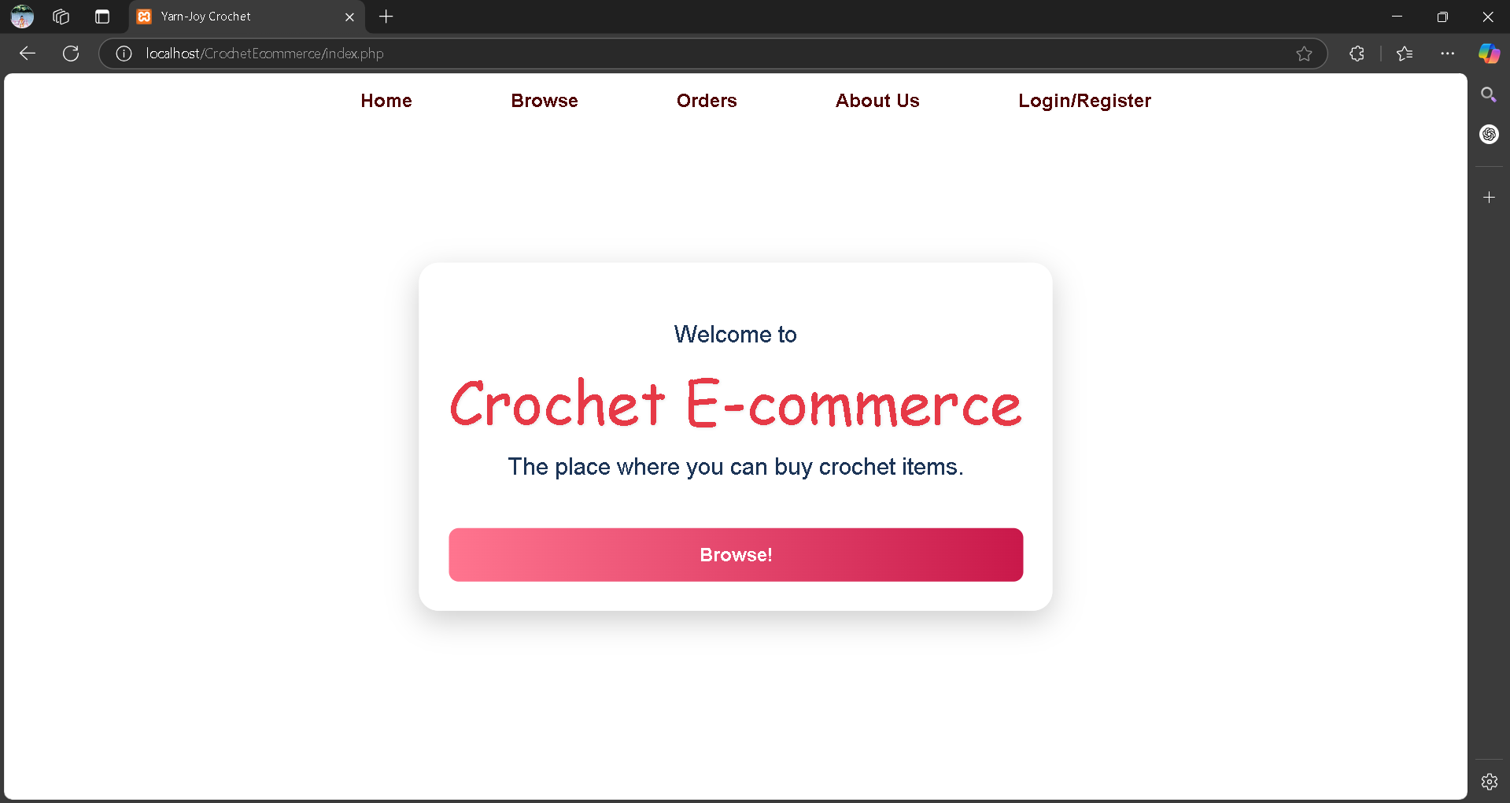

* User when logged in



1. **Browse Page**

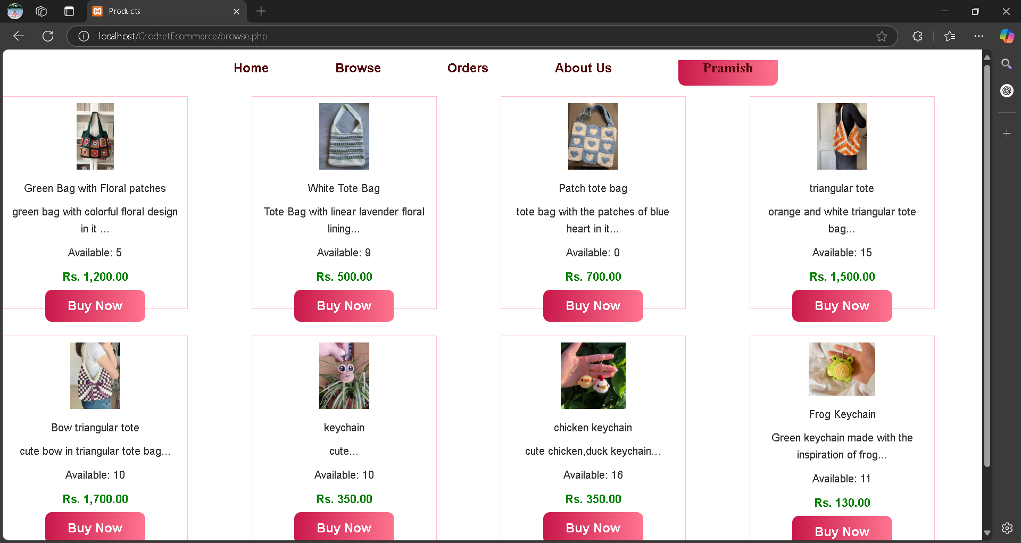

1. **Orders page**

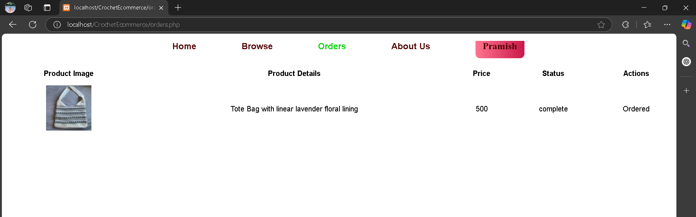

1. **About Us Page**

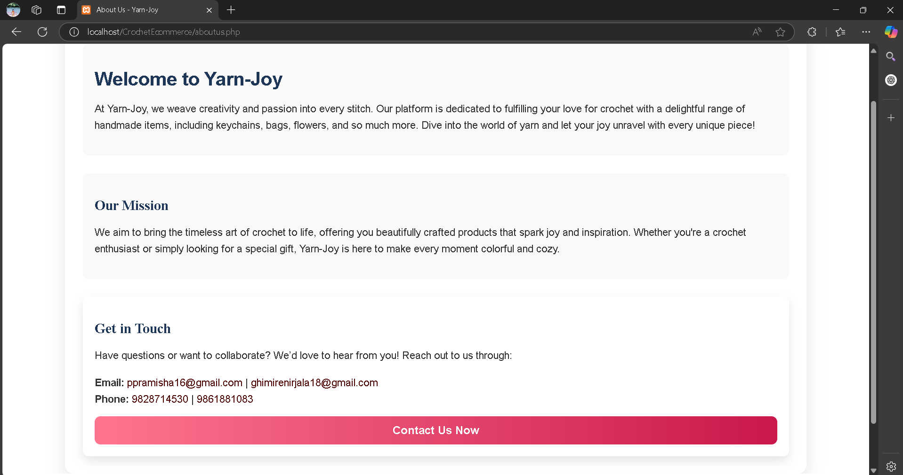

1. **Admin Page**

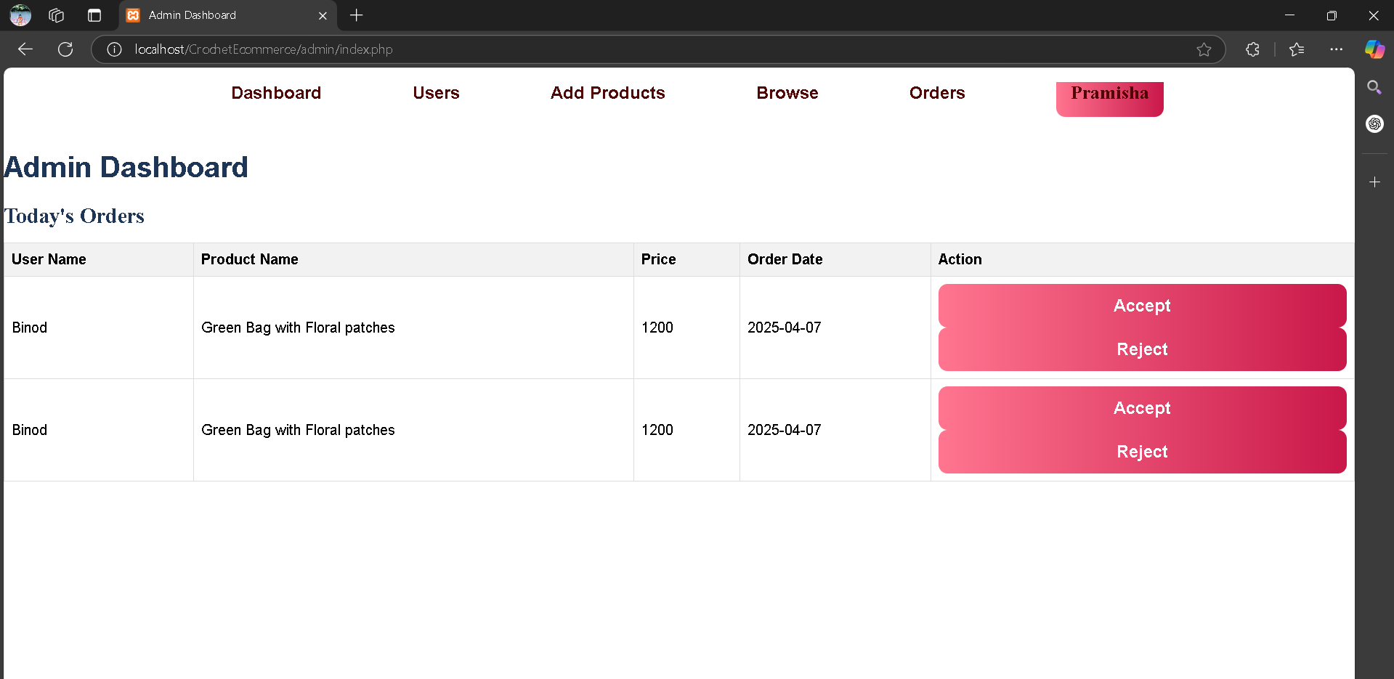

1. **Admin users Page**

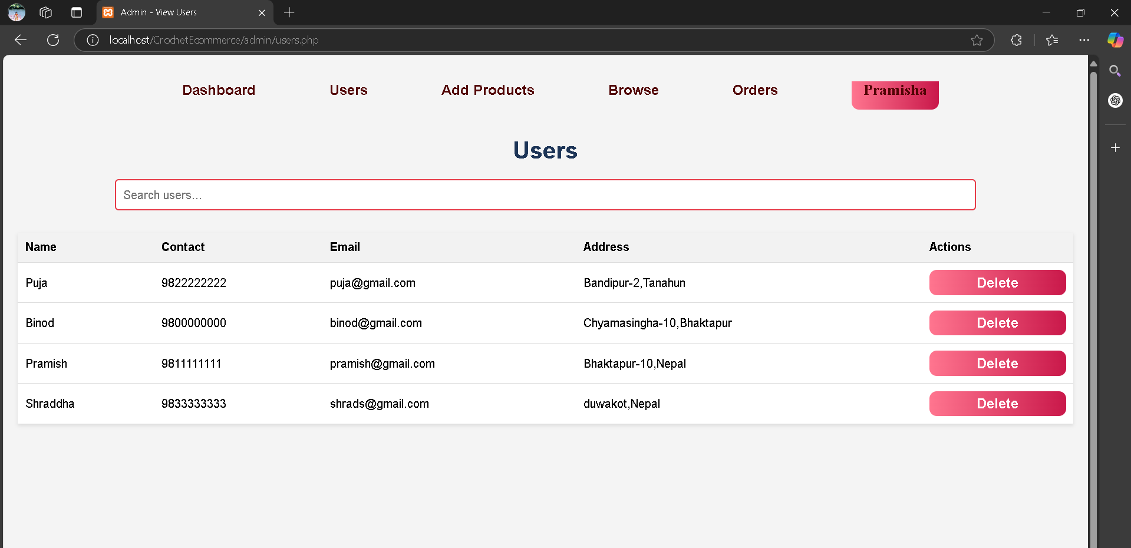

1. **Admin add products page**

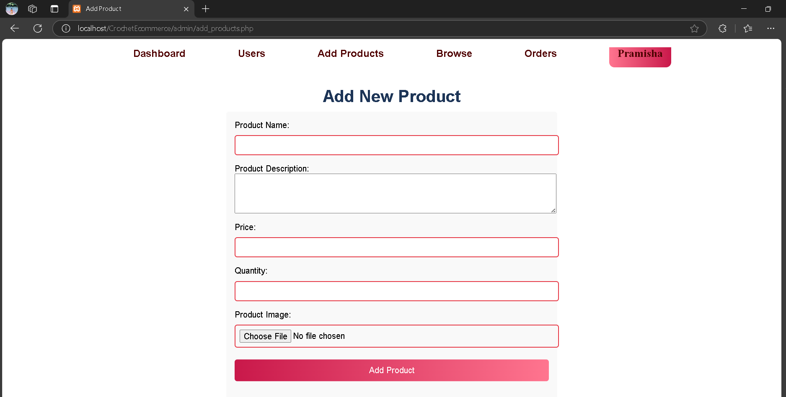

1. **Admin browse page**

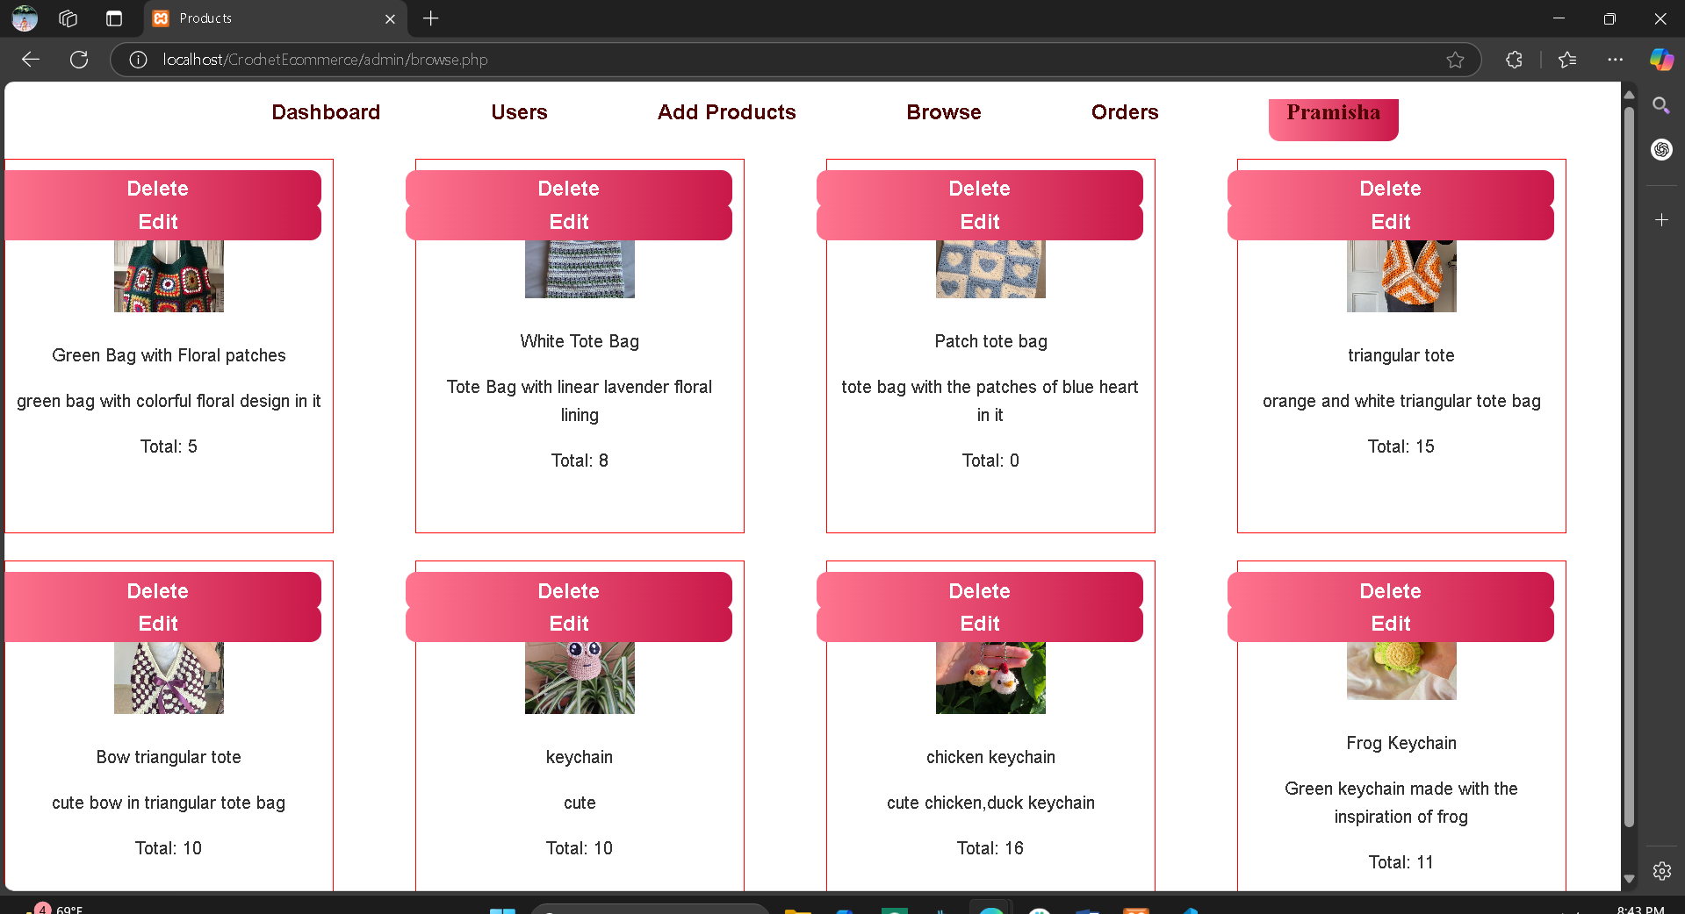

1. **Admin edit products page**

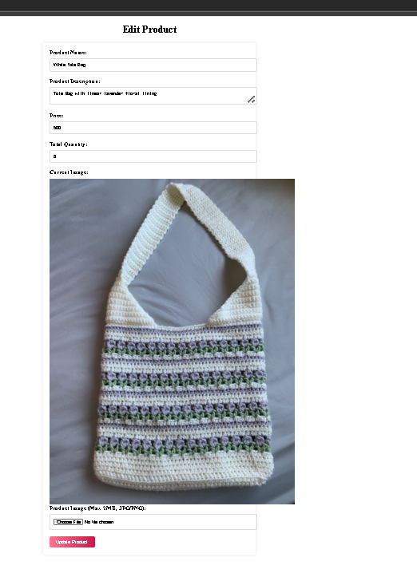

1. **Admin orders page**

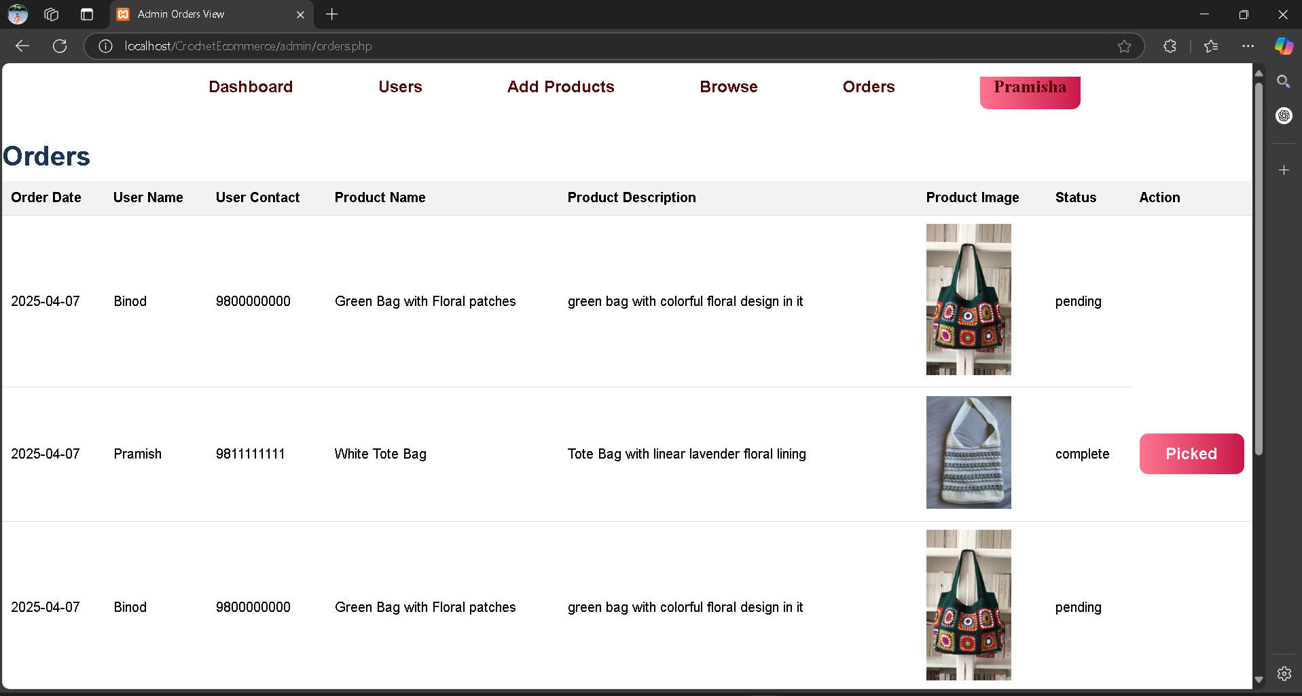

### 3.2.4 Activity diagram

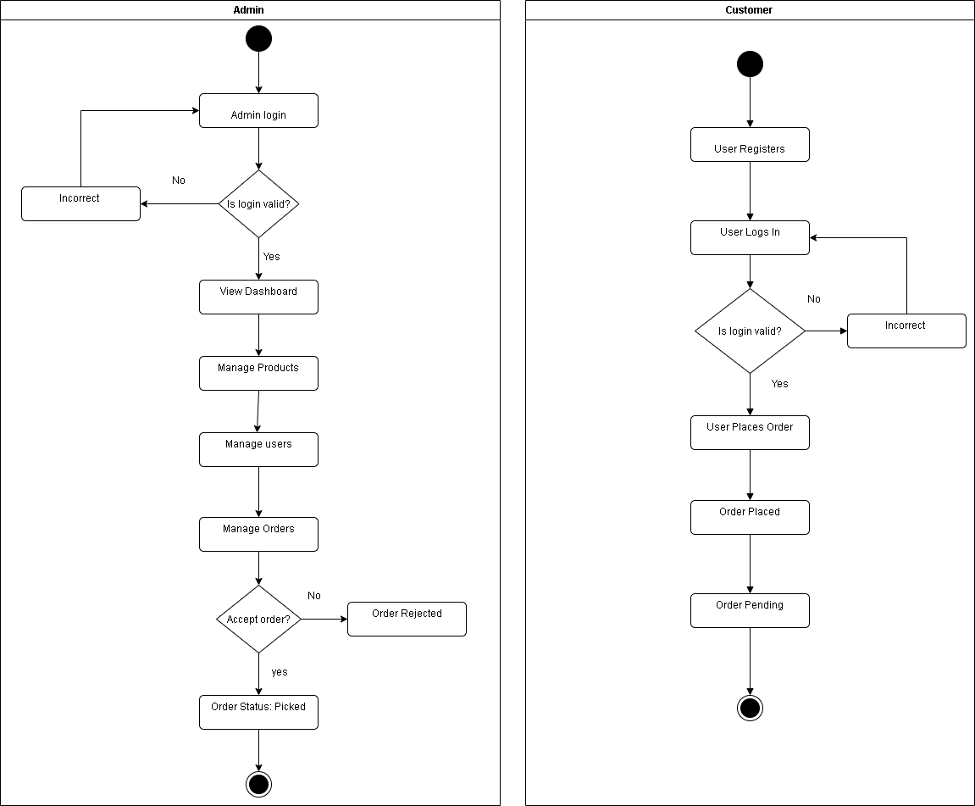

**Figure 3.8: Activity Diagram**

# CHAPTER 4: Implementation and Testing

## 4.1 Implementation

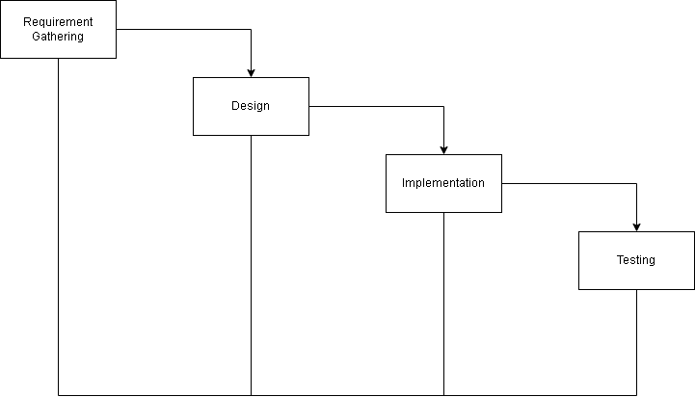

**Figure 4.1: Hybrid Waterfall Model**

The waterfall model is a classical model used in the system development life cycle to create a system with a linear and sequential approach. It is termed as waterfall because the model develops systematically from one phase to another in a downward fashion. This model is divided into different phases such as the output of one phase is used as input of another phase. For our project we used Waterfall Model because our project is a medium scaled project and all requirement needed for our projects were clearly known. Firstly, we analyzed our project and then we designed our system. Once we are done with the implementation phase, we will move toward the testing phase of the product. The ready product then will be deployed to the users.

### 4.1.1 Tools Used

#### Front-End Development (HTML, CSS, JavaScript)

* **HTML**: Structured web pages for essential functionalities like customer registration, login, product display, and order placement.
* **CSS**: Styled the interface, ensuring a clean, consistent, and user-friendly design across devices.
* **JavaScript**: Enabled dynamic elements, including form validation and real-time updates during order placement, improving user interactivity and experience.

#### Back-End Development (PHP)

* **PHP**: Managed server-side functionality, including user authentication, order processing, product catalog E-Commerce, and customer record handling. PHP scripts ensured secure and smooth interactions between the front-end and database.

#### Database Management (MySQL, phpMyAdmin)

* **MySQL**: Used to store and manage data related to products, customers, orders, and inventory. Efficient queries were designed to retrieve data quickly, facilitating quick product display and order processing.
* **phpMyAdmin**: Utilized for database administration, allowing easy management, backup, and updates to the database.

#### UI/Ux tool

* **Draw.io**: Created system diagrams such as ER diagrams and data flow diagrams to map out the system structure, data relationships, and workflows. These diagrams facilitated clear communication during the design and troubleshooting stages.

### 4.1.2 Implementation Details of Modules

* It also contains about us, offering website’s mission and values.

#### **Admin**

* **Login**: The admin can log in to the system using a customer name and password after registration.
* **Manage Products**: The admin can manage products by adding, updating, or deleting crochet-related items (such as yarn, tools, etc.).
* **Manage Customer Orders**: The admin can view customer orders, accept or decline them, and track the status of each order.
* **Update Password**: The admin can update their login password for security purposes.
* **Logout**: The admin can log out of the system after completing their tasks.

#### **Customer**

* **Registration**: Customers can register by filling in a registration form to create an account.
* **Browse Products**: Customers can view and browse available crochet products, including yarns and tools, via a categorized list or search functionality.
* **Login**: Customers can log in using the customer name and password they registered with.
* **Place Order**: Customers can place orders for products they wish to purchase.
* **View and Update Profile**: Customers can view their profile details and make updates if necessary.
* **Logout**: After completing their actions, customers can log out of the system.

## 4.2 Testing

Testing is a crucial step in building a system, where we run the program to catch any mistakes. The main goal is to find and fix issues that might impact how the program works. This involves checking how well the program interacts with the database, measuring its response time to user actions. This also makes sure the user interface is smooth.

### 4.2.1 Test Case for Unit Testing

**Table 4.1: Test case of Crochet Ecommerce System Admin Login**

|  |  |  |  |  |  |
| --- | --- | --- | --- | --- | --- |
| **ID** | **Test Case Description** | **Test Data** | **Expected Result** | **Actual Result** | **Pass/Fail** |
| Admin_Login_1 | Admin enters the wrong number or password | Phone: 9766907593  Password:12345678 | Message: Incorrect email or password | As expected, | Pass |
| Admin_Login_2 | Admin enters correct number and password | Phone:9766907593  Password:newadminpass | Message:  Correct email and password | As expected, | pass |

**Table 4.2: Test case of Crochet Ecommerce User Login**

|  |  |  |  |  |  |
| --- | --- | --- | --- | --- | --- |
| **ID** | **Test Case Description** | **Test Data** | **Expected Result** | **Actual Result** | **Pass/Fail** |
| User_Login_1 | User enters the wrong number or password | Phone: 9800000000  Password:12345678 | Message: Incorrect number or password | As expected, | Pass |
| User_Login_2 | User enters correct email and password | Phone:9800000000  Password:00000000 | Message:  Correct number and password | As expected, | pass |

**Table 4.3: Test case of Crochet Ecommerce System Registration**

|  |  |  |  |  |  |
| --- | --- | --- | --- | --- | --- |
| **ID** | **Test Case Description** | **Test Data** | **Expected Result** | **Actual Result** | **Pass/Fail** |
| User_Reg_1 | User forgets to enter a particular field | Name: Shraddha  Contact:9833333333  Email:shrads@gmail.com  Address:Duwakot,Nepal  Password: | Message: Please fill out this field | As expected, | Pass |
| User_Reg_2 | User enters valid information | Name: Shraddha  Contact:9833333333  Email:shrads@gmail.com  Address:Duwakot,Nepal  Password:33333333 | Message:  Successfully registered | As expected, | pass |

### 4.2.2 Test Case for System Testing

**Table 4.4: Test case of Crochet Ecommerce System**

|  |  |  |  |
| --- | --- | --- | --- |
| **TEST MODULE** | **TEST CASES** | **EXPECTED RESULT** | **TEST RESULT** |
| ADMIN | Provide valid login credential | Admin successfully logged in and directed to the admin panel | Pass |
| ADMIN | Enters invalid login credentials | Displays incorrect number/ password | Pass |
| ADMIN | Upon successful login, click on the Users tab | Display the list of registered users with their Name, Contact, Email, Address and a column of Actions to delete a user from the system | Pass |
| ADMIN | Upon successful login, click on Add Products tab | Display a form with product name, Product Description, Price, Quantity and Product image | Pass |
| ADMIN | Upon successful login, click on Browse tab | Display the products added by admin so far with the option of delete and edit for each product | Pass |
| ADMIN | Upon successful login, click on Orders tab | Display the orders made so far with the table consisting of attribute Order Date, User Name, User Contact, Product Name, Product Description, Product Image, Status and Action | Pass |
| CUSTOMER | Upon successful login, home page of Crochet Ecommerce system is displayed | Home page of the system shown along with the tabs Browse, Orders and About Us | Pass |
| CUSTOMER | Browse the product | Display the product with it’s image and name ,description and price with the buy now button | Pass |
| CUSTOMER | Ordering the product | Order Placement Successful Message | Pass |
| CUSTOMER | Upon successful login, click on Orders tab | Display the table with the list of all the orders made by user so far along with the option to cancel order | Pass |
| CUSTOMER | Upon successful login, click on About Us tab | Display the information provided by the admin end to know and contact to the owner of the system | Pass |

**CHAPTER 5: Conclusion and Future Recommendation**

## 5.1 Lesson Learnt/ Outcome

Building the Crochet Ecommerce System was a good learning experience. We learned how to design a simple system where users can register and the admin can manage products and orders. It helped us understand the importance of making things easy to use and handling problems like wrong login. We also improved our skills in PHP and working with existing code. Taking help from teachers and friends made the project better and helped us complete it successfully.

## 5.2 Conclusion

In conclusion, our Crochet Ecommerce System focuses on keeping things simple and user-friendly. The system allows users to register and request crochet items easily, even if they don’t have much technical knowledge. The clean design and clear product details help users make better choices. Admins can manage products and orders smoothly, making the system reliable. This project successfully achieved its goals by providing a simple and effective platform for selling crochet items. With regular updates and feedback, the system can continue to grow and improve over time.

## 5.3 Future Recommendation

Future recommendations are suggestions to improve the system’s performance and user experience. For the Crochet Ecommerce System, the following features can be added:

* 1. **Add Search and Filter Options**

Implementing search and category filters will help users quickly find specific crochet items, making browsing faster and easier.

1. **Enable Profile Customization**

Allow users to update their profile details and add profile pictures. This improves personalization and user experience on the platform.

1. **Integrate a Secure Payment Gateway**

Adding a secure online payment system will allow users to complete their orders conveniently and safely, improving the overall shopping process.

1. **Introduce Product Review Section**

Letting users rate and review crochet products will help new buyers make better decisions and build trust in the platform.

1. **Sales Analytics for Admin**

Improving the admin dashboard with basic sales reports or revenue tracking will help the shop owner better monitor performance and make informed decisions.

# References

|  |  |
| --- | --- |
| [1] | Handicrafts In Nepal, "Handicrafts In Nepal | Buy Nepali Handmade Product Wholesale," [Online]. Available: https://handicraftsinnepal.com/. [Accessed: 7-Jan-2025]. |
| [2] | Swodeshi, "Made In Nepal Products Online Worldwide | Swodeshi," 2021. [Online]. Available: https://swodeshi.com/. [Accessed: 8-Jan-2025]. |