DBMS PROJECT DOCUMENTATION

**TITLE :** IRON MIND

**ABSTRACT:**

This work deals with development Java-based multiple-choice question system, namely: IRONMIND . This application is developed for educational purpose, allowing the users to prepare the multiple choice questions for different examinations conducted on any topics. The main goal of the application is to enable users to gain knowledge, with focus on cricket field.. This quiz includes two functions: (i) Answer, (ii)Get Answer , which are also named as life lines that help users to answer questions correctly. These functions can be used any number of times by a user as knowing the answer is the important goal. It shows progress feedback during quiz play, and at the end, the app also shows the result.

**MODULES:**

This Project has its front-end build in Java and back-end in mysql

**Software used:** Netbeans,PhpMyadmin

**Database:** mysql

The packages Included are

* + - * + **Register**
        + **Quiz**

Module1 is used get user details like username,password and emailID

Module2 is used to conduct quiz.

Module 1 is used to get user details as mentioned above and enter into the user_details table.It has a on Insert trigger which stores the username and his highscore in another table called gamer_details

Module 2 shows a set of questions, which are fetched from table qna.It has a function and a procedure. A function get_answer() to get answer for a question and a procedure checker() to check if the selected answer is correct

**Concepts Used:**

* + Functions
  + procedures
  + Triggers
  + Cursors
  + Exception handling
  + Reports

**Tables:**

This project contains 4 primary tables

* User_Details
* Gamer_details
* qna
* ReportSheet

**User_deatails**: table holds username,password and email_id

**gamer_details**: table holds gamer_name,times_played,highscore

**qna**: table holds questions with 4 choices and a answer

**ReportSheet**: table holds the report of the quiz

**ENTITY RELATIONSHIP DIAGRAM:**

USER_DETAILS

SHEET

GAMER_DETAILS

QNA

CODING:

FUNCTIONS:

1.GET_ANSWER()

DELIMITER $$

CREATE DEFINER=`root`@`localhost` FUNCTION `GET_ANSWER`(`SNO` INT) RETURNS varchar(30) CHARSET utf8

NO SQL

BEGIN

return (SELECT answer from qna where qno = sno);

end$$

DELIMITER ;

PROCEDURES:

1.CHECKER()

DELIMITER $$

CREATE DEFINER=`root`@`localhost` PROCEDURE `checker`(IN `sno` INT, IN `ans` VARCHAR(50))

NO SQL

BEGIN

if ans like (SELECT answer from qna where qno = Sno) then

insert into sheet (qno,result) values(sno,1);

ELSE

insert into sheet (qno,result) values(sno,0);

end if;

END$$

DELIMITER ;

CURSORS:

1.REGISTERED_CURSOR()

DELIMITER $$

CREATE DEFINER=`root`@`localhost` PROCEDURE `registered_cursor`()

NO SQL

BEGIN

declare uname TEXT;

DECLARE EXIT_L BOOLEAN DEFAULT FALSE;

DECLARE UNAME_CURSOR CURSOR FOR SELECT USERNAME FROM USER_DETAILS;

DECLARE CONTINUE HANDLER FOR NOT FOUND SET EXIT_L = TRUE;

OPEN UNAME_CURSOR;

UNAME_LOOP:LOOP

FETCH FROM UNAME_CURSOR INTO UNAME;

IF EXIT_L THEN

LEAVE UNAME_LOOP;

ELSE

SELECT UNAME;

END IF;

END LOOP UNAME_LOOP;

CLOSE UNAME_CURSOR;

END$$

DELIMITER ;

TRIGGERS:

USER_GAMER:

CREATE TRIGGER `user_gamer` AFTER INSERT ON `user_details`

FOR EACH ROW BEGIN

INSERT INTO gamer_details(gamer_name,times_played,highscore)

values(NEW.username,1,0);

END

OUTPUT:

**QUIZ FORM:**

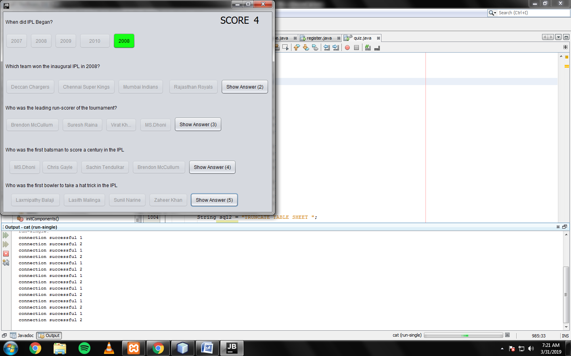

**REGISTRATION FORM:**

