Combining global tree cover loss data with historical national forest-cover maps to look at six decades of deforestation and forest fragmentation in Madagascar

#### Ghislain Vieilledent*,1,2, Clovis Grinand3, Fety A. Rakotomalala3, Rija Ranaivosoa5, Jean-Roger Rakotoarijaona5, Thomas F. Allnutt4, and Frédéric Achard1

(*) /Email: [ghislain.vieilledent@cirad.fr](mailto:ghislain.vieilledent@cirad.fr), /Phone: +39.329.457.2273

1. Joint Research Center of the European Commission, Bio-economy Unit (JRC.D.1), I-21027 Ispra (VA), ITALY
2. Cirad, UPR Forêts et Sociétés, F-34398 Montpellier, FRANCE
3. ETC Terra, F-75016 Paris, FRANCE
4. Wildlife Conservation Society, 101 Antananarivo, MADAGASCAR
5. Office National pour l'Environnement, 101 Antananarivo, MADAGASCAR

## Summary

1. *Context:* The island of Madagascar has an unparalleled biodiversity, both in terms of number of species and endemism. This biodiversity is mainly located in the tropical forests of the island and is highly threatened by anthropogenic deforestation, which is associated principally to slash-and-burn agriculture and pasture. Scattered forest maps from past studies at national level with substantial gaps (due to presence of cloud cover on satellite imagery) prevent from analyzing the deforestation trends on a long term perspective in Madagascar.
2. *Approach:* In this study, we propose a new approach combining historical (1953-2000) national forest-cover maps with recent (2000-2014) global annual tree cover loss data to look at six decades (1953-2014) of deforestation and forest fragmentation in Madagascar. We also produce new forest-cover maps at 30m-resolution over the full territory of Madagascar for the year 1990, and annually from 2000 to 2014.
3. *Results:* We estimate that Madagascar has lost 44% of its natural forest cover over the period 1953-2014 (including 37% over the period 1973-2014). Natural forests covered 8.9 Mha in 2014 (15% of the national territory) which were divided into 4.4 Mha (50%) of moist forests, 2.6 Mha (29%) of dry forests, 1.7 Mha of spiny forests (19%) and 177,000 ha (2%) of mangroves. Since 2005, the annual deforestation rate has progressively increased in Madagascar and has more than doubled from the period 2000-2005 to reach 99,000 ha/yr during 2010-2014 (corresponding to a rate of 1.08%/yr). Most of the forests are now located at less than 1.2km from forest edges while half of them were located far from forest edges in 1973 (i.e. between 1km and 4km from forest edges). The percentage of core forest has then decreased from 68% in 1973 to 50% in 2014.
4. *Conclusion:* Despite the conservation efforts in Madagascar, deforestation has continued to significantly increase at the national level since 2005, with strong consequences on biodiversity loss and carbon emissions. This increase in the deforestation rate can be related to a rapid population growth (close to 3%/yr) and to a poor law enforcement due to political instability in the country. More effort, including conservation and development programs, should be done in Madagascar to protect the remaining natural tropical forests, both to enhance local people livelihoods and answer to global environmental problems.

**Keywords**: biodiversity, climate-change, deforestation, Landsat, protected areas, Madagascar, tropical forest, tree cover.

**Potential journals** (2015 IF): Biological Conservation (3.985), Ambio (2.555), Environmental Conservation (2.235), Biotropica (1.944), Tropical Conservation Science (1.55).

## 1. Introduction

Separated from the African continent and the Indian plate about 165 and 88 million years ago respectively (Ali and Aitchison, 2008), the flora and fauna of Madagascar followed its own evolutionary path. Combined with a high number of micro-habitats (Pearson and Raxworthy, 2009), this has led to Madagascar's exceptional biodiversity both in term of number of species and endemism in many taxonomic groups (Crottini et al., 2012; Goodman and Benstead, 2005). Most of the biodiversity in Madagascar is concentrated in the tropical forests of the island which can be divided in three types: the moist forest in the East, the dry forest in the West and the spiny forest in the South (Vieilledent et al., 2016). This unparalleled biodiversity is severely threatened by anthropogenic deforestation (Harper et al., 2007; Vieilledent et al., 2013) associated to activities such as slash-and-burn agriculture and pasture (Scales, 2011). Tropical forests in Madagascar also store a large amount of carbon (Vieilledent et al., 2016) and high rates of deforestation in Madagascar are responsible for large CO2 emissions in the atmosphere (Achard et al., 2014). Deforestation threatens species survival by reducing their habitat (Brooks et al., 2002; Tidd et al., 2001). Associated to deforestation, forest fragmentation can also lead to species extinction by isolating populations from each others and creating forest patches too small to maintain viable populations (Saunders et al., 1991). Fragmentation also extents forest edge where ecological conditions (such as air temperature, light intensity and air moisture) can be dramatically modified, with consequences on the abundance and distribution of species (Murcia, 1995). Forest fragmentation can also have substantial effects on forest carbon storage capacity, carbon stocks being much lower at the forest edge than under a closed canopy (Brinck et al., 2017). Moreover, forest carbon stocks are varying spatially due to climate or soil factors (Saatchi et al., 2011; Vieilledent et al., 2016). As a consequence, accurate and spatially explicit maps of forest-cover and forest-cover change are necessary to monitor loss of biodiversity and carbon emissions associated to deforestation and forest fragmentation, assess the efficiency of present conservation strategies (Eklund et al., 2016), and implement new strategies for the future (Vieilledent et al., 2013, Vieilledent et al. 2016). Simple time-series of forest-cover estimates, such as those provided by the FAO Forest Resource Assessment report (Keenan et al., 2015) are not sufficient.

Unfortunately, accurate and exhaustive forest-cover maps are not available for Madagascar for the last fifteen years (2000-2015). Harper et al. (2007) produced maps of forest cover and forest cover changes over Madagascar for the years *c.* 1953, *c.* 1973, 1990 and 2000. The *c.* 1953 forest map was derived from the visual interpretation of aerial photography at coarse scale (1/1,000,000). Forest maps for the years *c.* 1973, 1990 and 2000, were obtained from supervised classification of Landsat satellite images at 60m resolution (for the year 1973) or 30m resolution (for years 1990 and 2000) and can be used to derive accurate estimates (89.5% accuracy reported for the forest / non-forest map of year 2000). Maps provided by Harper et al. (2007) were not exhaustive (due to the presence of clouds in the satellite imagery), e.g. 11 244 km2 are mapped as unknown cover type for the year 2000. Using a similar supervised classification approach as in Harper et al. (2007), more recent maps were produced for the periods 2000-2005-2010 by national institutions, with the technical support of international environmental NGOs (MEFT, USAID, and CI, 2009; ONE, DGF, FTM, MNP, and CI, 2013). Another set of recent forest cover maps using an advanced statistical tool for classification, the Random Forest classifier (Grinand et al., 2013; Rakotomalala et al., 2015), was produced for the periods 2005-2010-2013 (ONE, DGF, MNP, WCS, and Etc Terra, 2015). However, these maps are either too old to give recent estimates of deforestation (MEFT, USAID, and CI, 2009; ONE, DGF, FTM, MNP, and CI 2013), include large areas of missing information (due to images with more than 20% of clouds) for the 2010 map provided by ONE, DGF, FTM, MNP, and CI (2013), or show large mis-classification in specific areas, especially in the dry and spiny forest domain for which the spectral answer has a strong seasonal behavior due to the deciduousness of such forests (overall accuracy is lower than 0.8 for the dry and spiny forests for the maps produced by ONE, DGF, MNP, WCS, and Etc Terra (2015)). Moreover, the production of such forest maps from a supervised classification approach requires a significant amount of resources, especially regarding the image selection step (required to minimize cloud cover) and the training step (visual interpretation of a large number of polygons needed to train the classification algorithm) (Rakotomalala et al., 2015). Most of this work of image selection and visual interpretation would need to be repeated if one would intend to produce new forest maps in the future using a similar approach.

Global forest or tree cover products were also published recently and can be tested at the national scale for Madagascar. Kim et al. (2014) produced a global forest-cover change map from 1990 to 2000 (derived from Landsat imagery). This product was updated to cover the period 1975-2005 but forest-cover maps after 2005 were not produced. Moreover, the approach used in Kim et al. (2014) did not allow to correctly map the forests in the dry and spiny ecosystems of Madagascar (see Fig. 8 in Kim et al. (2014)). Hansen et al. (2013) mapped tree cover percentage, annual forest loss and forest gain from 2000 to 2012 at global scale and at 30 m resolution. Meanwhile, this product was updated and is now available up to the year 2014 (Hansen et al. 2013). To map forest cover from the Hansen et al. (2013) product, a tree cover threshold must be selected (to define forest cover). Selecting such a threshold is not straightforward as the accuracy of the global tree cover map strongly varies between forest types, being substantially lower for dry forests than for moist forests (Bastin et al. 2017, Gross et al., submitted). Moreover, the Hansen et al. (2013) product does not provide information on land-use. In particular the global tree cover map does not separate tree plantations such as oil palm or eucalyptus plantations from natural forests (Tropek et al., 2014). Thus, the global tree cover map from Hansen et al. (2013) cannot be used alone to produce a map of forest cover (Tuykavina et al. 2017). In complement to the tree cover percentage provided in Hansen et al. (2013), a layer of annual forest loss is also provided (i.e. complete loss of tree cover from a value higher than 10% to zero).

In this study, we present a simple approach which combines the maps from Harper et al. (2007) and products from Hansen et al. (2013) to derive annual wall-to-wall forest-cover change maps over the period 2000-2014 for Madagascar. Similarly to the approach of Harper et al. (2007), we assess then in details the trends in deforestation rates and forest fragmentation from *c.* 1953 to 2014. The approach described in this study should help assessing the efficiency of present conservation strategies and implementing new strategies for the future. Our approach could be easily extended to other tropical countries when at least a forest cover map exist between 2000 and 2014 or repeated in the future as and when the Hansen et al. (2013) products are updated.

## 2. Materials and Methods

### 2.1 Creation of new forest-cover maps of Madagascar from *c.* 1953 to 2014

We produced annual forest / non-forest maps at 30m resolution for the full territory of Madagascar for the period 2000-2014 by combining the forest map of year 2000 from Harper et al. (2007) and the tree cover percentage and annual forest cover loss maps over the period 2000-2014 from Hansen et al. (2013). The 2000 Harper's forest map includes 208,000 ha of unclassified areas due to the presence of clouds in input satellite imagery, mostly (88%) within the moist forest domain which covers 4.17 million ha in total. To provide a label (forest or non-forest) to these unclassified pixels, we use the 2000 tree cover percentage map of Hansen et al. (2013) by selecting a threshold of 75% tree cover to define forest cover as recommended by other studies for the moist domain (Achard et al., 2014). We thus obtained a forest-cover map for the year 2000 covering the full territory of Madagascar. We then combine this forest cover map of the year 2000 with the annual forest cover loss maps from 2000 to 2014 provided by Hansen et al. (2013) to create annual forest cover maps from 2010 to 2014 at 30m resolution. In a further step we completed the Harper’s forest map of year 1990 by filling unclassified areas using our forest cover map of year 2000: we assume that if forest was present in 2000, the pixel was also forested in 1990. The remaining unclassified pixels were limited to a relatively small total area of c. 8,000 ha. We labeled these residual pixels as non-forest as for the year 2000. Similarly we completed the Harper forest map of year 1973 by filling unclassified areas using our forest cover map of the year 1990 assuming that if forest was present in 1990, it was also present in 1973. Contrary to the year 1990, the remaining unclassified pixels for year 1973 corresponded to a significant total area of 3.32 million ha, which could not be labeled. The forest-cover map of year 1953 was only re-projected to a common projection. This map was produced by scanning a paper map derived from aerial photos, and thus could not be perfectly aligned with the other maps produced through digital processing of satellite imagery. Finally for all forest-cover maps from 1973, the isolated single non-forest pixels (i.e. fully surrounded by forest pixels) were removed, assuming that single non-forest pixels inside a forest patch were not corresponding to deforestation (they might correspond to selective logging activities). This allows avoiding to include very small scale events (<0.1 ha such as selective logging) as forest fragmentation. All the resulting maps are freely available at <https://bioscenemada.cirad.fr/forestmaps>.

### 2.2 Computing forest-cover areas and deforestation rates

From these new forest-cover maps we computed the total forest-cover area for six available years (1953-1973-1990-2000-2010-2014), and the annual deforested area and annual deforestation rate for the corresponding five time periods between 1953 and 2014. The annual deforestation rates were computed as follow (Puyravaud, 2003; Vieilledent et al., 2013):

where $θ$ is the annual deforestation rate (in %/yr), $F_{t_{2}}$ and $F_{t_{1}}$ are the forest cover free of clouds at both dates $t_{2}$ and $t_{1}$, and $t_{2}−t_{1}$ is the time-interval (in years) between the two dates.

Because of the large unclassified area (3.32 million ha) in 1973, the annual deforestation areas and rates for the two periods 1953-1973 and 1973-1990 are only indicative estimates. For these two periods the annual deforestation rates are computed as the ratio ${\left(F_{t_{2}}−F_{t_{1}}\right)}/{F_{t_{1}}}$ considering only the mapped forest pixels. Area and rate estimates are produced at the national scale and for the four forest ecosystems present in Madagascar: moist forest in the East, dry forest in the West, spiny forest in the South, and mangroves on the Western coast (Fig. 1). To define the forest domains, we used a map from the MEFT (*"Ministère de l'Environnement et des Forêts à Madagascar"*) with the boundaries of the four ecoregions in Madagascar. Ecoregions were defined on the basis of climatic and vegetation criteria using the climate classification by Cornet (1974) and the vegetation classification from the 1996 IEFN national forest inventory (Ministère de l’Environnement, 1996). Because mangrove forests are highly dynamic ecosystems that can expand or contract on decadal scales depending on changes in environmental factors (Armitage et al., 2015), a fixed delimitation of the mangrove ecoregion on six decades might not be fully appropriate. As a consequence, our estimates of the forest-cover and deforestation rates for mangroves in Madagascar must be considered with this limitation.

### 2.3 Comparison of our results with previous studies

We compared our estimates of forest-cover and deforestation rates with estimates from the three existing studies at the national scale for Madagascar : (i) Harper et al., 2007, (ii) MEFT, USAID, and CI, 2009 and (iii) ONE, DGF, MNP, WCS, and Etc Terra, 2015. Harper et al. (2007) provided forest-cover and deforestation estimates for the periods *c.* 1953-*c.* 1973-1990-2000. MEFT, USAID, and CI (2009) provided estimates for the periods 1990-2000-2005 and ONE, DGF, MNP, WCS, and Etc Terra (2015) provided estimates for the periods 2005-2010-2013. To compare our forest-cover and deforestation estimates over the same time periods, we consider three additional time-periods in our study (2000-2005, 2005-2010 and 2010-2013) by creating extra forest cover maps for years 2005 and 2013.

We computed the Pearson's correlation coefficient and the root mean square error (RMSE) between our forest-cover estimates and forest-cover estimates from previous studies for all the dates and the four forest types. For previous studies, the computation of annual deforestation rates (in %/yr) is not always detailed and might slightly differ from one study to another (see Puyravaud, 2003). Harper et al. (2007) provide also total deforested areas for the two periods 1973-1990 and 1990-2000. We converted these values into annual deforested area estimates. When annual deforested areas were not reported (for 1953-1973 in Harper et al. (2007) and in MEFT, USAID, and CI (2009) and ONE, DGF, MNP, WCS, and Etc Terra (2015)), we compute them from the forest-cover estimates in each study. These estimates cannot be corrected from the potential bias due to the presence of residual clouds. Forest-cover and deforestation rates are then compared between all studies for the whole Madagascar and the four ecoregions. The same ecoregion boundaries as in our study were used in ONE, DGF, MNP, WCS, and Etc Terra (2015) but this was not the case for Harper et al. (2007) and MEFT, USAID, and CI (2009), which can explain part of the differences between the estimates

### 2.3 Fragmentation

An analysis of the changes in forest fragmentation was carried out from our forest-cover maps over Madagascar for the years 1953, 1973, 1990, 2000, 2010 and 2014. We applied the method developed by Riitters et al. (2000) which uses a moving window to characterize the fragmentation around each forested pixel. Computation were done using the function r.forestfrag of the GRASS GIS software (Neteler and Mitasova, 2008). Six categories of fragmentation are identified from the amount of forest and its occurrence as adjacent forest pixels: "interior", "perforated", "edge", "transitional", "patch", and "undetermined". We use a moving window of 7x7 pixels (4.4 ha). Using this window size, forest edge had a width of about 90 m (Riitters et al., 2000). The interior category can be interpreted as the most intact forest (Potapov et al. , 2017). We report the area of forest in each fragmentation category for the six years and analyzed the dynamics of fragmentation over the six decades. We also computed the distance to forest edge for all forest pixels for the years 1953, 1973, 1990, 2000, 2010 and 2014. For that, we used the function gdal_proximity.py of the GDAL software (<http://www.gdal.org/>). We computed the mean and 95% quantiles of the distance to forest edge and looked at the evolution of these values with time.

## 3. Results

### 3.1 Dynamics of forest cover and deforestation intensity

Natural forests in Madagascar covered 16.0 Mha in 1953, about 27% of the national territory of 587,041 km2. In 2014, the forest cover has dropped down to 8.9 Mha, corresponding to about 15% of the national territory (Fig. 2 and Tab. 1). Madagascar has lost 44% and 37% of its natural forests between 1953 and 2013, and between c. 1973 and 2014 respectively (Fig. 2 and Tab. 1). In 2014 the remaining 8.9 Mha of natural forest were distributed as: 4.4 Mha of moist forest (50% of total forest cover), 2.6 Mha of dry forest (29%), 1.7 Mha of spiny forest (19%) and 0.18 Mha (2%) of mangrove forest (Fig. 1 and Tab. 2). Regarding the deforestation trend, we observed a progressive decrease of the deforestation rate after1990 from 205,000 ha/yr (1.63%/yr) over the period 1973-1990 to 44,300 ha/yr (0.43%/yr) over the period 2000-2005 (Tab. 1). Then from 2005, the deforestation rate has progressively increased and has more than doubled over the period 2010-2014 (98,700 ha/yr, 1.08%/yr) compared to 2000-2005 (Tab. 1). The deforestation trend characterized by a progressive decrease of the deforestation rate over the period 1990-2005 and a progressive increase of the deforestation after 2005 is valid for all four ecoregions (Tab. 3), excepting the spiny forest domain for which the deforestation rate during the period 2010-2013 was lower than during 2005-2010 (Tab. 3).

### 3.2 Comparison with previous forest-cover change studies in Madagascar

Forest-cover maps provided by previous studies over Madagascar were not exhaustive (unclassified areas) due to the presence of clouds in satellite imagery used to produce such maps. In Harper et al. (2007), the maps of years 1990 and 2000 include 0.5 and 1.12 Mha of unknown cover type respectively. Proportions of unclassified areas are not reported in the two other existing studies by MEFT, USAID, and CI (2009) and ONE, DGF, MNP, WCS, and Etc Terra (2015). With our approach, we produced wall to wall forest-cover change maps from 1990 to 2014 for the full territory of Madagascar (Tab. 1). This allows to produce more robust estimates of forest-cover and deforestation rates over this period. Quite logically, our forest-cover estimates over the period 1953-2013 (considering forest cover estimates at national level and by ecoregions for the 6 available dates) were well correlated (0.99) to estimates from the three previous studies (Tab. 2) with a RMSE of 300,000 ha (6% of the mean forest cover of 4.8 Mha when considering all dates and forest types together). These small differences can be partly attributed to differences in ecoregion boundaries. Despite significant differences in deforestation estimates (Tab. 3), a similar deforestation trend was observed across studies with a decrease of deforestation rates over the period 1990-2005 followed by a progressive increase of the deforestation after 2005.

### 3.3 Evolution of forest fragmentation with time

In parallel to the dynamics of deforestation, forest fragmentation has progressively increased since 1953 in Madagascar. We observed a continuous decrease of the mean distance to forest edges from 1953 to 2014 in Madagascar. The mean distance to forest edge has decreased to c. 300m in 2014 while it was previously c. 1km in 1973 (Fig. 3). Moreover, a large proportion of the natural forests were located far from forest edges in 1973 (between 2km and 4km), while the majority of forests were at less than 1.2 km from forest edges in 2014 (Fig. 3). The percentage of forest that can be considered intact in Madagascar has continuously decreased since 1953: the percentage of forest belonging to the "interior" category (most intact forests) has fallen from 68% in 1973 to 50% in 2014. In 2014, more than 16% of the forest belonged to the "patch" and "transitional" categories (isolated small forest patches) compared to 9.5% in 1973 (Tab. 4).

## 4. Discussion

### 4.1 Benefits of the combined use of recent global annual tree cover loss data with historical national forest-cover maps

In this study, we combined recent (2001-2014) global annual tree cover loss data (Hansen et al., 2013) with historical (1953-2000) national forest-cover maps (Harper et al., 2007) to look at six decades (1953-2014) of deforestation and forest fragmentation in Madagascar. We produced annual forest-cover maps at 30m-resolution covering Madagascar for the period 2000 to 2014. This approach tackles the issue associated with the forest definition which is needed to transform the 2000 global tree cover dataset from Hansen et al. (2013) into a forest/non-forest map (Tropek et al., 2014). We demonstrate that an historical national forest-cover map, based on an national forest definition can be used as a mask. This approach could be easily extended to other regions or countries for which an accurate forest-cover map is available at any date within the period 2000-2014, but preferably at the beginning of the period to take profit of the full period to derive estimates of deforestation. Moreover, this approach can be repeated in the future when the global tree cover product will be updated. The R/GRASS code used for this study is made freely available in a GitHub repository (see Data availability statement) and can be applied to other study areas.

The accuracy of the derived forest-cover change maps depends directly on the accuracies of the historical forest-cover maps and the tree cover loss dataset. The reported global accuracy of the tree cover loss dataset is 99.6% (see Tab. S5 in Hansen et al. (2013)). Verhegghen et al. (2016) have compared deforestation estimates derived from the global tree cover loss dataset (Hansen et al. 2013) with results derived from semi-automated supervised classification of Landsat satellite images (Achard et al. , 2014) for six countries in Central Africa and they found a good agreement between these two sets of estimates. Consistently with Harper et al. (2007), we did not consider potential forest regrowths in Madagascar (although Hansen et al. (2013) provided a tree cover gains layer for the period 2001-2013) for the following reasons: (i) the tree gain layer of Hansen et al. (2013) includes and catches more easily tree plantations than natural forest regrowth (Tropek et al., 2014); (ii) there is little evidence of natural forest regeneration in Madagascar (Harper et al., 2007, Grouzis et al. 2001) - this can be explained by several ecological processes following burning practice such as soil erosion (Grinand et al., 2017) and reduced seed bank due to fire and soil loss (Grouzis et al., 2001), (iii) in areas where forest regeneration is ecologically possible, young forest regrowth are more easily re-burnt for agriculture and pasture; and (iv) young secondary forests provide more limited ecosystem services compared to old-growth natural forests in terms of biodiversity and carbon storage.

### 4.2 Dynamics of forest-cover in Madagascar from 1953 to 2014

We estimate that natural forests in Madagascar cover 8.9 Mha in 2014 (corresponding to 15% of the country) and that Madagascar has lost 44% of its natural forest since 1953 (37% since 1973). There is a scientific debate about the exact human role in the disturbance impact on the natural forest landscapes from their large-scale settlement around 800 CE (Burns et al., 2016; Cox et al., 2012). French naturalists stated that the full island was originally covered by forest (Humbert, 1927; Perrier de La Bâthie, 1921), leading to the common statement that 90% of the natural forests have disappeared since the arrival of humans on the island (Kull, 2000). More recent studies counter-balanced that point of view saying that grasslands existed in Madagascar long before human arrival and were determined by climate, natural grazing and other natural factors (Virah-Sawmy, 2009, Vorontsova et al. 2016). Other authors have questioned the entire narrative of extensive alteration of the landscape by early human activity which, through legislation, has severe consequences on local people (Klein, 2002; Kull, 2000). Whatever the original proportion of natural forests and grasslands in Madagascar, our results demonstrate that human activities since the 195Os have profoundly impacted the natural tropical forests and that recent conservation and development programs in Madagascar have failed to stop deforestation in the recent years. Deforestation has strong consequences on biodiversity and carbon emissions in Madagascar. Around 90% of Madagascar's species are forest dependent (Allnutt et al., 2008; Goodman and Benstead, 2005) and Allnutt et al. (2008) estimated that deforestation between 1953 and 2000 had led to an extinction of 9% of the species. The additional deforestation we observed over the period 2000-2014 (around 1Mha of natural forest) worsen this result. Regarding carbon emissions, using the 2010 aboveground forest carbon map by Vieilledent et al. (2016), we estimate that deforestation on the period 2010-2014 has led to 40.2 Mt C of carbon emissions in the atmosphere (10 Mt C /yr) and that the remaining aboveground forest carbon stock in 2014 is 832.8 Mt C. Associated to deforestation, we show that the remaining forests of Madagascar are highly fragmented with 95% of the forests being at less than 1.2 km of the forest edge. Small forest fragments do not allow to maintain viable populations and 'edge effects' at forest/non-forest interfaces have impacts on both carbon emissions (Brinck et al., 2017) and biodiversity loss (Gibson et al., 2013; Murcia, 1995).

### 4.3 Causes of the acceleration of the deforestation since 2005

In our study, we show that the progressive decrease of the deforestation rate on the period 1990-2005 was followed by a continuous increase in the deforestation rate on the period 2005-2014. We show in particular that deforestation rate has more than doubled on the period 2010-2014 compared to 2000-2005. Our results are confirmed by previous studies (Harper et al., 2007; MEFT, USAID, and CI, 2009; ONE, DGF, MNP, WCS, and Etc Terra, 2015) despite differences in the methodologies regarding (i) forest definition (associated to independent visual interpretations of observation polygons to train the classifier), (ii) classification algorithms, (iii) deforestation rate computation method, and (iv) correction for the presence of clouds. Our deforestation rate estimates from 1990 to 2014 have been computed from wall to wall maps at 30 m resolution. Our forest-cover and deforestation rate estimates can be used as source of information for the next FAO Forest Resources Assessment project (Keenan et al., 2015). Our estimate of current rates of deforestation can also be used to build reference scenarios for deforestation in Madagascar and contribute to the implementation of deforestation mitigation activities in the framework of REDD+ (Olander et al., 2008).

The increase of deforestation rates after 2005 can be explained by population growth and political instability in the country. Nearly 90% of Madagascar's population relies on biomass for their daily energy needs (Minten et al., 2013) and the link between population size and deforestation has previously been demonstrated in Madagascar (Gorenflo et al., 2011; Vieilledent, et al., 2013). With a mean demographic growth rate of about 2.8%/yr and a population which has increased from 16 to 24 million people on the period 2000-2015 (United Nations, 2015), the increasing demand in wood-fuel and space for agriculture is likely to explain the increase in deforestation rates. The political crisis of 2009 (Ploch and Cook, 2012), followed by several years of political instability and weak governance could also explain the increase in the deforestation rate observed on the period 2005-2014 (Smith et al., 2003). These results show that despite the conservation policy in Madagascar (Freudenberger, 2010), deforestation has dramatically increased at the national level since 2005. More efforts should be done to identify the real causes and mechanisms explaining this rampant deforestation in order to implement new conservation strategies that will be effective at conserving the few remaining natural tropical forests in Madagascar.

## 5. Tables

|  |  |  |  |  |
| --- | --- | --- | --- | --- |
| Year | Forest (Mha) | Unmap (ha) | Annual defor. (Kha/yr) | Rate (%/yr) |
| 1953 | 15.97 | 0 | - | - |
| 1973 | 14.24 | 3.32 | 86.3 | 0.57 |
| 1990 | 10.76 | 0 | 204.7 | 1.63 |
| 2000 | 9.88 | 0 | 88.3 | 0.85 |
| 2005 | 9.67 | 0 | 42.3 | 0.43 |
| 2010 | 9.32 | 0 | 69.5 | 0.73 |
| 2014 | 8.93 | 0 | 98.6 | 1.08 |

Table 1: **Evolution of the forest cover and deforestation rates from 1950s to 2014 in Madagascar**.

|  |  |  |  |  |  |  |  |  |  |
| --- | --- | --- | --- | --- | --- | --- | --- | --- | --- |
| Forest type | Source | 1953 | 1973 | 1990 | 2000 | 2005 | 2010 | 2013 | 2014 |
| Total | Harper-2007 | 15.99900 | 14.17 | 10.61 | 8.98 | - | - | - | - |
|  | MEFT-2009 | - | - | 10.65 | 9.68 | 9.41 | - | - | - |
|  | ONE-2015 | - | - | - | - | 9451350 | 8977337 | 8485509 | - |
|  | this study | 15968176 | 14242592 | 10762494 | 9879031 | 9667553 | 9319851 | 9051029 | 8925246 |
| Moist | Harper2007 | 8765600 | 6876000 | 5234300 | 4166800 | - | - | - | - |
|  | MEFT-2009 | - | - | 5270599 | 4787771 | 4700430 | - | - | - |
|  | ONE-2015 | - | - | - | - | 4555788 | 4457184 | 4345093 | - |
|  | this study | 8578299 | 6989942 | 5270169 | 4872016 | 4767876 | 4633104 | 4470194 | 4409842 |
| Dry | Harper-2007 | 4252100 | 4027700 | 2711800 | 2457000 | - | - | - | - |
|  | MEFT-2009 | - | - | 3320582 | 3084976 | 3027505 | - | - | - |
|  | ONE-2015 | - | - | - | - | 3223028 | 2970192 | 2678640 | - |
|  | this study | 4761551 | 4434871 | 3224917 | 2940970 | 2880819 | 2734639 | 2642253 | 2595621 |
| Spiny | Harper-2007 | 2978200 | 3029800 | 2420000 | 2132200 | - | - | - | - |
|  | MEFT-2009 | - | - | 2123630 | 1871735 | 1756884 | - | - | - |
|  | ONE-2015 | - | - | - | - | 1681527 | 1558533 | 1466765 | - |
|  | this study | 2462830 | 2582880 | 2054724 | 1857628 | 1810704 | 1744427 | 1731308 | 1712731 |
| Mangroves | Harper-2007 | - | - | 239600 | 226100 | - | - | - | - |
|  | MEFT-2009 | - | - | - | - | - | - | - | - |
|  | ONE-2015 | - | - | - | - | 173564 | 171220 | 169877 | - |
|  | this study | 143412 | 199853 | 181226 | 177708 | 177492 | 177149 | 176890 | 176718 |

Table 2: **Comparison of Madagascar forest-cover estimates (in Mha) with previous studies on the period 1953-2014**..

|  |  |  |  |  |  |  |  |
| --- | --- | --- | --- | --- | --- | --- | --- |
| Forest type | Source | 1953-1973 | 1973-1990 | 1990-2000 | 2000-2005 | 2005-2010 | 2010-2013 |
| Total | Harper-2007 | 91.1 (0.30) | 200.2 (1.70) | 80.7 (0.90) | - | - | - |
|  | MEFT-2009 | - | - | 97.1 (0.83) | 53.0 (0.53) | - | - |
|  | ONE-2015 | - | - | - | - | 94.8 (1.18) | 163.9 (1.50) |
|  | this study | 86.3 (0.57) | 204.7 (1.63) | 88.3 (0.85) | 42.3 (0.43) | 69.5 (0.73) | 89.6 (0.97) |
| Moist | Harper-2007 | 94.5 (0.60) | 87.2 (1.70) | 32.2 (0.80) | - | - | - |
|  | MEFT-2009 | - | - | 48.3 (0.79) | 17.5 (0.35) | - | - |
|  | ONE-2015 | - | - | - | - | 19.7 (0.50) | 37.4 (0.94) |
|  | this study | 79.4 (1.02) | 101.1 (1.65) | 39.8 (0.78) | 20.8 (0.43) | 26.9 (0.57) | 54.3 (1.19) |
| Dry | Harper-2007 | 11220 (0.20) | 77153 (1.90) | 19820 (0.70) | - | - | - |
|  | MEFT-2009 | - | - | 23561 (0.67) | 11494 (0.40) | - | - |
|  | ONE-2015 | - | - | - | - | 50567 (1.80) | 97184 (2.29) |
|  | this study | 16334 (0.35) | 71174 (1.86) | 28395 (0.92) | 12030 (0.41) | 29236 (1.04) | 30795 (1.14) |
| Spiny | Harper-2007 | -2580 (-0.10) | 35865 (1.20) | 28170 (1.20) | - | - | - |
|  | MEFT-2009 | - | - | 25190 (1.19) | 22970 (1.23) | - | - |
|  | ONE-2015 | - | - | - | - | 24599 (1.69) | 30589 (1.66) |
|  | this study | -6002 (-0.24) | 31068 (1.34) | 19710 (1.00) | 9385 (0.51) | 13255 (0.74) | 4373 (0.25) |
| Mangroves | Harper-2007 | - | - | 550 (0.20) | - | - | - |
|  | MEFT-2009 | - | - | - | - | - | - |
|  | ONE-2015 | - | - | - | - | 469 (0.32) | 448 (0.20) |
|  | this study | -2822 (-1.67) | 1096 (0.57) | 352 (0.20) | 43 (0.02) | 69 (0.04) | 86 (0.05) |

Table 3: **Comparison of Madagascar annual deforestation rates with previous studies on the period 1953-2014**. Annual deforestation rates are providing in 103ha/yr and in %/yr (number in parenthesis). Deforestation rates in ha/yr are computed from forest-cover estimates in Tab. 2 (except for Harper et al. (2007) for which annual deforestation rates in ha/yr were derived from numbers reported in the original publication).

|  |  |  |  |  |  |  |  |
| --- | --- | --- | --- | --- | --- | --- | --- |
| Year | Forest (Mha) | patch (%) | transitional (%) | edge (%) | perforated (%) | interior (%) | NA (%) |
| 1953 | 15.97 | 0.01 | 1.12 | 4.46 | 0.58 | 93.83 | 0.00 |
| 1973 | 14.24 | 2.21 | 7.25 | 19.81 | 2.86 | 67.87 | 0.01 |
| 1990 | 10.76 | 3.00 | 8.17 | 21.28 | 3.81 | 63.73 | 0.01 |
| 2000 | 9.88 | 3.09 | 8.37 | 22.13 | 3.92 | 62.49 | 0.01 |
| 2010 | 9.67 | 4.28 | 9.72 | 22.94 | 8.52 | 54.52 | 0.02 |
| 2014 | 9.32 | 5.18 | 10.72 | 23.25 | 10.58 | 50.24 | 0.03 |

Table 4: **Evolution of the forest fragmentation from 1950s to 2014 in Madagascar**..

## 6. Figures

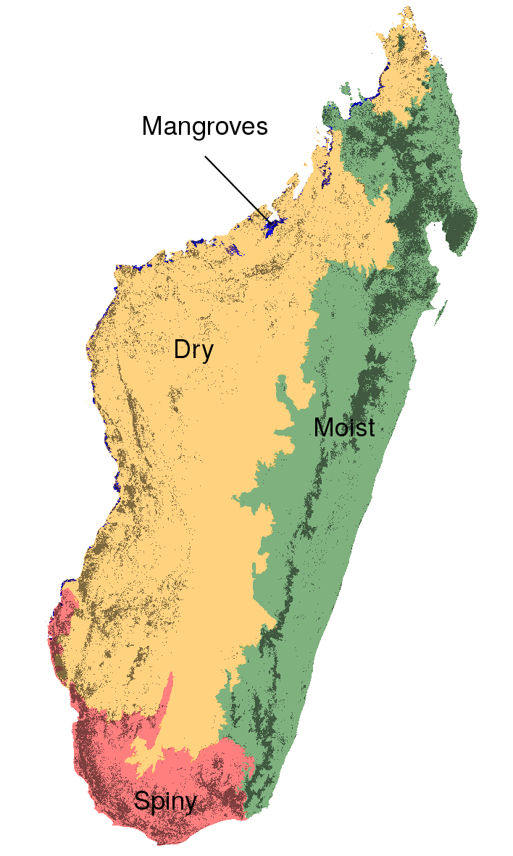

Figure 1: **Ecoregions and forest types in Madagascar.** Madagascar is divided into four climatic ecoregions with four forest types: the moist forest in the East (green), the dry forest in the West (orange), the spiny forest in the South (red), and the mangroves on the West coast (blue). Ecoregions were defined following climatic (Cornet, 1974) and vegetation (Ministère de l’Environnement, 1996)) criteria. The dark grey areas represent the remaining natural forest cover for the year 2014.

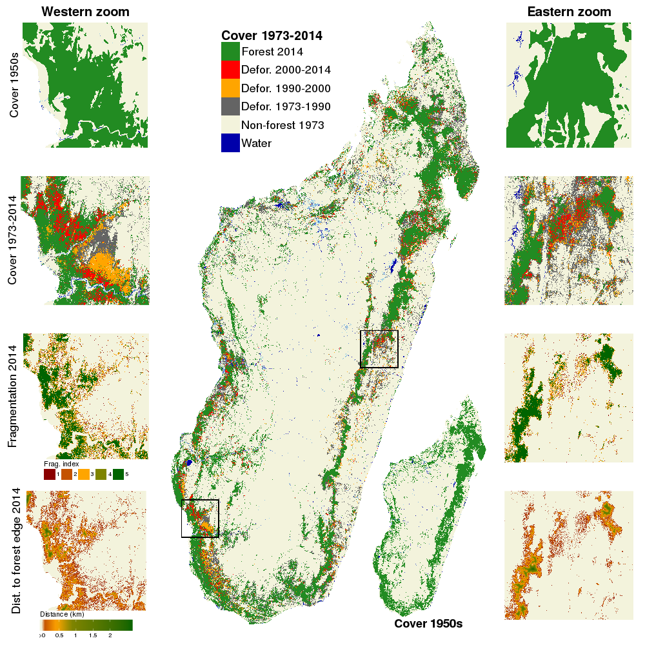

Figure 2: **Forest-cover change on six decades from c. 1953 to 2014 in Madagascar.** Forest cover changes from c. 1973 to 2014 are shown in the main figure, and forest cover in c. 1953 is shown in the bottom-right inset. Two zooms in the western dry (left part) and eastern moist (right part) ecoregions present more detailed views of (from top to bottom): forest-cover in 1950s, forest-cover change from c. 1973 to 2014, forest fragmentation in 2014 and distance to forest edge in 2014. Data on water bodies (blue) and water seasonality (light blue for seasonal water to dark blue for permanent water) has been extracted from Pekel et al. (2016).

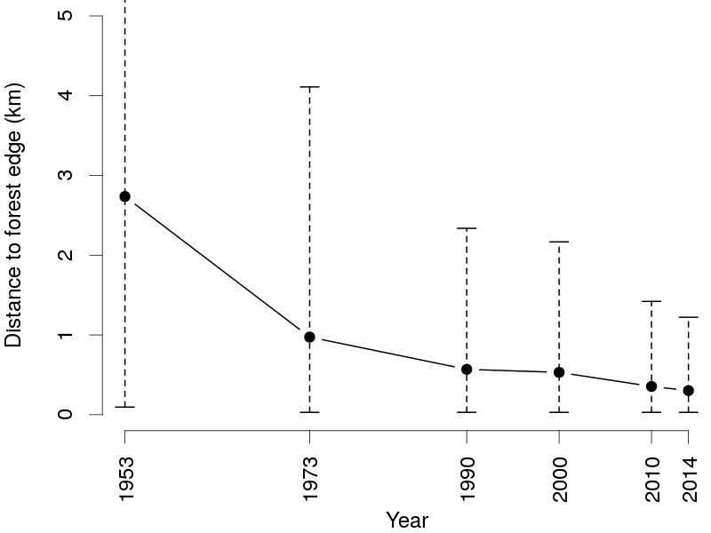

Figure 3: **Evolution of the mean distance to forest edge from 1953 to 2014 in Madagascar.** Black dots represent the mean distance to forest edge for each year. Vertical dashed segments represent the 95% quantiles of the distance to forest edge.

## Acknowledgements

This study is part of the Cirad's BioSceneMada project ([https://bioscenemada.cirad.fr](https://bioscenemada.cirad.fr/)) and the Joint Research Center's ReCaREDD project (<http://forobs.jrc.ec.europa.eu/recaredd>). The BioSceneMada project is funded by FRB (Fondation pour la Recherche sur la Biodiversité) and the FFEM (Fond Français pour l'Environnement Mondial) under the project agreement AAP-SCEN-2013 I. The ReCaREDD project is funded by the European Commission.

## Data availability statement

All the data and codes used for this study are made publicly available in the deforestmap GitHub repository (<https://github.com/ghislainv/deforestmap.git>). The results and the manuscript are fully reproducible running the R script deforestmap.R located inside the deforestmap repository.

## References

Achard, F., Beuchle, R., Mayaux, P., Stibig, H.-J., Bodart, C., Brink, A., Carboni, S., Desclée, B., Donnay, F., Eva, H.D., Lupi, A., Raši, R., Seliger, R., Simonetti, D., 2014. Determination of tropical deforestation rates and related carbon losses from 1990 to 2010. Global Change Biology 20, 2540–2554. doi:[10.1111/gcb.12605](https://doi.org/10.1111/gcb.12605)

Ali, J.R., Aitchison, J.C., 2008. Gondwana to asia: Plate tectonics, paleogeography and the biological connectivity of the indian sub-continent from the middle jurassic through latest eocene (166–35 ma). Earth-Science Reviews 88, 145–166.

Allnutt, T.F., Ferrier, S., Manion, G., Powell, G.V.N., Ricketts, T.H., Fisher, B.L., Harper, G.J., Irwin, M.E., Kremen, C., Labat, J.-N., Lees, D.C., Pearce, T.A., Rakotondrainibe, F., 2008. A method for quantifying biodiversity loss and its application to a 50-year record of deforestation across madagascar. Conservation Letters 1, 173–181.

Armitage, A.R., Highfield, W.E., Brody, S.D., Louchouarn, P., 2015. The contribution of mangrove expansion to salt marsh loss on the texas gulf coast. PloS one 10, e0125404.

Bastin J.F. et al., 2017. Science

Brinck, K., Fischer, R., Groeneveld, J., Lehmann, S., Dantas De Paula, M., Pütz, S., Sexton, J.O., Song, D., Huth, A., 2017. High resolution analysis of tropical forest fragmentation and its impact on the global carbon cycle. Nature Communications 8, 14855.

Brooks, T.M., Mittermeier, R.A., Mittermeier, C.G., Fonseca, G.A.B. da, Rylands, A.B., Konstant, W.R., Flick, P., Pilgrim, J., Oldfield, S., Magin, G., Hilton-Taylor, C., 2002. Habitat loss and extinction in the hotspots of biodiversity. Conservation Biology 16, 909–923.

Burns, S.J., Godfrey, L.R., Faina, P., McGee, D., Hardt, B., Ranivoharimanana, L., Randrianasy, J., 2016. Rapid human-induced landscape transformation in madagascar at the end of the first millennium of the common era. Quaternary Science Reviews 134, 92–99. doi:[http://dx.doi.org/10.1016/j.quascirev.2016.01.007](https://doi.org/http://dx.doi.org/10.1016/j.quascirev.2016.01.007)

Cornet, A., 1974. Essai de cartographie bioclimatique à Madagascar. Orstom.

Cox, M.P., Nelson, M.G., Tumonggor, M.K., Ricaut, F.-X., Sudoyo, H., 2012. A small cohort of island southeast asian women founded madagascar. Proceedings of the Royal Society B: Biological Sciences 279, 2761–2768.

Crottini, A., Madsen, O., Poux, C., Strauß, A., Vieites, D.R., Vences, M., 2012. Vertebrate time-tree elucidates the biogeographic pattern of a major biotic change around the k–T boundary in madagascar. Proceedings of the National Academy of Sciences 109, 5358–5363.

Eklund, J., Blanchet, F.G., Nyman, J., Rocha, R., Virtanen, T., Cabeza, M., 2016. Contrasting spatial and temporal trends of protected area effectiveness in mitigating deforestation in madagascar. Biological Conservation 203, 290–297. doi:[http://dx.doi.org/10.1016/j.biocon.2016.09.033](https://doi.org/http://dx.doi.org/10.1016/j.biocon.2016.09.033)

Freudenberger, K., 2010. Paradise lost? Lessons from 25 years of usaid environment programs in madagascar. International Resources Group, Washington DC.

Gibson, L., Lynam, A.J., Bradshaw, C.J., He, F., Bickford, D.P., Woodruff, D.S., Bumrungsri, S., Laurance, W.F., 2013. Near-complete extinction of native small mammal fauna 25 years after forest fragmentation. Science 341, 1508–1510.

Goodman, S.M., Benstead, J.P., 2005. Updated estimates of biotic diversity and endemism for madagascar. Oryx 39, 73–77.

Gorenflo, L.J., Corson, C., Chomitz, K.M., Harper, G., Honzák, M., Özler, B., 2011. Exploring the association between people and deforestation in madagascar. Springer Berlin Heidelberg.

Grinand, C., Le Maire, G., Vieilledent, G., Razakamanarivo, H., Razafimbelo, T., Bernoux, M., 2017. Estimating temporal changes in soil carbon stocks at ecoregional scale in madagascar using remote-sensing. International Journal of Applied Earth Observation and Geoinformation 54, 1–14.

Grinand, C., Rakotomalala, F., Gond, V., Vaudry, R., Bernoux, M., Vieilledent, G., 2013. Estimating deforestation in tropical humid and dry forests in madagascar from 2000 to 2010 using multi-date landsat satellite images and the random forests classifier. Remote Sensing of Environment 139, 68–80.

Gross, D., Achard, F. Dubois, G., Brink, A., Prins H.T., Uncertainties in tree cover maps of Sub-Saharan Africa and their implications for measuring progress towards CBD Aichi Targets. Remote Sensing in Ecology and Conservation. submitted

Grouzis, M., Razanaka, S., Le Floc’h, E., Leprun, J.-C., 2001. Évolution de la végétation et de quelques paramètres édaphiques au cours de la phase post-culturale dans la région d’Analabo. Sociétés paysannes, transitions agraires et dynamiques écologiques dans le Sud-Ouest de Madagascar, Antananarivo, IRD/CNRE 327–337.

Hansen, M.C., Potapov, P.V., Moore, R., Hancher, M., Turubanova, S.A., Tyukavina, A., Thau, D., Stehman, S.V., Goetz, S.J., Loveland, T.R., Kommareddy, A., Egorov, A., Chini, L., Justice, C.O., Townshend, J.R.G., 2013. High-resolution global maps of 21st-century forest cover change. Science 342, 850–853. doi:[10.1126/science.1244693](https://doi.org/10.1126/science.1244693) Data available on-line from:http://earthenginepartners.appspot.com/science-2013-global-forest. Accessed through Global Forest Watch on May 2016. www.globalforestwatch.org

Harper, G.J., Steininger, M.K., Tucker, C.J., Juhn, D., Hawkins, F., 2007. Fifty years of deforestation and forest fragmentation in Madagascar. Environmental Conservation 34, 325–333. doi:[10.1017/S0376892907004262](https://doi.org/10.1017/S0376892907004262)

Humbert, H., 1927. La destruction d’une flore insulaire par le feu. principaux aspects de la végétation à madagascar. Mémoires de l’Académie Malgache 5, 1–80.

Keenan, R.J., Reams, G.A., Achard, F., Freitas, J.V. de, Grainger, A., Lindquist, E., 2015. Dynamics of global forest area: Results from the FAO Global Forest Resources Assessment 2015. Forest Ecology and Management 352, 9–20. doi:[https://doi.org/10.1016/j.foreco.2015.06.014](https://doi.org/https://doi.org/10.1016/j.foreco.2015.06.014)

Kim, D.-H., Sexton, J.O., Noojipady, P., Huang, C., Anand, A., Channan, S., Feng, M., Townshend, J.R., 2014. Global, landsat-based forest-cover change from 1990 to 2000. Remote Sensing of Environment 155, 178–193.

Klein, J., 2002. Deforestation in the madagascar highlands – established “truth” and scientific uncertainty. GeoJournal 56, 191–199. doi:[10.1023/A:1025187422687](https://doi.org/10.1023/A:1025187422687)

Kull, C.A., 2000. Deforestation, erosion, and fire: Degradation myths in the environmental history of madagascar. Environment and History 6, 423–450.

MEFT, USAID, and CI, 2009. Evolution de la couverture de forêts naturelles à madagascar, 1990-2000-2005. Antananarivo.

Ministère de l’Environnement, 1996. IEFN: Inventaire Ecologique Forestier National. Ministère de l’Environnement de Madagascar, Direction des Eaux et Forêts, DFS Deutsch Forest Service GmbH, Entreprise d’études de développement rural “Mamokatra”, FTM.

Minten, B., Sander, K., Stifel, D., 2013. Forest management and economic rents: Evidence from the charcoal trade in madagascar. Energy for Sustainable Development 17, 106–115. doi:[https://doi.org/10.1016/j.esd.2012.08.004](https://doi.org/https://doi.org/10.1016/j.esd.2012.08.004)

Murcia, C., 1995. Edge effects in fragmented forests: Implications for conservation. Trends in Ecology & Evolution 10, 58–62. doi:[http://dx.doi.org/10.1016/S0169-5347(00)88977-6](https://doi.org/http://dx.doi.org/10.1016/S0169-5347(00)88977-6)

Neteler, M., Mitasova, H., 2008. Open source gis: A grass gis approach. Springer.

Olander, L.P., Gibbs, H.K., Steininger, M., Swenson, J.J., Murray, B.C., 2008. Reference scenarios for deforestation and forest degradation in support of redd: A review of data and methods. Environmental Research Letters 3, 025011.

ONE, DGF, FTM, MNP, and CI, 2013. Evolution de la couverture de forêts naturelles à madagascar 2005-2010. Antananarivo.

ONE, DGF, MNP, WCS, and Etc Terra, 2015. Changement de la couverture de forêts naturelles à madagascar, 2005-2010-2013. Antananarivo.

Pearson, R.G., Raxworthy, C.J., 2009. The evolution of local endemism in madagascar: Watershed versus climatic gradient hypotheses evaluated by null biogeographic models. Evolution 63, 959–967.

Pekel, J.-F., Cottam, A., Gorelick, N., Belward, A.S., 2016. High-resolution mapping of global surface water and its long-term changes. Nature 540, 418–422.

Perrier de La Bâthie, H., 1921. La végétation malgache. Musée Colonial.

Ploch, L., Cook, N., 2012. Madagascar’s political crisis.

Potapov, P., Hansen, M.C., Laestadius, L., Turubanova, S., Yaroshenko, A., Thies, C., Smith, W., Zhuravleva, I., Komarova, A., Minnemeyer, S., Esipova, E., 2017. The last frontiers of wilderness: Tracking loss of intact forest landscapes from 2000 to 2013. Science Advances 3. doi:[10.1126/sciadv.1600821](https://doi.org/10.1126/sciadv.1600821)

Puyravaud, J.P., 2003. Standardizing the calculation of the annual rate of deforestation. Forest Ecology and Management 177, 593–596. doi:[10.1016/S0378-1127(02)00335-3](https://doi.org/10.1016/S0378-1127(02)00335-3)

Rakotomalala, F.A., Grinand, C., 2015. Estimation de la déforestation des forêts humides à madagascar entre 2005, 2010 et 2013: Combinaison multi-date d’images landsat, utilisation de l’algorithme random forest et procédure de validation. Revue Française de Photogrammétrie et de Télédétection 11–23.

Riitters, K., Wickham, J., O’Neill, R., Jones, B., Smith, E., 2000. Global-scale patterns of forest fragmentation. Conservation Ecology 4, 3.

Saatchi, S.S., Harris, N.L., Brown, S., Lefsky, M., Mitchard, E.T.A., Salas, W., Zutta, B.R., Buermann, W., Lewis, S.L., Hagen, S., Petrova, S., White, L., Silman, M., Morel, A., 2011. Benchmark map of forest carbon stocks in tropical regions across three continents. Proceedings of the National Academy of Sciences 108, 9899–9904. doi:[10.1073/pnas.1019576108](https://doi.org/10.1073/pnas.1019576108)

Saunders, D.A., Hobbs, R.J., Margules, C.R., 1991. Biological consequences of ecosystem fragmentation: A review. Conservation Biology 5, 18–32. doi:[10.1111/j.1523-1739.1991.tb00384.x](https://doi.org/10.1111/j.1523-1739.1991.tb00384.x)

Scales, I.R., 2011. Farming at the forest frontier: Land use and landscape change in western madagascar, 1896-2005. Environment and History 17, 499–524. doi:[10.3197/096734011X13150366551481](https://doi.org/10.3197/096734011X13150366551481)

Smith, R.J., Muir, R.D.J., Walpole, M.J., Balmford, A., Leader-Williams, N., 2003. Governance and the loss of biodiversity. Nature 426, 67–70. doi:[http://dx.doi.org/10.1038/nature02025](https://doi.org/http://dx.doi.org/10.1038/nature02025)

Tidd, S.T., Pinder, J., Ferguson, G.W., 2001. Deforestation and habitat loss for the malagasy flat-tailed tortoise from 1963 through 1993. Chelonian Conservation and Biology 4, 59–65.

Tropek, R., Sedláček, O., Beck, J., Keil, P., Musilová, Z., Šímová, I., Storch, D., 2014. Comment on “high-resolution global maps of 21st-century forest cover change”. Science 344, 981–981. doi:[10.1126/science.1248753](https://doi.org/10.1126/science.1248753)

United Nations, 2015. World population prospects: The 2015 revision, key findings and advance tables. working paper no. esa/p/wp.241.

Verhegghen, A., Eva, H., Desclée, B., Achard, F., 2016. Review and combination of recent remote sensing based products for forest cover change assessments in cameroon. International Forestry Review 18, 14–25. doi:[10.1505/146554816819683807](https://doi.org/10.1505/146554816819683807)

Vieilledent, G., Cornu, C., Cuní Sanchez, A., Leong Pock-Tsy, J.-M., Danthu, P., 2013. Vulnerability of baobab species to climate change and effectiveness of the protected area network in Madagascar: Towards new conservation priorities. Biological Conservation 166, 11–22.

Vieilledent, G., Gardi, O., Grinand, C., Burren, C., Andriamanjato, M., Camara, C., Gardner, C.J., Glass, L., Rasolohery, A., Rakoto Ratsimba, H., Gond, V., Rakotoarijaona, J.-R., 2016. Bioclimatic envelope models predict a decrease in tropical forest carbon stocks with climate change in Madagascar. Journal of Ecology 104, 703–715. doi:[10.1111/1365-2745.12548](https://doi.org/10.1111/1365-2745.12548)

Vieilledent, G., Grinand, C., Vaudry, R., 2013. Forecasting deforestation and carbon emissions in tropical developing countries facing demographic expansion: A case study in madagascar. Ecology and Evolution 3, 1702–1716. doi:[10.1002/ece3.550](https://doi.org/10.1002/ece3.550)

Virah-Sawmy, M., 2009. Ecosystem management in madagascar during global change. Conservation Letters 2, 163–170.

Vorontsova, M.S., Besnard, G., Forest, F., Malakasi, P., Moat, J., Clayton, W.D., Ficinski, P., Savva, G.M., Nanjarisoa, O.P., Razanatsoa, J., Randriatsara, F.O., Kimeu, J.M., Luke, W.R.Q., Kayombo, C., Linder, H.P., 2016. Madagascar’s grasses and grasslands: Anthropogenic or natural? Proceedings of the Royal Society of London B: Biological Sciences 283. doi:[10.1098/rspb.2015.2262](https://doi.org/10.1098/rspb.2015.2262)