Spatial forecasting of tropical moist forest cover change over the 21 century

Ghislain VIEILLEDENT, Christelle VANCUTSEM, and Frédéric ACHARD

16 octobre, 2020

# Abstract

Tropical forests are disappearing at an alarming rate because of human activities. Here we modelled spatially the anthropogenic deforestation process in 119 tropical territories (92 countries) including all the humid tropical forests in the world. We demonstrated the effectiveness of protected areas at deplacing deforestation and the negative impact of road infrastructures on forest conservation globally. We derived high resolution global maps of the deforestation risk and likely future forest cover for the 21 century under a “business-as-usual” scenario. If large areas of tropical forest will still remain in 2100 at the heart of the Amazon, in the Congo Basin, and in New-Guinea, many countries will entirely lose their tropical forests before the end of the 21 century. Remaining forests will be strongly fragmented and located in remote places.

**Keywords:** deforestation, forecasts, forest cover change, forest refuge areas, moist tropical forests, spatial modelling, scenarios.

**One sentence summary:** Tropical moist forests will still exist at the end of the 21 century, but not everywhere in the tropics.

# Introduction

Tropical forests are the “Jewels of the Earth”. They shelter 30 million species of plants and animals representing half of the Earth’s wildlife and at least two-thirds of its plant species (Gibson *et al.* 2011; Wilson *et al.* 2012). They also play an important role in the global carbon cycle, and at regulating the global climate (Bonan 2008; Pan *et al.* 2011; Baccini *et al.* 2017). At the local scale, they regulate the regional climate (Dickinson & Kennedy 1992), cooling the atmosphere (Ellison *et al.* 2017; De Frenne *et al.* 2019), and facilitating access to water (Ellison *et al.* 2017). They also provide protection against erosion and flooding (Bradshaw *et al.* 2007). Close to 1.6 billion people (a quarter of the world’s population) rely on forest resources for their livelihoods (FAO 2015). Despite the many ecosystem services they provide, tropical forests are disappearing at an alarming rate (Hansen *et al.* 2013; Achard *et al.* 2014; Keenan *et al.* 2015; Vancutsem *et al.* 2020), mostly because of human activites (Geist & Lambin 2001; Curtis *et al.* 2018). Currently, around 8 Mha (twice the size of Switzerland) of tropical forest are disappearing each year (FAO 2015). At this rate, will there still be tropical forests in 2100 and where will they be concentrated?

Statistical modelling of deforestation can help understand better the deforestation process, identifying the main drivers of deforestation and quantifying their relative effects. Regarding roads, modelling deforestation can help assess the impact of roads on the risk of deforestation and anticipate the changes in forest-cover associated to the potential development of road infrastructure.

Spatial forecast of tropical deforestation and inform policy makers on what’s going to happen if they do nothing versus what is likely to happen in response to decisions.

In this study, we present the first attempt to model and forecast tropical deforestation globally using high resolution data.

# Spatial model of deforestation

* Some methodological information

# Effectiveness of protected areas

# Road’s impact on deforestation

# Remaining forests in 2100

* Countries having lost their forest
* Residual fragmented forest
* Intact forest blocks

# Impact on ecosystem services

* Impact on carbon emissions
* Biodiversity loss (map of biodiversity)
* Risk of zoonose and pandemy associated to deforestation

# Priority areas for conservation

* Refuge areas
* Impact on policies
* Various scenarios: map of probability can be used with different scenarios regarding deforestation intensity.

# Scenarios of deforestation

* Alternatives to “business-as-usual” scenarios of deforestation
* Which mean do we consider 2000–2010 or 2010–2020 or mean?
* No need to take into account diffusion of deforestation between countries and continents before 2100 (see linear change of perc with time per continent)

# Importance of assessing tropical forest resilience to climate change

(Vieilledent *et al.* 2016; Esquivel-Muelbert *et al.* 2018; Zellweger *et al.* 2020)

# Ackowledgements

Authors warmly thank Rémy Dernat and Philippe Verley for their help on using the computing cluster of the Montpellier Bioinformatics Biodiversity (MBB) plateform. **Funding**: BioSceneMada project funded by FRB-FFEM (AAP-SCEN-2013 I), Roadless Forest funded by the European Commission, RELIQUES project funded by CNRT, LabEx CeMEB funded by ANR “Investissements d’avenir” program (ANR-10-LABX-04-01). **Authors contributions**: GV and FA conceived the study, CV provided the historical forest cover change maps and advices on using the deforestation annual product, GV performed the analysis and wrote the original draft, all authors reviewed and edited the final manuscript. **Competing interests**: All authors declare that they have no competing interests. **Data and materials availability**: All data, code, and materials used for the analysis are available on the following GitHub repository: <https://github.com/ghislainv/forestatrisk-tropics>.

# Tables

# Figures

## Relative spatial probability of deforestation

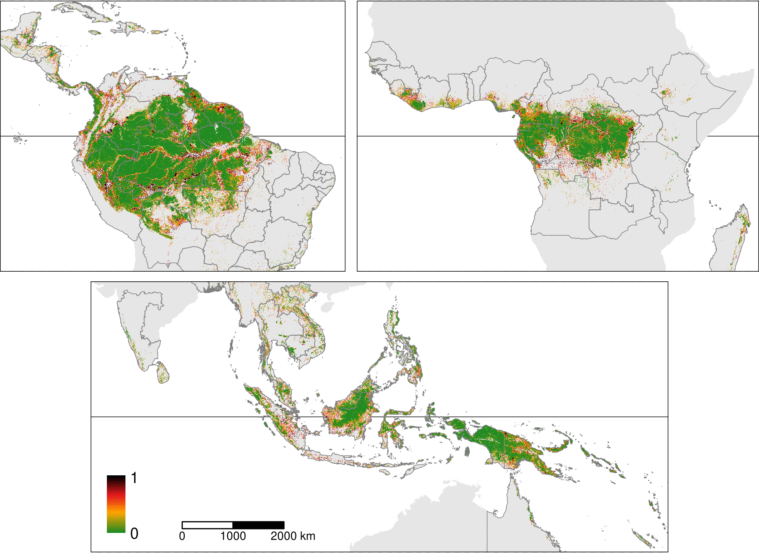

Figure 1: **Predicted relative spatial probability of deforestation**. Map of the spatial probability of deforestation computed for each forest pixel in 2020. On the map, we clearly see the effect of the distance to nearest town, road, and river, and the effect of the distance to forest edge on the spatial probability of deforestation.

## Projected forest cover change

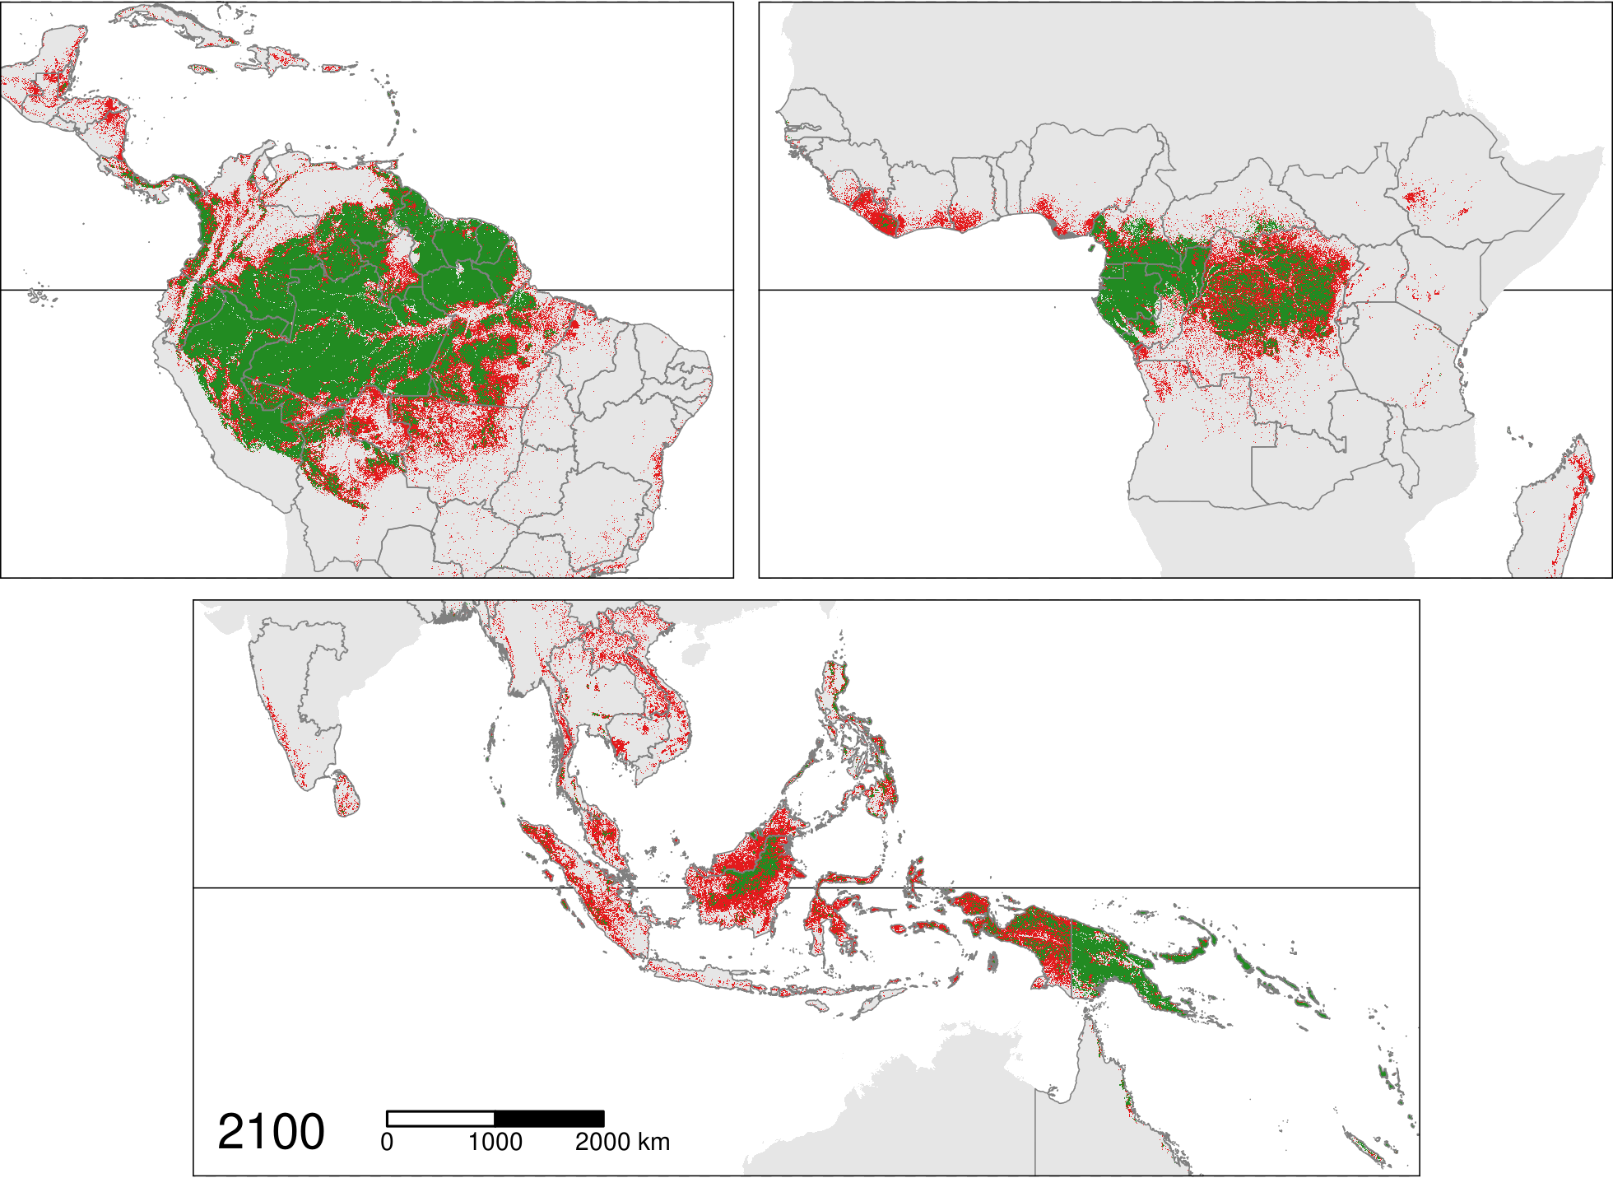

Figure 2: **Projected forest cover change**. Maps of the projected forest cover change (2020–2100). : projected deforestation, : remaining forest cover. Besides the loss of forest cover, we show a progressive fragmentation of the forest in the future, with an increasing number of forest patchs of smaller size.

# References

Achard, F., Beuchle, R., Mayaux, P., Stibig, H.-J., Bodart, C., Brink, A., Carboni, S., Desclée, B., Donnay, F., Eva, H.D., Lupi, A., Raši, R., Seliger, R. & Simonetti, D. (2014) Determination of tropical deforestation rates and related carbon losses from 1990 to 2010. *Global Change Biology*, **20**, 2540–2554.

Baccini, A., Walker, W., Carvalho, L., Farina, M., Sulla-Menashe, D. & Houghton, R.A. (2017) Tropical forests are a net carbon source based on aboveground measurements of gain and loss. *Science*, **358**, 230–234.

Bonan, G.B. (2008) Forests and climate change: Forcings, feedbacks, and the climate benefits of forests. *Science*, **320**, 1444–1449.

Bradshaw, C.J.A., Sodhi, N.S., Peh, K.S...H. & Brook, B.W. (2007) Global evidence that deforestation amplifies flood risk and severity in the developing world. *Global Change Biology*, **13**, 2379–2395.

Curtis, P.G., Slay, C.M., Harris, N.L., Tyukavina, A. & Hansen, M.C. (2018) Classifying drivers of global forest loss. *Science*, **361**, 1108–1111.

De Frenne, P., Zellweger, F., Rodrı́guez-Sánchez, F., Scheffers, B.R., Hylander, K., Luoto, M., Vellend, M., Verheyen, K. & Lenoir, J. (2019) Global buffering of temperatures under forest canopies. *Nature Ecology & Evolution*, **3**, 744–749.

Dickinson, R.E. & Kennedy, P. (1992) Impacts on regional climate of amazon deforestation. *Geophysical Research Letters*, **19**, 1947–1950.

Ellison, D., Morris, C.E., Locatelli, B., Sheil, D., Cohen, J., Murdiyarso, D., Gutierrez, V., Noordwijk, M. van, Creed, I.F., Pokorny, J., Gaveau, D., Spracklen, D.V., Tobella, A.B., Ilstedt, U., Teuling, A.J., Gebrehiwot, S.G., Sands, D.C., Muys, B., Verbist, B., Springgay, E., Sugandi, Y. & Sullivan, C.A. (2017) Trees, forests and water: Cool insights for a hot world. *Global Environmental Change*, **43**, 51–61.

Esquivel-Muelbert, A., Baker, T.R., Dexter, K.G., Lewis, S.L., Brienen, R.J.W., Feldpausch, T.R., Lloyd, J., Monteagudo-Mendoza, A., Arroyo, L., Álvarez-Dávila, E., Higuchi, N., Marimon, B.S., Marimon-Junior, B.H., Silveira, M., Vilanova, E., Gloor, E., Malhi, Y., Chave, J., Barlow, J., Bonal, D., Cardozo, N.D., Erwin, T., Fauset, S., Hérault, B., Laurance, S., Poorter, L., Qie, L., Stahl, C., Sullivan, M.J.P., Steege, H. ter, Vos, V.A., Zuidema, P.A., Almeida, E., Oliveira, E.A. de, Andrade, A., Vieira, S.A., Aragão, L., Araujo-Murakami, A., Arets, E., C, G.A.A., Baraloto, C., Camargo, P.B., Barroso, J.G., Bongers, F., Boot, R., Camargo, J.L., Castro, W., Moscoso, V.C., Comiskey, J., Valverde, F.C., Costa, A.C.L. da, Aguila Pasquel, J. del, Fiore, A.D., Duque, L.F., Elias, F., Engel, J., Llampazo, G.F., Galbraith, D., Fernández, R.H., Coronado, E.H., Hubau, W., Jimenez-Rojas, E., Lima, A.J.N., Umetsu, R.K., Laurance, W., Lopez-Gonzalez, G., Lovejoy, T., Cruz, O.A.M., Morandi, P.S., Neill, D., Vargas, P.N., Camacho, N.C.P., Gutierrez, A.P., Pardo, G., Peacock, J., Peña-Claros, M., Peñuela-Mora, M.C., Petronelli, P., Pickavance, G.C., Pitman, N., Prieto, A., Quesada, C., Ramı́rez-Angulo, H., Réjou-Méchain, M., Correa, Z.R., Roopsind, A., Rudas, A., Salomão, R., Silva, N., Espejo, J.S., Singh, J., Stropp, J., Terborgh, J., Thomas, R., Toledo, M., Torres-Lezama, A., Gamarra, L.V., Meer, P.J. van de, Heijden, G. van der, Hout, P. van der, Martinez, R.V., Vela, C., Vieira, I.C.G. & Phillips, O.L. (2018) Compositional response of amazon forests to climate change. *Global Change Biology*, **25**, 39–56.

FAO. (2015) *Global Forest Resources Assessment 2015*. Food; Agriculture Organization of the United Nations.

Geist, H.J. & Lambin, E.F. (2001) *What Drives Tropical Deforestation? A Meta-Analysis of Proximate and Underlying Causes of Deforestation Based on Subnational Case Study Evidence*. LUCC International Project Office, University of Louvain.

Gibson, L., Lee, T.M., Koh, L.P., Brook, B.W., Gardner, T.A., Barlow, J., Peres, C.A., Bradshaw, C.J.A., Laurance, W.F., Lovejoy, T.E. & Sodhi, N.S. (2011) Primary forests are irreplaceable for sustaining tropical biodiversity. *Nature*, **478**, 378–381.

Hansen, M.C., Potapov, P.V., Moore, R., Hancher, M., Turubanova, S.A., Tyukavina, A., Thau, D., Stehman, S.V., Goetz, S.J., Loveland, T.R., Kommareddy, A., Egorov, A., Chini, L., Justice, C.O. & Townshend, J.R.G. (2013) High-resolution global maps of 21st-century forest cover change. *Science*, **342**, 850–853.

Keenan, R.J., Reams, G.A., Achard, F., Freitas, J.V. de, Grainger, A. & Lindquist, E. (2015) Dynamics of global forest area: Results from the {fao} global forest resources assessment 2015. *Forest Ecology and Management*, **352**, 9–20.

Pan, Y., Birdsey, R.A., Fang, J., Houghton, R., Kauppi, P.E., Kurz, W.A., Phillips, O.L., Shvidenko, A., Lewis, S.L., Canadell, J.G., Ciais, P., Jackson, R.B., Pacala, S.W., McGuire, A.D., Piao, S., Rautiainen, A., Sitch, S. & Hayes, D. (2011) A large and persistent carbon sink in the world’s forests. *Science*, **333**, 988–993.

Vancutsem, C., Achard, F., Pekel, J.-F., Vieilledent, G., Carboni, S., Simonetti, D., Gallego, J., Aragao, L. & Nasi, R. (2020) Long-term (1990-2019) monitoring of tropical moist forests dynamics. *bioRxiv*.

Vieilledent, G., Gardi, O., Grinand, C., Burren, C., Andriamanjato, M., Camara, C., Gardner, C.J., Glass, L., Rasolohery, A., Rakoto Ratsimba, H., Gond, V. & Rakotoarijaona, J.-R. (2016) Bioclimatic envelope models predict a decrease in tropical forest carbon stocks with climate change in Madagascar. *Journal of Ecology*, **104**, 703–715.

Wilson, J.B., Peet, R.K., Dengler, J. & Pärtel, M. (2012) Plant species richness: The world records. *Journal of Vegetation Science*, **23**, 796–802.

Zellweger, F., Frenne, P.D., Lenoir, J., Vangansbeke, P., Verheyen, K., Bernhardt-Römermann, M., Baeten, L., Hédl, R., Berki, I., Brunet, J., Calster, H.V., Chudomelová, M., Decocq, G., Dirnböck, T., Durak, T., Heinken, T., Jaroszewicz, B., Kopecký, M., Máliš, F., Macek, M., Malicki, M., Naaf, T., Nagel, T.A., Ortmann-Ajkai, A., Petřı́k, P., Pielech, R., Reczyńska, K., Schmidt, W., Standovár, T., Świerkosz, K., Teleki, B., Vild, O., Wulf, M. & Coomes, D. (2020) Forest microclimate dynamics drive plant responses to warming. *Science*, **368**, 772–775.