**Appendices**

***Appendix A: Sampling strategy, and plot structural and compositional features***

The stratified sampling of the vegetation was based on a vegetation map built from Landsat and Spot images (Laumonier et al., 2013). Supervised classification coupled with photo-interpretation led to a 30-m resolution map depicting ca. 40 different classes of vegetation (e.g. logged-over lowland forest) and land uses (e.g. settlement). We surveyed the main vegetation types of the study area: (1) lowland forest, (2) logged-over lowland forest, (3) lowland secondary regrowth, (4) smallholder rubber gardens, (5) lowland forest on sandstone (i.e. lowland *Kerangas* forest), (6) hill forest, (7) hill forest on sandstone (i.e. hill *Kerangas* forest), (8) freshwater swamp forest, (9) mixed peat swamp forest, (10) deep peat swamp forest, and (11) riparian secondary regrowth.

For lowland secondary regrowth and smallholder rubber gardens, plots of 20 × 20 m were randomly selected across the landscape to capture the variability of vegetation structure and composition inherent to such vegetation/land-use types. For the other vegetation types, plots of 100 × 20 m were mostly used, usually at a distance of 100 m from each other. When bigger plots were selected (e.g. location KL.BK, Table A.1), they were subsequently subdivided into strips of 100 × 20 m for the sake of comparison.

Leaf samples were collected at least once for each vernacular name (consistently given by the same group of highly knowledgeable local people using the Iban language) for lowland secondary regrowth and rubber gardens, and in a semi-systematic way for the other vegetation types (i.e. at least once per sampling site for a few very common and easily identifiable species, and for each tree otherwise).

For each plot, we computed different indices to characterize TAD: species richness, S100, and Fisher's α (see Table A.1). Species richness is the simplest measure of species diversity and represents the number of species found in the plot. Because species richness cannot be used to compare plots with different sampling area, we computed S100, that is the expected number of species found in a sample of a hundred randomly chosen individuals (Hurlbert, 1971). S100 was computed using the ‘rarefy’ function of the ‘vegan’ R package (Oksanen et al., 2015). Yet, because some plots did not reach 100 individuals (see Table A.1), we had to model rarefaction curves to extrapolate S100 values. We tested two different functions, sqrt(x) and log(1+x), and selected the former because of better fit (Fig. A.1). Consequently, for plots with n < 100 individuals, S100 is the value of the model using the sqrt(x) function extrapolated for n = 100.

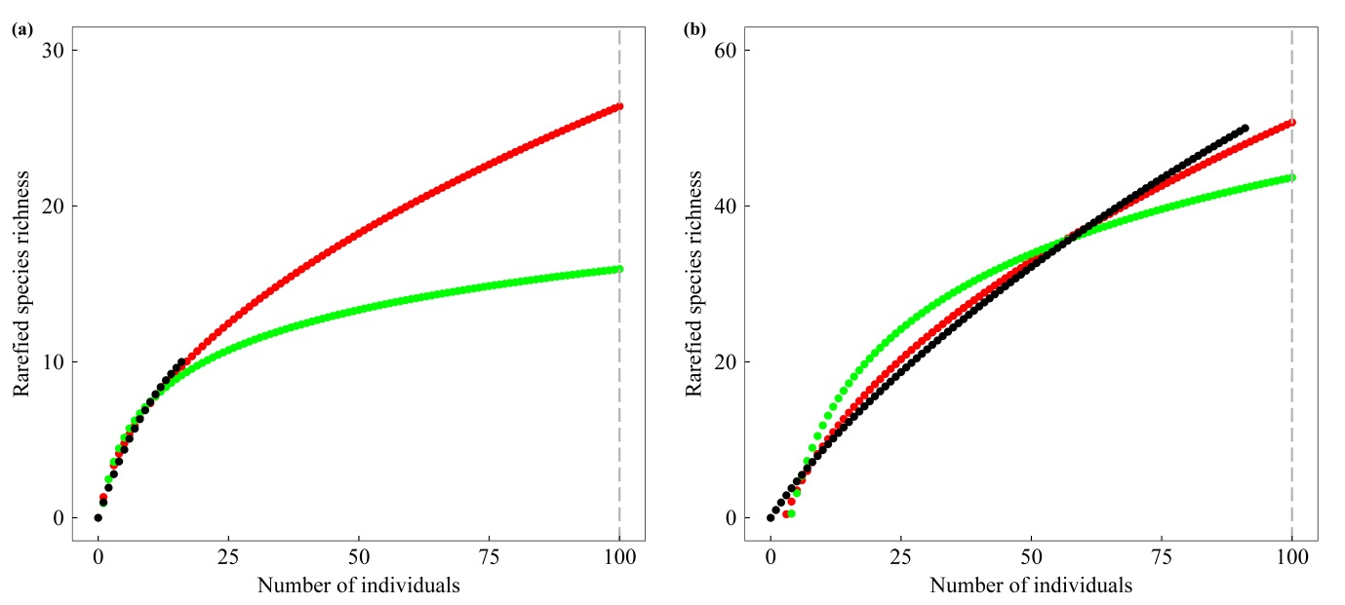

**Fig. A.1** Examples of S100 computation for two sampling plots with n < 100 individuals. The model using the sqrt(x) function (red dots) better fits the rarefaction curve (black dots) compared to the model using the log(1+x) function (green dots).

After having conducted modeling and subsequent analysis with both S100 and Fisher’s α, we decided to use only Fisher’s α because correlations between TAD and either ACD or SCD, and spatial congruence of their respective hotspots were very similar whichever the indicator used (S100 and Fisher’s α were very strongly correlated; Pearson’s *r* = 0.98, p < 0.001), and because Fisher’s α measures did not suffer potential bias due to the aforementioned computation technique.

**Table A.1** Information on plot structure and diversity features. One plot was consistently discarded in ACD-related analyses because of outlier behavior (see grey-tinted line; ACD = 710 Mg ha-1).

| **Plot ID** | **X_coord** | **Y_coord** | **Vegetation condition a and type b** | **Area** | **ACD**  **(Mg ha-1)** | **Tree number** | **Tree density (ha-1)** | **DBH (cm)** | **Height (m)** | **WSG**  **(g cm-3)** | **Species richness** | **S100** | **Fisher's α** |
| --- | --- | --- | --- | --- | --- | --- | --- | --- | --- | --- | --- | --- | --- |
| KL.SR 1 | 640522.2 | 127291.4 | RuG_low | 0.04 | 29.9 | 22 | 550 | 17.6 | 10.7 | 0.483 | 6 | 12.7 | 2.7 |
| KL.SR 3 | 640527.9 | 127461.1 | RuG_low | 0.04 | 14.7 | 28 | 700 | 13.1 | 10.8 | 0.399 | 7 | 13.5 | 3.0 |
| KL.SR 4 | 640533.6 | 127483.4 | RuG_low | 0.04 | 37.7 | 18 | 450 | 18.1 | 12.1 | 0.493 | 11 | 26.5 | 12.0 |
| KL.SR 5 | 640792.7 | 127749.8 | RuG_low | 0.04 | 9.8 | 17 | 425 | 13.8 | 9.4 | 0.452 | 7 | 18.0 | 4.5 |
| KL.SR 6 | 639219.8 | 127014.4 | RuG_low | 0.04 | 27.6 | 27 | 675 | 15.5 | 11.9 | 0.464 | 5 | 9.2 | 1.8 |
| KL.SR 7 | 639189.1 | 127004.8 | RuG_low | 0.04 | 33.6 | 35 | 875 | 14.8 | 11.3 | 0.479 | 11 | 18.9 | 5.5 |
| KL.SR 8 | 640355.8 | 127411.2 | RuG_low | 0.04 | 66.2 | 20 | 500 | 19.4 | 11.7 | 0.501 | 10 | 24.1 | 8.0 |
| KL.SR 9 | 640422.6 | 127344.4 | RuG_low | 0.04 | 61.7 | 22 | 550 | 20.4 | 12.1 | 0.488 | 7 | 15.5 | 3.5 |
| KL.SR 10 | 640450.9 | 127738.2 | RuG_low | 0.04 | 38.4 | 11 | 275 | 23.8 | 12.7 | 0.548 | 8 | 24.3 | 13.2 |
| KL.SR 11 | 640631.3 | 127753.7 | RuG_low | 0.04 | 72.6 | 27 | 675 | 22.1 | 12.7 | 0.538 | 15 | 30.3 | 13.9 |
| KL.SR 12 | 640622.2 | 127688.9 | RuG_low | 0.04 | 63.5 | 34 | 850 | 18.9 | 11.8 | 0.512 | 16 | 28.4 | 11.8 |
| KL.SR 13 | 640409.2 | 127576.9 | RuG_low | 0.04 | 86.5 | 16 | 400 | 29.8 | 12.9 | 0.453 | 11 | 28.6 | 15.5 |
| KL.SR 14 | 640397.2 | 127588.4 | RuG_low | 0.04 | 49.8 | 18 | 450 | 21.5 | 12.7 | 0.497 | 8 | 20.1 | 5.5 |
| KL.SR 15 | 640999.5 | 127471.1 | RuG_low | 0.04 | 55.4 | 24 | 600 | 20.7 | 12.3 | 0.552 | 11 | 23.5 | 7.9 |
| KL.SR 16 | 641092.5 | 127564.9 | RuG_low | 0.04 | 48.3 | 22 | 550 | 21.4 | 13.0 | 0.498 | 12 | 26.5 | 10.8 |
| KL.SR 17 | 640263.1 | 128179.2 | RuG_low | 0.04 | 31.9 | 11 | 275 | 23.1 | 12.9 | 0.516 | 8 | 24.3 | 13.2 |
| KL.SR 18 | 640071.7 | 128248.7 | RuG_low | 0.04 | 55.7 | 20 | 500 | 22.0 | 14.3 | 0.492 | 11 | 25.3 | 10.0 |
| KL.SR 21 | 640592.1 | 127500.4 | SeR_low | 0.04 | 16.8 | 22 | 550 | 14.1 | 11.0 | 0.455 | 10 | 22.2 | 7.1 |
| KL.SR 22 | 640560.6 | 127223.7 | SeR_low | 0.04 | 26.9 | 17 | 425 | 17.2 | 9.8 | 0.496 | 11 | 27.6 | 13.5 |
| KL.SR 23 | 640627.8 | 127517.6 | SeR_low | 0.04 | 21.0 | 12 | 300 | 14.7 | 9.5 | 0.467 | 5 | 14.7 | 3.2 |
| KL.SR 24 | 640726.0 | 127939.0 | SeR_low | 0.04 | 21.0 | 41 | 1025 | 14.0 | 10.9 | 0.332 | 8 | 12.7 | 3.0 |
| KL.SR 25 | 640703.7 | 127946.2 | SeR_low | 0.04 | 14.1 | 35 | 875 | 12.7 | 9.8 | 0.369 | 8 | 14.0 | 3.2 |
| KL.SR 26 | 640485.0 | 127110.0 | SeR_low | 0.04 | 64.7 | 21 | 525 | 20.0 | 11.1 | 0.524 | 11 | 25.1 | 9.3 |
| KL.SR 27 | 640378.2 | 127070.3 | SeR_low | 0.04 | 31.3 | 25 | 625 | 16.8 | 10.9 | 0.529 | 18 | 37.6 | 28.8 |
| KL.SR 28 | 639835.6 | 127086.7 | SeR_low | 0.04 | 13.8 | 16 | 400 | 15.1 | 11.1 | 0.489 | 10 | 26.4 | 11.4 |
| KL.SR 29 | 639617.4 | 127015.6 | SeR_low | 0.04 | 103.8 | 23 | 575 | 23.0 | 12.7 | 0.515 | 15 | 33.1 | 18.7 |
| KL.SR 30 | 639523.4 | 127050.8 | SeR_low | 0.04 | 22.1 | 16 | 400 | 16.0 | 12.9 | 0.589 | 13 | 33.4 | 32.4 |
| KL.SR 31 | 639936.6 | 127121.8 | SeR_low | 0.04 | 116.7 | 20 | 500 | 25.5 | 13.1 | 0.586 | 12 | 27.7 | 12.7 |
| KL.SR 32 | 639873.5 | 127059.3 | SeR_low | 0.04 | 76.1 | 21 | 525 | 21.4 | 13.3 | 0.541 | 13 | 29.1 | 14.6 |
| KL.SR 33 | 640692.5 | 128118.7 | SeR_low | 0.04 | 37.9 | 39 | 975 | 15.6 | 11.4 | 0.464 | 11 | 17.5 | 5.1 |
| KL.SR 34 | 640898.2 | 128537.1 | SeR_low | 0.04 | 93.1 | 29 | 725 | 23.4 | 11.3 | 0.568 | 19 | 37.6 | 23.9 |
| KL.SR 35 | 641023.4 | 127403.8 | SeR_low | 0.04 | 38.0 | 30 | 750 | 16.5 | 10.4 | 0.573 | 18 | 33.9 | 19.0 |
| KL.SR 36 | 640647.3 | 127206.6 | SeR_low | 0.04 | 110.7 | 23 | 575 | 26.8 | 13.6 | 0.591 | 16 | 35.3 | 23.3 |
| KL.SR 44 | 640765.8 | 128856.4 | SeR_low | 0.04 | 3.0 | 7 | 175 | 10.7 | 10.1 | 0.535 | 2 | 7.4 | 0.9 |
| KL.SR 47 | 640762.0 | 128992.8 | SeR_low | 0.04 | 107.5 | 16 | 400 | 26.7 | 21.5 | 0.493 | 6 | 15.2 | 3.5 |
| KL.LR 1 | 640745.6 | 130090.4 | LoF_low | 0.20 | 63.7 | 124 | 620 | 20.1 | 11.1 | 0.552 | 55 | 48.2 | 37.9 |
| KL.LR 2 | 640268.6 | 130293.3 | LoF_low | 0.20 | 49.5 | 115 | 575 | 18.8 | 13.1 | 0.512 | 37 | 33.9 | 18.9 |
| KL.LR 3 | 640033.1 | 130994.7 | LoF_low | 0.20 | 21.0 | 151 | 755 | 13.2 | 10.9 | 0.485 | 59 | 45.5 | 35.6 |
| KL.LR 4 | 640147.4 | 131207.4 | LoF_low | 0.20 | 92.1 | 170 | 850 | 18.9 | 13.5 | 0.558 | 75 | 56.0 | 51.3 |
| KL.LR 5 | 640191.0 | 131491.5 | LoF_low | 0.20 | 53.5 | 145 | 725 | 18.2 | 12.0 | 0.538 | 63 | 49.7 | 42.4 |
| KL.BK 1 | 639923.4 | 130079.3 | NaF_low | 0.20 | 130.7 | 157 | 785 | 20.1 | 19.2 | 0.599 | 56 | 44.7 | 31.1 |
| KL.BK 2 | 639900.2 | 130063.4 | NaF_low | 0.20 | 168.1 | 135 | 675 | 21.8 | 19.5 | 0.587 | 46 | 39.7 | 24.6 |
| KL.BK 3 | 639858.6 | 130035.6 | NaF_low | 0.20 | 99.8 | 124 | 620 | 19.6 | 19.0 | 0.568 | 60 | 52.3 | 45.8 |
| KL.BK 4 | 639880.0 | 130049.0 | NaF_low | 0.20 | 141.3 | 139 | 695 | 19.7 | 18.5 | 0.599 | 55 | 46.3 | 33.6 |
| KL.BK 5 | 639945.5 | 130096.3 | NaF_low | 0.20 | 95.3 | 141 | 705 | 19.1 | 17.0 | 0.588 | 64 | 54.1 | 45.2 |
| KL.BK 6 | 639798.2 | 130127.6 | NaF_low | 0.20 | 203.4 | 172 | 860 | 21.6 | 20.4 | 0.605 | 55 | 43.4 | 28.0 |
| KL.BK 7 | 639820.0 | 130140.2 | NaF_low | 0.20 | 186.1 | 145 | 725 | 22.8 | 20.2 | 0.575 | 54 | 45.2 | 31.2 |
| KL.BK 8 | 639837.2 | 130155.4 | NaF_low | 0.20 | 137.5 | 163 | 815 | 20.3 | 18.1 | 0.588 | 63 | 47.5 | 37.7 |
| KL.BK 9 | 639861.7 | 130171.3 | NaF_low | 0.20 | 122.0 | 164 | 820 | 19.3 | 17.9 | 0.594 | 58 | 44.7 | 32.0 |
| KL.BK 10 | 639883.5 | 130187.2 | NaF_low | 0.20 | 113.6 | 166 | 830 | 18.9 | 17.5 | 0.565 | 54 | 40.3 | 27.8 |
| KL.BK 11 | 639734.1 | 130220.9 | NaF_low | 0.20 | 217.3 | 174 | 870 | 24.1 | 20.6 | 0.560 | 44 | 33.9 | 19.0 |
| KL.BK 12 | 639759.8 | 130232.1 | NaF_low | 0.20 | 205.8 | 186 | 930 | 20.9 | 20.0 | 0.608 | 53 | 37.5 | 24.7 |
| KL.BK 13 | 639775.7 | 130245.4 | NaF_low | 0.20 | 142.4 | 166 | 830 | 20.0 | 19.4 | 0.587 | 63 | 49.0 | 37.0 |
| KL.BK 14 | 639796.9 | 130259.9 | NaF_low | 0.20 | 181.6 | 151 | 755 | 21.8 | 18.1 | 0.613 | 54 | 43.3 | 30.1 |
| KL.BK 15 | 639820.7 | 130278.4 | NaF_low | 0.20 | 182.0 | 155 | 775 | 21.4 | 19.3 | 0.593 | 51 | 43.1 | 26.5 |
| KL.BK 16 | 639673.9 | 130312.2 | NaF_low | 0.20 | 204.5 | 146 | 730 | 23.0 | 19.7 | 0.581 | 46 | 38.3 | 23.1 |
| KL.BK 17 | 639697.0 | 130324.1 | NaF_low | 0.20 | 192.5 | 151 | 755 | 22.4 | 20.1 | 0.615 | 50 | 41.1 | 26.1 |
| KL.BK 18 | 639714.2 | 130338.6 | NaF_low | 0.20 | 249.0 | 135 | 675 | 25.1 | 19.6 | 0.587 | 57 | 48.5 | 37.2 |
| KL.BK 19 | 639735.4 | 130351.9 | NaF_low | 0.20 | 208.0 | 138 | 690 | 22.5 | 19.5 | 0.599 | 53 | 44.3 | 31.5 |
| KL.BK 20 | 639757.9 | 130369.1 | NaF_low | 0.20 | 265.9 | 149 | 745 | 24.0 | 20.4 | 0.593 | 61 | 48.5 | 38.6 |
| ND.BP 1 | 705149.4 | 37293.3 | NaF_low | 0.20 | 357.1 | 152 | 760 | 26.5 | 23.1 | 0.676 | 43 | 32.6 | 20.0 |
| ND.BP 2 | 705181.9 | 37276.1 | NaF_low | 0.20 | 179.9 | 95 | 475 | 25.1 | 22.0 | 0.619 | 44 | 44.9 | 31.8 |
| ND.BP 3 | 705240.9 | 37305.8 | NaF_low | 0.20 | 252.6 | 87 | 435 | 26.9 | 24.9 | 0.588 | 44 | 46.0 | 35.6 |
| ND.BP 4 | 705273.5 | 37284.8 | NaF_low | 0.20 | 176.1 | 131 | 655 | 20.1 | 19.0 | 0.597 | 65 | 54.7 | 51.2 |
| ND.BP 5 | 705269.6 | 37335.6 | NaF_low | 0.20 | 259.7 | 121 | 605 | 22.7 | 20.8 | 0.548 | 61 | 53.8 | 49.1 |
| ND.BP 6 | 705304.7 | 37316.2 | NaF_low | 0.20 | 394.4 | 109 | 545 | 28.0 | 24.1 | 0.583 | 58 | 55.0 | 50.3 |
| ND.BP 7 | 705153.7 | 37427.0 | NaF_low | 0.20 | 311.5 | 108 | 540 | 26.7 | 25.8 | 0.599 | 53 | 50.4 | 41.2 |
| ND.BP 8 | 705174.8 | 37473.1 | NaF_low | 0.20 | 342.0 | 120 | 600 | 23.6 | 22.4 | 0.557 | 44 | 40.1 | 25.1 |
| ND.BP 9 | 705190.2 | 37504.8 | NaF_low | 0.20 | 294.3 | 110 | 550 | 24.5 | 21.1 | 0.557 | 49 | 46.0 | 33.9 |
| ND.BP 10 | 705208.5 | 37539.7 | NaF_low | 0.20 | 91.1 | 91 | 455 | 21.2 | 18.5 | 0.518 | 50 | 50.8 | 45.5 |
| NH.BK 1 | 749547.4 | 115440.8 | NaF_low | 0.20 | 128.9 | 107 | 535 | 22.1 | 16.0 | 0.579 | 61 | 58.0 | 58.9 |
| NH.BK 2 | 749455.8 | 115342.7 | NaF_low | 0.20 | 221.8 | 120 | 600 | 23.2 | 16.9 | 0.598 | 66 | 58.6 | 60.2 |
| NH.BK 3 | 749495.8 | 115190.5 | NaF_low | 0.20 | 123.7 | 112 | 560 | 21.2 | 16.7 | 0.612 | 53 | 48.6 | 39.3 |
| NH.BK 4 | 749712.6 | 115109.2 | NaF_low | 0.20 | 205.0 | 181 | 905 | 21.7 | 17.4 | 0.600 | 88 | 61.8 | 67.5 |
| NH.BK 5 | 749774.5 | 114950.5 | NaF_low | 0.20 | 163.9 | 129 | 645 | 20.8 | 19.8 | 0.600 | 69 | 58.1 | 60.3 |
| NH.BK 6 | 751041.1 | 108433.2 | NaF_low | 0.20 | 275.9 | 144 | 720 | 23.8 | 17.5 | 0.612 | 79 | 61.7 | 71.8 |
| NH.BK 7 | 750941.9 | 108282.4 | NaF_low | 0.20 | 247.5 | 145 | 725 | 23.4 | 18.8 | 0.605 | 72 | 56.3 | 56.8 |
| NH.BK 8 | 750628.4 | 107881.0 | NaF_low | 0.20 | 264.4 | 168 | 840 | 24.2 | 19.4 | 0.584 | 91 | 62.6 | 81.1 |
| NH.BK 9 | 751012.0 | 107762.0 | NaF_low | 0.20 | 268.4 | 154 | 770 | 23.0 | 17.8 | 0.611 | 84 | 62.1 | 75.6 |
| NH.BK 10 | 750849.3 | 107604.6 | NaF_low | 0.20 | 214.1 | 162 | 810 | 22.6 | 16.5 | 0.586 | 94 | 65.8 | 93.5 |
| ND.SB 1 | 711037.7 | 33829.6 | NaF_hill | 0.20 | 414.0 | 137 | 685 | 24.3 | 27.4 | 0.591 | 68 | 56.8 | 53.6 |
| ND.SB 2 | 710922.4 | 33851.1 | NaF_hill | 0.20 | 135.2 | 147 | 735 | 19.8 | 19.5 | 0.568 | 69 | 55.0 | 50.7 |
| ND.SB 3 | 710789.3 | 33887.9 | NaF_hill | 0.20 | 319.3 | 133 | 665 | 24.1 | 27.8 | 0.568 | 65 | 55.5 | 50.2 |
| ND.SB 4 | 710666.4 | 33919.6 | NaF_hill | 0.20 | 288.5 | 118 | 590 | 24.2 | 26.3 | 0.578 | 73 | 64.7 | 81.6 |
| ND.SB 5 | 710573.3 | 33943.8 | NaF_hill | 0.20 | 710.2 | 133 | 665 | 29.0 | 29.7 | 0.592 | 70 | 57.9 | 59.8 |
| ND.SB 6 | 710452.7 | 33978.2 | NaF_hill | 0.20 | 412.5 | 141 | 705 | 23.4 | 25.9 | 0.564 | 74 | 59.4 | 63.0 |
| ND.SB 7 | 710332.0 | 34004.1 | NaF_hill | 0.20 | 331.6 | 81 | 405 | 26.8 | 29.2 | 0.582 | 57 | 61.6 | 85.6 |
| ND.SB 8 | 710233.7 | 34035.1 | NaF_hill | 0.20 | 372.6 | 133 | 665 | 23.8 | 26.6 | 0.556 | 68 | 56.4 | 55.8 |
| ND.SB 9 | 710144.1 | 34066.2 | NaF_hill | 0.20 | 337.5 | 128 | 640 | 23.1 | 25.3 | 0.573 | 74 | 62.3 | 73.2 |
| ND.SB 10 | 710028.5 | 34102.4 | NaF_hill | 0.20 | 368.5 | 119 | 595 | 24.1 | 25.3 | 0.537 | 50 | 45.4 | 32.5 |
| ND.PP 1 | 708115.7 | 36334.0 | NaF_kerL | 0.20 | 177.2 | 171 | 855 | 19.5 | 22.1 | 0.589 | 43 | 34.0 | 18.5 |
| ND.PP 2 | 708110.8 | 36224.0 | NaF_kerL | 0.20 | 192.2 | 152 | 760 | 20.0 | 23.4 | 0.591 | 35 | 29.4 | 14.2 |
| ND.PP 3 | 708111.4 | 36085.6 | NaF_kerL | 0.20 | 195.6 | 203 | 1015 | 19.5 | 22.5 | 0.573 | 40 | 29.7 | 14.9 |
| ND.PP 4 | 708109.4 | 35977.9 | NaF_kerL | 0.20 | 165.0 | 193 | 965 | 17.8 | 23.3 | 0.594 | 45 | 35.0 | 18.5 |
| ND.PP 5 | 708107.0 | 35838.2 | NaF_kerL | 0.20 | 141.6 | 232 | 1160 | 15.7 | 24.9 | 0.599 | 50 | 34.5 | 19.6 |
| ND.PP 6 | 707887.3 | 35831.9 | NaF_kerL | 0.20 | 194.8 | 175 | 875 | 19.6 | 29.6 | 0.599 | 44 | 33.5 | 18.9 |
| ND.PP 7 | 707886.6 | 35950.5 | NaF_kerL | 0.20 | 154.0 | 187 | 935 | 17.7 | 24.4 | 0.609 | 38 | 29.3 | 14.4 |
| ND.PP 8 | 707889.9 | 36077.6 | NaF_kerL | 0.20 | 186.8 | 229 | 1145 | 17.3 | 26.7 | 0.605 | 45 | 30.7 | 16.8 |
| ND.PP 9 | 707891.5 | 36199.0 | NaF_kerL | 0.20 | 260.7 | 174 | 870 | 21.0 | 33.6 | 0.602 | 42 | 32.9 | 17.6 |
| ND.PP 10 | 707889.9 | 36319.7 | NaF_kerL | 0.20 | 152.0 | 159 | 795 | 18.2 | 27.1 | 0.600 | 41 | 32.8 | 17.9 |
| ND.BT 1 | 710118.2 | 32158.0 | NaF_kerH | 0.20 | 131.4 | 213 | 1065 | 18.1 | 18.6 | 0.622 | 39 | 30.9 | 14.0 |
| ND.BT 2 | 710216.7 | 32224.7 | NaF_kerH | 0.20 | 128.2 | 212 | 1060 | 18.5 | 17.4 | 0.598 | 59 | 42.1 | 27.1 |
| ND.BT 3 | 710329.4 | 32286.6 | NaF_kerH | 0.20 | 119.0 | 221 | 1105 | 18.4 | 15.7 | 0.620 | 47 | 33.8 | 18.3 |
| ND.BT 4 | 710416.7 | 32346.9 | NaF_kerH | 0.20 | 144.8 | 191 | 955 | 20.5 | 16.7 | 0.615 | 62 | 43.7 | 31.9 |
| ND.BT 5 | 710526.2 | 32412.0 | NaF_kerH | 0.20 | 65.9 | 160 | 800 | 16.8 | 15.0 | 0.620 | 50 | 39.3 | 25.0 |
| ND.BT 6 | 710637.3 | 32221.5 | NaF_kerH | 0.20 | 112.4 | 146 | 730 | 19.7 | 17.6 | 0.623 | 66 | 52.5 | 46.4 |
| ND.BT 7 | 710734.2 | 32285.0 | NaF_kerH | 0.20 | 136.7 | 247 | 1235 | 18.0 | 17.7 | 0.599 | 66 | 43.7 | 29.5 |
| ND.BT 8 | 710834.2 | 32350.1 | NaF_kerH | 0.20 | 96.2 | 215 | 1075 | 17.4 | 16.3 | 0.621 | 78 | 51.6 | 44.0 |
| ND.BT 9 | 710946.9 | 32407.2 | NaF_kerH | 0.20 | 136.3 | 189 | 945 | 20.6 | 18.0 | 0.609 | 60 | 44.0 | 30.3 |
| ND.BT 10 | 711039.0 | 32461.2 | NaF_kerH | 0.20 | 108.6 | 170 | 850 | 19.2 | 17.8 | 0.628 | 47 | 36.6 | 21.5 |
| BL.NS 1 | 671571.1 | 108900.9 | NaF_fsf | 0.20 | 53.5 | 141 | 705 | 18.1 | 12.0 | 0.523 | 48 | 40.3 | 25.6 |
| BL.NS 2 | 671612.5 | 108802.6 | NaF_fsf | 0.20 | 81.0 | 167 | 835 | 19.1 | 13.9 | 0.520 | 51 | 39.3 | 25.0 |
| BL.NS 3 | 671646.9 | 108690.9 | NaF_fsf | 0.20 | 75.0 | 141 | 705 | 20.1 | 13.8 | 0.514 | 39 | 34.3 | 17.8 |
| BL.NS 4 | 672412.8 | 109856.9 | SeR_rf | 0.20 | 93.1 | 178 | 890 | 19.5 | 15.5 | 0.592 | 13 | 9.5 | 3.2 |
| BL.NS 5 | 672277.3 | 109664.6 | SeR_rf | 0.20 | 78.6 | 232 | 1160 | 16.9 | 14.4 | 0.527 | 33 | 21.3 | 10.5 |
| BT.NS 6 | 693335.6 | 118770.0 | NaF_dpsf | 0.20 | 216.8 | 401 | 2005 | 16.7 | 19.3 | 0.572 | 24 | 15.9 | 5.6 |
| BT.NS 7 | 693246.8 | 119168.4 | NaF_dpsf | 0.20 | 148.6 | 310 | 1550 | 16.0 | 18.4 | 0.567 | 22 | 16.3 | 5.4 |
| BT.NS 8 | 688794.8 | 117500.7 | NaF_mpsf | 0.20 | 278.5 | 110 | 550 | 28.1 | 23.0 | 0.552 | 23 | 22.2 | 8.9 |
| BT.NS 9 | 689016.7 | 117421.1 | NaF_mpsf | 0.20 | 192.5 | 110 | 550 | 25.2 | 19.9 | 0.556 | 33 | 31.7 | 16.0 |
| BT.NS 10 | 688947.3 | 117317.8 | NaF_mpsf | 0.20 | 242.2 | 114 | 570 | 26.9 | 18.8 | 0.555 | 28 | 27.0 | 11.9 |

a Vegetation condition: LoF = logged-over; NaF = natural; SeR = secondary regrowth; RuG = rubber garden

b Vegetation type: dpsf = deep peat swamp forest; fsf = freshwater swamp forest; hill = hill forest; kerH = hill *Kerangas* forest; kerL = lowland *Kerangas* forest; low = lowland forest; mpsf = mixed peat swamp forest; rf = riparian forest

Abbreviations: ACD = aboveground carbon density; DBH: diameter at breast height: WSG: wood specific gravity

***Appendix B: Comparing ACD, SCD and TAD******values computed from our field measurements with those extracted from existing maps***

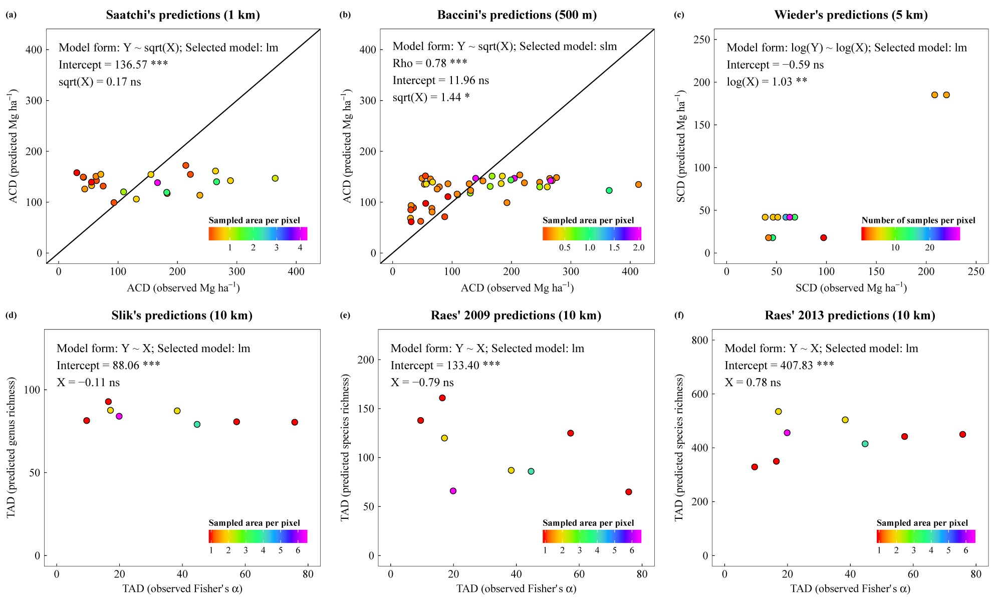

**Fig. B.1** Comparison of our field measurements with values extracted from existing maps of (a) ACD (Baccini et al., 2012); (b) ACD (Saatchi et al., 2011); (c) SCD (Wieder et al., 2014); (d) TAD (Slik et al., 2009); (e) TAD (Raes et al., 2009); (f) TAD (Raes et al., 2013). Information about the best-fit significant model (selected among linear and spatial regression models) is displayed in each facet. Model coefficients (for spatial dependence and/or intercept and independent variable) are presented along with information on statistical significance. Variable: ACD = aboveground carbon density; SCD = soil carbon density; TAD = tree alpha diversity; Selected model: lm = linear model; slm = spatial lag model; Significance: n.s. non-significant; * p < 0.05; ** p < 0.01; *** p < 0.001

***Appendix C: Explanatory variable selection***

A random forest is made up of a user-defined number of unpruned classification or, as in our case, regression trees (Breiman, 2001; Cutler et al., 2007). Our explanations will only focus on the use of random forests for regression. For each tree, a bootstrap sample of the dataset (ca. 63% of the response and associated explanatory variable values; replacement is allowed) is selected. For each node of any single tree, a defined number of explanatory variables – one third of the total number of explanatory variables, by default – is selected at random, and the variable providing the best split – i.e. the lowest weighted mean-squared error – is kept (Breiman et al., 1984). Each tree is fully grown, i.e. until the number of unique cases in each node does not exceed five. To test tree performance, all out-of-bag values (the remaining ca. 37% of the values that were not selected in the bootstrap sample) are then dropped down the tree and error is computed (against the mean value of node cases). For prediction, new values (i.e. explanatory variable values from a new dataset) are dropped down every tree of the forest and the average value over individual tree predictions is computed.

We ran random forests for each of the response variables (ACD and SCD, and TAD using Fisher’s α) with the 20 explanatory variables. Two key features were first used to choose which variables to keep: minimal depth and importance value (see Fig. C.1–C.3). The minimal depth of a variable is the depth at which the variable first splits within a tree, relative to the root node. The smaller the minimal depth, the more predictive the variable is (Chen and Ishwaran, 2013). Variable importance (VIMP) is obtained by: (1) randomly permuting variable values in the out-of-bag dataset, (2) dropping them down the tree, (3) calculating the resulting prediction error, (4) computing the difference with the error without permutation, (5) averaging the differences over all trees (Chen and Ishwaran, 2013). The larger the VIMP of a variable, the more predictive it is (Breiman, 2001).

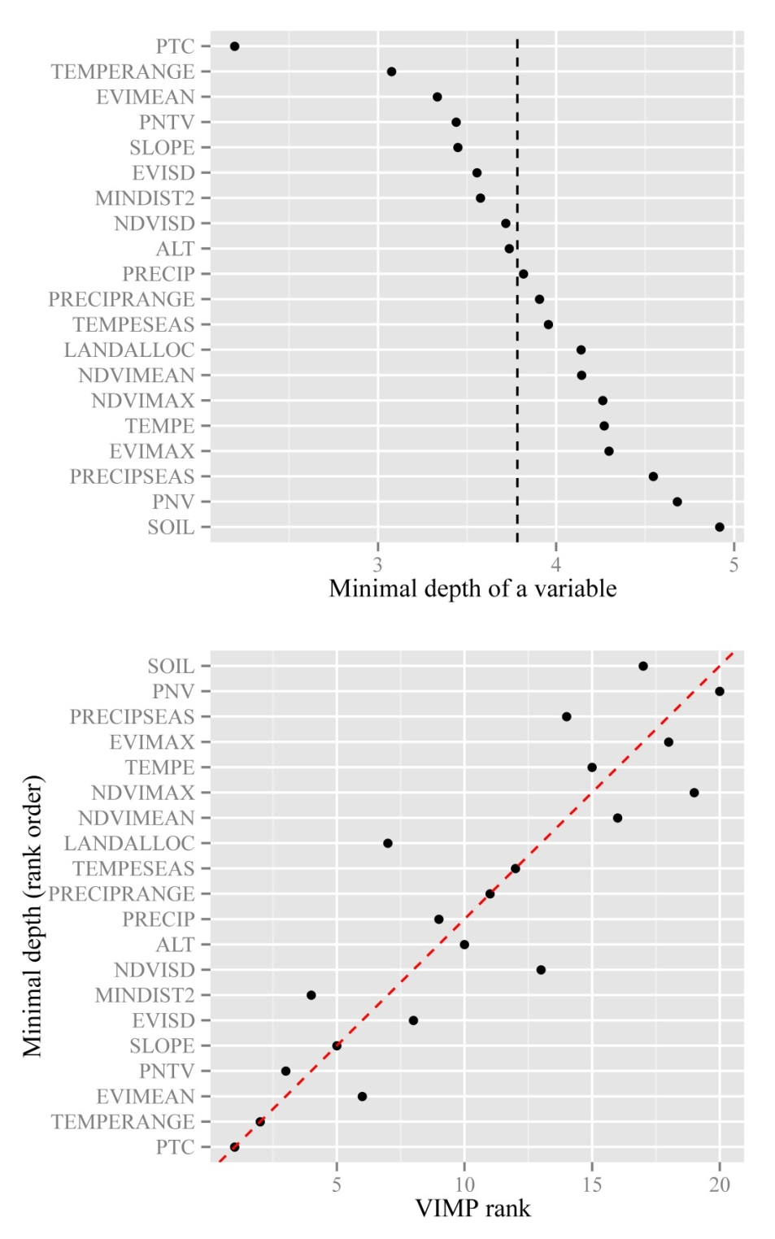

**Fig. C.1** Variable selection process for ACD. Variables with minimal depth lower than the vertical dashed line in the upper panel (average minimal depth) are considered strong predictors and were preferably selected. We checked that potential variables simultaneously had a high VIMP (cf. lower panel). Abbreviations: ALT = altitude; EVIMAX = maximum Enhanced Vegetation Index (EVI); EVIMEAN = mean EVI; EVISD = standard deviation EVI; LANDALLOC = land allocation; MINDIST2 = minimum distance to disturbance source (either road, river or village); NDVIMAX = maximum Normalized Difference Vegetation Index (NDVI); NDVIMEAN = mean NDVI; NDVISD = standard deviation NDVI; PNTV = percent non tree vegetation; PNV = percent non vegetation; PRECIP = mean annual precipitation; PRECIPRANGE = precipitation range; PRECIPSEAS = precipitation seasonality; PTC = percent tree cover; SLOPE = slope; SOIL = soil group; TEMPE = mean annual temperature; TEMPERANGE = temperature range; TEMPESEAS = temperature seasonality

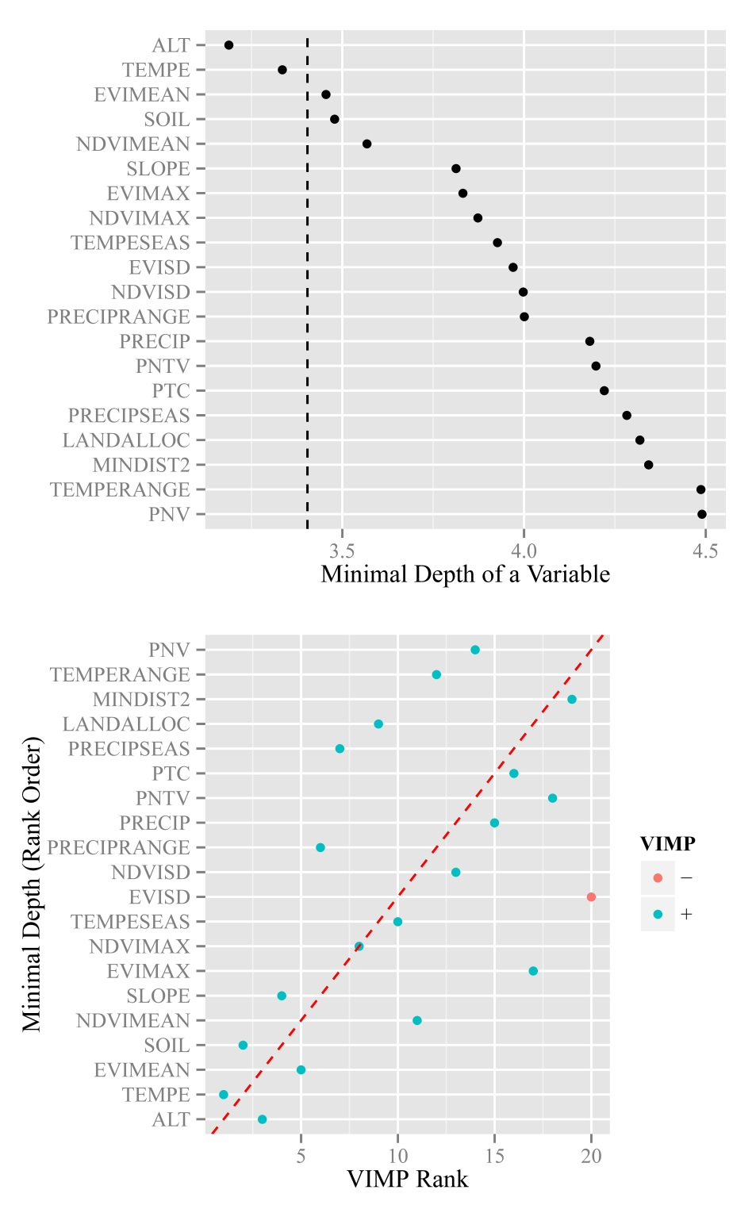

**Fig. C.2** Variable selection process for SCD. Variables with minimal depth lower than the vertical dashed line in the upper panel (average minimal depth) are considered strong predictors and were preferably selected. We checked that potential variables simultaneously had a high VIMP (cf. lower panel). Note that VIMP (i.e. average difference between errors from out-of-bag predictions with and without permutation over all trees) can be negative. Abbreviations: ALT = altitude; EVIMAX = maximum Enhanced Vegetation Index (EVI); EVIMEAN = mean EVI; EVISD = standard deviation EVI; LANDALLOC = land allocation; MINDIST2 = minimum distance to disturbance source (either road, river or village); NDVIMAX = maximum Normalized Difference Vegetation Index (NDVI); NDVIMEAN = mean NDVI; NDVISD = standard deviation NDVI; PNTV = percent non tree vegetation; PNV = percent non vegetation; PRECIP = mean annual precipitation; PRECIPRANGE = precipitation range; PRECIPSEAS = precipitation seasonality; PTC = percent tree cover; SLOPE = slope; SOIL = soil group; TEMPE = mean annual temperature; TEMPERANGE = temperature range; TEMPESEAS = temperature seasonality

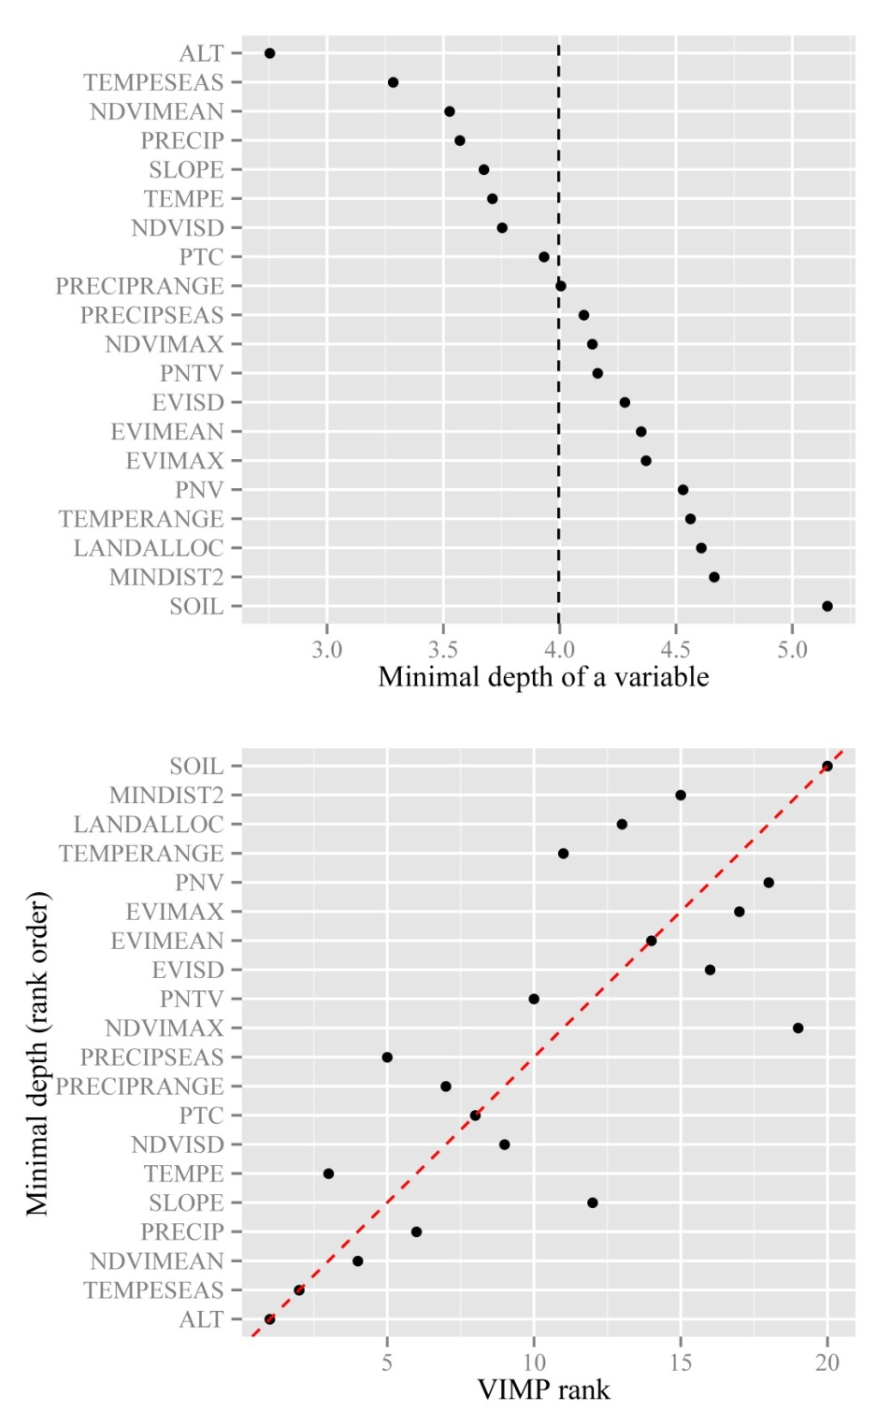

**Fig. C.3** Variable selection process for TAD (using Fisher’s α). Variables with minimal depth lower than the vertical dashed line in the upper panel (average minimal depth) are considered strong predictors and were preferably selected. We checked that potential variables simultaneously had a high VIMP (cf. lower panel). Abbreviations: ALT = altitude; EVIMAX = maximum Enhanced Vegetation Index (EVI); EVIMEAN = mean EVI; EVISD = standard deviation EVI; LANDALLOC = land allocation; MINDIST2 = minimum distance to disturbance source (either road, river or village); NDVIMAX = maximum Normalized Difference Vegetation Index (NDVI); NDVIMEAN = mean NDVI; NDVISD = standard deviation NDVI; PNTV = percent non tree vegetation; PNV = percent non vegetation; PRECIP = mean annual precipitation; PRECIPRANGE = precipitation range; PRECIPSEAS = precipitation seasonality; PTC = percent tree cover; SLOPE = slope; SOIL = soil group; TEMPE = mean annual temperature; TEMPERANGE = temperature range; TEMPESEAS = temperature seasonality

After potential variables were selected based on their minimal depth and VIMP, they underwent a last selection step during which we checked that (1) the range of values covered by the 65 composite sample sites matched that of the whole study area, (2) partial dependence behavior was not counter-intuitive, and (3) obvious artifacts on prediction maps that used these variables were not evidenced through visual inspection. Outcomes of the selection process are displayed in Table C.1.

**Table C.1** Selection/rejection of variables of highest minimum depth and importance value.

|  |  |  |  |  |
| --- | --- | --- | --- | --- |
| Response | Variables of highest min. depth | Selected | Rejected | |
|  |  |  | Restricted range | PD b behavior |
| ACD | PTC a | X |  |  |
|  | TEMPERANGE |  |  | X |
|  | EVIMEAN |  | X |  |
|  | PNTV |  | X |  |
|  | SLOPE |  | X |  |
|  | EVISD |  | X |  |
|  | MINDIST2 |  | X |  |
|  | NDVISD |  | X |  |
|  | ALT | X |  |  |
| SCD | ALT | X |  |  |
|  | TEMPE | X |  |  |
|  | EVIMEAN |  | X |  |
|  | SOIL | X |  |  |
| TAD (Fisher's α) | ALT | X |  |  |
|  | TEMPESEAS | X |  |  |
|  | NDVIMEAN |  |  | X |
|  | PRECIP |  |  | X |
|  | SLOPE |  | X |  |
|  | TEMPE | X |  |  |
|  | NDVISD |  | X |  |
|  | PTC | X |  |  |

a ALT = altitude; EVIMEAN = mean Enhanced Vegetation Index (EVI); EVISD = standard deviation EVI; MINDIST2 = minimum distance to disturbance source (either road, river or village); NDVIMEAN = mean Normalized Difference Vegetation Index (NDVI); NDVISD = standard deviation NDVI; PNTV = percent non tree vegetation; PRECIP = mean annual precipitation; PTC = percent tree cover; SLOPE = slope; SOIL = soil group; TEMPE = mean annual temperature; TEMPERANGE = temperature range; TEMPESEAS = temperature seasonality

b PD = partial dependence

***Appendix D: Relationships between ACD, SCD and TAD at two different spatial resolutions***

**Table D.1** Relationships between ACD, SCD and TAD (response variables) over the study area depending on soil type (mineral vs. peat). Analyses were performed on a random subset of response variable values (n = 250) from our predictions at (a) 1 km, and (b) 10 km spatial resolution. We used original, square root- or log-transformed data, whichever format led to data distribution closest to normality. Depicted values are either test statistics (for Moran’s I, Lagrange Multiplier and the selected model) or model coefficients, and are presented along with information on statistical significance. Note that the most parsimonious model did not necessarily include soil type and/or its interaction.

|  |  |  |  |  |  |  |  |
| --- | --- | --- | --- | --- | --- | --- | --- |
|  | |  | | | | | |
| General model form | | **Y ~ X * PEAT** | | | | | |
|  |  |  |  |  |  |  |  |
| (a) resolution = 1 km |  |  |  |  |  |  |  |
|  |  | Model 1 | | Model 2 | | Model 3 | |
| Variable 1 | | Y = TAD | X = ACD | Y = TAD | X = SCD | Y = ACD | X = SCD |
| Data format | | sqrt | sqrt | original | log + 1 | original | log + 1 |
| Moran's I | on variable | 0.23 *** | 0.23 *** | 0.21 *** | 0.18 *** | 0.28 *** | 0.20 *** |
| on linear model residuals | 0.05 *** | | 0.17 *** | | 0.21 *** | |
| Lagrange Multiplier (LM) | LM err | 26.74 *** | | 331.11 *** | | 440.65 *** | |
| LM lag | 25.29 *** | | 324.23 *** | | 507.26 *** | |
| Selected model type 2 | | sem | | sem | | slm | |
| Model statistic 3 | | 286.05 *** | | 2361.54 *** | | 5091.80 *** | |
| Model coefficients | Intercept | 0.89 ns | | 126.18 *** | | 315.92 *** | |
| X | 0.40 *** | | -21.14 *** | | -71.92 *** | |
| PEAT | 2.29 * | | − | | 43.33 ** | |
| X:PEAT | -0.31 *** | | − | | − | |
| Spatial dependence 4 | 0.92 *** | | 0.97 *** | | 0.98 *** | |
|  |  |  |  |  |  |  |  |
| (b) resolution = 10 km |  |  |  |  |  |  |  |
|  |  | Model 1 | | Model 2 | | Model 3 | |
| Variable 1 | | Y = TAD | X = ACD | Y = TAD | X = SCD | Y = ACD | X = SCD |
| Data format | | original | original | original | log + 1 | original | log + 1 |
| Moran's I | on variable | 0.26 *** | 0.32 *** | 0.26 *** | 0.19 *** | 0.32 *** | 0.19 *** |
| on linear model residuals | 0.07 *** | | 0.18 *** | | 0.25 *** | |
| Lagrange Multiplier (LM) | LM err | 77.65 *** | | 566.96 *** | | 1104.81 *** | |
| LM lag | 11.48 *** | | 520.87 *** | | 1096.74 *** | |
| Selected model type 2 | | sem | | sem | | sem | |
| Model statistic 3 | | 539.19 *** | | 4657.55 *** | | 12999.29 *** | |
| Model coefficients | Intercept | -1.62 ns | | 158.96 *** | | 554.29 ** | |
| X | 0.22 *** | | -26.43 *** | | -76.90 *** | |
| PEAT | 17.28 ns | | − | | 20.07 * | |
| X:PEAT | -0.21 ** | | − | | − | |
| Spatial dependence 4 | 0.94 *** | | 0.98 *** | | 0.99 *** | |

1 Variable: ACD = aboveground carbon density; SCD = soil carbon density; TAD = tree alpha diversity; PEAT = binary variable with mineral = 0 and peat = 1

2 sem = spatial error model; slm = spatial lag model

3 Wald statistic for spatial error or spatial lag model

4 Rho in case of spatial lag model, Lambda in case of spatial error model

n.s. non-significant; * p < 0.05; ** p < 0.01; *** p < 0.001

***Appendix E: Comparing our predicted values of ACD, SCD and TAD over the study area with those extracted from existing maps***

As existing maps were systematically produced at a coarser spatial resolution, our prediction data were consistently aggregated to meet the reference resolution. Our predictions of aboveground carbon density (ACD) were compared with previous pantropical works from Baccini et al. (2012) and Saatchi et al. (2011) at resolutions of 500 m and 1 km, respectively. Our predictions of soil carbon density (SCD) were compared with values from the regridded Harmonized World Soil Database (0–30 cm layer; Wieder et al., 2014) at a 5 km resolution. Our predictions of tree alpha diversity (TAD, using Fisher’s α) were compared with Borneo- (Raes et al., 2009; Slik et al., 2009) and Sundaland-wide (Raes et al., 2013) tree diversity estimates at a 10 km resolution. Though methodology was different, two of these studies provided information on tree species richness (Raes et al., 2009; Raes et al., 2013). Slik et al. (2009) worked at a generic level but their study was nonetheless included for comparison on the grounds of good match between generic and species diversity patterns (Higgins and Ruokolainen, 2004). This was the case in our study area, in which we found a very strong positive correlation between species and genus richness (Pearson’s *r* = 0.98, p < 0.001; correlation corrected for spatial autocorrelation) in our dataset. Signs and significance of spatial regression model coefficients were used to assess relationships between our predictions and those from existing maps. For comparisons with predictions from Baccini et al. (2012) and Saatchi et al. (2011), we only used aggregated grid cells for which all initial grid cells had values. For comparison with predictions from Wieder et al. (2014), Raes et al. (2009; 2013) and Slik et al. (2009), due to much coarser resolution, we only used aggregated grid cells for which at least half initial grid cells had values.

***Appendix F: Spatial congruence between, and spatial distribution of, hotspots of ACD, SCD and TAD using a 20% and a 30% threshold***

**Table F.1** Spatial congruence between hotspots of ACD, SCD and TAD (response variables) at 10 km spatial resolution using a 20% threshold. Values (percentage of overlapping grid cells over the total number of grid cells) potentially range from 0 to 20%. Expected spatial congruence for two variables with random spatial distribution is 4%. For the sake of readability, values are highlighted with different colors depending on the nature of the response variables under consideration (yellow, green and blue for ACD-SCD, ACD-TAD and SCD-TAD, respectively).

|  |  |  |  |  |  |  |  |  |
| --- | --- | --- | --- | --- | --- | --- | --- | --- |
|  | SCD (this study) | TAD (this study) | ACD (Baccini's) | SCD (Wieder's) | TAD (Slik's) | ACD (Saatchi's) | TAD (Raes' 2009) | TAD (Raes' 2013) |
| ACD (this study) | 0.0 | 12.6 | 4.3 | 0.0 | 0.0 | 11.4 | 1.6 | 3.9 |
| SCD (this study) |  | 0.0 | 0.0 | 16.9 | 9.8 | 0.0 | 6.7 | 0.4 |
| TAD (this study) |  |  | 5.9 | 0.0 | 0.0 | 12.2 | 3.1 | 7.1 |
| ACD (Baccini's) |  |  |  | 0.0 | 2.0 | 5.1 | 3.5 | 5.9 |
| SCD (Wieder's) |  |  |  |  | 9.8 | 0.0 | 8.7 | 0.8 |
| TAD (Slik's) |  |  |  |  |  | 0.0 | 9.1 | 5.9 |
| ACD (Saatchi's) |  |  |  |  |  |  | 3.1 | 6.7 |
| TAD (Raes' 2009) |  |  |  |  |  |  |  | 5.5 |

Variable: ACD = aboveground carbon density; SCD = soil carbon density; TAD = tree alpha diversity.

**Table F.2** Spatial congruence between hotspots of ACD, SCD and TAD (response variables) at 10 km spatial resolution using a 30% threshold. Values (percentage of overlapping grid cells over the total number of grid cells) potentially range from 0 to 30%. Expected spatial congruence for two variables with random spatial distribution is 9%. For the sake of readability, values are highlighted with different colors depending on the nature of the response variables under consideration (yellow, green and blue for ACD-SCD, ACD-TAD and SCD-TAD, respectively).

|  |  |  |  |  |  |  |  |  |
| --- | --- | --- | --- | --- | --- | --- | --- | --- |
|  | SCD (this study) | TAD (this study) | ACD (Baccini's) | SCD (Wieder's) | TAD (Slik's) | ACD (Saatchi's) | TAD (Raes' 2009) | TAD (Raes' 2013) |
| ACD (this study) | 0.0 | 21.7 | 13.8 | 2.0 | 1.2 | 18.1 | 6.3 | 10.6 |
| SCD (this study) |  | 0.0 | 0.0 | 23.6 | 18.5 | 0.0 | 15.0 | 3.5 |
| TAD (this study) |  |  | 14.6 | 2.0 | 0.0 | 18.9 | 4.7 | 14.2 |
| ACD (Baccini's) |  |  |  | 2.8 | 4.3 | 14.6 | 6.3 | 11.2 |
| SCD (Wieder's) |  |  |  |  | 13.8 | 2.4 | 15.7 | 2.4 |
| TAD (Slik's) |  |  |  |  |  | 2.4 | 16.5 | 9.1 |
| ACD (Saatchi's) |  |  |  |  |  |  | 5.5 | 14.6 |
| TAD (Raes' 2009) |  |  |  |  |  |  |  | 7.9 |

Variable: ACD = aboveground carbon density; SCD = soil carbon density; TAD = tree alpha diversity.

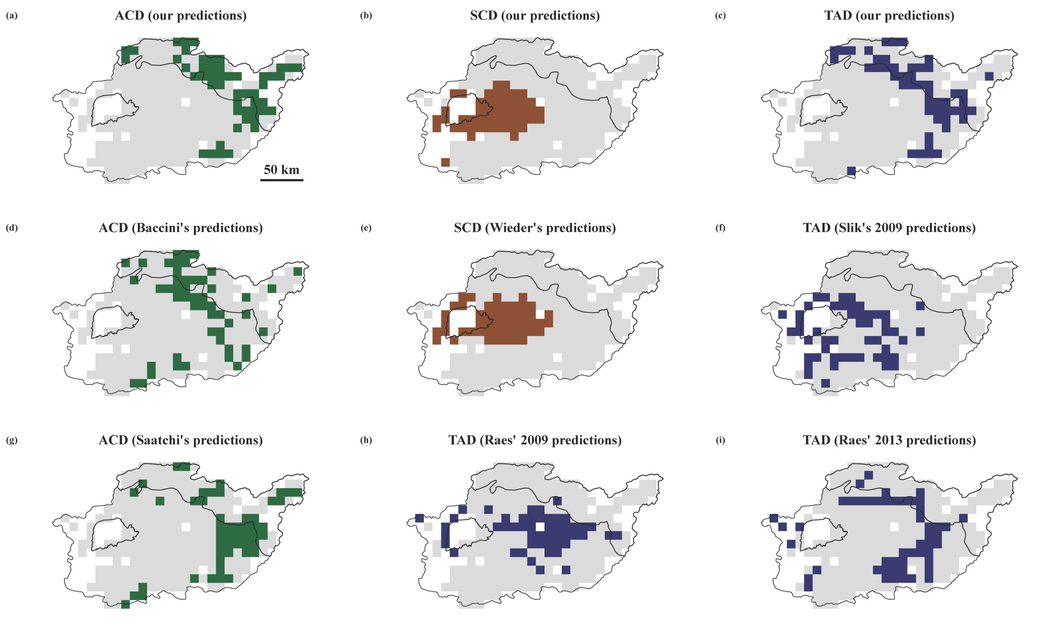 **Fig. F.1** Spatial distribution of hotspots of response variables at 10 km spatial resolution using a 20% threshold: (a) ACD (our predictions); (b) SCD (our predictions); (c) TAD (our predictions); (d) ACD (Baccini et al., 2012); (e) SCD (Wieder et al., 2014); (f) TAD (Slik et al., 2009); (g) ACD (Saatchi et al., 2011); (h) TAD (Raes et al., 2009); (i) TAD (Raes et al., 2013). Variable: ACD = aboveground carbon density; SCD = soil carbon density; TAD = tree alpha diversity.

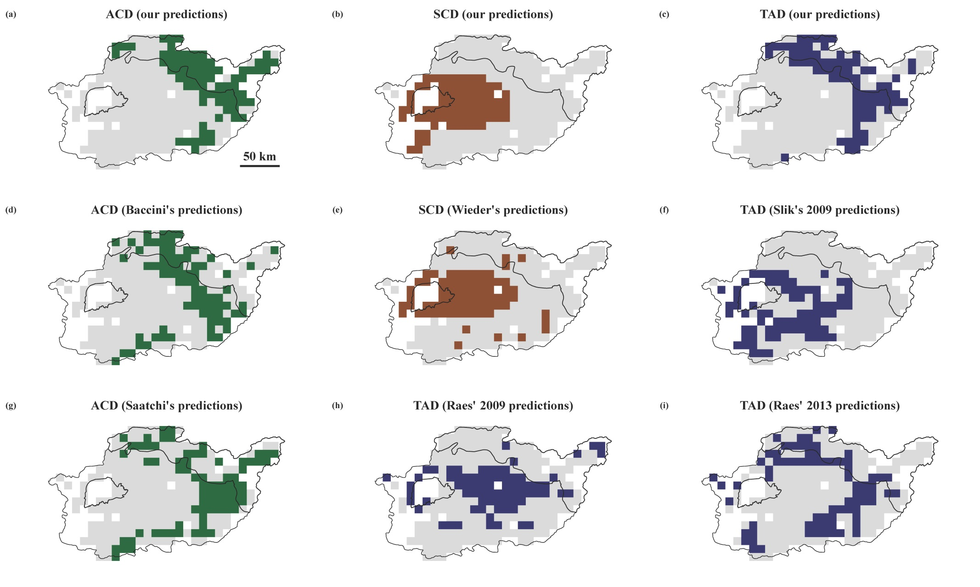 **Fig. F.2** Spatial distribution of hotspots of response variables at 10 km spatial resolution using a 30% threshold: (a) ACD (our predictions); (b) SCD (our predictions); (c) TAD (our predictions); (d) ACD (Baccini et al., 2012); (e) SCD (Wieder et al., 2014); (f) TAD (Slik et al., 2009); (g) ACD (Saatchi et al., 2011); (h) TAD (Raes et al., 2009); (i) TAD (Raes et al., 2013). Variable: ACD = aboveground carbon density; SCD = soil carbon density; TAD = tree alpha diversity.

***Appendix G: Potential threats from concessions over carbon and tree diversity hotspots***

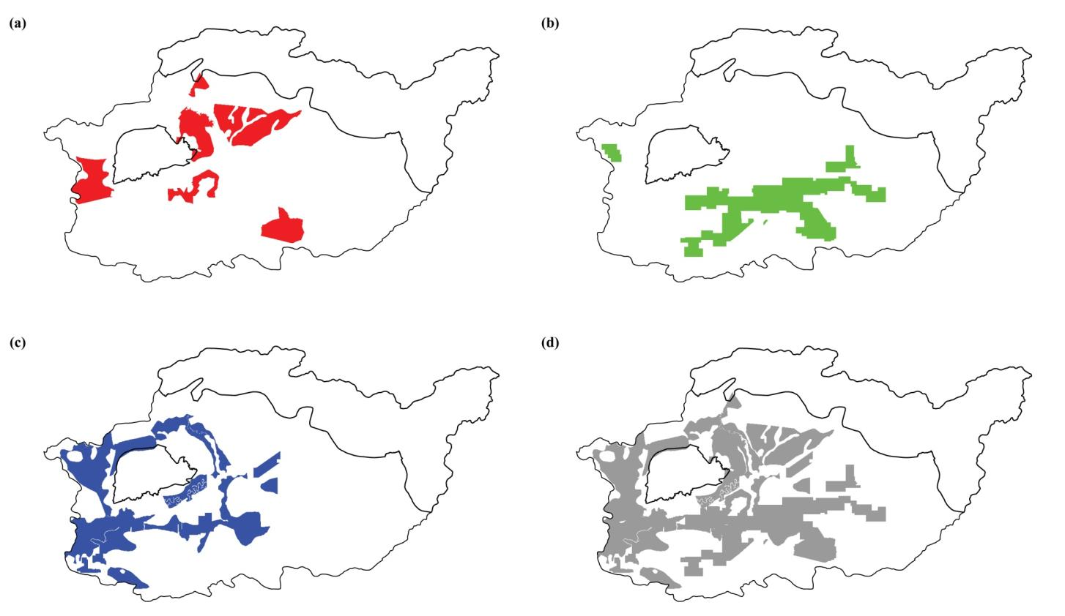

**Fig. G.1** Location of concessions over the study area depending on concession type: (a) logging concessions, (b) mining concessions, (c) plantation concessions, (d) combination of the three different types of concessions. Affected areas represent ca. 2500 km², 2800 km² and 4100 km² for logging, mining and plantation concessions, respectively. Note that some areas might simultaneously be under different types of concessions. Some concessions overlapped slightly with national park borders.

**References**

Baccini, A., Goetz, S.J., Walker, W.S., Laporte, N.T., Sun, M., Sulla-Menashe, D., Hackler, J., Beck, P.S.A., Dubayah, R., Friedl, M.A., Samanta, S., Houghton, R.A., 2012. Estimated carbon dioxide emissions from tropical deforestation improved by carbon-density maps. Nat. Clim. Change 2, 182–185. http://dx.doi.org/10.1038/Nclimate1354

Breiman, L., 2001. Random forests. Mach Learn 45, 5–32. http://dx.doi.org/10.1023/A:1010933404324

Breiman, L., Friedman, J., Stone, C.J., Olshen, R.A., 1984. Classification and regression trees. CRC press, Belmont, CA.

Chen, X., Ishwaran, H., 2013. Pathway hunting by random survival forests. Bioinformatics 29, 99–105. http://dx.doi.org/10.1093/bioinformatics/bts643

Cutler, D.R., Edwards, T.C., Beard, K.H., Cutler, A., Hess, K.T., 2007. Random forests for classification in ecology. Ecology 88, 2783–2792. http://dx.doi.org/10.1890/07-0539.1

Higgins, M.A., Ruokolainen, K., 2004. Rapid tropical forest inventory: a comparison of techniques based on inventory data from western Amazonia. Conserv. Biol. 18, 799–811. http://dx.doi.org/10.1111/j.1523-1739.2004.00235.x

Hurlbert, S.H., 1971. The nonconcept of species diversity: a critique and alternative parameters. Ecology 52, 577–586. http://dx.doi.org/10.2307/1934145

Laumonier, Y., Setiabudi, Hadi, D., 2013. Vegetation of Kapuas Hulu, West Kalimantan. Scale 1:50,000. Bogor, Indonesia: CoLUPSIA – CIRAD and partners. Avaible at: http://www1.cifor.org/fileadmin/subsites/colupsia/maps/Kapuas_Hulu/Vegetasi/indeksvegetasi.htm

Oksanen, J., Blanchet, F.G., Kindt, R., Legendre, P., Minchin, P.R., O'Hara, R.B., Simpson, G.L., Solymos, P., Stevens, M.H.H., Wagner, H., 2015. vegan: Community Ecology Package. R package version 2.2-1. http://CRAN.R-project.org/package=vegan.

Raes, N., Roos, M.C., Slik, J.W.F., van Loon, E.E., ter Steege, H., 2009. Botanical richness and endemicity patterns of Borneo derived from species distribution models. Ecography 32, 180–192. http://dx.doi.org/10.1111/j.1600-0587.2009.05800.x

Raes, N., Saw, L.G., van Welzen, P.C., Yahara, T., 2013. Legume diversity as indicator for botanical diversity on Sundaland, South East Asia. S. Afr. J. Bot. 89, 265–272. http://dx.doi.org/10.1016/j.sajb.2013.06.004

Saatchi, S.S., Harris, N.L., Brown, S., Lefsky, M., Mitchard, E.T.A., Salas, W., Zutta, B.R., Buermann, W., Lewis, S.L., Hagen, S., Petrova, S., White, L., Silman, M., Morel, A., 2011. Benchmark map of forest carbon stocks in tropical regions across three continents. Proc. Natl. Acad. Sci. USA 108, 9899–9904. http://dx.doi.org/10.1073/pnas.1019576108

Slik, J.W.F., Raes, N., Aiba, S.I., Brearley, F.Q., Cannon, C.H., Meijaard, E., Nagamasu, H., Nilus, R., Paoli, G., Poulsen, A.D., Sheil, D., Suzuki, E., van Valkenburg, J.L.C.H., Webb, C.O., Wilkie, P., Wulffraat, S., 2009. Environmental correlates for tropical tree diversity and distribution patterns in Borneo. Divers. Distrib. 15, 523–532. http://dx.doi.org/10.1111/j.1472-4642.2009.00557.x

Wieder, W.R., Boehnert, J., Bonan, G.B., Langseth, M., 2014. Regridded Harmonized World Soil Database v1.2. Data set. Available on-line [http://daac.ornl.gov] from Oak Ridge National Laboratory Distributed Active Archive Center, Oak Ridge, Tennessee, USA. http://dx.doi.org/10.3334/ORNLDAAC/1247.