5-Whys Guide& Template

The 5-Whys is a simple brainstorming tool that can help QI teams identify the root cause(s) of a problem. Once a general problem has been recognized (either using the Fishbone Diagram or Process Mapping), ask “why” questions to drill down to the root causes. Asking the 5-Whys allows teams to move beyond obvious answers and reflect on less obvious explanations or causes.

**Step-by-step instructions**

1. State the problem you have identified as a strategic problem to work on.

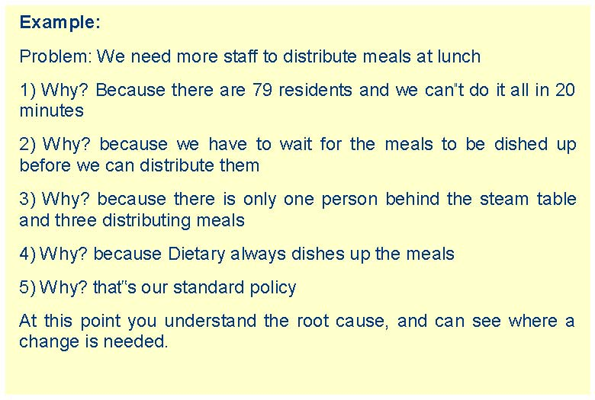

2. Start asking “why” related to the problem. Like an inquisitive toddler, keep asking why in response to each suggested cause.

3. Ask as many whys as you need in order to get insight at a level that can be addressed (asking five times is typical). You will know you have reached your final „why‟ because it does not make logical sense to ask why again.

The 5-Whys is a strategy that is often used after an issue has been identified using another tool, such as a Fishbone Diagram or Process Mapping. Guard against using the 5-Whys questions on their own to avoid a narrow focus or bias.

It is said that only by asking "Why?" five times successively, can you delve into a problem deeply enough to understand the ultimate root cause. By the time you get to the 4th or 5th why, you will likely be looking squarely at management practices (more than five whys may be required for complex problems).

This methodology is closely related to the Cause & Effect (Fishbone) diagram, and can be used to complement the analysis necessary to complete a Cause & Effect diagram.

5) Why? that‟s our standard policy

At this point you understand the root cause, and can see where a change is needed.

**5-Why Analysis Template**

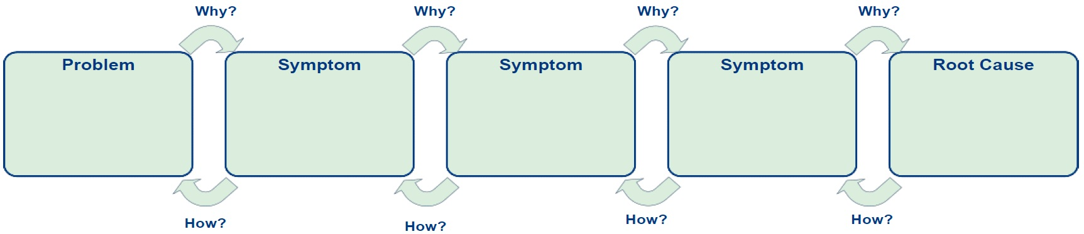

**Asking Powerful Questions**

**5 Whys Worksheet**

Define the Problem:

You don’t want to list 5 different reasons; you want to go deep on 1 reason.

Why is it happening?

Caution:

* If your last answer is something you can’t control, go back up to the previous answer on 1 reason
* Cannot because of a person

**Action:**

Why is that?

Why is that?

Why is that?

Why is that?