**Assignment 1**

2011140138

황 태림

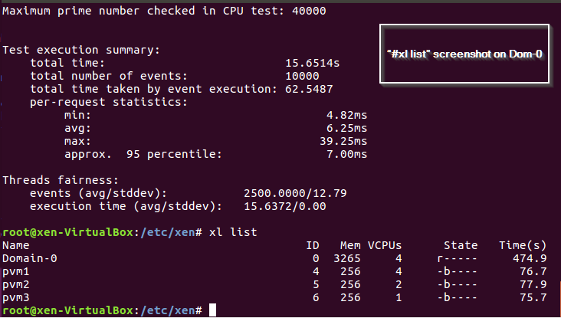**Dom-0 #xl list**

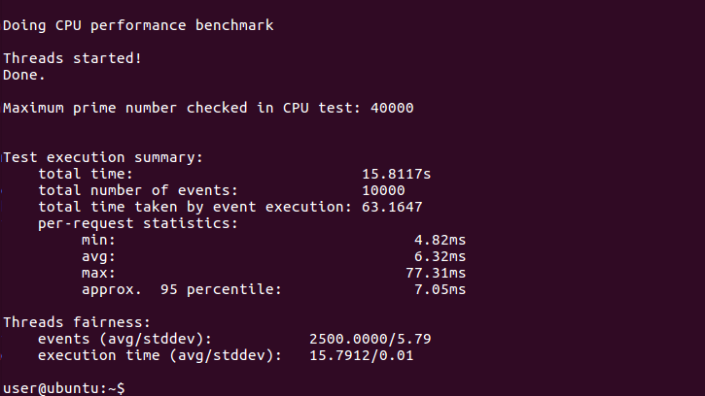**Pvm1 sysbench**

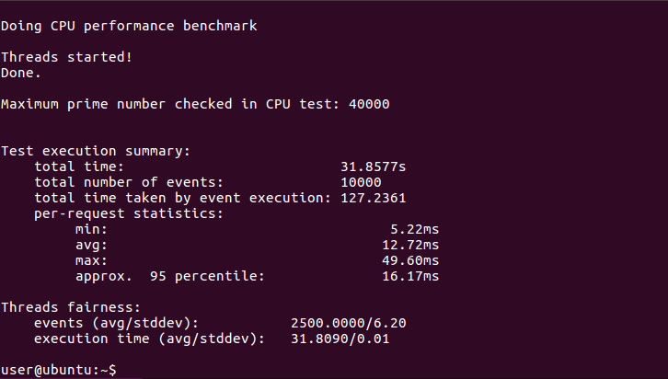**Pvm2 sysbench**

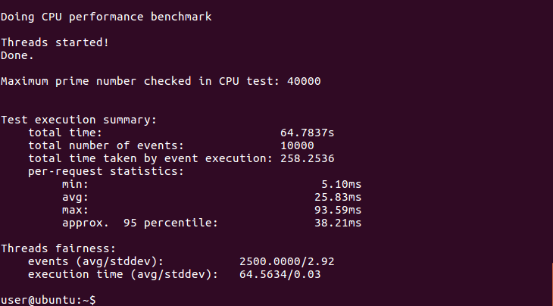**Pvm3 sysbench**