**1.**

(1) plot normal distribution:

Central-limit theorem

$$x=\sum_{i}{rand()}$$

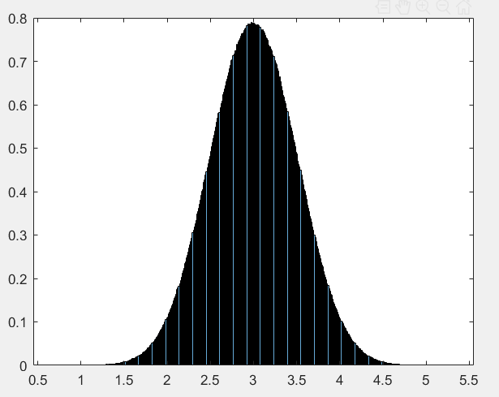

(2) plot triangle distribution

$u_{1}\left(a, b\right)+u_{2}(a, b)$

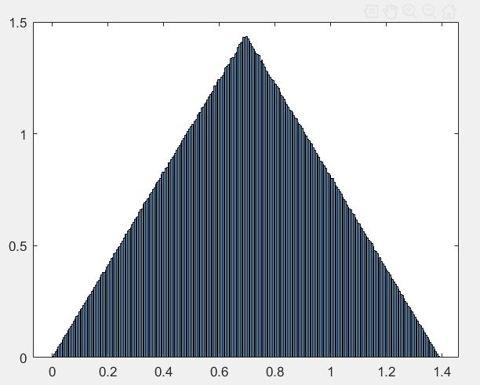

(3) plot abs distribution

**Rejection sampling** or **use Axisymmetric transformation of triangle sampling**

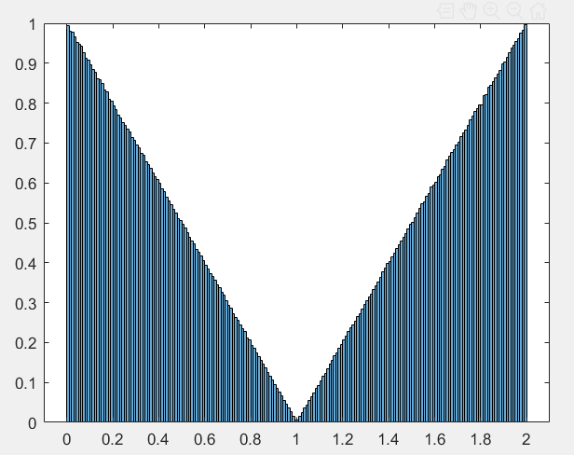

**2.** see the code

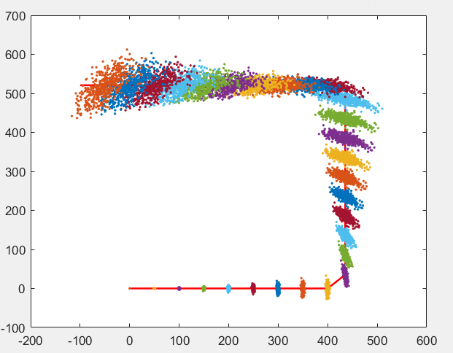

**3.**

Case 1 **small velocity estimation error** and **large angular velocity estimation error**

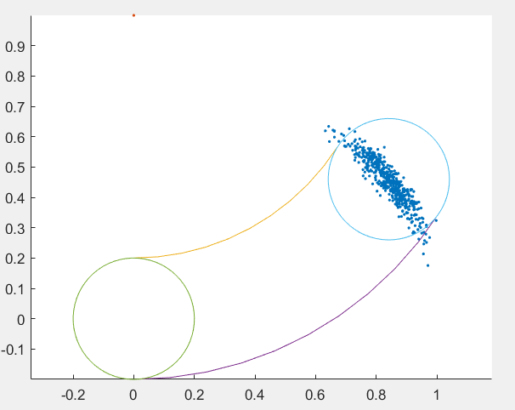

Case 2 **large velocity estimation error** and **small angular velocity estimation error**

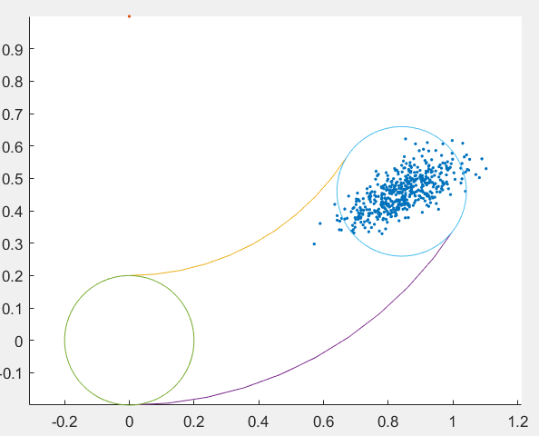

Case 3 **small velocity estimation error** and **very large angular velocity estimation error**

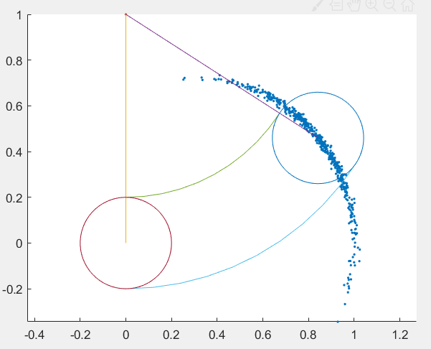

**4.**

Assume the machine driven in the obstacle is 0

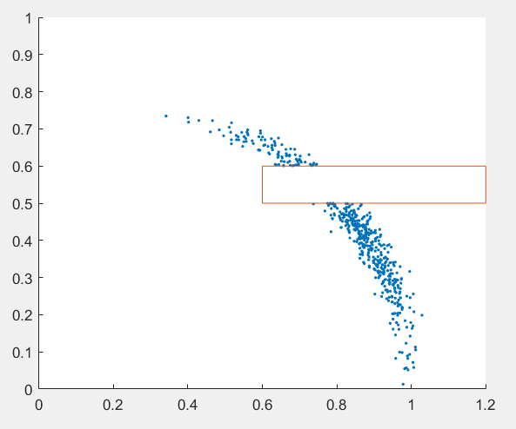

**Addition chapter 5 exercise 7**

Assume $forward speed$ is $v_{1}$, $orthogonal sidewards velocity$ is $v_{2}$, $use θ as angular$

$$Δx=\left(v_{1}*\cos{θ}+v_{2}\cos\left(θ+\frac{π}{2}\right)\right)*Δt=(v_{1}*\cos{θ}-v_{2}\sin{θ )*Δt}$$

$$Δy=\left(v_{1}*\sin{θ}+v_{2}\sin\left(θ+\frac{π}{2}\right)\right)*Δt= {(v}_{1}*\cos{θ}+v_{2}\cos{θ)*Δt}$$

$$Δθ=w*Δt$$

$$x_{t}=x_{t-1}+Δx$$

$$y_{t}=y_{t-1}+Δy$$

$$θ_{t}=θ_{t+1}+Δθ$$

1. State a mathematical model for such a robot, assuming that its controls are subject to independent Gaussian noise.

Replace above $\left[v_{1}, v_{2}, w\right]$ to $\left[v_{1}^{'}, v_{2}^{'}, w^{'} \right]$ such that

$v_{1}^{'}=v_{1}+sample(α_{1}v_{1}+α_{2}v_{2}+α_{3}w)$

$v_{2}^{'}=v_{2}+sample(α_{4}v_{1}+α_{5}v_{2}+α_{6}w)$

$w^{'}=w+sample(α_{7}v_{1}+α_{8}v_{2}+α_{9}w)$

Where $sample(a)$ means sample from $X\sim N(0, a^{2})$

1. Provide a procedure for calculating $p\left(x_{t} | u_{t}, x_{t-1}\right)$

$$x_{t}=x_{t-1}+((v_{1}+sample(α_{1}v_{1}+α_{2}v_{2}+α_{3}w))*\cos{θ}-(v_{2}+sample(α_{4}v_{1}+α_{5}v_{2}+α_{6}w))*\sin{θ )*Δt}$$

$= x_{t-1}+c+Δt*sample(\sqrt{{\left(α_{1}v_{1}+α_{2}v_{2}+α_{3}w\right)}^{2}+{\left(α_{4}v_{1}+α_{5}v_{2}+α_{6}w\right)}^{2}} )$

Where $c=\left(v_{1}*\cos{θ}+v_{2}\cos\left(θ+\frac{π}{2}\right)\right)*Δt$

$$x_{t}\sim N(x_{t-1}+c, { \left(α_{1}v_{1}+α_{2}v_{2}+α_{3}w\right)}^{2}+{\left(α_{4}v_{1}+α_{5}v_{2}+α_{6}w\right)}^{2})$$

$$p\left(x_{t} | u_{t}, x_{t-1}\right)= N(x_{t-1}+c, {\left(α_{1}v_{1}+α_{2}v_{2}+α_{3}w\right)}^{2}+{\left(α_{4}v_{1}+α_{5}v_{2}+α_{6}w\right)}^{2})$$

1. Provide a sampling procedure for sampling $x_{t}\sim \left(x_{t} \right|u_{t}, x_{t-1})$

$$p\left(x_{t} | u_{t}, x_{t-1}\right)= N(x_{t-1}+c, {\left(α_{1}v_{1}+α_{2}v_{2}+α_{3}w\right)}^{2}+{\left(α_{4}v_{1}+α_{5}v_{2}+α_{6}w\right)}^{2})$$

$$f(x_{t})=N(x_{t-1}+c, {\left(α_{1}v_{1}+α_{2}v_{2}+α_{3}w\right)}^{2}+{\left(α_{4}v_{1}+α_{5}v_{2}+α_{6}w\right)}^{2})$$

sample algorithm, rejection sampling:

input $f, b$

1. Repeat

$x=rand\left(-b, b\right)$

$Y=rand\left(0,\frac{1}{σ_{0}\sqrt{2π}}\right)$

4. Until ($y≤f(x)$)
5. Return $x+x_{t-1}+c$