机器人lab1

11612126

Q1

x, y location

u, v vector diagram vector

theta car direction

x(k), y(k) car position at time k

V car’s velocity

x(k)=V*cos(theta(k))* T+x(k-1); % calculating x

y(k)=V*sin(theta(k))* T+y(k-1); % calculating y

Uniform

Q1.1:

u=c, v=0, c is a constant

theta=0

Q1.2

[draw_x, draw_y]=meshgrid(-1:.1:1, -1:.1:1);

draw_u=ones(21, 21);draw_v=zeros(21, 21);

quiver(draw_x, draw_y, draw_u, draw_v, 0.5);

hold on

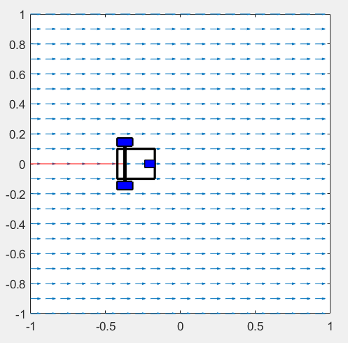

Q1.3

V=0.5;

theta(1)=0;

theta(k)=theta(k-1); % calculating theta



perpendicular

Q1.1

u=0, v=c, c is a constant

theta=pi/2

Q1.2

[draw_x, draw_y]=meshgrid(-1:.1:1, -1:.1:1);

draw_u=-draw_x;draw_v=-draw_y;

quiver(draw_x, draw_y, draw_u, draw_v, 0.5);

hold on

plot(polyshape([-1 -1 1 1],[-1 -0.8 -0.8 -1]))

hold on

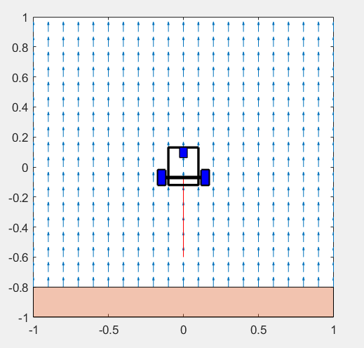

Q1.3

V=0.5;

theta(2)=pi/2; % initilize the state theta

theta(k)=theta(k-1); % calculating theta



attractive

Q1.1

u=-x; v=-y

$theta=\arctan\left(\frac{y\left(k\right)}{x\left(k\right)}\right)+\frac{pi}{2}*(sign\left(x\left(k\right)\right)+1)$

$V=\sqrt{x_{k-1}^{2}+y_{k-1}^{2}}$// increase with distance to center

Q1.2

[draw_x, draw_y]=meshgrid(-1:.1:1, -1:.1:1);

draw_u=-draw_x;draw_v=-draw_y;

quiver(draw_x, draw_y, draw_u, draw_v);

hold on

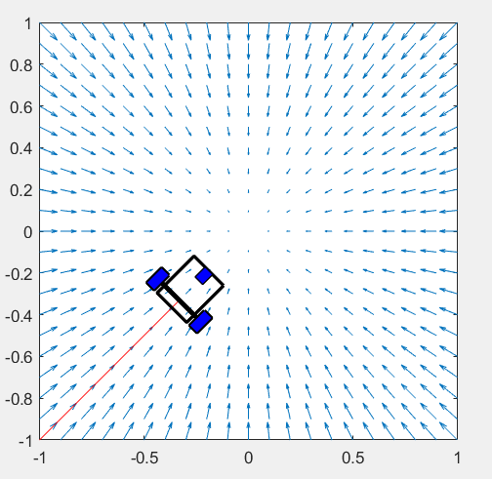

Q1.3

V=(x(k-1)^2+y(k-1)^2)^0.5;W=1;

theta(k)=atan(y(k)/x(k))+pi/2*(sign(x(k))+1); % calculating theta



repulse

Q1.1

u=x, v=y

$theta=\arctan\left(\frac{y\left(k\right)}{x\left(k\right)}\right)+\frac{pi}{2}*(sign\left(x\left(k\right)\right)-1)$% calculating theta

$V=\sqrt{x_{k-1}^{2}+y_{k-1}^{2}}$

Q1.2

[draw_x, draw_y]=meshgrid(-1:.1:1, -1:.1:1);

draw_u=draw_x;draw_v=draw_y;

quiver(draw_x, draw_y, draw_u, draw_v);

hold on

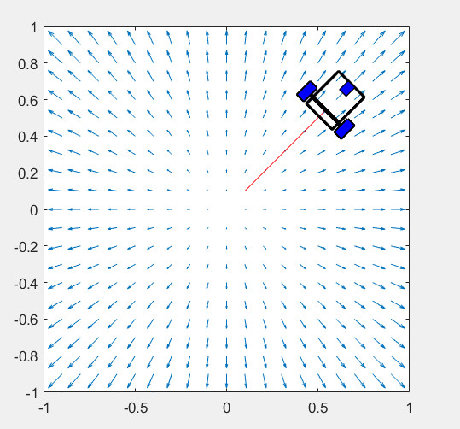

Q1.3

V=(x(k-1)^2+y(k-1)^2)^0.5;

theta(k)=atan(y(k)/x(k))+pi/2*(sign(x(k))-1); % calculating theta



tangential

Q1.1

We set the center of circle with (0, 0.5)

Considering $x=\cos{θ}, y=\sin{θ+0.5}$

Then $\frac{dx}{dθ}= -\sin{θ}= -y+0.5,\frac{dy}{dθ}=\cos{θ}=x$

So we have u=0.5-y, v=x

theta(k)=W*T + theta(k-1);

W is the angular velocity

We assume the circle radius is 0.5, so we set $V=\sqrt{x^{2}+{\left(y-0.5\right)}^{2}}$ and W=1(a constant)

So this could be uniform circular motion

Q1.2

[draw_x, draw_y]=meshgrid(-1:.1:1, -.5:.1:1.5);

draw_u=.5-draw_y;draw_v=draw_x;

draw_u=draw_x;draw_v=draw_y;

quiver(draw_x, draw_y, draw_u, draw_v);

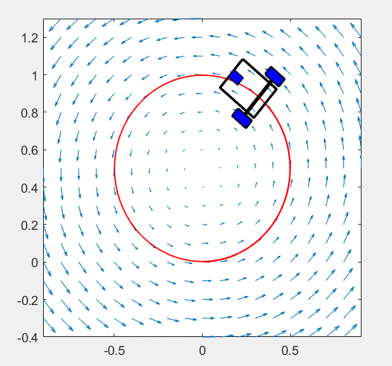

Q1.3

theta(k)=W*T+theta(k-1); % calculating theta

V=(x(k)^2+(y(k)-0.5)^2)^0.5;

