11612126李可明

Lab2

1.

|  |  |  |  |  |  |
| --- | --- | --- | --- | --- | --- |
|  | differential drive | Ackerman Drive | Synchronous Drive | XR4000 drive | Mecanum Drive |
| cost | medium | low | low | high | high |
| degree of mobility | 2 | 1 | 1 | 1 | 2 |
| degree of mobility of steerability | 0 | 1 | 1 | 2 | 0 |
| degree of maneuverability | 2 | 2 | 2 | 3 | 2 |
| workload capacity | medium | high | high | medium | low |
| motion control complexity | high | high | high | Low | medium |

2.

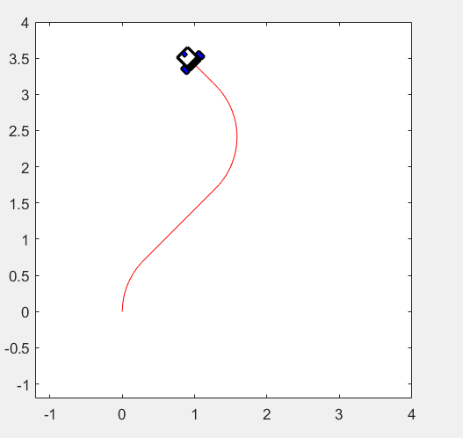

Effects of different selections of goal:

If there is no limitation, there will be infinite suitable trajectory for a certain goal

If there is limitations, we need to separate the goal into several sub-goal.

Effects of different selections of velocities:

Cause (r+L/2)/v=L/(vr-vl); v=(vr+vl)/2

That is [1 -1; 1 1]*[vr;vl]=[L*v/(r+L/2) 2*v]

when $r, L ,v is fixed$, we can always generate different suitable vr and vl

We conclude that with different velocities, we can keep the trajectory.

3.

|  |  |
| --- | --- |
| $$k_{ρ}, k_{α}, k_{β}$$ | |
| 3， 8， -1.5 | 5， 8， -1.5 |
|  |  |
| 3， 12， -1.5 | 3， 8， -2.5 |
|  |  |