本人

11612126 李可明

队友名单：

陈德缘 11611310

任涛 11612717

王森 11612110

1. 流程
2. roslaunch turtlebot_bringup minimal.launch 连接机器人
3. roslaunch turtlebot_teleop keyboard_teleop.launch 利用按键控制机器人移动
4. roslaunch freenect_launch freenect-registered-xyzrgb.launch 连接相机
5. 成功运行接收到topic

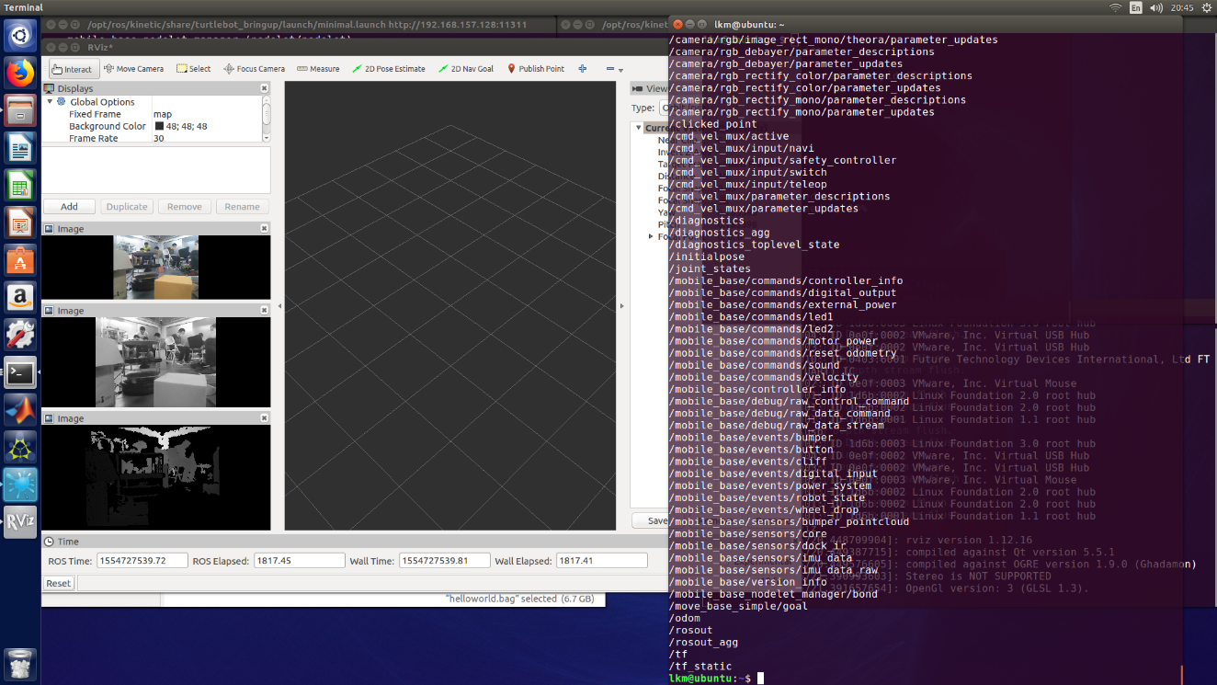

1. Topic echo result

/camera/rgb/image_color

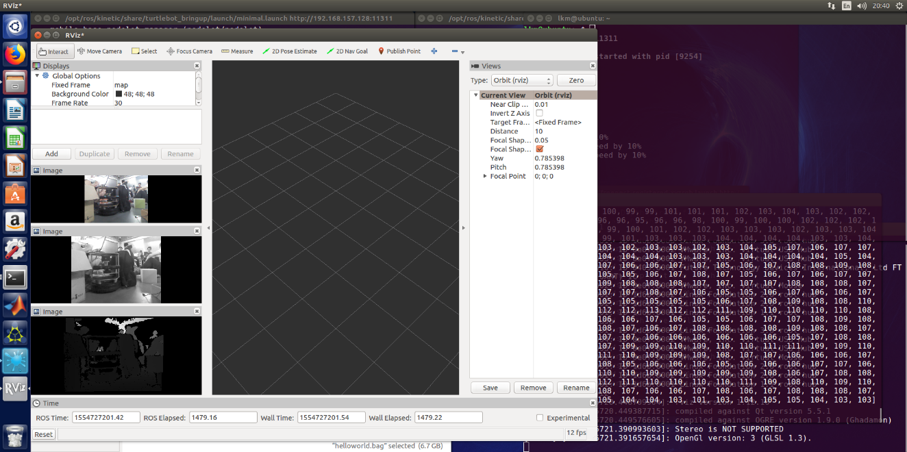

/camera/rgb/image_mono

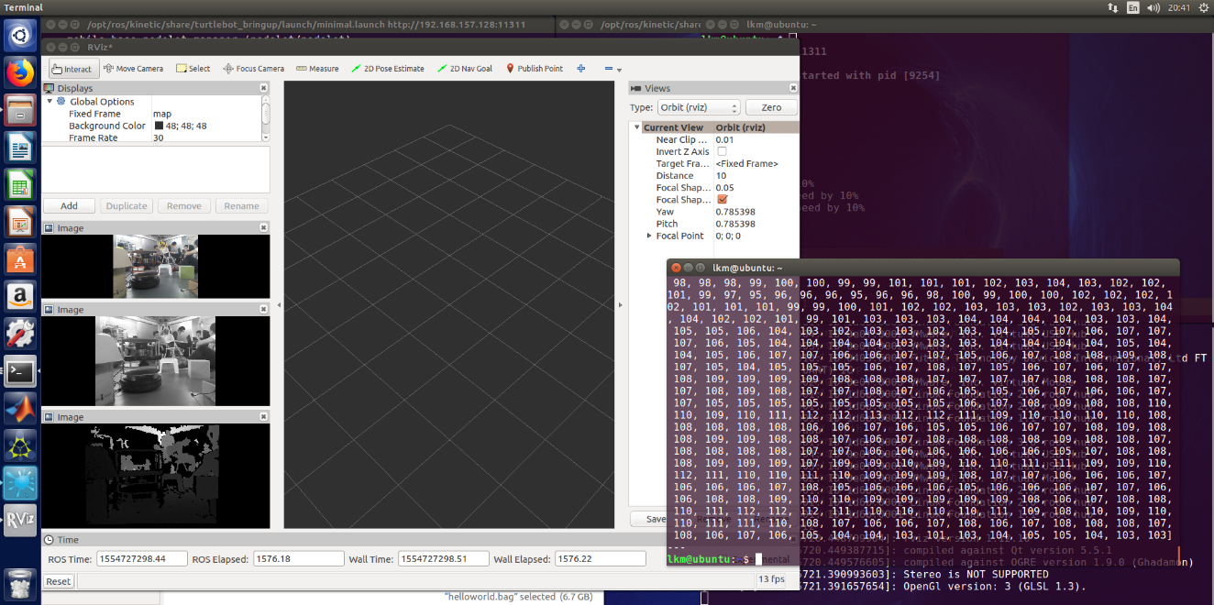

1. **Topic graph**

/camera/rgb/image_color

/camera/depth_registered/image_raw

/camera/rgb/image_mono

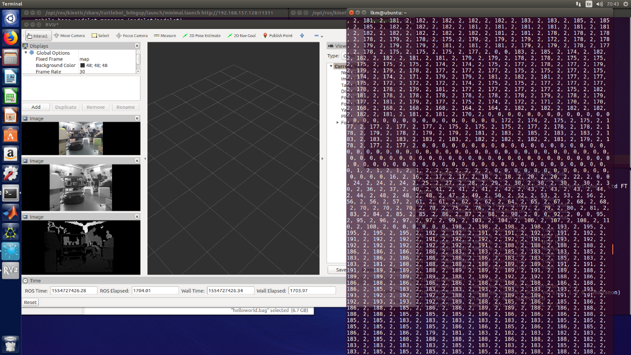

1. Meaning of each topic

/camera/rgb/image_color 彩色像素点

/camera/depth_registered/image_raw 深度图像素点

/camera/rgb/image_mono 单色像素点

/odom odometry 相关的内容

/tf Transformation Tree

tf is a package that lets the user keep track of multiple coordinate frames over time. tf maintains the relationship between coordinate frames in a tree structure buffered in time, and lets the user transform points, vectors, etc between any two coordinate frames at any desired point in time.

/tf_static For greater efficiency tf now has a static transform topic "/tf_static" This topic has the same format as "/tf" however it is expected that any transform on this topic can be considered true for all time. Internally any query for a static transform will return true.

1. rosrun rqt_image_view rqt_image_view

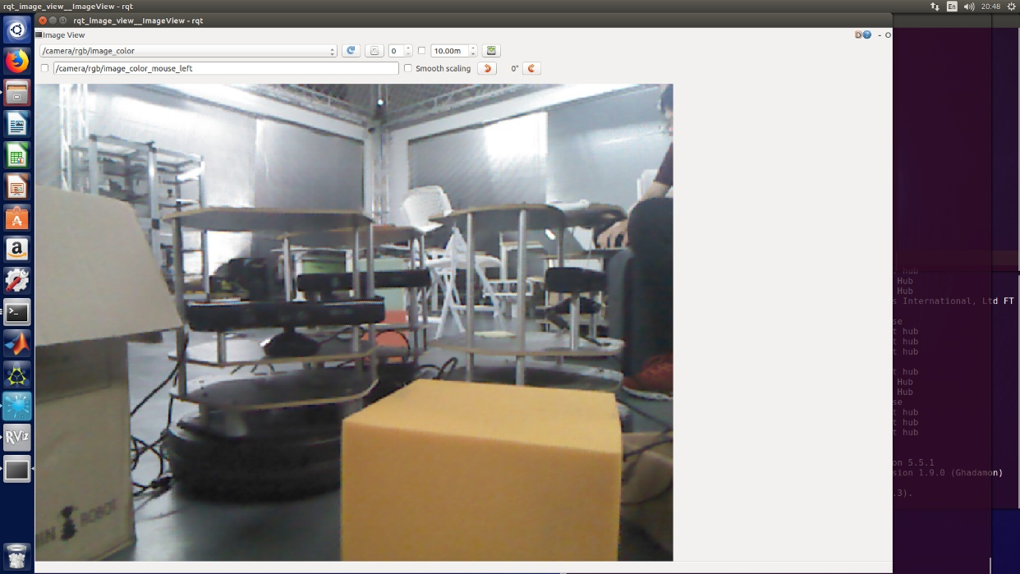

Other topic result is in part 4 with small graphs

遇到的问题：

相机连不上

问题所在：

相机的连接线有问题

解决办法

等其他组做完借他们的设备完成