|  |  |  |  |
| --- | --- | --- | --- |
| **Dataset** | **instance** | **attribute** | **class** |
| Wine | 178 | 13 | 3 |
| Glass | 214 | 9 | 6 |
| Breast cancer | 699 | 9 | 2 |
| Gesture | 1743 | 32 | 5 |
| sat | 6435 | 36 | 6 |
| avila | 20867 | 10 | 12 |

**Cut migration and Copy migration**

**Population size (evaluation time set to 150000)**

**Migration frequency and num**

**Migration time statistic**

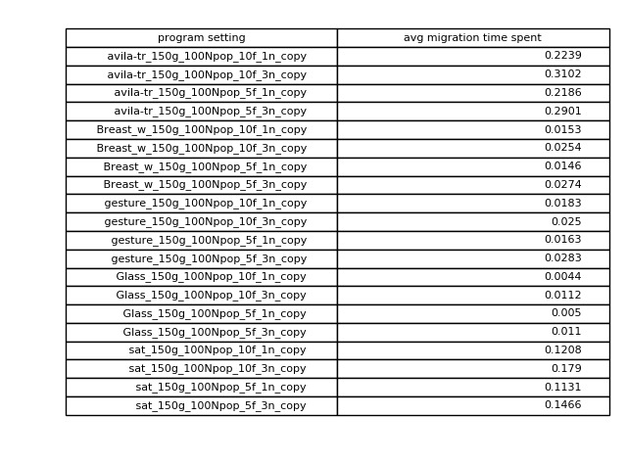

**Each generation time in different number of Cores**

