*Gregorio Loi*

*Sunday, March 26, 2023*

*Computer Networks*

# Programming Assignment 2 Report

This document contains the Report for my Programming Assignment 2

# Project Synopsis

For this project, I was tasked to write a Python program that would allow for a Server to listen for Client connections with TCP Sockets – Upon receiving a connection, the Server was to transfer files to the Client from Server side when prompted. The prompts were given, as well as some execution samples, which made creating the project so much easier.

# Execution Samples / Testing Scenarios

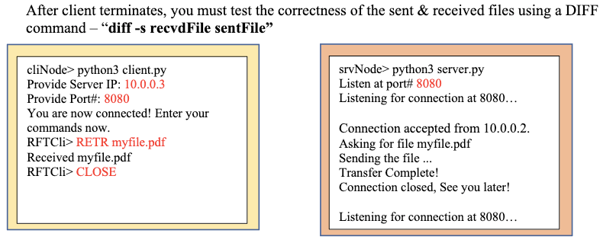

The figure above represents the execution sample we were given in our project synopsis, as well as a way to test if our sent and received files match!

The figure above shows a sample test scenario for retrieving a text file, as well as some possible errors that were prevented (Error 404)

The figure above shows an extended sample test scenario, where we close our previous connection and start a new one, and request two more sample files of different extensions

The figure above shows that we received each file successfully and that they match the corresponding server files! The sequence of files received is even represented with the order of the files (sample.txt – mickey.png – pug.mp4)

# Instructions for Running the Program

1. Create a Folder called “Server” and a Folder called “Client” in the directories of your python scripts

* 1. If your Server and Client are running on different machines, you just need to have their respective folder in the same directory

1. Run the Server program for your server with “***python rft1Server.py***”
2. After establishing a Port number to listen on, you are now awaiting connections from clients!
3. On a different machine or a different terminal, run the Client program for your client with “***python rft1Client.py***”
4. Once your client program runs, it will prompt you to enter the IP Address and Port Number that your server program is listening on
5. After inputting the IP Address and Port Number that your server program is listening on, it will prompt you to enter a command (case sensitive)
   1. CLOSE
      1. Closes the TCP connection session and terminates the client program!
   2. RETR *filename*
      1. Retrieves the file with name *filename* if it exists in the Server folder on the Server side
      2. Places the file inside the Client folder on the Client side
6. Done! You are able to successfully run the program and use the commands to retrieve files from the Server!

# References Used

* Project Synopsis PDF as well as ***ALL OF THE*** Links inside the Project Synopsis PDF
* w3schools.com for python language documentation checks
* ChatGPT AI Bot for specific questions I couldn’t find anywhere else online
  + ChatGPT AI Bot is an open sourced AI Chat Bot that you can ask questions for a descriptive answer
  + Common Questions asked included:
    - What are the parameters and return values for socket.connect in python?
    - What is the typical format for an HTTP Get request?
    - Why does my socket.connect keep yielding 404 Not Found?
    - What are the readable, writable, and exceptional return values for in regards to select in python?

# Conclusion

This project gave me an in depth understanding on how to use TCP Sockets. One thing I loved about this project was that it was very clear in defining what needed to be done! The practicality of this project is also amazing, with my current situation where I have two computers, I feel like I can utilize this project after I make some security additions (encryption) and accessibility improvements (specifying directories to pull files from). Overall, this project was a deeper dive on TCP Sockets from the first assignment and it helped me to greatly appreciate the many resources I was offered.

## To learn more and get OneNote, visit [www.onenote.com](http://go.microsoft.com/fwlink/?LinkID=523891).