Project Task: TODO -List Manager

Candidate Name: Mohamed Ghobashy

Contact Info:

Email: [ghobashy2@gmail.com](mailto:ghobashy2@gmail.com)

Phone No.: +201227901531

Technology Overview:

Database: MySQL, Firebase

Server side: Java

Client side: Angular 4

System High-level Architecture:

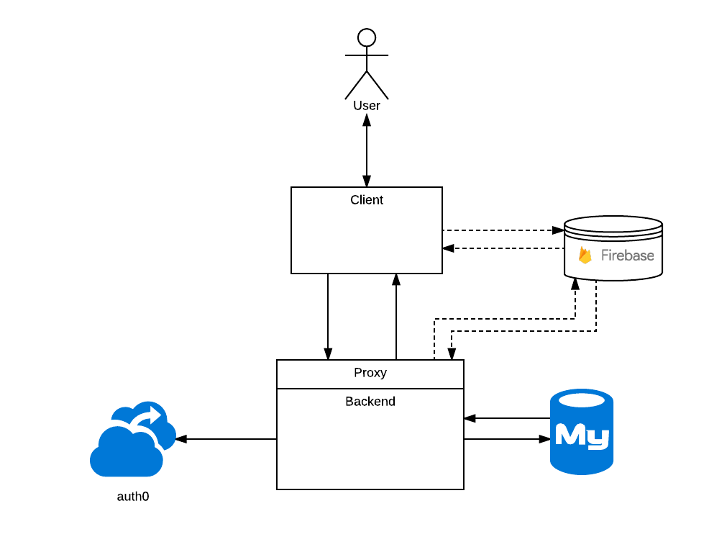

Database:

Availability is our main factor is choosing DB. And considering the scalability of the solution and having integration between users To-do-lists and assigning different tasks so we might consider consistency. **CA** options will be **relational** databases oracle or MySQL.

Decision is to use MySQL DB as it a free licensed.

Live DB:

We might consider to-do lists integration between tasks with reminders and assigning different tasks as new features. So Firebase might be a perfect solution for live features for notification/Reminders/List updates.

Server Side:

Client side:

Cross Cutting modules:

