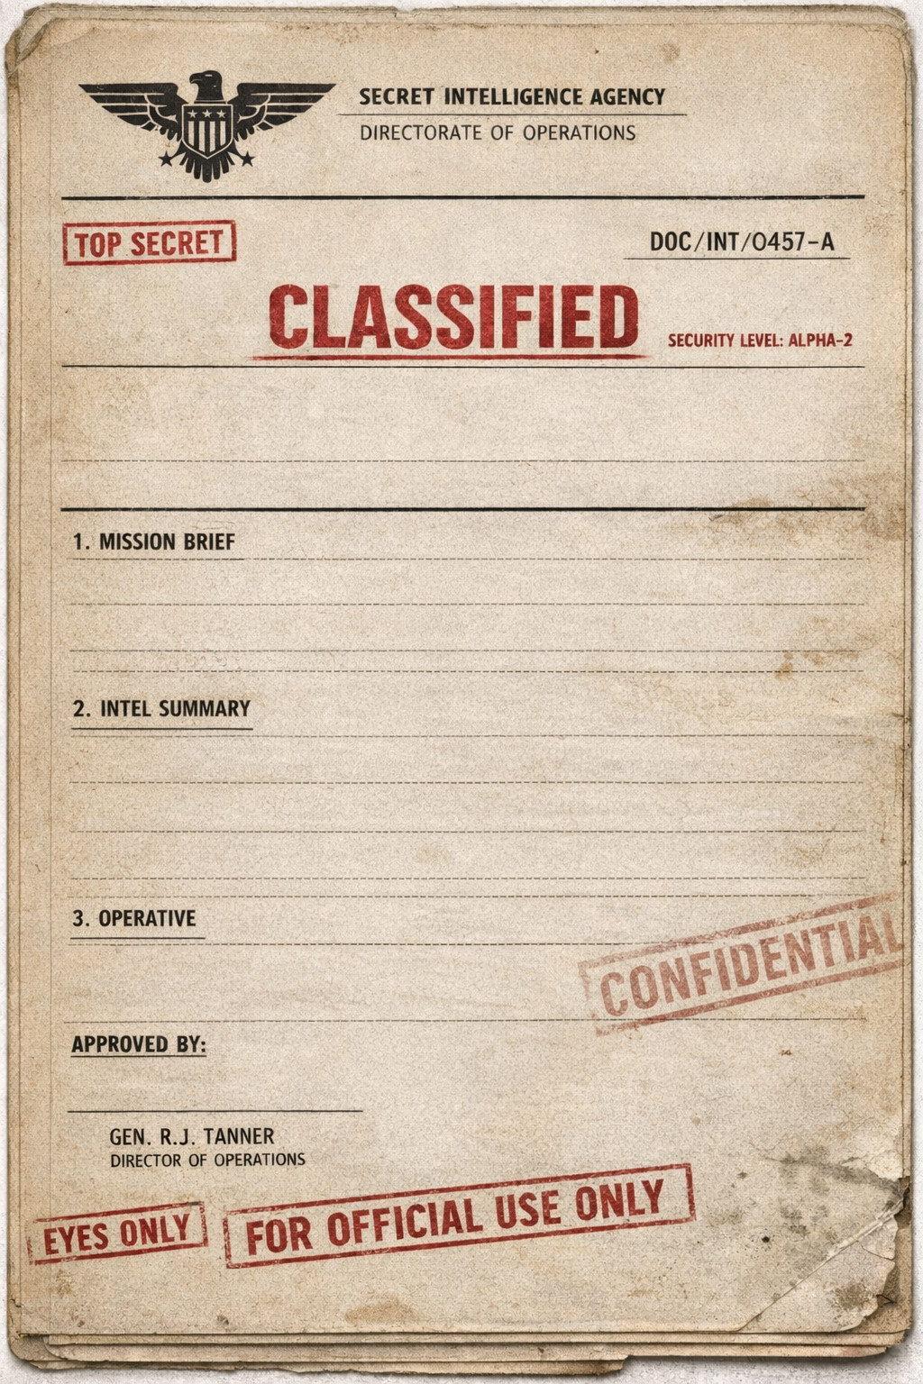

DATE:
FILE NO:
SUBJECT:

-

-

-

-

-

-

-

