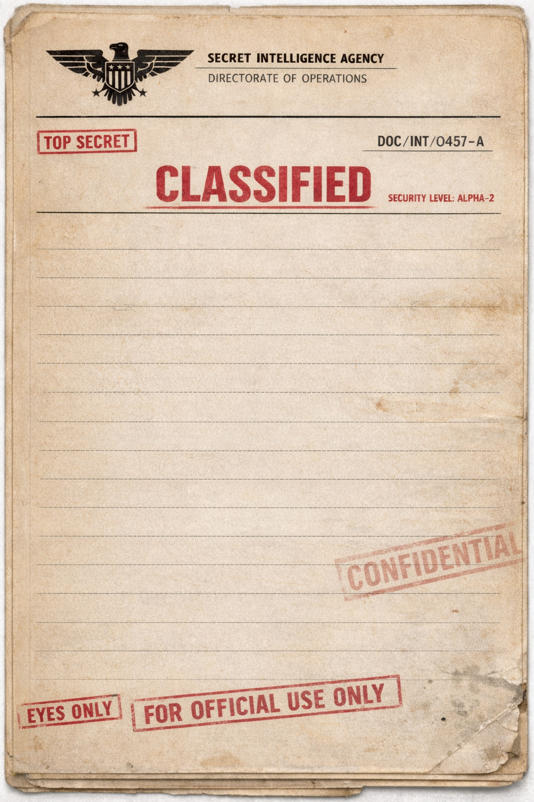

SCENARIO DATA
date: 06/03/26
file no: 119
subject: test

Mission Brief
Intel has gathered that there is a hostile submarine in your location.
Avoid combat at all costs, use counter meassures effectivly. Last sighted
co-ordiantes (10,5) move to co-ordinates (8,5). At a speed of 8 knots.

Intel Summary
Enemy sumbarine is of Class: Akula, Last sighted co-ordinates (0,5).
Intel predicts that they will move to co-ordinates (5,5), At a speed of 10 knots.

Operative
Class: Type 45.

Approved By
Gabe hockin

