Lab 3 – Create New BPM Project Lab

Objectives:

Add the essential structure for Organization, Repository, and Project.

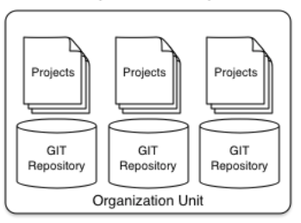

**Organization Unit**

This is the top level. An installation may have one or more organization units.

**Repository**

Each Organizational unit can have one or more repositories. A repository is a physical git repository, stored on disk.

**Project**

Each Repository can have one or more projects. A project forms the deployable unit and complies down to a jar. A project can depend on one or more other projects.

1. Log In

1. If necessary, restart your jboss server and create new application user.
2. Open a web browser, and go to http://localhost:8080/business-central. A log-in screen appears.
3. Log in with the username and password. The JBoss BPM Suite 6.3 home page appears.

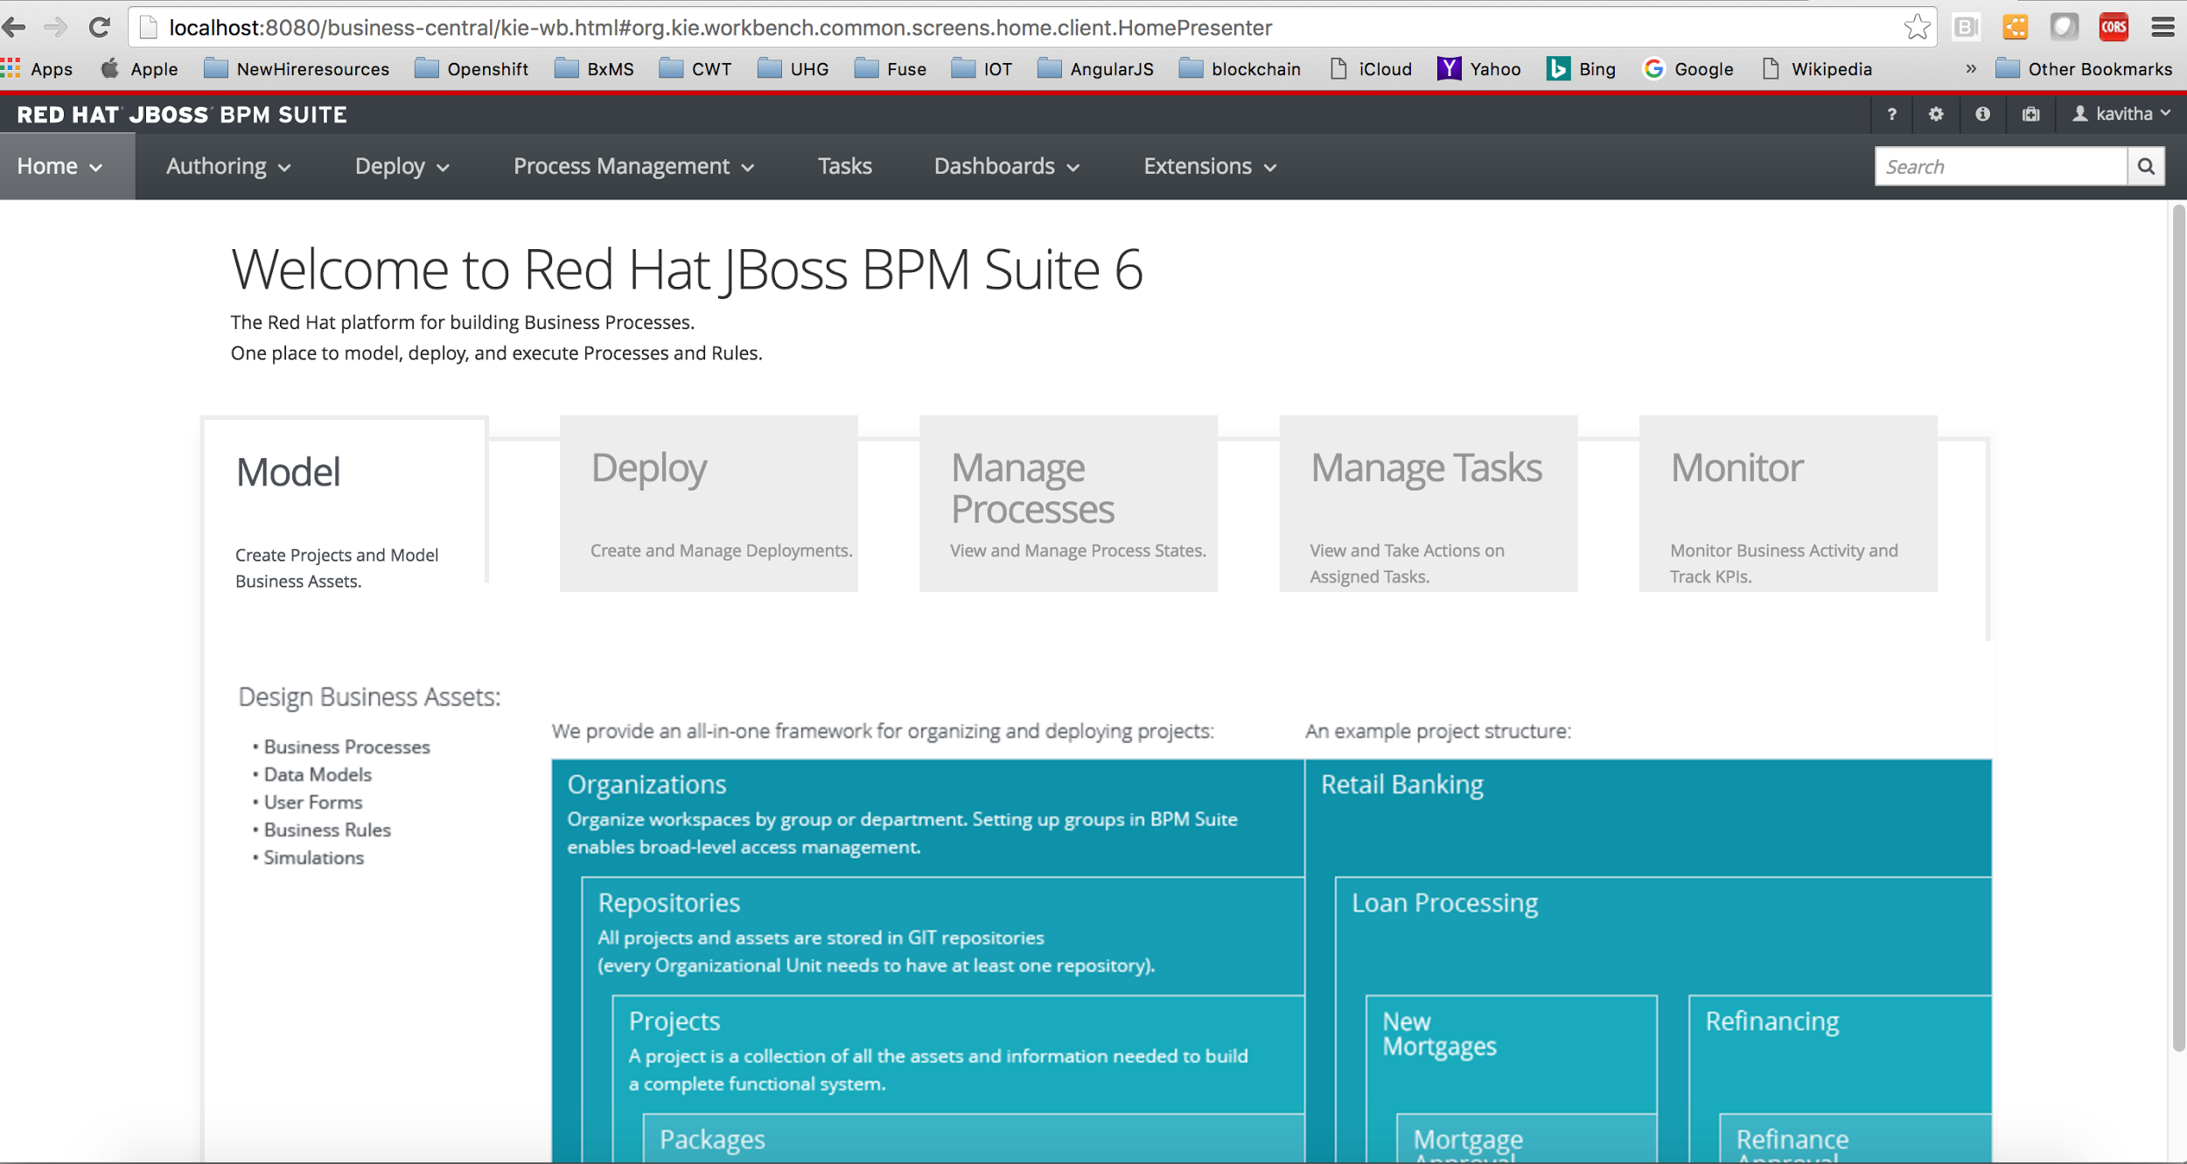

Figure 1. JBoss BPM Suite 6.3 home page

2. Add a New Organizational Unit

In JBoss BPM Suite 6.3, assets are organized into organizational units, repositories, and projects. Therefore, you first need to create an organizational unit.

1. From the menu, select **Authoring → Administration**.
2. Select **Organizational Units → Manage Organizational Units**.
3. On the **Organizational Unit Manager** screen, click **Add**.
4. On the screen that appears, enter the following:
   * **Name** - acme
   * **Owner** - jboss
5. Click **Ok**.

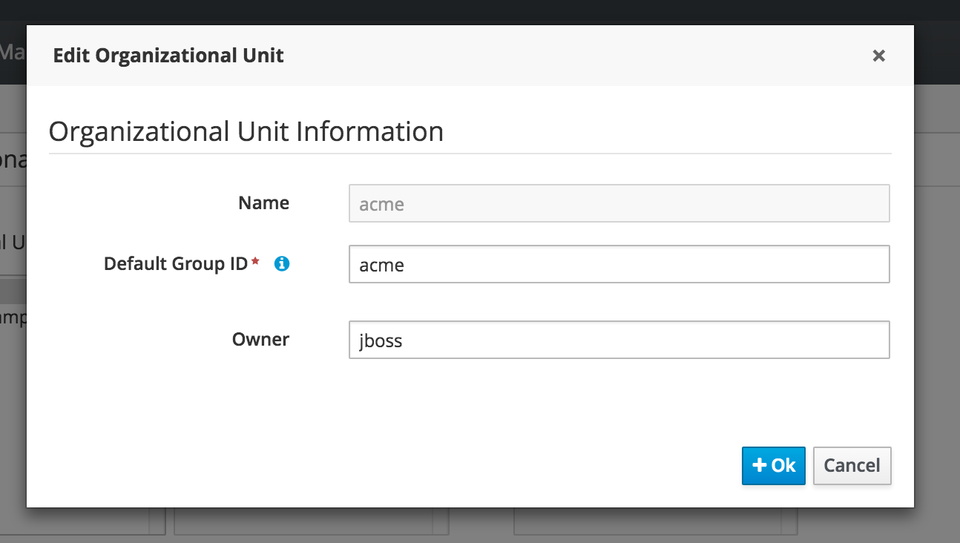 Figure 2. Add New Organizational Unit screen

3. Create a New Repository

Next, you need to create or clone a repository. JBoss BPM Suite 6.3 uses Git to provide the repository structure, so you can either clone an existing Git repository or create a new one. For this lab, create a new repository.

1. Click the **Repositories** link (next to **Organizational Units** on the administration page) and select **New repository**.
2. On the screen that appears, enter or select the following:
   * **Repository Name** - insurancepolicy
   * **Organizational Unit** - acme
3. Click **Create**.
4. Click **Ok**.

4. Create a New Project

Now you can create a project, which is the main organizational and deployment unit for your business rules assets. A project is modeled like a Maven project. When you deploy a project, it deploys as a Maven artifact (.jar and .pom) in a Maven repo , ready to be incorporated and consumed by applications.

1. From the main menu, select **Authoring → Project Authoring**.
2. **The Project Explorer** screen appears, which shows the organizational structure. Make sure that the acme organizational unit and the insurancepolicy repository are selected.
3. On the menu, select **New Item → Project**.
4. In the **Resource Name** field, enter policyquote.
5. Click **Finish**.

