**Lab 4 - Data Modeler**

The data modeler allows non-technical users to view, edit or create these data models. business process analyst or data analyst will capture the requirements for a process or application and turn these into a formal set of interrelated data structures. The new Data Modeler tool provides an easy, straightforward and visual aid for building both logical and physical data models, without the need for advanced development skills or explicit coding.

**Goal:**

Create the domain model classes to use in rule processing and process executions.

**1. Create a data model**

To open the data modeler:

1. Use your browser to navigate to the **Authoring → Project Authoring** perspective of the **BPM Central** web application of JBoss BPM Suite 6.3.
2. Select **New → Data object** from the menu.

**2. Create a Data Object**

1. Click New→Data Object and enter the values Rejection and pick package “acme.policyquote”. The screenshot of this is below:

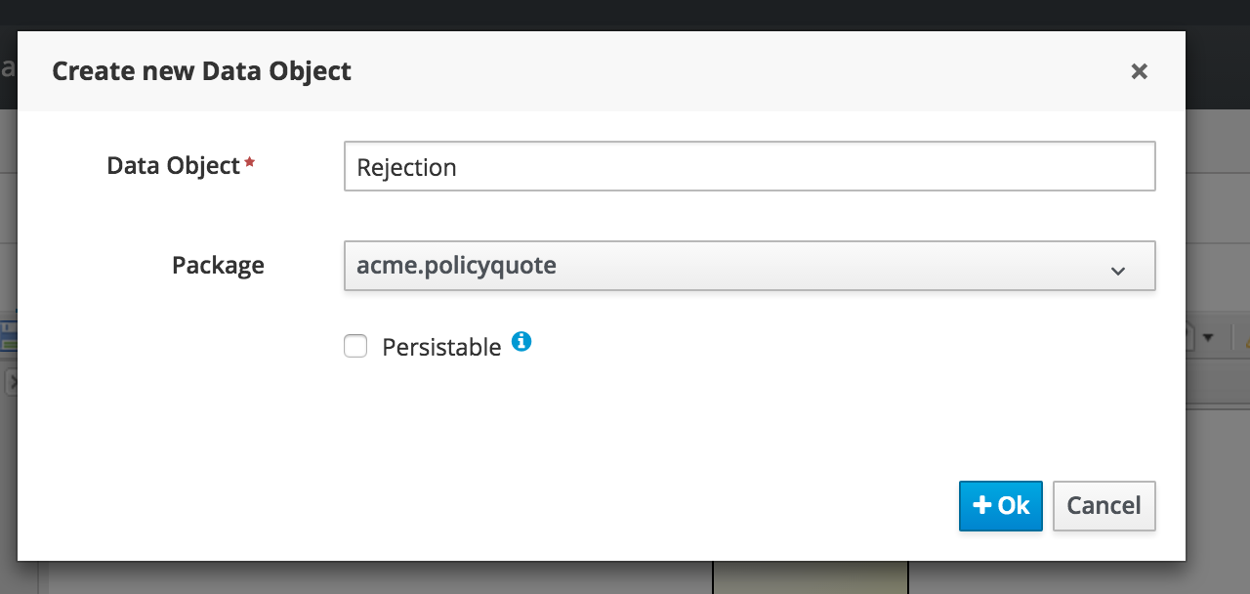

1. Click **Ok**.

**3. Create Data Object Fields**

1. In the **Objects** panel, click the **Rejection** object.
2. Click “add Field” to enter the following field properties:

Id:reason, Label : Reason , Type: String

1. Click **Create** button and after its done click Save

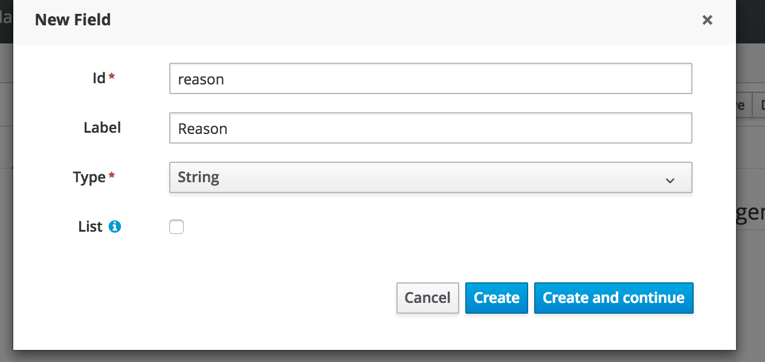

**4. Create Other Objects**

1. From the menu again Click “New Item”and choose “Data Object”
2. Create a **Driver** object with package: acme.policyquote

1. In the **Objects** panel, click **Driver** and add the following fields:

Table 3. Driver object fields

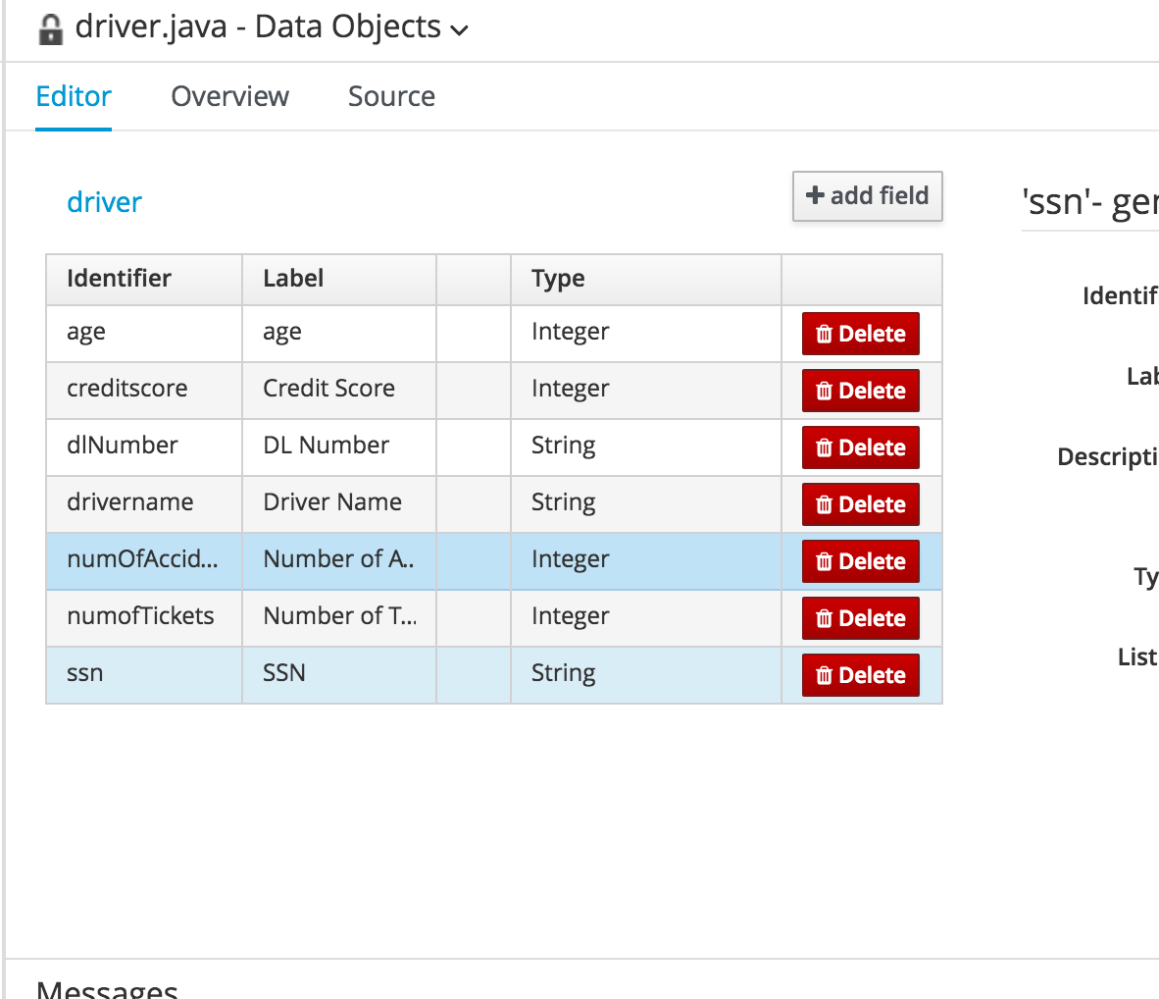

1. Create a **Policy** object.
2. For Fields of this object first create a driver field referring to the DO created earlier like in screenshot below.

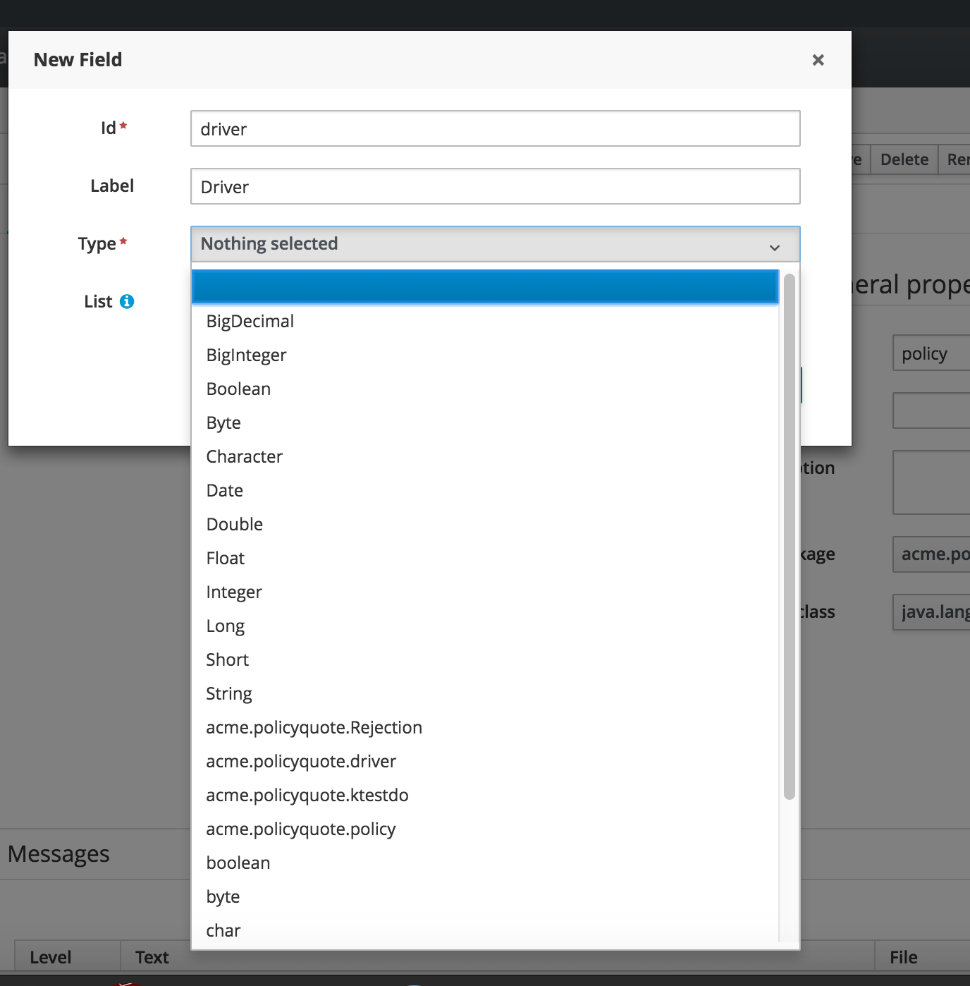

Now create the rest of the attributes and ensure that when done you have the following attributes for this DO.

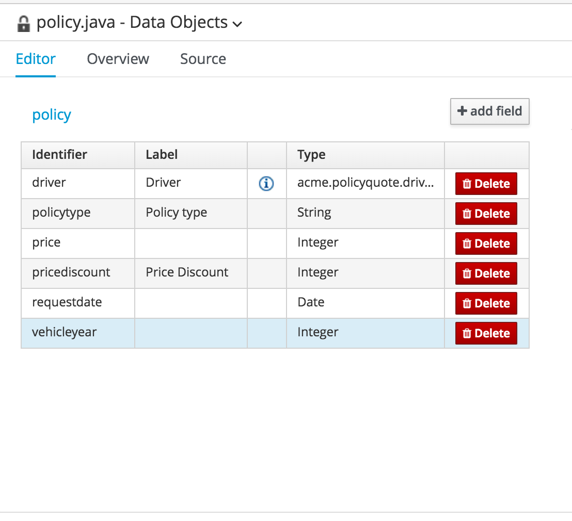

Table 4. Policy object fields

1. Click **Create** and then Save