**Lab 5 – Guided Rule Editor**

**Goal:**

Use the JBoss BPM Suite 6 Guided Rule Editor to create a few new rules.

**1. Create Exclusion Rules**

Use the Guided Rule Editor to create several exclusion rules. There are multiple rule *formats*, but from the JBoss BPM Suite 6 point of view, they are all *assets*.

1. Click **New Item → Guided Rule**.
2. Enter the name **TooYoung**.
3. Click **Ok**.

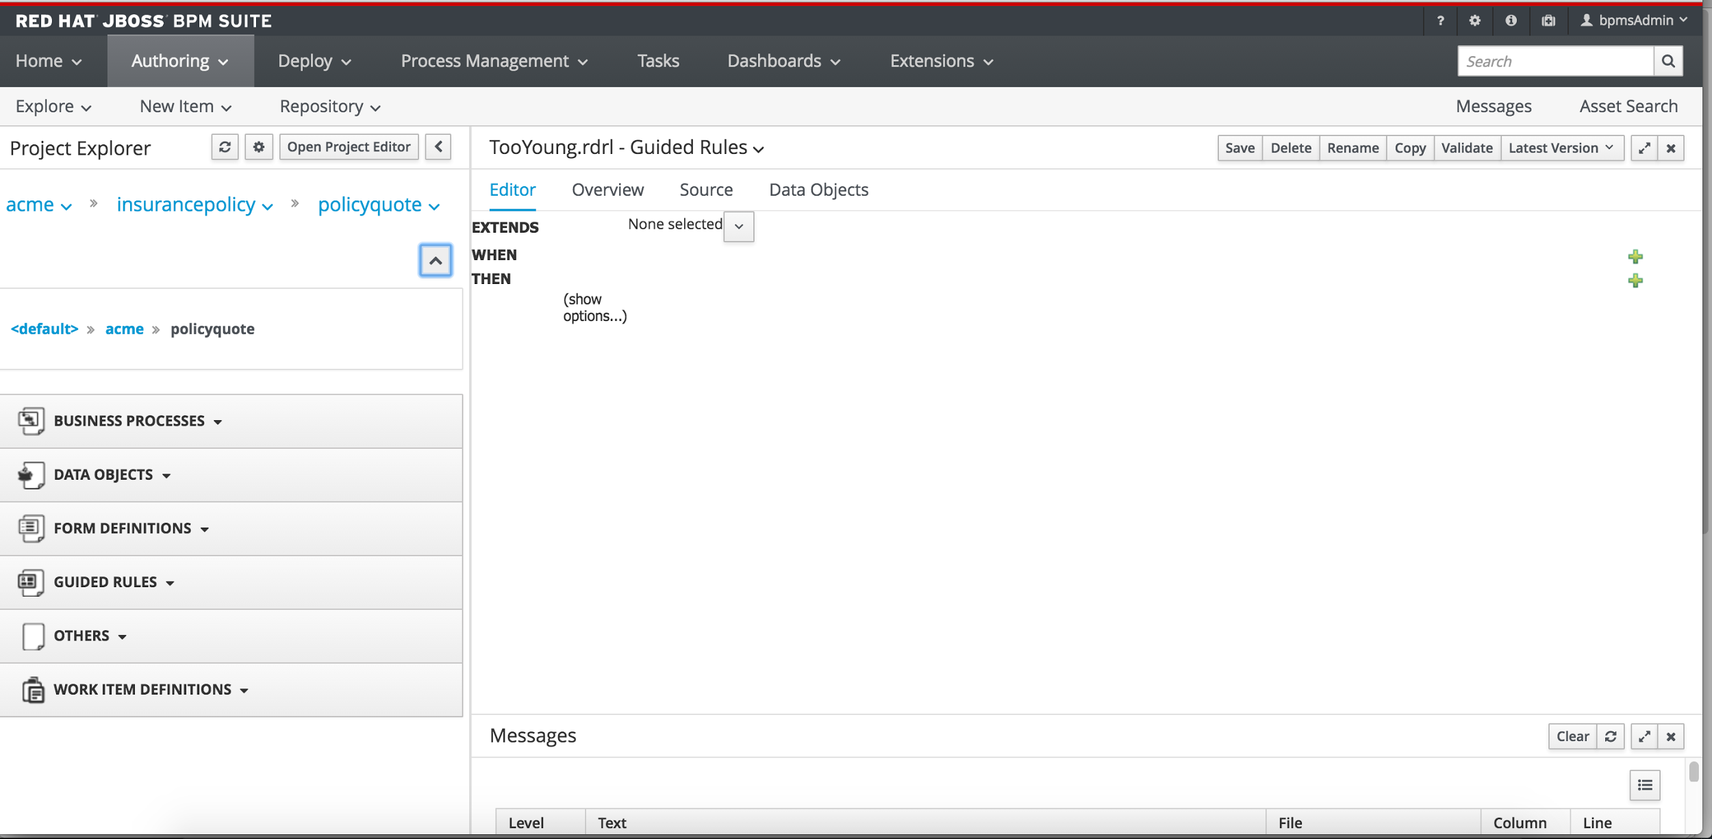

**2.2. Create Rules**

We are going to create a rule that says if the driver’s age is less than 18, we reject the policy with the reason “TooYoung”.

Steps

* 1. Click on the + along when
  2. Choose driver
  3. Click on ‘There is a driver’
  4. Pick age as the constraint per screenshot below

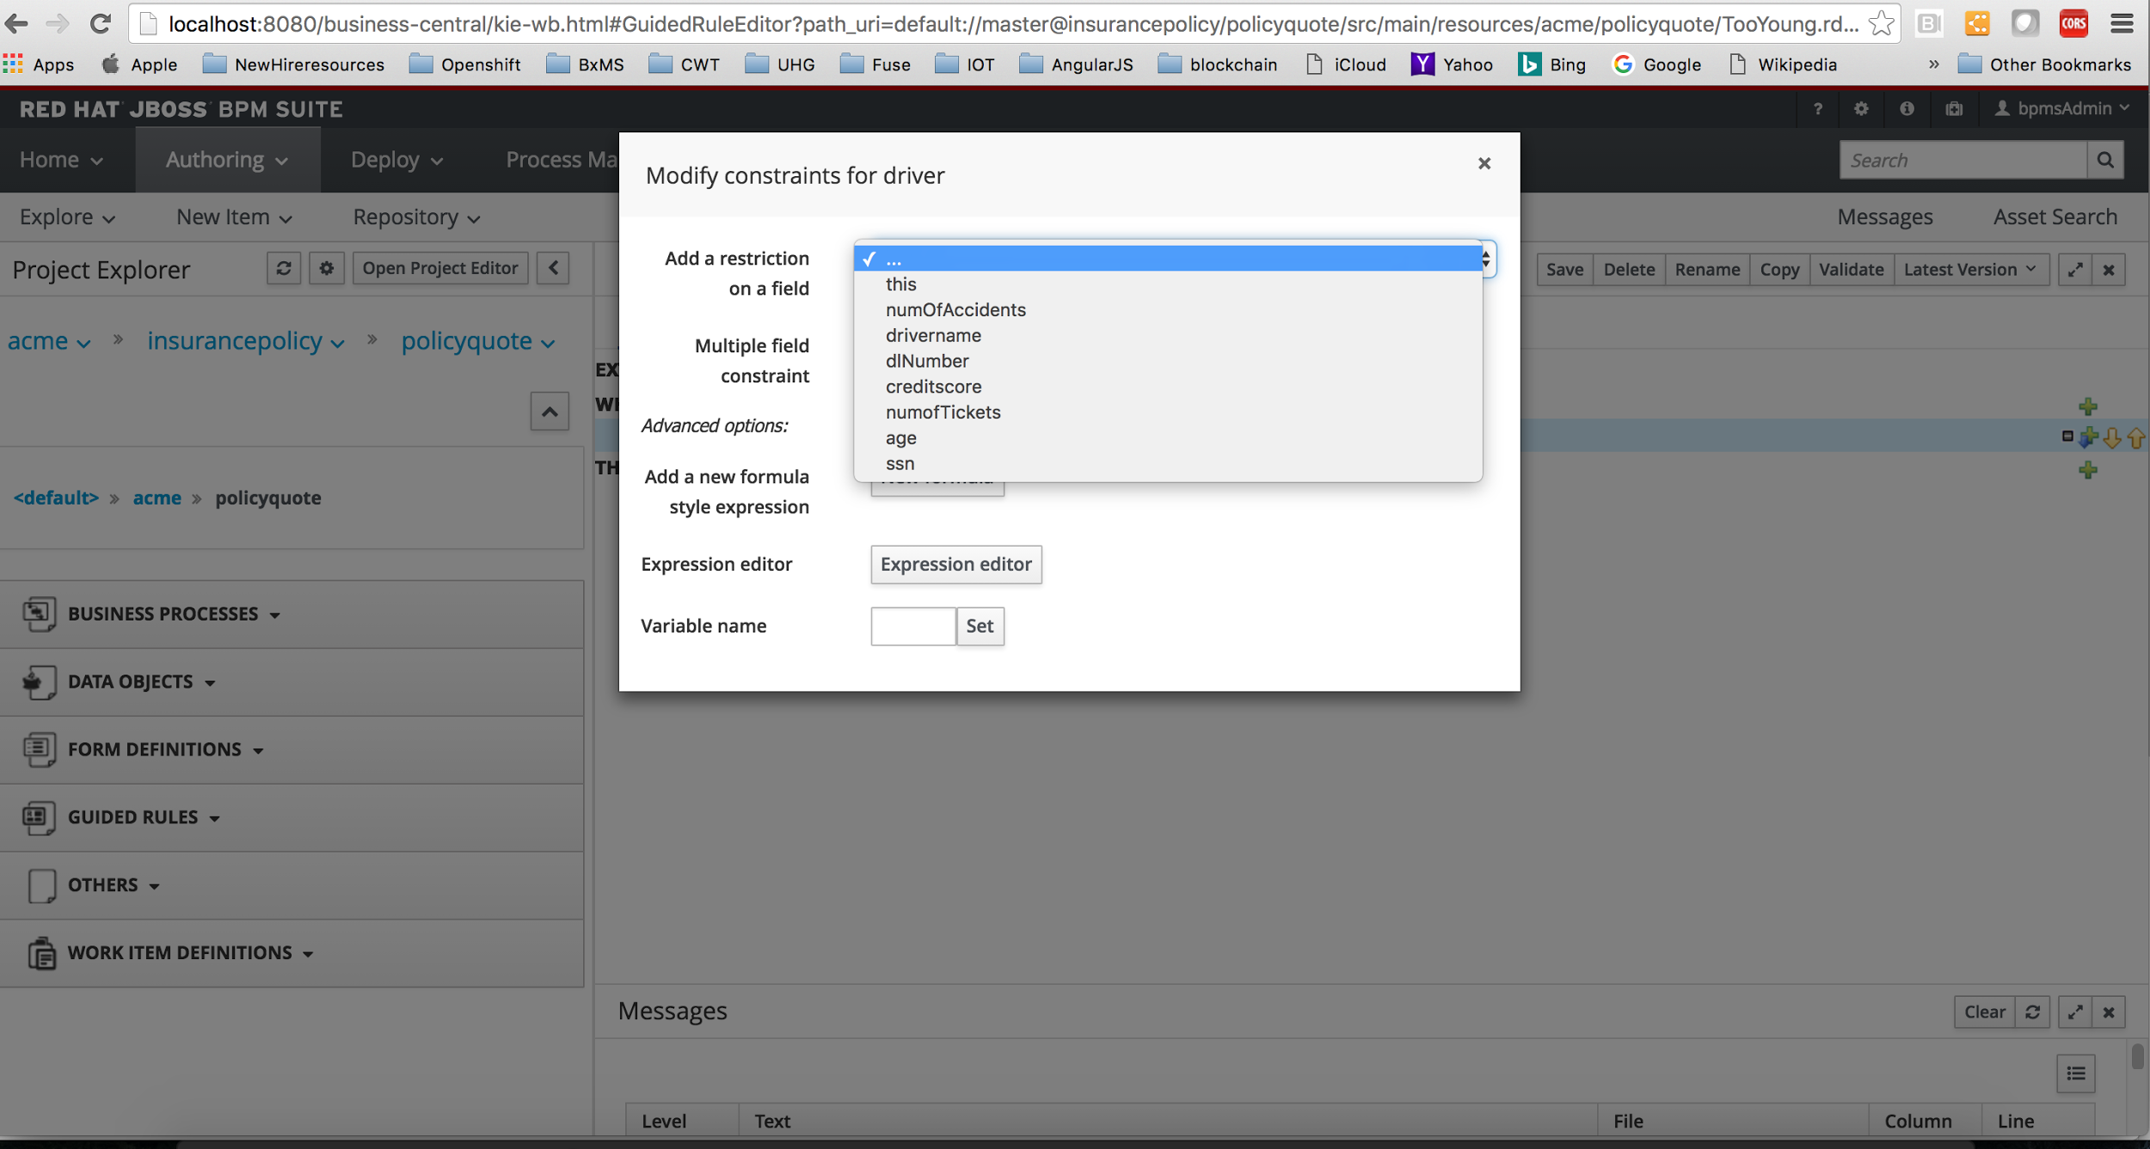

1. Pick condition “lesser than” from the drop down
2. Click on the pencil icon and set a literal value to 18.

That completes our WHEN clause. Moving on to defining THEN clause..

1. Click on the Green + along THEN
2. Pick Insert fact Rejection like in screenshot below

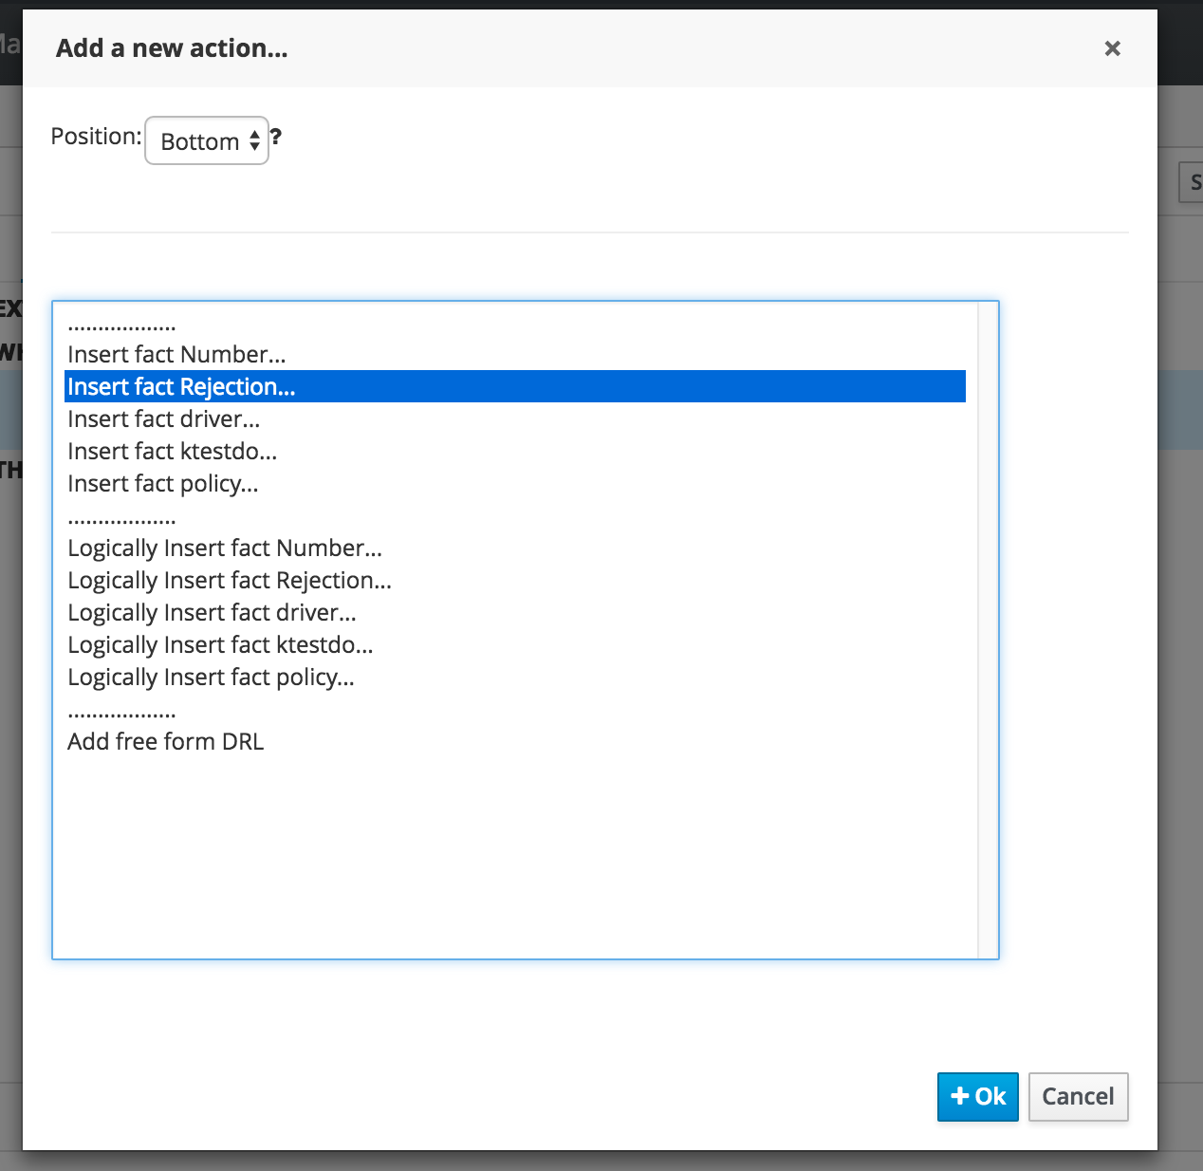

1. Click on“Insert Rejection”
2. Add a field : pick “reason”
3. Click the pencil icon

11. In the **Field value** dialog box, select **Literal value**, and then enter **Too Young**

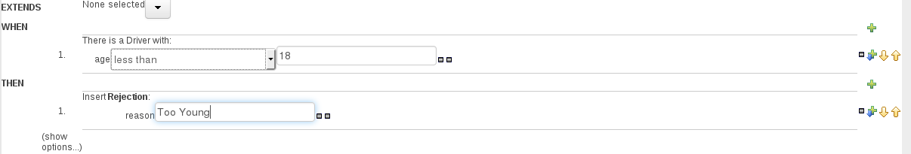

1. Click “show options” and then on the same line click 
2. In the dialog box, select **ruleflow-gruop** in the Attributes text box.

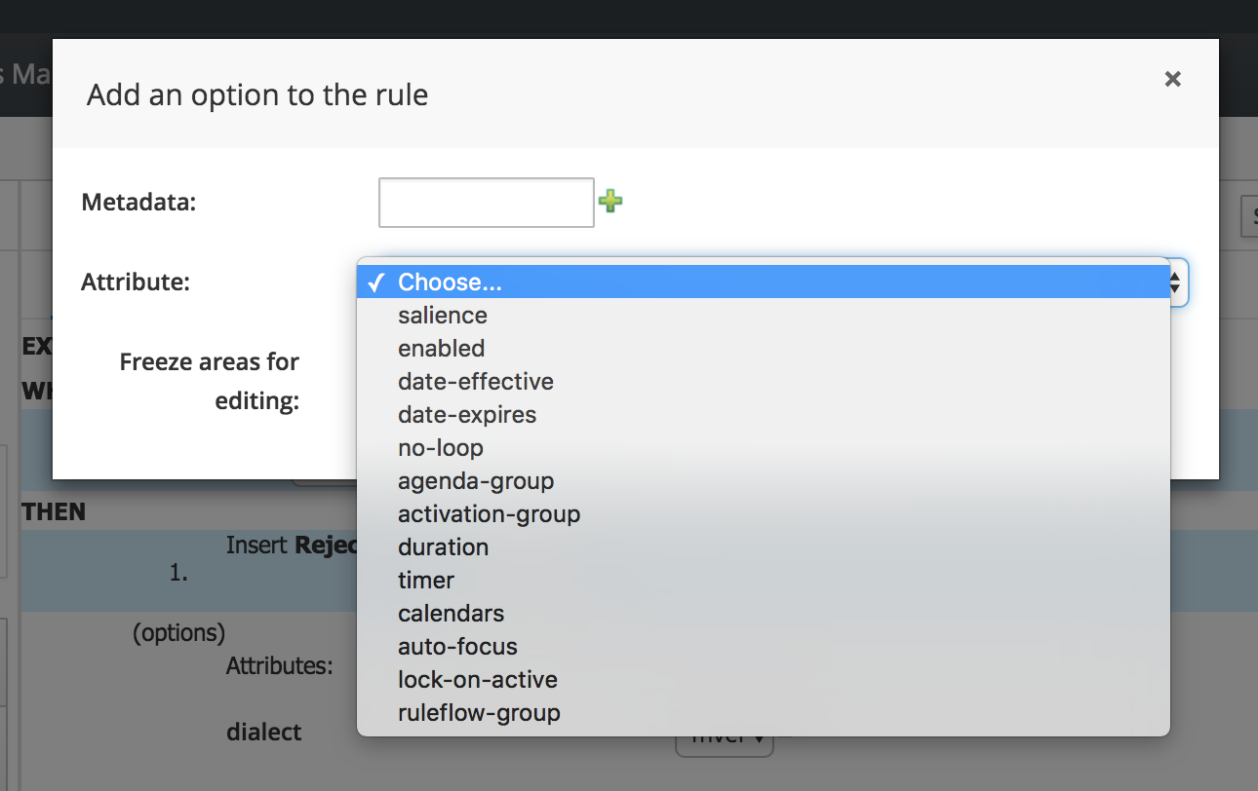

1. Type **rejection** in the **ruleflow-group** text box.

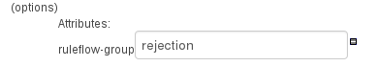

1. Click **Validate** and then click **Save**.

The final rule should resemble the following:

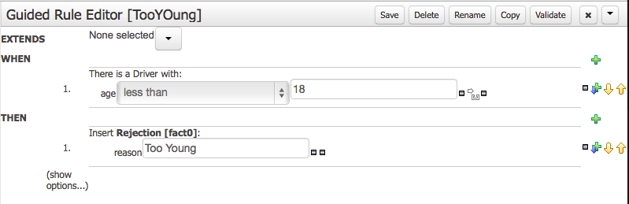

Create the other rules listed below. Remember to click **Validate** and **Save** after you finish each rule.

Table 1. Exclusion rules

|  |  |  |
| --- | --- | --- |
| **Rule Name** | **Condition** | **Action** |
| TooOld | If the driver age is greater than 100 | Then reject with reason Too Old |
| TooManyAccidents | If the driver **numberOfAccidents** is greater than 4 | Then reject with reason **Too Many Accidents** |
| TooManyTickets | If the driver **numberOfTickets** is greater than 6 | Then reject with reason **Too Many Tickets** |

Here are the screenshots for the TooManyAccidents and TooManyTickets rules.

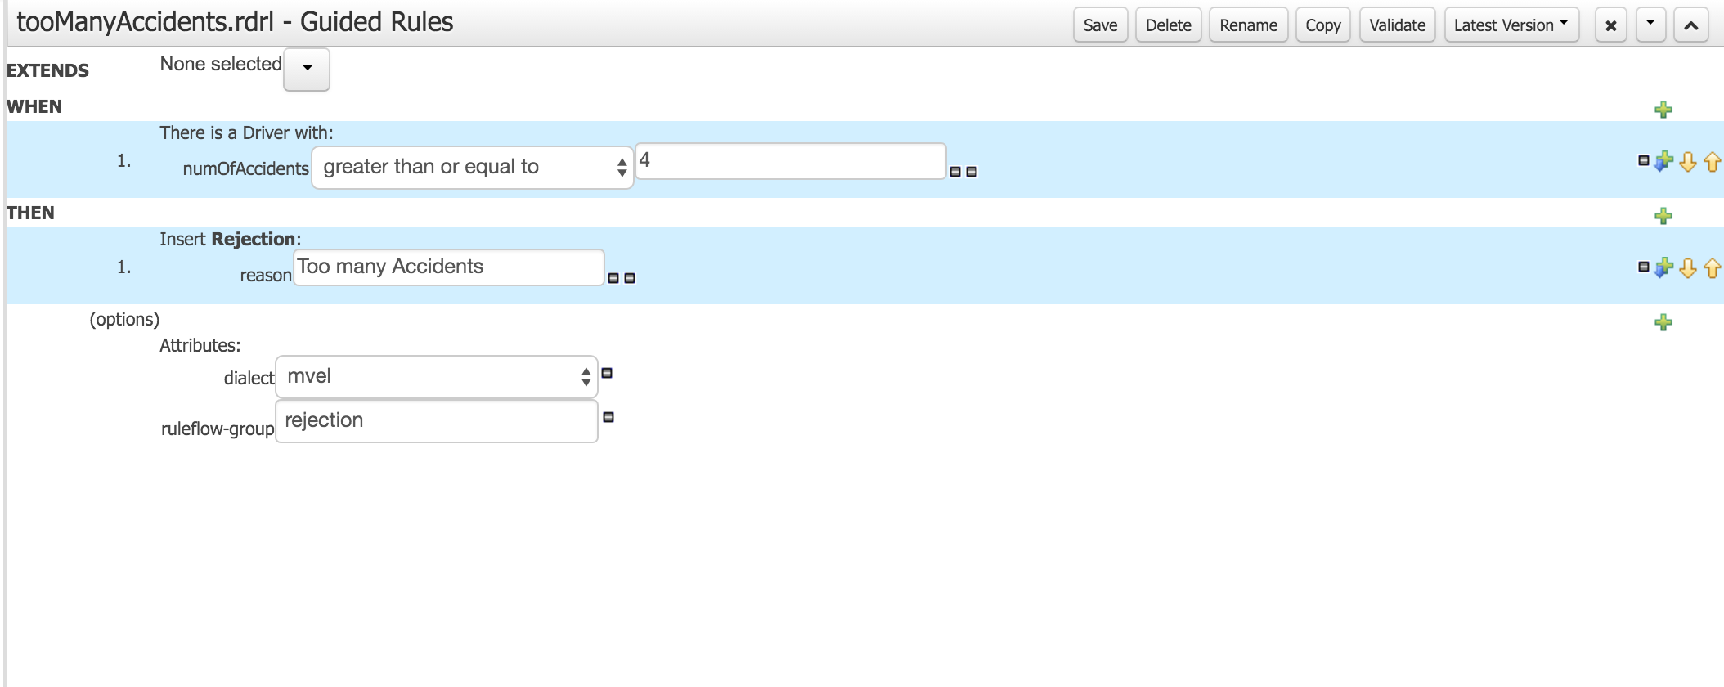

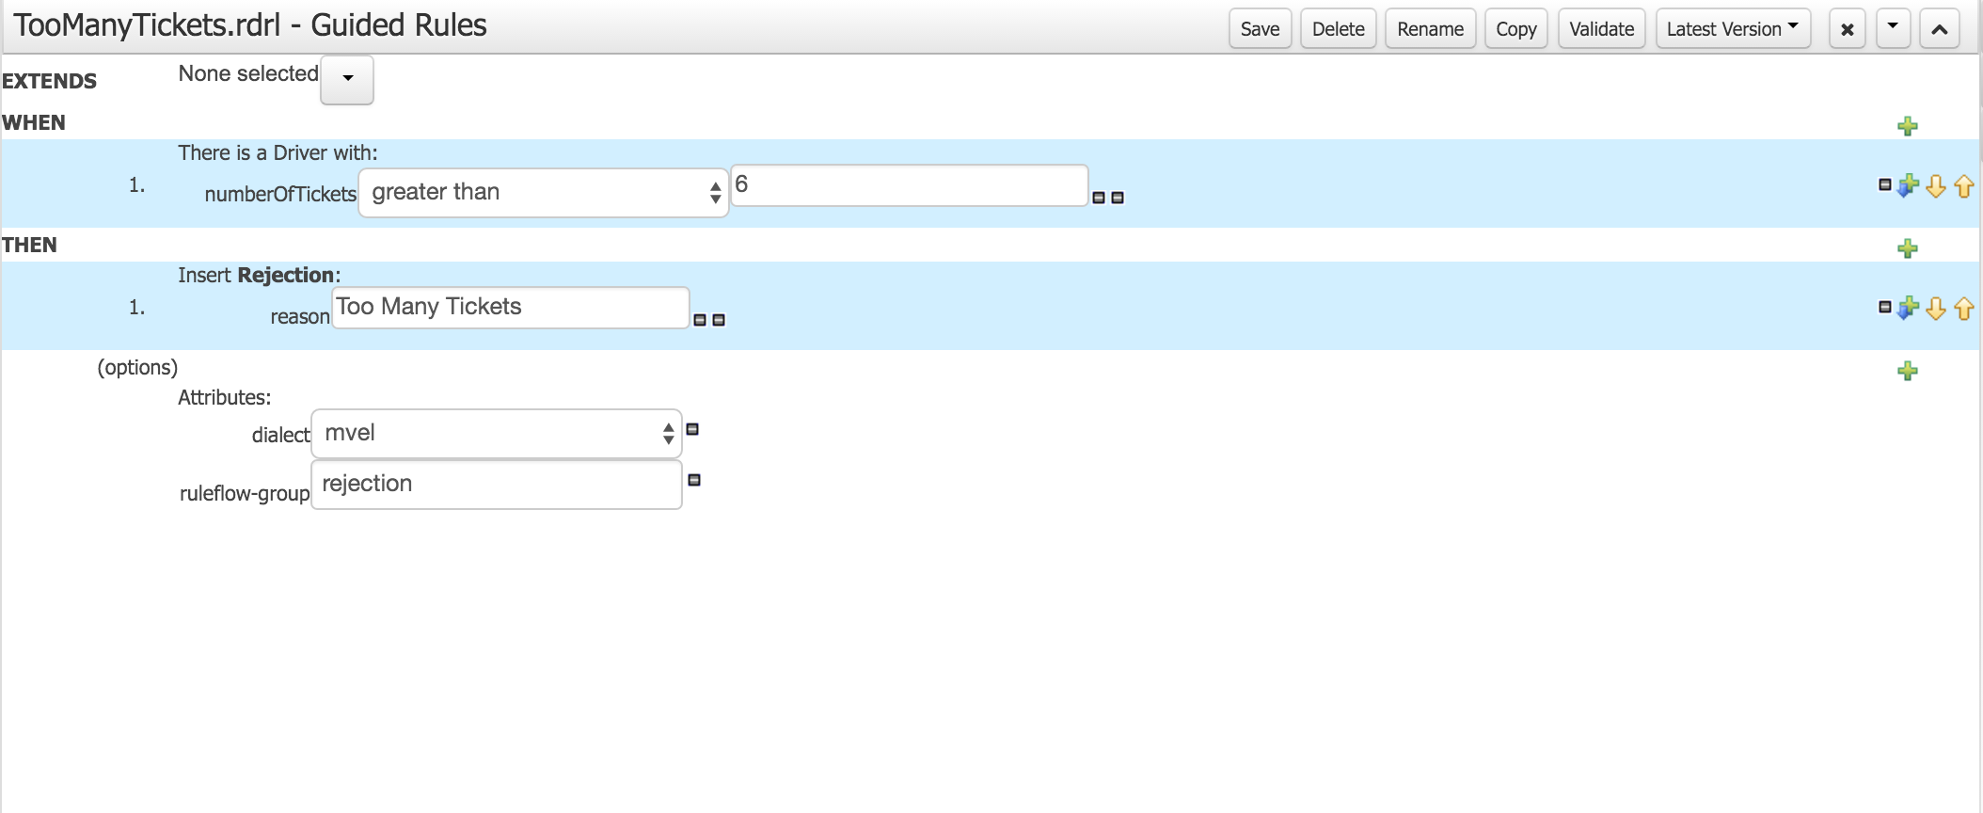

**2.3. Build and deploy**

After you create the four rules in the previous section, build the package as follows:

1. Click **Open Project Editor**.
2. Click **Save**.
3. Click **Build & Deploy**.
4. Click **Yes**.

**2.4. About Deployment**

The BPM Central web application of JBoss BPM Suite 6.3 also has a user interface to manage these Deployment Units. In your browser, navigate to **Deploy → Process Deployments**. At this point, you should see a Deployment Unit with unique identifier like below

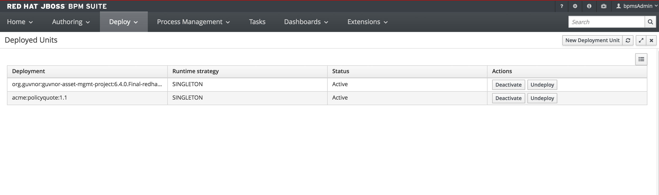

Figure 4. Deployment Unit