**Lab 6 - Decision Table**

Decision tables use a spreadsheet-like format and provide another way to author rules. This method is especially useful when you have sets of rules that are similar in nature, but some parameters or values differ. JBoss BPM Suite 6 supports decision tables written in a spreadsheet (Excel, OpenOffice), as well as a web-based decision table editor. In this lab, you will use the web-based decision table editor to author rules that determine the price discount level on a car policy based on the driver’s credit score level.

**Goal:**

Use a Guided Decision Table to create decision table rules.

**1. Create a New Decision Table**

1. Using your browser, navigate to the http://localhost:8080/business-central
2. Make sure you have the project open and path: acme.policyquote
3. Select **New Item** → **Guided Decision Table**.
4. In the pop-up window, enter **CreditScoreDiscount** as the table name.
5. Check **Extended entry, values defined in table body**.
6. Click **Ok**.

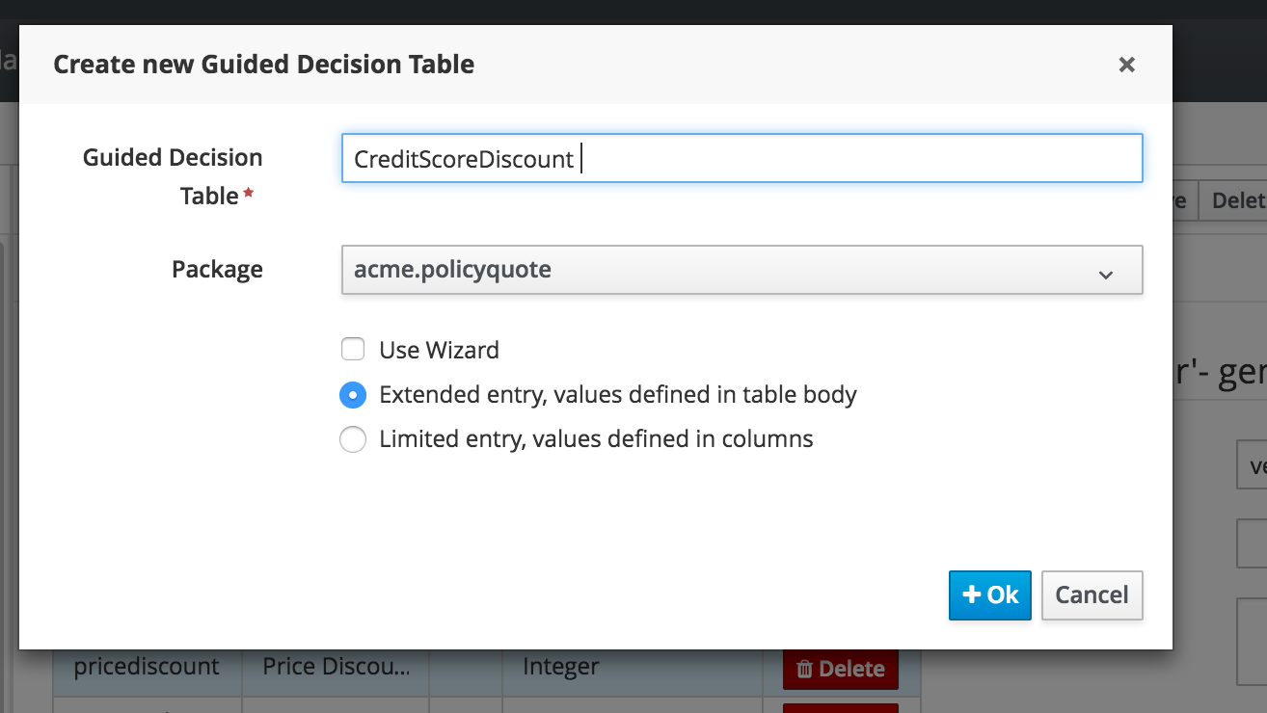

**3. Add Table Rows**

The condition table enables you to add constraints to fields in your fact objects that are consistent across a set of rules that you created in your decision tables. Each row in the condition table corresponds to a constraint on a selected field.

1. Click on Decision table to open it
2. Click on the Green plus next to **New column,** and select **Add a simple condition** as the column type.

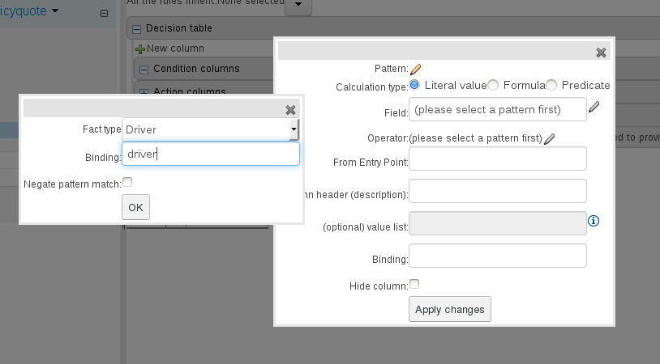

Now select “creditscore” for the field and greater than for the operator

Provide column header name “Min Score”



1. Add the following additional condition columns:

Table 1. Condition columns

|  |  |  |  |  |  |  |  |  |
| --- | --- | --- | --- | --- | --- | --- | --- | --- |
| **Pattern** | **Calculation Type** | **Field** | **Operation** | **From Entry Point** | **Value List** | **Column Header** | **Default value** | **Hide Column** |
| Driver (bind to driver) | Literal value | creditScore | Less than or equal to | Leave blank | Leave blank | Max Score | Leave blank | Leave unchecked |
| Policy (bind to policy) | Literal value | price | Greater than | Leave blank | Leave blank | Price | 0 | Leave unchecked |

Add another condition for policytype and set operation ‘is equal to’.

The decision table now looks like this:

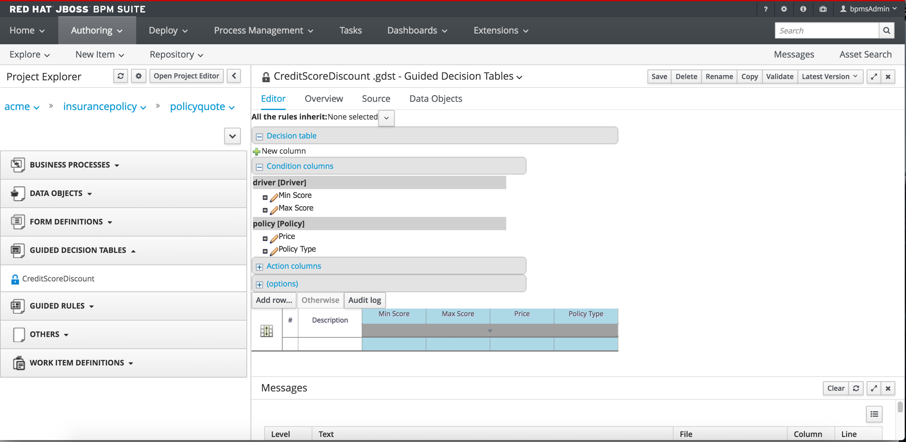

1. Now we add Actions:

Click **New column,** and select **Set the value of a field** as the column type.

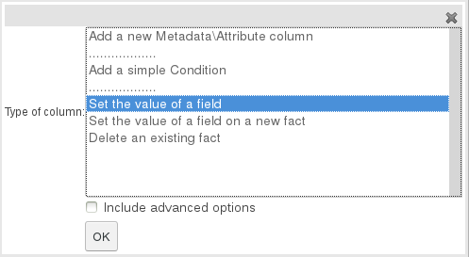

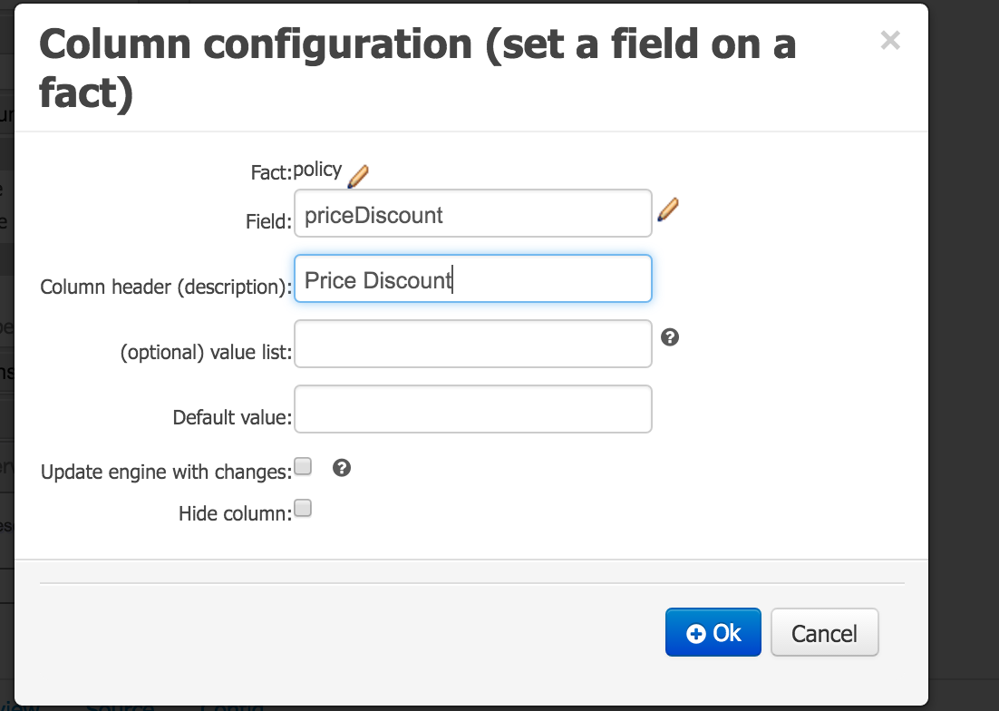

The decision table now looks like this with the columns in blue representing the condition columns and the white the action columns

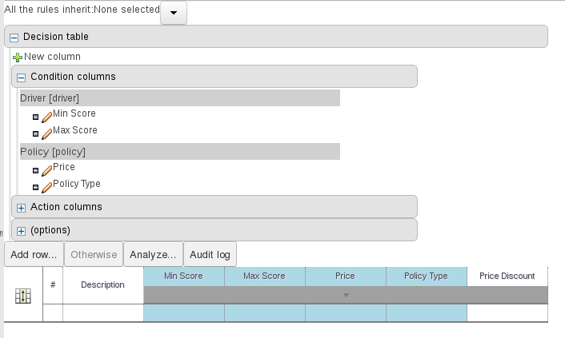

**4. Add Meta data Attributes**

When a rule’s consequence modifies a fact, the consequence may cause the rule to activate again, which can cause an infinite loop. Setting the no-loop attribute to true prevents another activation of the rule with the current set of facts.

To add the no-loop attribute:

1. Click **New column**.
2. Select **Add a new Metadata/Attribute column** as the column type.
3. In the pop-up window, select the no-loop attribute.
4. Check the box for Default value and do not check the hide column.

Next add the ‘ruleflow group’ attribute following the same steps 1 and 2 above. Select the ‘ruleflow group’ attribute and add “discount”

Before you move on to adding the rules in the next step, the decision table looks like this:

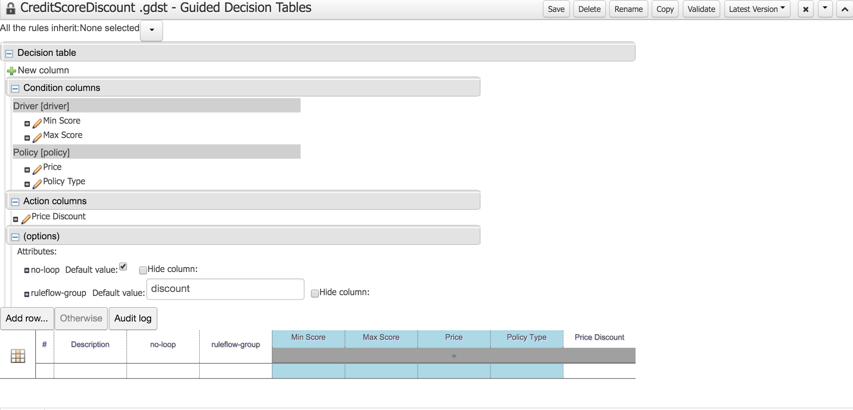

**5. Add Rules**

Now you can add the rules to the decision table.

1. Click **Add row**.
2. Click the  icon to add three more rows.
3. Enter the following values:

Table 3. Rule values

|  |  |  |  |  |
| --- | --- | --- | --- | --- |
| **Description** | **Min Score** | **Max Score** | **No Loop** | **Price Discount** |
| bad credit | 0 | 400 | Check the box | 0 |
| good credit | 400 | 600 | Check the box | 10 |
| very good credit | 600 | 700 | Check the box | 25 |
| excellent credit | 700 | Leave blank | Check the box | 50 |

Your finished table should resemble the following: (Ignore the Price condition in the screenshot)

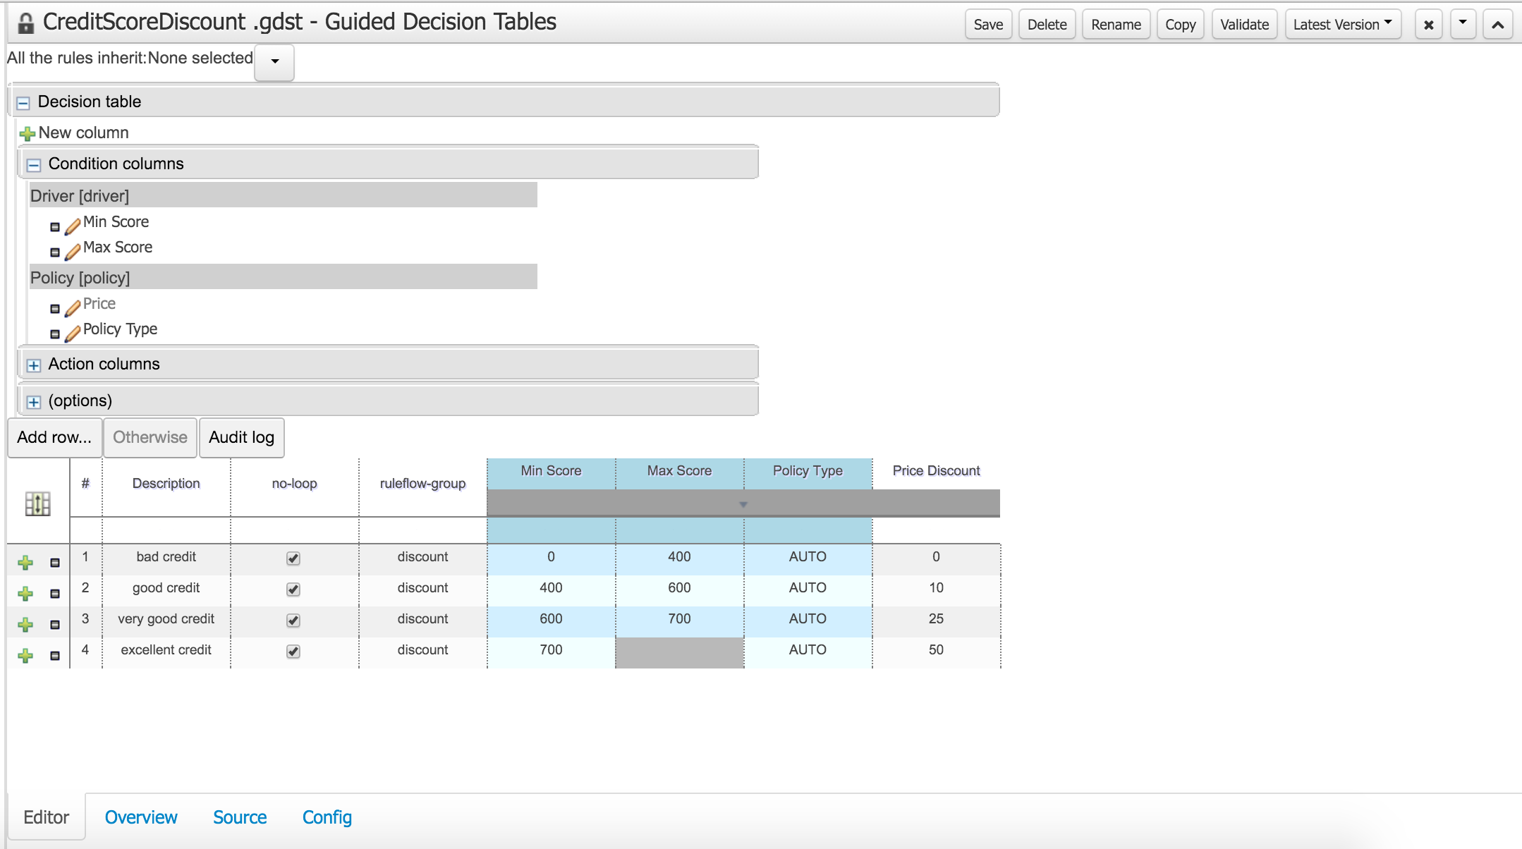

Figure 1. Credit score decision table

1. Click the **Source** tab to see the DRL source for this decision table.
2. Observe that each row in the table represents one rule.
3. Click **Validate** to validate the table.
4. Click **Save** to save it.