**Lab 7 – Testing Rules**

Just like regular code, you should test rules to make sure they produce the desired result. When using JBoss Developer Studio to author rules, you can test rules with plain Java unit tests using JUnit or TestNG. JBoss BPM Suite 6.3 also has facilities to define test scenarios against rules.

**Goal:**

Use the Test Scenarios feature to create a few test scenarios for your rules.

**1. Create a New Test**

Your first task is to write a test for your TooYoung rule.

1. Open the **Projects** page of the web based BPM Console by selecting **Authoring → Project Authoring**.
2. In **Project Explorer**, Select **New Item → Test Scenario**.
3. In the pop-up window, enter **TooYoungTest** as the name of the test.
4. Click **Ok**.

**2. Define the Test**

In a typical test, you provide some data and describe what you expect when the rule(s) execute.

1. Define input values for the test:
   1. Go back to the **Test Scenario** tab.
   2. Click the  icon next to **Given**.
   3. In the **Insert a new fact** list, select **Driver,** and name it driver.
   4. Click **Add**.
   5. Click **Add a field**.
   6. Select **age**.
   7. Click  .
   8. Select **Literal value** and enter 14 in the text box.
   9. Click the  icon next to **Given**.
   10. In the **New Input** dialog box, enter **rejection** in the **Activate rule flow group** text box.
2. Define expected results:
   1. Click the  icon next to **Expect**.
   2. In the **Any fact that matches** list, select Rejection.
   3. Click **Add**.
   4. Click on ‘A fact of type Rejection as values’ and add condition ‘reason’
   5. Click **Ok**.
   6. In the **reason** list, select **equals**, and enter **Too Young** in the text box.
3. Because you want to test your rule in isolation, specify that the rule TooYoung should fire at least once:
   1. Next to **configuration**, select **Allow these rules to fire:**.
   2. Click the  icon to select the TooYoung rule.

After it is finished, your test should resemble the following:

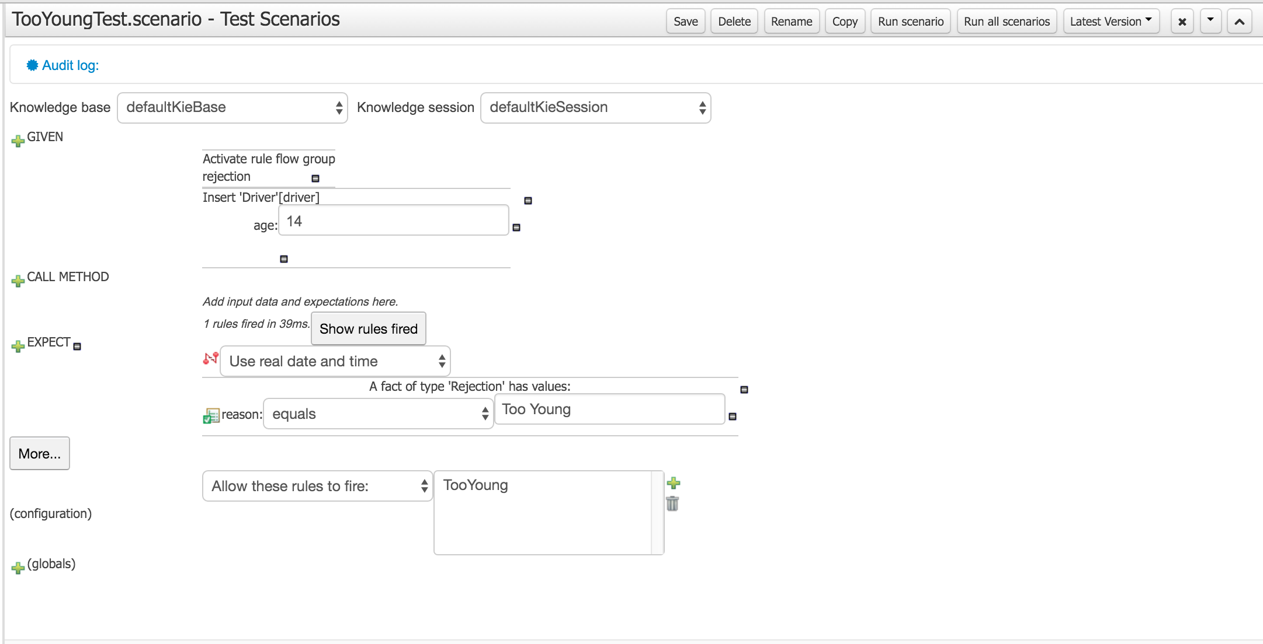

Figure 1. Too-Young test

**4. Execute the Test**

1. Click **Run scenario** to run this test.
2. Click **Save** to save the test scenario.
3. Look in the Reporting pane for a Success message. If there are test errors, fix the test or the rule you are testing.

|  |
| --- |
| To run all tests at once, select the **All Test Scenarios** tab, and click **Run all scenarios**. |