**Lab 9 – Technical Rules Authoring (DRL)**

**1. Create New technical Rule**

1. Open the **Projects** page by selecting **Authoring** → **Project Authoring**.
2. In **Project Explorer**, select **New Item** → **DRL file**.
3. In the Create new DRL file pop-up window, enter **SafeYouth** as the rule name.

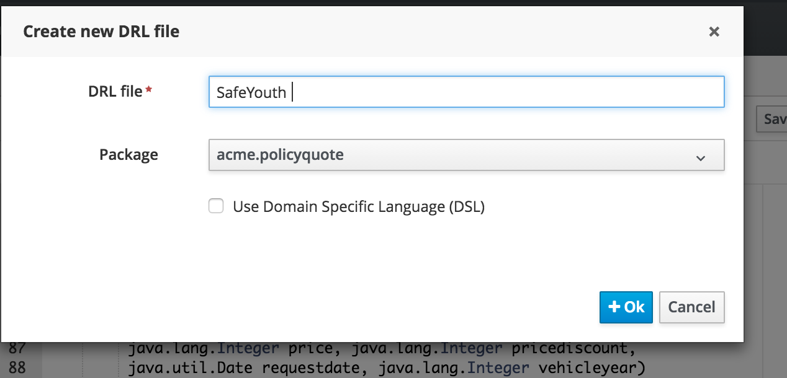

1. Click **Ok**.
2. In the DRL Editor[SafeYouths], copy paste the following code....
3. Click **Validate** and **Save**.

rule "SafeYouths"

no-loop true

//lock-on-active true

salience 150

ruleflow-group "calculation"

when

driver : driver(age >= 18 && < 25, numOfAccidents < 2, numofTickets <= 2)

policy : policy( policytype == "AUTO")

then

modify(policy) {setPrice(450)};

System.out.println("fired rule " + kcontext.getRule().getName());

end

1. Repeat the above for steps for **RiskyYouth.drl, SafeAdults.drl, RiskyAdults.drl**

**RiskyYouth.drl**

rule "RiskyYouth"

no-loop true

salience 100

//lock-on-active true

ruleflow-group "calculation"

when

driver : driver(age >= 18 && < 25, numOfAccidents >= 2 || numofTickets >=3)

policy : policy( policytype == "AUTO")

then

modify(policy) {setPrice(700)};

System.out.println("fired rule " + kcontext.getRule().getName());

end

**SafeAdults.drl**

rule "SafeAdults"

no-loop true

//lock-on-active true

ruleflow-group "calculation"

when

driver : driver(age > 24, numOfAccidents < 2, numofTickets <= 2)

policy : policy( policytype == "AUTO")

then

modify(policy) {setPrice(120)};

System.out.println("fired rule " + kcontext.getRule().getName());

end

**RiskyAdults.drl**

package acme.policyquote;

rule "RiskyAdults"

no-loop true

//lock-on-active true

//salience 120

ruleflow-group "calculation"

when

driver : driver(age > 25, numOfAccidents >= 3 || numofTickets >=3)

policy : policy(policytype == "AUTO")

then

modify(policy) {setPrice(300)};

System.out.println("fired rule " + kcontext.getRule().getName());

end