**Lab 10 – Create Rule Flow (BPM Process Management)**

**Goal:**

Learn how to use ruleflow to control the sequence of rule execution.

**Lab Assets:**

With this and the remaining labs, we transition from rules management to Business Process Model and Notation 2 (BPMN2) and control.

**1. Create a New Business Process**

Create a new business process to manage ruleflow using the Process Designer (also called Web Designer).

1. In the BPM Console of BPM Suite 6, click **Authoring** → **Project Authoring.**
2. On the Project Explorer screen, Click **New Item → Business Process**.
3. On the screen that appears, in the Name field, enter **policyquotecalculationprocess**.
4. Click Ok.

**2. Set Properties and Imports for the Diagram**

In this section, you’ll add properties such as id and package as well as import statements. The value of the id property for the diagram is important. As you will see in a later lab, you can use the Id value to execute this business process.

* Click anywhere on the canvas, and then click the **<<** icon in the upper-right corner of the screen to open the **Properties** panel.
* Verify that the Id property of the process to is set to **policyquote.policyquotecalculationprocess**.
* Change the Package property to **acme.policyquote**
* On the Properties panel, click the Imports drop-down arrow.
* On the screen that appears, click Add Import and add the Data Objects created. When completed the screen looks as below:
* 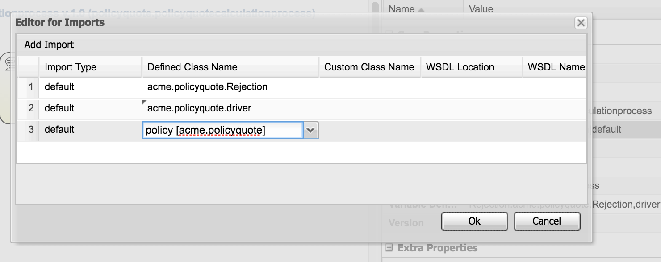

**3. ADDING EVENTS**

An event is something that happens during the course of a process. Events affect the flow of the process, usually have a cause or an impact, and generally require or allow for a reaction.

A task is an atomic activity in a BPMN2 process.

**With the Start Event icon selected, observe the shortcut items that appear next to the start node:**

* Click the icon that is square with rounded corners.
* With the new task node selected, click the << icon in the upper-right corner of the drawing palette to open the Properties panel.
* Under Core Properties, change the name of the task to **Rejection**.
* For the **Task Type**, select **Business Rule**.
* For the **RuleFlow Group** property, set the value to **rejection**.

The process now looks like this

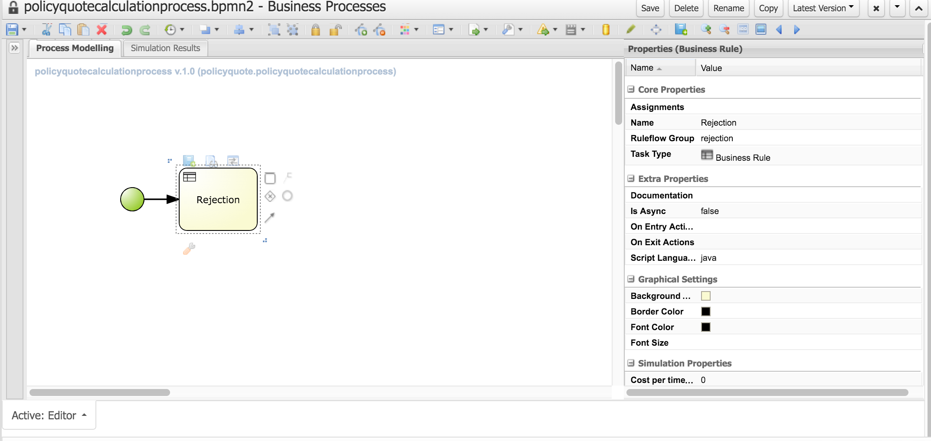

**4. Create a Conditional Business Process Flow**

1. Create two gateways:

* Select the Rejection task.
* Right Click and choose an XOR gateway to add.
* On the Properties panel, for the Exclusive Or gateway name, enter **Gateway**.
* With Exclusive Or selected, rightclick and add another gateway.
* On the Properties panel, for the Exclusive Or gateway name, enter **Join Gateway**.

1. With the second Exclusive Or gateway selected, select the circle icon that does not have a double line around it from the shortcut palette; this is the End Event icon.

The process looks like this after this step:

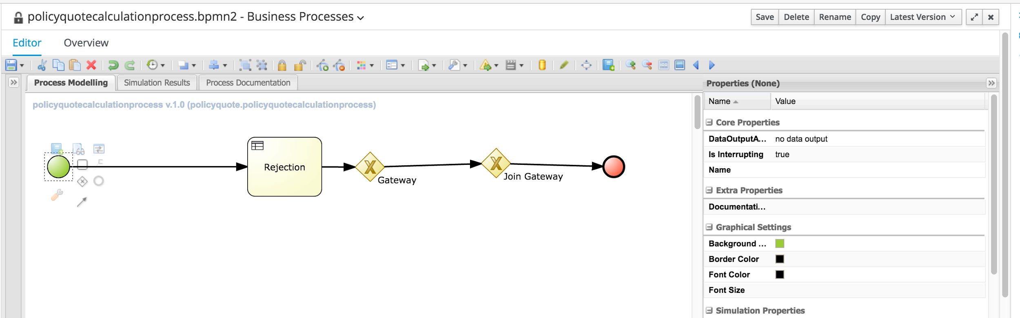

1. Add a Calculation task and properties:

* Select the first Exclusive Or gateway again. Drag the Task icon from the shortcut palette and drop it onto the canvas under the sequence line that connects the two gateways.
* With this task node selected, go to the Properties (Task) panel on the right.
* Select Business Rule for the Task Type and name it **Calculation**.
* Find the **RuleFlow Group** property and set the value to **calculation**.

The process now looks like this

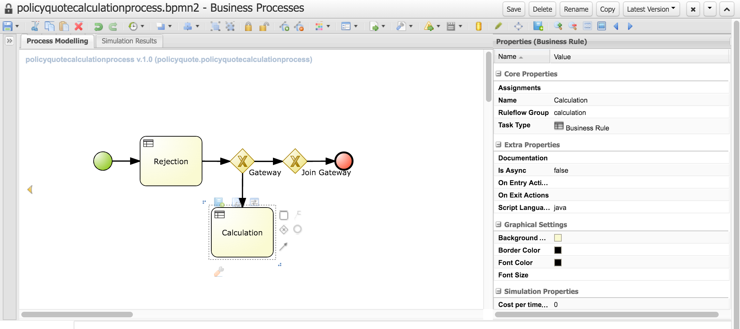

1. Select the sequence flow between the first Exclusive Or gateway and the Calculation task:

* On the Properties (Sequence Flow) panel on the right, select Drools for the Condition Expression Language and enter **not Rejection()** for the Condition Expression.
* Enter **Non Rejection** for the Name property and use a value of **1** for the **Priority** property.

Note :

***When using the XOR type, the route with the lowest priority value is evaluated first.***

* For the sequence flow between the two gateways, select Drools again for the Condition Expression Language and enter **Rejection()** for the Condition Expression.
* Enter **Rejection** for the Name property and use a value of **2** for the **Priority** property.

The process now looks like this

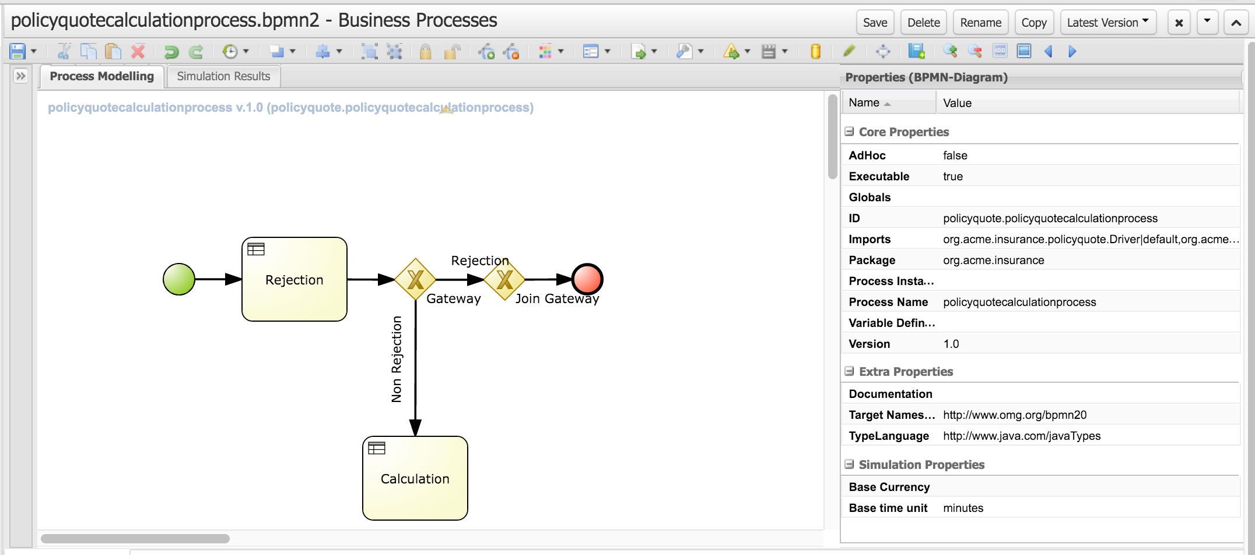

**NOTE the REST OF THE TASKS ARE OPTIONAL IF YOU ARE SHORT ON TIME.**

**5. Complete Additional Business Rule Tasks**

1. Add a Discount task and properties:

* Click the Calculation task. Click another Task icon from the shortcut palette.
* With this task node selected, go to the Properties (Task) panel on the right.
* Add the following properties to the new task node:

Table 2. Discount task properties

|  |  |
| --- | --- |
| **Name** | Discount |
| **RuleFlow Group** | Discount |
| **Task Type** | Business Rule |

Your diagram should resemble the following:

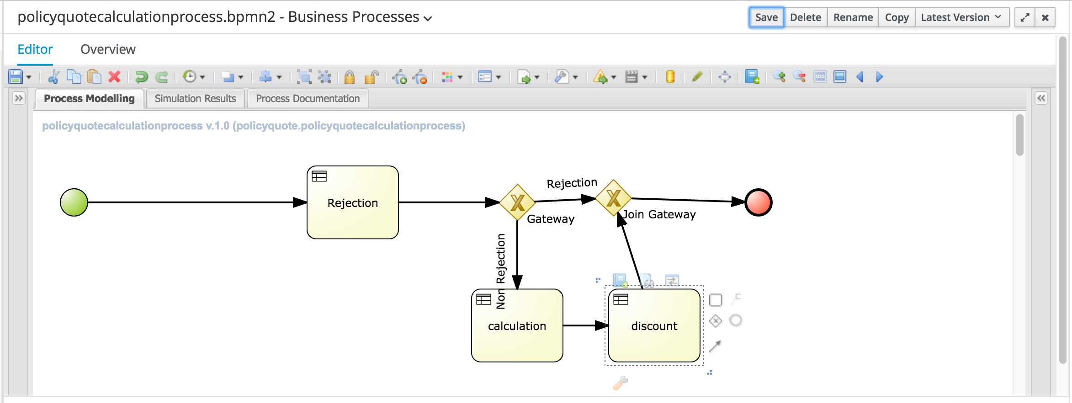

Figure 3. Policy quote process diagram

**6. Save the Process**

Select the Save menu option off the disk icon.