**Lab 12 - Human Task**

**Goals:**

* Use the Process Designer (also called Web Designer) to create a **Review Quote** User Task after the **Calculate Quote** that is part of the **reviewer** group.
* Add an Exclusive Or gateway to route to the User Task if the policy price is greater than $500.
* Create a test scenario to test the process.

**Lab Assets:**

**1. Create a User Task**

1. Click the **Calculate Policy Quote** node on the canvas.
2. On the screen that appears, drag the **Exclusive Or** gateway from the palette to the right, and drop it on the canvas.
3. With the first **Exclusive Or** gateway selected, drag a second **Exclusive Or** gateway to the right, and drop it on the canvas.
4. Select the first **Exclusive Or** gateway again. Drag the **Task** icon from the shortcut palette and drop it on the canvas under the sequence line that connects the two gateways.
5. With the new task node selected, go to the **Properties (Task)** panel on the right and enter the following:

Table 1. Review Quote task properties

|  |  |
| --- | --- |
| **Name** | Review Quote |
| **Task Type** | User |

1. Select the Review Quote node on the diagram again.
2. Drag the sequence line from the shortcut palette to the second **Exclusive Or** gateway. When the red highlights turn green, drop the line:

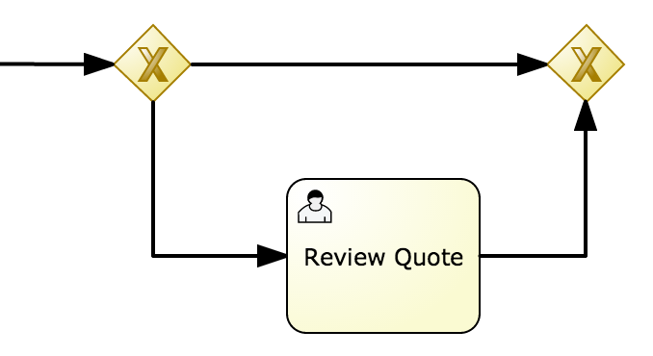

Figure 1. Gateways and human task

1. Select the sequence flow between the first **Exclusive Or** gateway and the Review Quote task.
2. On the **Properties (Sequence Flow)** panel on the right, set the following:

Table 2. Sequence flow between first gateway and Review Quote task

|  |  |
| --- | --- |
| **Condition Expression Language** | Drools |
| **Condition Expression** | Policy(price > 500) |
| **Name** | Over 500 |

1. Select the sequence flow between the two gateways and set the property values as follows:

Table 3. Sequence flow between the two gateways

|  |  |
| --- | --- |
| **Condition Expression Language** | Drools |
| **Condition Expression** | Policy(price <= 500) |
| **Name** | 500 or less |

The diagram should now resemble the following:

**2. Assign Human Task to Reviewer Group**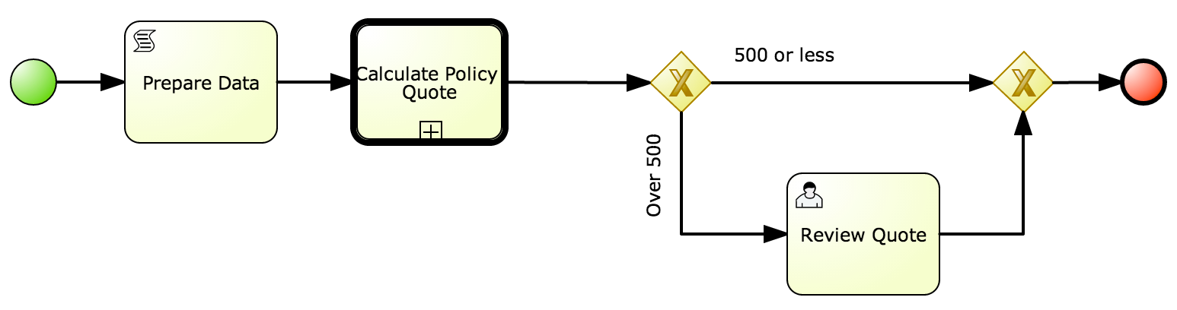

Later in this lab, an instance of this *policyquoteprocess* process will be created. When the process token reaches this Human Task node, the process instance will be persisted to the jbpm database. The process instance is now in a *wait-state* awaiting the life-cycle of this human task (ie: claim, start, complete) to be completed. In this section of the lab, this human task will be assigned to the user ‘bpmsAdmin’. Note that one can create say a *reviewer* group, add users to the group and assign.

However to keep the lab experience simple we are directly assigning to task to the user ‘bpmsAdmin’

Execute the following in the BPM Designer to associate this Human Task with the *reviewer* group:

1. Click the Review Quote node.
2. Select the **Actor** property from the **Properties** palette.
3. Enter the name **‘bpmsAdmin’**.
4. Set the value of the **Task Name** property to **reviewQuote**.
5. Click the **Save** icon and select the option to save to disk.
6. 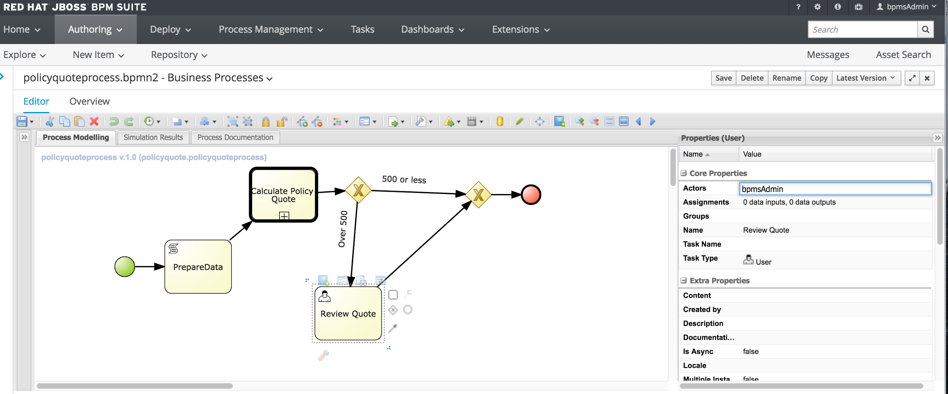

**3. Create Data Input Sets and Data Output Sets**

Data input sets collect data for use by the task. Data output sets capture data coming out of the task. In this procedure, you first set up the input and output data sets for the Review Quote task, and then add another process variable to prepare for the next lab.

Before we edit the review Quote task, we will create another process variable.

Steps to create a process variable:

1. Click an empty area of the diagram (not on any element).
2. Expand the **Core Properties** section.
3. Click the **Variable Definitions** drop-down arrow.
4. On the editor screen, click **Add Variable**.

Add a variable with the name **price** and the type **Integer**

**Screenshot below:**

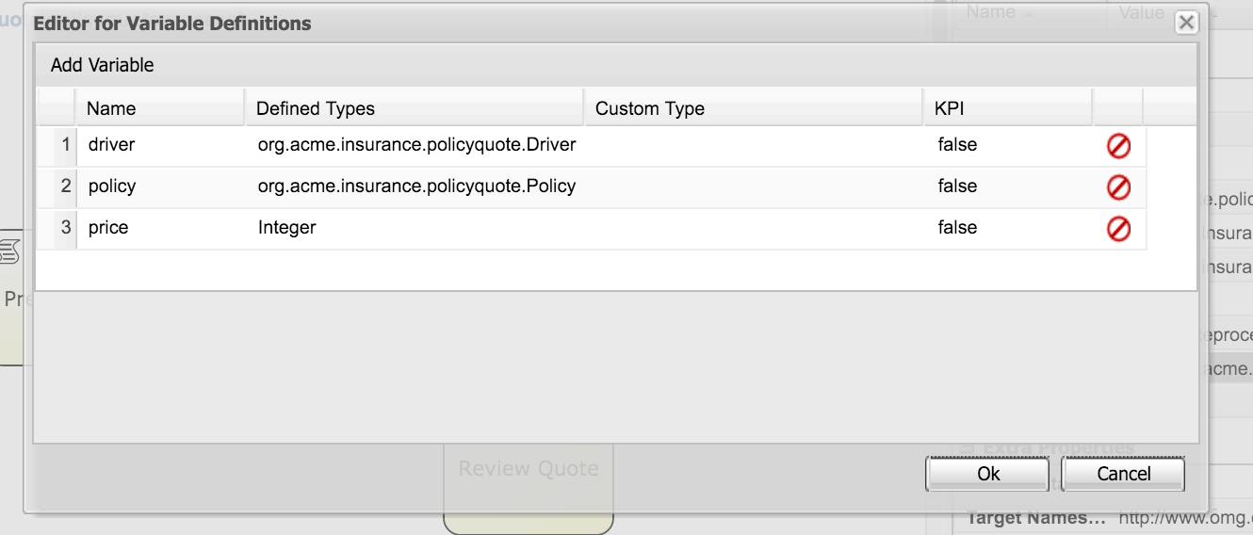

**Now we will assign all these process variables in the Review Quote task.**

1. Click the Review Quote task.
2. On the **Properties (Task)** panel, click the **Assignments** drop-down arrow.
3. enter the following for **Data Input**

|  |  |  |
| --- | --- | --- |
| Name | Datatype | source |
| driverin  policyin  taskpriceIn | Pick driver  Pick policy  Integer | driver  policy  price |

And enter the following for **Data Output**

|  |  |
| --- | --- |
|  |  |
| |  |  |  | | --- | --- | --- | | Name | Datatype | source | | policyout  taskpriceout | Pick policy  Integer | policy  price | |  |

Here is a screenshot

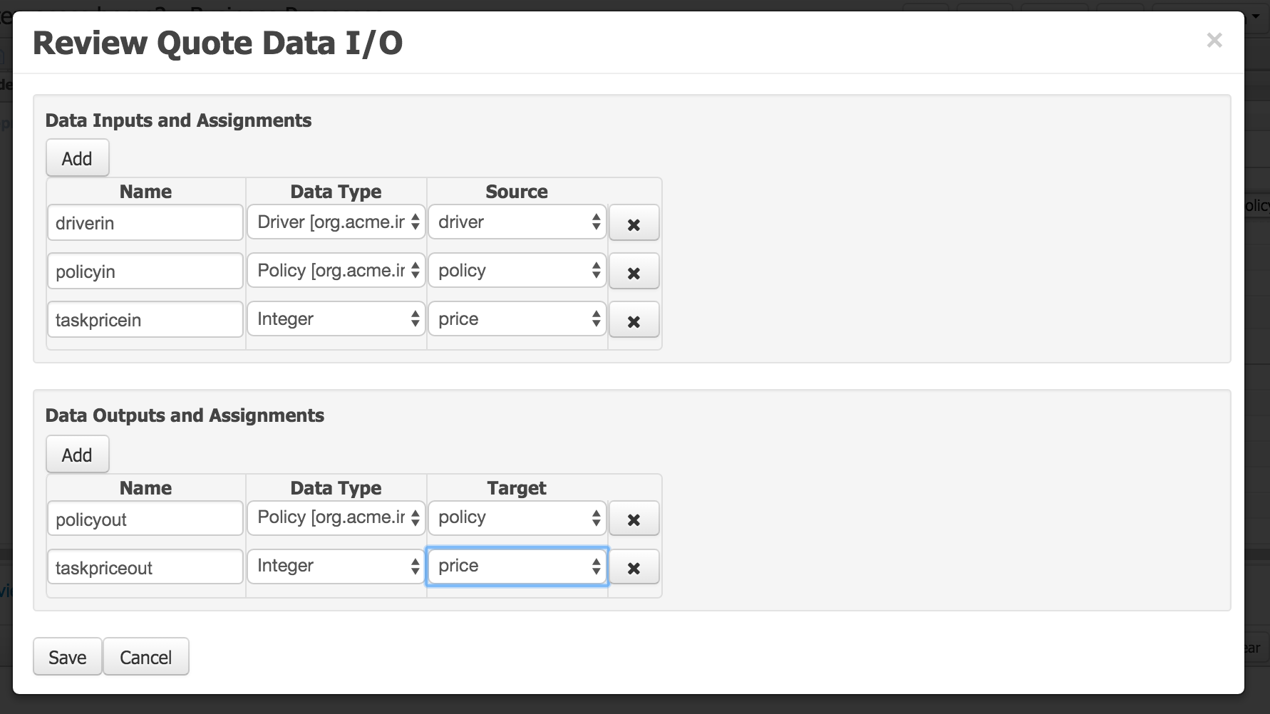

Figure 3. Data assignment editor

1. Click **Ok**.
2. Click the **Save** icon and select the option to save to disk.

**4. Add a Task to Retract Facts**

If you select a SINGLETON session strategy, you must clear facts from working memory to avoid interfering with later rule executions. Follow these steps to remove the facts.

1. Create three retractions rules:
   1. Create three new guided business rules.
   2. For each rule, use **acme.policyquote** for the package.
   3. Use the rule names from the following table, and then click **Ok**.
      * For the **When** entries, click **There is …** and then define the correct variable names.
      * For the **Then** entries, use **Add free form drl**.
      * Be sure to validate and save your progress after you create each rule.

Table 6. Retraction rules

|  |  |  |  |
| --- | --- | --- | --- |
| **Rule Name** | **RuleFlow Group** | **When** | **Then** |
| RetractDriver | retract | driver: Driver()  Variable name d | System.out.println("Retracting Driver " ); retract (d); |
| RetractPolicy | retract | policy: Policy()  Variable name p | System.out.println("Retracting policy: ") ; retract(p); |
| RetractRejection | retract | rejection: Rejection() | System.out.println("Retracting rejection: " + Rejection); retract(Rejection);  Here are the 3 screenshots for these rules |

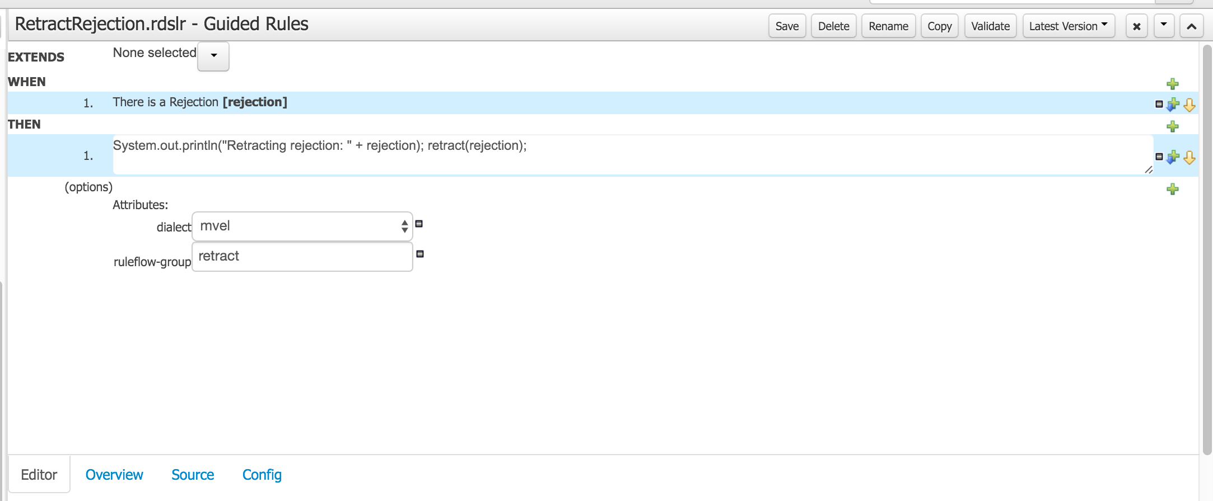

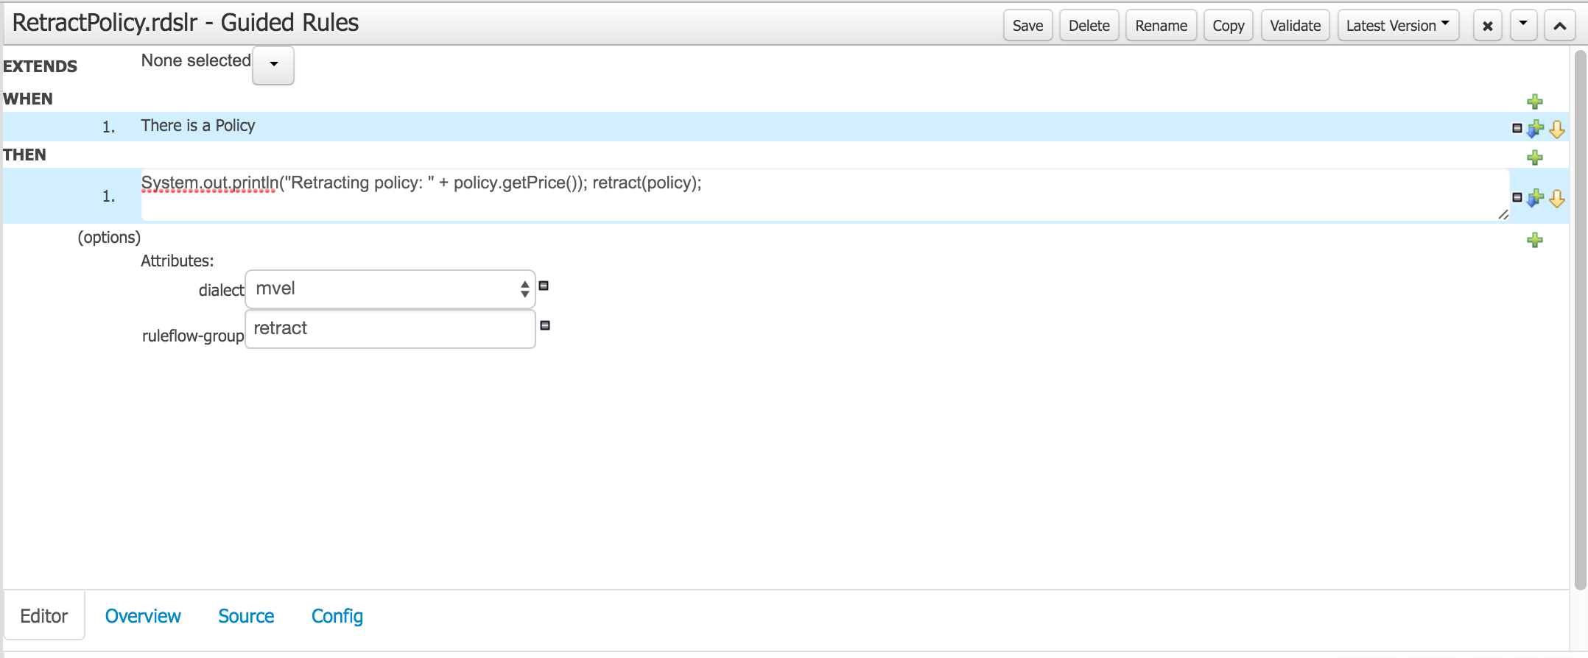

Go to the process policyquoteprocess now.

1. Click the **End Event** of the process and delete it. This should automatically remove the sequence flow leading to the end event as well.
2. Add a task to execute the retraction rules:
   1. From the shortcut menu, drag a **Task** icon from the second **Exclusive Or** gateway to the right.
   2. With the new task icon selected, set the following:

Table 7. Retract Facts task properties

|  |  |
| --- | --- |
| **Property** | **Value** |
| Name | Retract Facts |
| Task Type | Business Rule |
| Ruleflow Group | retract |

1. Add a new **End Event** after this **Retract Facts** task.
2. Click the **Save** icon and select the option to save to disk.

Your diagram should resemble the following:

Figure 4. Retract Facts task added